**DISABILITY REPORT**

**Beth Sheehan’s Trip – May 2012**

In April 2010 I came to Malawi for a month with Landirani Trust and the school partnership team.

During my first 2 weeks I was predominantly involved with the projects the team was working on such as building wells, painting classrooms and building fuel saving ovens. Due to my background as an accredited exercise physiologist I was also asked to assist in some basic assessments of individuals with varying disabilities and also provide some basic first aid workshops to the Local Based Committee Members in the various centres. This sparked my interest in working with people who have disabilities and as a result has created a working initiative for me in Australia creating a program for athletes with disabilities for a local based sports academy at the Gold Coast.

This trip unfortunately has only been 2 weeks but I have had the opportunity to assist in the creation of a disability register in 3 out of our 14 centres via ‘drop in sessions’.

Prior to these 3 sessions I met with MAP (Malawi Against Physical Disabilities) and MACOHA (Malawi Council for the Handicapped). In meeting with these 2 organisations, we have been able to determine what sort of referrals and assistance we can provide via these organisations to certain cases and the process and funding required to facilitate this.

Disabilities in Malawi are vast and varied in their presentation. It is however a testament to Malawian people and their ability to survive with many of the conditions for as long as they do, despite often being ostracized by their community and families.

Landirani Trust would be able to supply the following services and aides if we have funding and fuel: transport to MAP for physical assessments, treatment & surgery, clean clothes for children with disabilities to attend school, wheelchairs/walking sticks/and other ambulation aides etc.

Below is just a small sample of some of the stories we came across during the drop in sessions at Chibwata, Mbang’ombe and Mwilembila. The solution for many of the cases in the scheme of things could be quite simple but again it is having the funding and ability to provide the services that Landirani needs.

These registers are only the start of our long journey ahead. We have started to train the Local Based Committee members to continue gathering data from their own villages. Landirani’s area covers approximately 45 000 people of that there could be a significant number who are disabled. It is then that we will need to determine the most urgent cases and work in conjunction with organisations like MAP & MACOHA in order to supply the appropriate assessments and aides. Due to lack of money it will be hard to assist all but we hope that at least by starting this process we can highlight awareness within the community and work towards a more inclusive society for the disabled individuals and in time educate the community and hopefully provide medical treatment to the vulnerable

**Grace Patisoni**

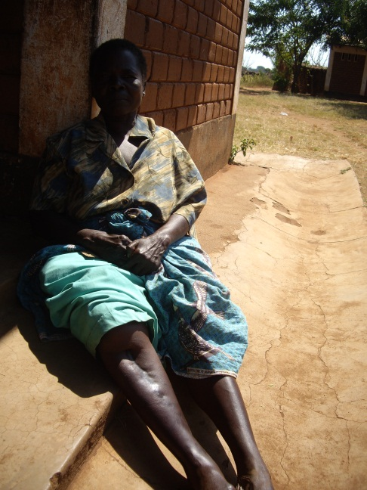

Grace is approximately 50 years old. She woke one day at the age of 10-15 years old with a swollen right lower leg. Her parents took her to hospital where they proceeded to operate and take out her tibia. Grace spent 12months in hospital learning to walk again before returning to the village. For the majority of the population if their tibia had been removed they would not be walking as it is a primary weight bearing bone.

Her parents were getting her pain medication for her up until 10-15 years ago when they passed away. Since then she has had no pain medication and her right leg is in pain from her foot to her knee. She struggles to walk distances and has made herself a walking stick. If someone would simply pick up her medicine when they go to the clinic her quality of life would be significantly improved.

**Judith Chitikula**

Judith is a 12 year old girl whose primary complaint is sore feet and knees from having flat feet. I believe however that the cause of this is the typical gait often associated with mild cerebral palsy. Although she would benefit from a physiotherapy assessment and shoe fitting as we delved deeper into her case it became apparent that she stopped attending school in standard 2. The main reason she ceased attending was due to the state of her clothes. Probing some more we discovered that if we could provide something as simple as a uniform or clean clothes she would return to school.

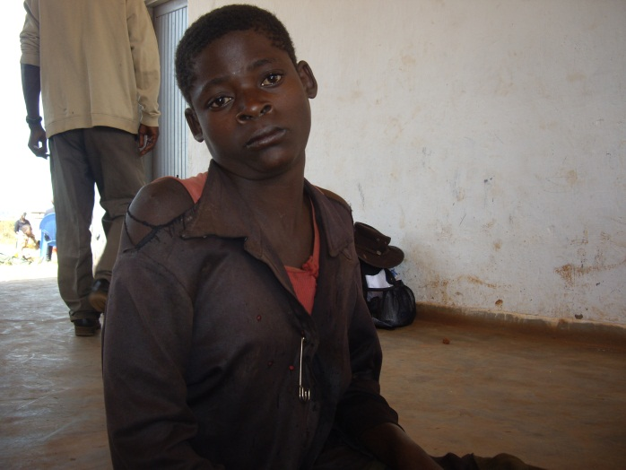

­­­­­­­­­­ **Thokozani Banda**

Thokozani is a 16 year old boy who has been predominantly deaf since birth. If his mother stands close to him and shouts he can vaguely hear what she says. He is currently in standard 5 as he has had to repeat a few classes due to his hearing. His mother however reported that he is quite bright. On probing him a bit more we discovered that he always sits at the back of the classroom.

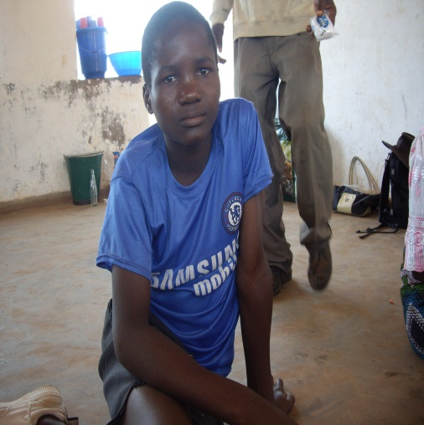

Thokozani is a primary candidate for hearing aids. His mother has also been encouraged to talk to the headmaster in order to ensure he sits at the front of the class for all his classes to ensure he has the best possible opportunity to absorb the information.

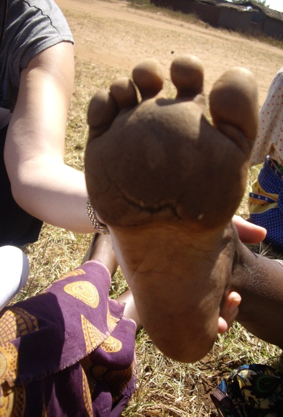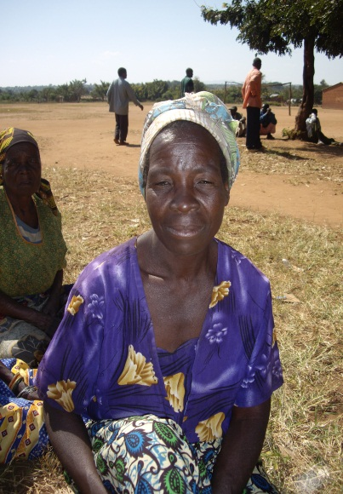

_________________

At the age of 2, this girl’s (name not known) mother dreamt that her foot was being taken away. Her mother then assumed that she was possessed and took her to the witch doctor. The doctor then proceeded to perform a ceremony and broke her foot in two. she now walks the ball of her foot and has a significant crease along the bottom of the foot where the foot was clearly broken.