|  |  |
| --- | --- |
|  | **Landirani – “Please receive”**  Supporting orphans in Malawi |

**Landirani Trust & Raab Vitalfood GmbH**

**Local Food Distribution Programme – February to April 2012**

Background

In December 2011, Raab Vitalfood GmbH very kindly donated £300/350 Euros to the Landirani Trust. They suggested that if possible, it be used to support heath projects but left the final decision to the team here in Malawi

Making use of the donation

At our January 2012 meeting, we discussed how we could best use the funds and knew that in the immediate future, orphans and other vulnerable people (OVCs) in our area would face real hunger as food supplies stored at the end of the previous growing season (December to May) would start to run out. We really wanted to do something long-term and sustainable with the funds; but also realised that if we did this, some of the most vulnerable people we work with would literally starve to death. So we agreed to use the funds to:

* Buy sacks to transport and mill food that many of our centres and schools had grown last year, and stored for just this kind of emergency;
* Provide funds for transporting the food locally and to pay local workers to transport, mill and distribute the food;
* Assist local our local committees with ‘humanitarian’ work such as urgent repairs to the homes of OVCs e.g. to provide plastic sheeting for roof repairs for this ‘rainy’ season to minimise health and malaria risks;
* Buy a few simple pieces of fabric – *chitenji* – for one committee to give to a local disabled lady who would use it to make clothes for OVCs in that centre.

Our Activities

As with many things in Malawi, things did not quite go to plan…! On the day we planned to buy the sacks needed, there were riots in Lilongwe, which was a ‘no go’ area. So we had to go out late in the evening, buying a few sacks here and there from local vendors. This meant many were not clean, or had been used for fertiliser so they all had to be washed by hand by Lodzani, our night guard; and then left to dry in the sun..!

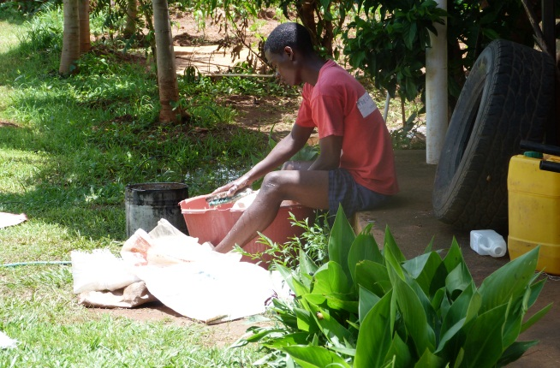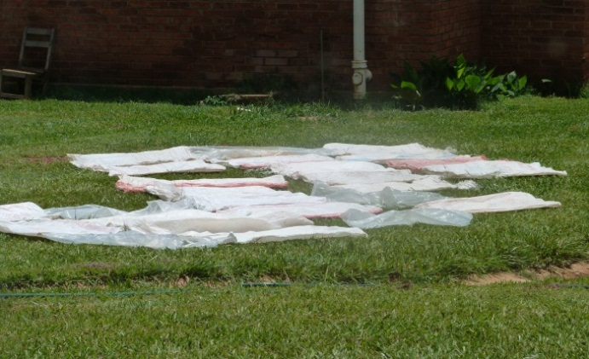

Despite this delay, we still received quotes from all centres, detailing how many sacks they needed and the cost of local transport. During the week of 6 to 9 February (whilst we were also doing a book rotation across 14 schools) we managed to delivery most of the sacks and funds to the 10 centres in our area; and also most of the plastic sheeting needed for roof repairs.

Our friend Sebastian, who you know, assisted us by providing a spread-sheet to enable each centre to know how much food they could distribute to each OVC and so how many OVCs they could support in each centre. Centres worked together to make sure the funds and food they had was used as efficiently as possible:

|  |  |
| --- | --- |
| **A local committee member sharing out food at Chitsime Centre** | **Orphans and vulnerable children (OVCs) with their ‘food pack’ of carbohydrate and protein at M’bang’ombe Centre** |

Local committees in four centres helped repair roofs for orphans and other vulnerable people – so important during the rainy season to prevent illness and simply keep things dry. Imagine your home flooding every time it rains!

|  |  |
| --- | --- |
| **The roof repaired by our local committee at Lumbadzi, using your funds** | **A gogo (grandmother) and the orphans she cares for in the home you helped repair at Lumbadzi** |

Within weeks of making our decision on how best to use your funds, our community **received invaluable support from you** to enable them to:

* Feed over 200 very vulnerable people
* Repair the roofs and homes of over 20 other vulnerable people
* Provide children with some basic clothing
* Sustain one of our income generating businesses by ‘buying’ a used car battery to support their phone charging business, the profits from which go towards support OVCs all year round.

|  |
| --- |
| **A smiling young orphan girl at Lumbadzi,**  **wearing a new dress made from *chitenji* that you bought** |

We can tell you that of the 100,000MK/350 Euros you donated we used:

17,000MK/65 Euros to buy sacks and plastic sheeting

4,000MK/15 Euros on fuel to distribute the sack, funds and sheeting

3,000MK/ 11.5 Euros on ‘chitenji’ (material)

2,000MK/7.5 Euros on the used car battery

75,000/270 Euros shared across 10 centres to pay for

* milling of maize into ‘ufa’ (maize flour) to make ‘nsima’ – the staple source of carbohydrate here in Malawi;
* distribution of ufa with locally grown protein (beans, soya or groundnuts); and
* a small allowance (250MK per day – about one Euro) to feed local workers who undertook this work over several days

We hope that you have enjoyed reading about how we used your invaluable contribution and can see the different that it has made to hundreds of people. We hope, too, that you appreciate why we took the decision to use the money in this way and that lives had been sustained and improved by it.

**Zikomo Kwambiri from your very grateful friends in the team here in Malawi; and an even more grateful community that it is our privilege to support and work for.**

**May 2012**