- TECHNOLOGY
A list of the underlying technology used by the application:
- Java
- JSP (Java Server Pages)
- JavaScript
- HTML
- CSS
- Tomcat

- SYSTEM INSTALLATION
- Application is located at location: \tomcat\webapps\Simulation\
- The tomcat/lib folder should contain following library files

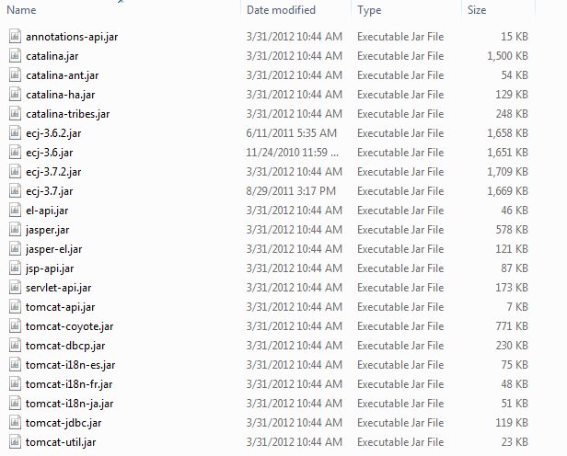

- Website is located at http://{SERVER_ADDRESS}:8080/Simulation/index.jsp
SERVER_ADDRESS is by default localhost, until it is changed to the IP address of the server.
The IP Address of the server where this Web application is currently deployed is 172.22.191.198
Website URL then becomes:
http://172.22.191.198:8080/Simulation/index.jsp

Changes to make when the IP address changes or to make change from localhost to the IP address
Inside JSP page search for similar code and make the required change of IP address:

<%@ page language = "java" import="java.io.*"%>
<%@ page language = "java" import="java.util.*"%>
<%
// make change from locahost to IP address here
String baseurl = "http://localhost:8080/Simulation/";
%>

- index.jsp – Is the main page displayed when website is visited.
- simulate.jsp – This JSP page displays the Corrosion Single Pit Growth Simulation (2D) form.
- sim2D.jsp – This JSP page displays the Corrosion Multi Pit Growth Simulation (2D) form.
- Materialconstants.jsp – This page displays the Corrosion Fatigue Life Prediction form.
- Imageanalysis.jsp – This page provides feature to upload image and Analyze Corrosion Image
- siaform.jsp – This page displays the Neural Network Analysis form

Applet Settings:
For Applets to be executed give permission for applet file read and write http://docs.oracle.com/javase/tutorial/security/tour1/wstep1.html
- create simulation policy file as seen in link above
- In java.security file under jre/lib add below line
policy.url.2=file:/C:/tomcat/webapps/Simulation/permissions/simulationpolicy

- Corrosion Single Pit Growth Simulation
- Simulate.jsp file located under tomcat\webapps\Simulation folder contains the main code
- The simulate.jsp page makes calls to
  - SimulateBean.class file ( located at \tomcat\webapps\Simulation\WEB-INF\classes\com\sim)
(Java file located at \tomcat\webapps\Simulation\src\com\sim)
  - Sim2DV1.jar file (located under tomcat\webapps\Simulation) which provides the applet functionality
  - post_chart.jsp file (located under tomcat\webapps\Simulation) which provides the graph functionality. ( Google Chart API is integrated in this file)

Input Parameters:
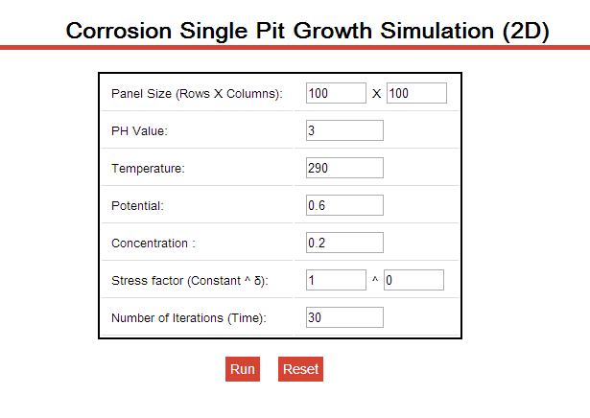
RESET Functionality: Parameter values can be reset. Acts like a refresh button functionality
RUN Functionality:
- When the Run button is clicked, a bean class is called from JSP program (com.sim. SimulateBean.class) .This class is generated to set and fetch the input parameters on page load.
- A Java applet is called when the Run button is clicked. The Java applet is compiled into a Jar class file Sim2DV1.jar and is called from JSP file as shown
<jsp:plugin type="applet" code="Sim2D.class" archive="Sim2DV1.jar,charts4j-1.3.jar,junit-4.4.jar" jreversion="1.6" width="400" height="400" > <jsp:params>
(NOTE: Java applet has to be digitally signed to execute it from a JSP page. Refer to JarSigning.doc file)

- Sim2DV1.jar file is located at tomcat/webapps/Simulation/ and is created using Sim2D.class and ImageMatrix.class files. (Located at \tomcat\webapps\Simulation\Sim2DV1)

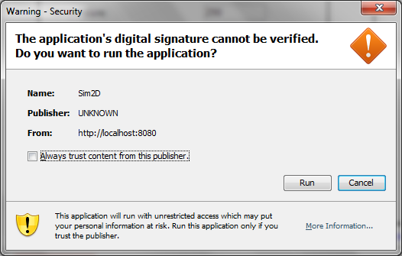

- When a Java applet is executed on the system for the first time, screen pops up asking to accept digital signature application. A jar was created and digitally signed, due to which this screen asks if you want to run the application. Please click run to execute the Java applet
- Output looks like the below screen
- 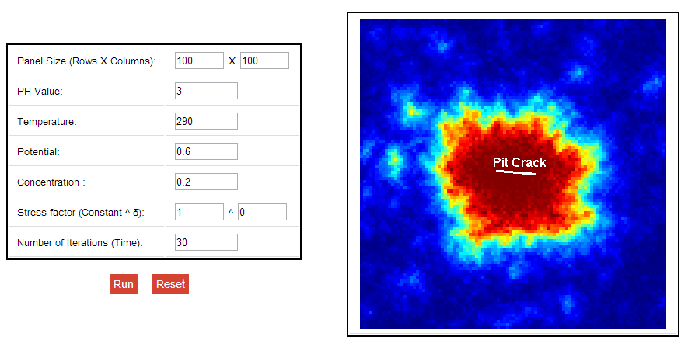

DISPLAY GRAPH Functionality
- This button appears after the Run command is given and applet is executed.
- Please wait until the pit growth is completely executed and a Pit Crack display appears in the application
- After clicking the Display Graph button, graphs are populated , one indicating the no of Iterations Vs the Pit Size and the other is No of Iterations Vs the Pit Growth Rate

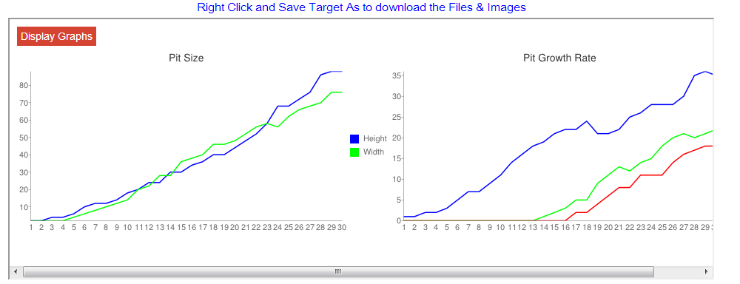
- post_chart.jsp is called when the DisplayGraph button is clicked. This JSP contains code to display graph. Google chart API is used with imageLineChart type functionality.

IMPORTANT FEATURES TO BE NOTED IN CODE
- C:/tmp/ location should be created, as the program generates image files and txt files that are used during coding.
- For Corrosion Single Pit Growth Simulation, C:/tmp/files/ directory is created and 4 files are generated and data is written into it for graphical display.
  - Features.txt
  - Others.txt
  - PitSize.txt
  - PitGrowthRate.txt
  - simulation.JPG
  - simFiles.zip is also created for downloading all files from server
- Make sure 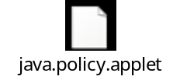 is present in \tomcat\webapps\Simulation folder

- Corrosion Multi Pit Growth Simulation
- sim2D.jsp file located under tomcat\webapps\Simulation folder contains the main code
- The sim2D.jsp page makes calls to
  - SimulateBean2D.class file ( located at \tomcat\webapps\Simulation\WEB-INF\classes\com\sim)
    - (Java file located at \tomcat\webapps\Simulation\src\com\sim)
  - Sim2DMulV1.jar file (located under tomcat\webapps\Simulation) which provides the applet functionality

Input Parameters
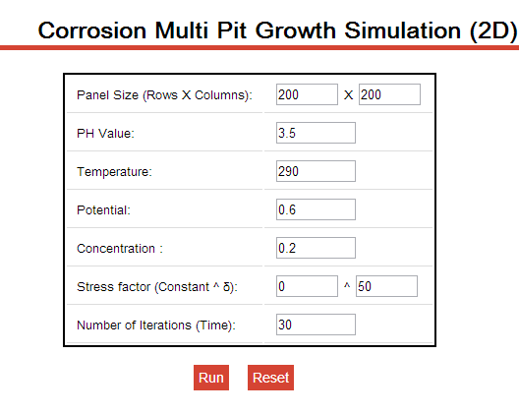
RESET Functionality: Parameter values can be reset. Acts like a refresh button functionality
RUN Functionality:
- When the Run button is clicked, a bean class is called from JSP program (com.sim. SimulateBean2D.class) .This class is generated to set and fetch the input parameters on page load.
- A Java applet is called when the Run button is clicked. The Java applet is compiled into a Jar class file Sim2DMulV1.jar and is called from JSP file as shown
<jsp:plugin type="applet" code="Simulate2D.class" archive="Sim2DMulV1.jar,charts4j-1.3.jar,junit-4.4.jar" jreversion="1.6" width="400" height="400" >
(NOTE: Java applet has to be digitally signed to execute it from a JSP page. Refer to JarSigning.doc file)

- Sim2DMulV1.jar file is located at tomcat/webapps/Simulation/ and is created using Simulate2D.class and ImageMatrix2D.class files. (Located at \tomcat\webapps\Simulation\Sim2DMulV1)

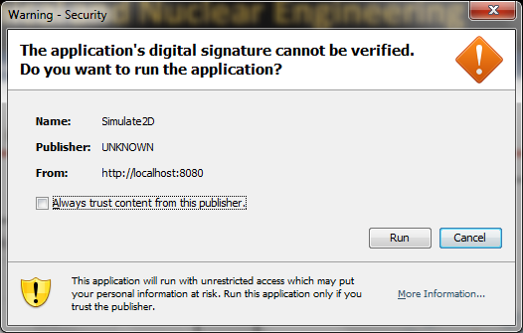

- When a Java applet is executed on the system for the first time, screen pops up asking to accept digital signature application. A jar was created and digitally signed, due to which this screen asks if you want to run the application. Please click run to execute the Java applet
- Output looks like the below screen
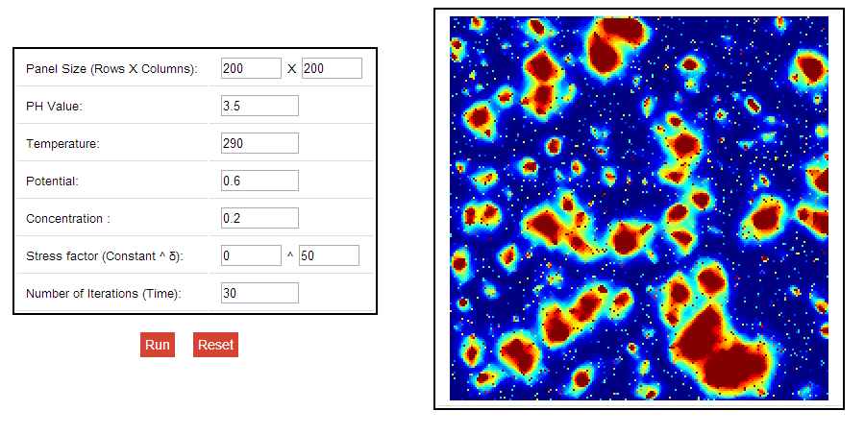

IMPORTANT FEATURES TO BE NOTED IN CODE
- C:/tmp/ location should be created, as the program generates image files and txt files that are used during coding.
- For Corrosion Multi Pit Growth Simulation, C:/tmp/files2D/ directory is created and 4 files are generated and data is written into it for graphical display.
  - Features1.txt
  - Others1.txt
  - PitSize1.txt
  - PitGrowthRate1.txt
  - Simulation1.JPG
  - Sim2DFiles.zip is also created for downloading all files from server
- Make sure java.policy.applet file is present in \tomcat\webapps\Simulation folder

- Corrosion Fatigue Life Prediction
- materialconstants.jsp file located under tomcat\webapps\Simulation folder contains the main code
- The materialconstants.jsp page makes calls to
  - inputMaterial.jsp file – which mainly pops up a window screen where input parameter values can be set and when submitted calculates the required output.
  - CorrosionBean.class file ( located at \tomcat\webapps\Simulation\WEB-INF\classes\com\sim)
(Java file located at \tomcat\webapps\Simulation\src\com\sim)
  - CorrosionBean.class file apart from setting and getting parameters also calculates the Output values – Initiation Life (Ni), Crack Propagation Value (Np)
and Fatigue Life Value (Nf).

Input Parameters
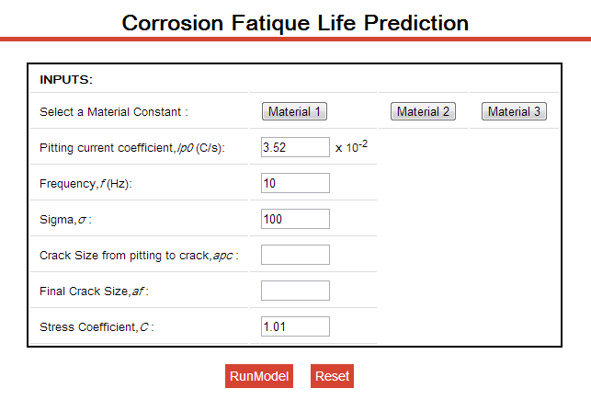

- To enter the input parameters, selecting a Material Constant is mandatory.
- Default values are set for Material 1 and Material 2 selection
- Clicking on Material 1 /Material 2/ Material 3 will populate a separate window
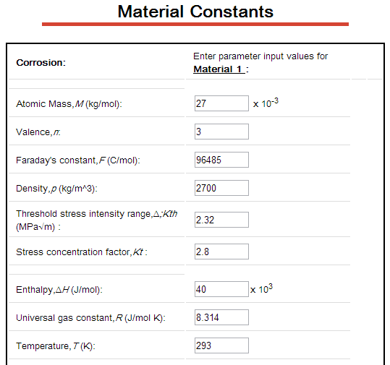
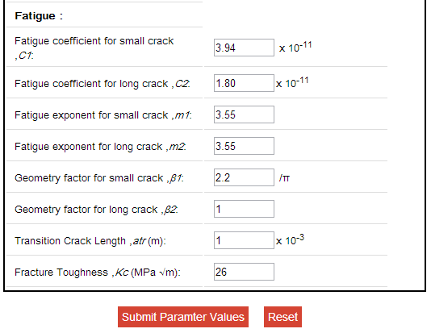
- After entering the required values and clicking Submit Parameter Values, the screen will redirect back to Main Parameter page.

- RUN MODEL functionality
  - This functionality does calls the functions from CorrosionBean.class file and returns the desired results

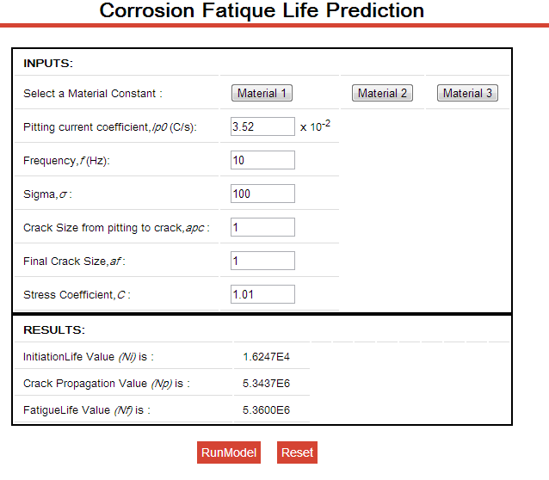

- Corrosion Image Analysis
- In this program, an image is to be uploaded (preferably JPG image) , the image uploaded from local machine is sent to the server image folderusing servlet and this image is then read from the Image Wavelet transformation code and the segmented output is generated in C:\tmp\images folder
- Few files are read from the program, so make sure they are present at location C:\tmp\readfiles
  - Equalized-PC10-W1-EC-04k
  - Equalized-Weights-Identify-PC10-EC-04k
  - Equalized-Weights-Quantify-PC10-EC-04k
  - HistoMap-EC-04k
- imageanalysis.jsp located under tomcat\webapps\Simulation folder contains the main code.

- ImageUpload.java – a servlet file which reads image from local machine and uploads it to server images (\tomcat\webapps\Simulation\images) folder.
  - Place the imageupload.class file in tomcat\webapps\Simulation\WEB-INF\classes folder
  - Servlet can be called by making the entry of servlet in web.xml file located under tomcat\webapps\Simulation\WEB-INF
    - The following entry should be present in web.xml file
<servlet>
<servlet-name>ImageUpload</servlet-name>
<servlet-class>ImageUpload</servlet-class>
</servlet>
<servlet-mapping>
<servlet-name>ImageUpload</servlet-name>
<url-pattern>/ImageUpload</url-pattern>
</servlet-mapping>
- ImgWaveV1.jar is called from the main page when Submit button is clicked ((located under tomcat\webapps\Simulation)
  - A Java applet is called when the Submit button is clicked. The Java applet is compiled into a Jar class file ImgWaveV1.jar and is called from JSP file as shown
<jsp:plugin type="applet" code="ImageAnalysis.class" archive="ImageWaveV1.jar,charts4j-1.3.jar,junit-4.4.jar" jreversion="1.6" width="500" height="500" >
(NOTE: Java applet has to be digitally signed to execute it from a JSP page. Refer to JarSigning.doc file)
  - ImgWaveV1.jar file is located at tomcat/webapps/Simulation/ and is created using Simulate2D.class and ImageMatrix2D.class files. (Located at \tomcat\webapps\Simulation\ImgWaveV1)

Input Parameters
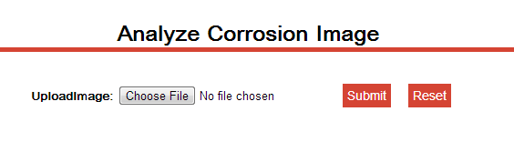
- Upload an image from any location and click Submit. Sample Image file is located at tomcat\webapps\Simulation\images\9.jpg or 10.jpg etc.
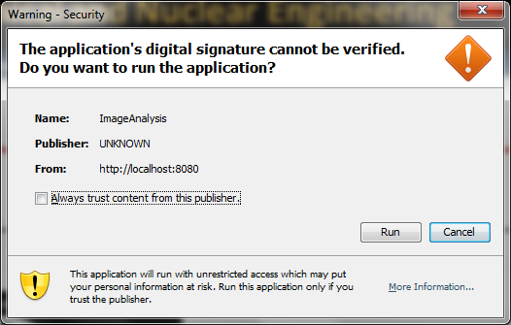

- When a Java applet is executed on the system for the first time, screen pops up asking to accept digital signature application. A jar was created and digitally signed, due to which this screen asks if you want to run the application. Please click run to execute the Java applet

Output Page
- The page displays the original image which was uploaded from local machine and the wavelet transformed image on the right side.

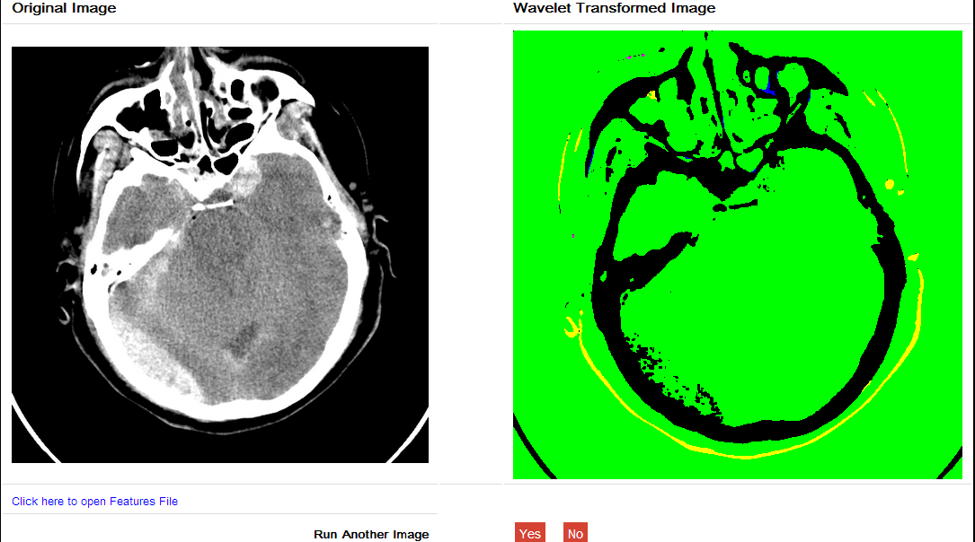

- Neural Network Analysis

- This program provides the feature to train or test the neural network.
- siaform.jsp file located under tomcat\webapps\Simulation folder contains the main code
- This page makes a call to SiaServet , which calls the nnet class file , which contains the code to generate various files white training or testing neural network data.
- Siaresults.jsp page displays the results page, it provides link to download or see the files generated after the program was run. This page also contains code to display the errorgraph. ( Google chart API was used)
- SiaServlet.java – a servlet file which helps users to upload the traindata.txt file on server (\tomcat\webapps\Simulation\upload) folder. Source code of this servlet can be found at
\tomcat\webapps\Simulation\src\com\sim\)
  - Place the SiaServlet.class file in tomcat\webapps\Simulation\WEB-INF\classes\com\sim\ folder
  - Servlet can be called by making the entry of servlet in web.xml file located under tomcat\webapps\Simulation\WEB-INF
    - The following entry should be present in web.xml file
<servlet>
<servlet-name>SiaServlet</servlet-name>
<servlet-class>com.sim.SiaServlet</servlet-class>
</servlet>

<servlet-mapping>
<servlet-name>SiaServlet</servlet-name>
<url-pattern>/servlet/SiaServlet</url-pattern>
</servlet-mapping>
- nnet.java
  - The class file nnet is called from SiaServlet and the Input parameters entered by user are passed on this file and depending on whether Test or Train Neural network feature is selected, appropriate code call is made.The source code can be found at tomcat\webapps\Simulation\src\com\sim\)
  - After compiling this file various class files are generated and should be placed in tomcat\webapps\Simulation\WEB-INF\classes\com\sim\ folder
    - nnet.class, NET.class, LAYER.class, Sda.class are the files to be placed
- SAMPLE TRAIN AND TEST DATA Files are located under tomcat\webapps\Simulation\Documents\SampleTestandtraindatafiles
- Pyroelectric_Data_Optimized.xls – This file contains the Input and Output data, once this data is available user will have to optimize that data. Formulaes for optimizing the data is provided in the excel file. The Value/ Max(Column Value) is the idea.
- traindata.txt – this is a sample file which user will upload for Training of Neural Network
- testdata.txt – this is a sample file which user will upload for Testing of Neural Network

INPUT PARAMETERS
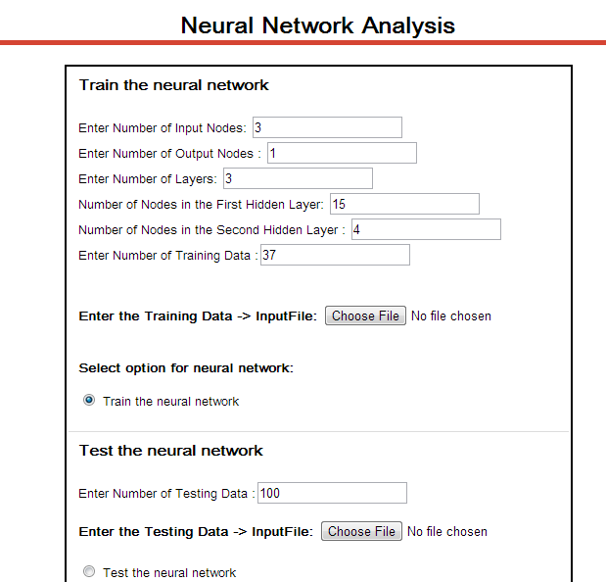

Train the Neural Network (Sample file traindata.txt is required for reference to understand the input parameters)
Input:
- Enter the number of Input Nodes: 3 (These are the first three columns from the text file, optimized data), depending on number of input columns the Number of Input Nodes will change. ( When entering values in txt file make it tab separated)
- Enter Number of Output Nodes: 1 ( This will be the last column from the traindata.txt file)
- Enter Number of Training Data :37 ( this the count of records available in the traindata.txt file)
- All other input parameters can be changed as desired

Output
- Uploading the traindata.txt file, and choosing the train neural network option , the results page will display the files generated related to training
  - Error File
  - Weight File
  - Display Graph – This shows the Error graph values based on the error file generated
- (Note: Results File is generated only after the Test neural network option is submitted)
- The files are generated on server at location (tomcat\webapps\Simulation\nnet_sia)

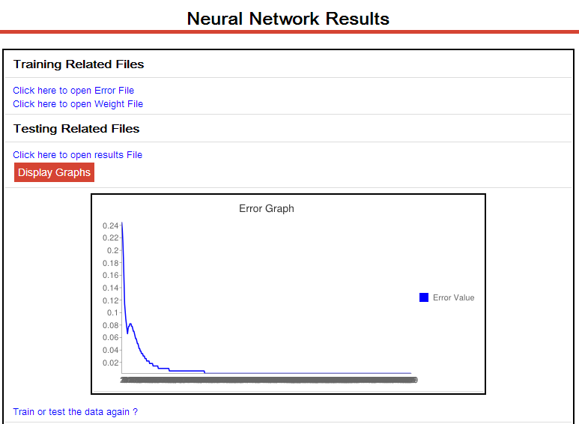

Test the Neural Network (Sample file testdata.txt is required for reference to understand the input parameters)
Input:
- Enter number of Testing data: 100
  - Refer to the testdata.txt file, there are 100 rows in that file and contains only the Input columns from the excel file/ the traindata.txt file. The 100 records are generated by randomizing the column data and adding more rows to the traindata.txt input columns.

Output
- Uploading the testdata.txt file, and choosing the test neural network option , the results page will display the files generated related to testing
    - Results.txt - The file is generated on server at location (tomcat\webapps\Simulation\nnet_sia)

IMPORTANT – The Output Results.txt file generated can be compared with traindata.txt Output column to confirm if the neural network train and test data results are generated properly.

