XLLPlus Instructions
How to Clone and Modify Existing Functions

- VISUAL STUDIO PROJECT
Open Visual Studio 2017 and the MLIBQ Quant Library, MLIBQ_2017.sln

- EXCEL ADDIN FOLDER
Navigate to the filter MLIBQ_ADDIN->src->etrading->Curve and open meCurves.cpp

- XLL PLUS MENU
From the XllPlus menu, under Visual Studio->Tools, select New XLL+ Function

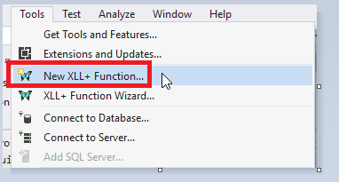

- CREATE NEW FUNCTION
Copy the Function Name and append the suffix “NV”

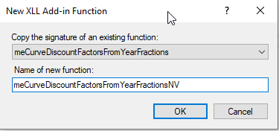

- MAKE NEW FUNCTION NON-VOLATILE
A window will appear from which select the “Features” tab (1) and then untick the “Volatile” checkbox (2). Please ensure that Thread Safe is not selected, sometimes this is ticked by default.

Press OK, upon which the XLL Plus plugin will copy and create the new function at the bottom of the file.

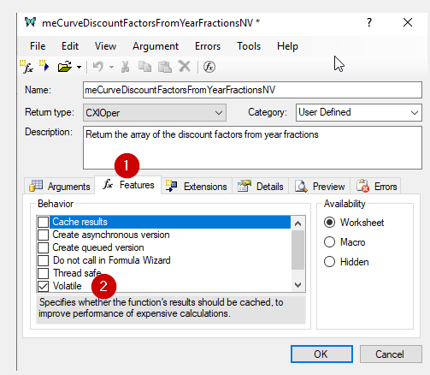

- COPY CODE FROM THE ORIGINAL-TO NEW FUNCTION
Copy the source code of the original function into the new non-volatile function, as per the example below.

FROM
Search for the original function with the suffix “_impl” and copy the code from and including the MLIB_START to the MLIB_END

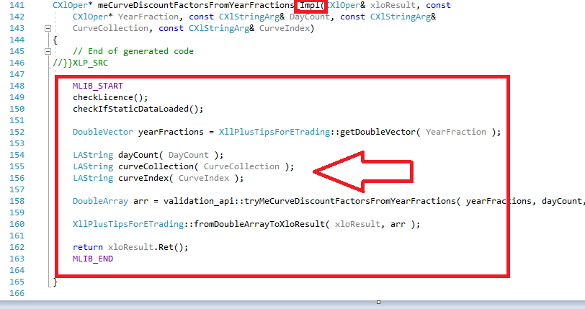

TO
Make sure your change goes below the // TODO comment block

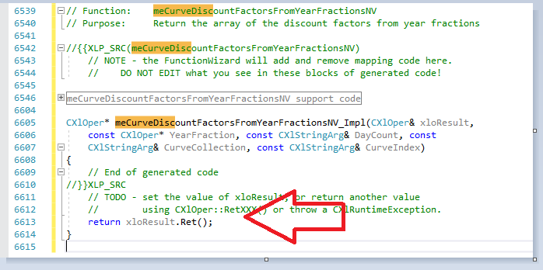

- SAVE & COMPILE
Save the File and check the file compiles using “Ctrl”+F7

