Curve Calibration Overview

Code Flow: OIS Curve Calibration
- meCurveCalibrate
- tryMeCurveCalibrate
- SingleCurveObect::Calibrate
- CurveEngine::CalibrateOISCurve
- LAUpdateStaticDataManager::SetupOISCurve
- LAUpdateStaticDataManager::generateSDEMarketData
- LAUpdateStaticDataManager::generateInitialValue
- LADataProcedure::estimate
- LAPriceYieldGenerator::estimate
- LAPriceYieldGenerator::calcDiscountFactor
- LAPriceYieldGenerator::calcOISDiscountFactor

Code Flow: Standard Swap Curve Calibration
- meCurveCalibrate
- tryMeCurveCalibrate
- SingleCurveObect::Calibrate
- CurveEngine::CalibrateSwapCurve
- LAUpdateStaticDataManager::SetupSwapCurve
- LAUpdateStaticDataManager::generateSDEMarketData
- LAUpdateStaticDataManager::generateInitialValue
- LADataProcedure::estimate
- LAPriceYieldGenerator::estimate
- LAPriceYieldGenerator::calcDiscountFactor

Code Flow: Basis Curve Calibration
- meCurveCalibrate
- tryMeCurveCalibrate
- SingleCurveObect::Calibrate
- CurveEngine::CalibrateTenorBasisCurve
- LAUpdateStaticDataManager::SetupBasisCurve
- LAUpdateStaticDataManager::generateSDEMarketData
- LAUpdateStaticDataManager::generateInitialValue
- LADataProcedure::estimate
- LAPriceYieldGenerator::estimate
- BasisCurveCalibration::setBasisRates
- setBasisRates – bootstrapLibors (Bootstrap Libor Fixings)
- setBasisRates – bootstrapFRAs (Bootstrap FRAs)
- setBasisRates – calcBasisCF (Target Function for Basis Solver)

Section A) Excel Layer
In this layer we marshal Excel XLOper data types to / from native C++ types.
- meCurveCalibrate

Section B) Validation Layer
The validation layer captures structured exceptions and prevents C++ crashes via the VALID_EXCEPTION_START and VALID_EXCEPTION_END macros.
We also record function inputs using the macros RECORD_DECORATED_INPUTS and RECORD_DECORATED_OUPUTS, which only record if recording has been enabled, using the meUtilityRecord() Excel function. We use the record methods to create scripted tests and as a mechanism for users to record and report issues and errors to the Quant team.
- tryMeCurveCalibrate

Section C) LWO Curve Objects & Serialization
The Light Weight Object (LWO) layer is responsible for object instantiation in memory and object serialization into JSON string and file formats.
- SingleCurveObject

- calibrate

Section D) Curve Results Framework
The Curve Results object framework is a wrapper on the Legacy Object Pool.
The Object Pool contains thousands of lines of messy, difficult and error-prone static and market data code, where data is often stored in text format on an individual parameter basis. Instrument data is built up and stored in duplicate for every instrument type and tenor and then dis-guarded at the end, making data access slow and requiring repeated unnecessary calls to reconstruct instruments to query curve parameters and settings.
To mitigate working with the Object Pool and the issues it presents, we created the Curve Results framework to conveniently store both static and market data and also curve forward, discount factor and risk results to bypass the Object Pool and the need to marshal thousands of lines of unnecessary text data.
- CurveEngine
The curve engine wraps and calls the legacy calibration routines, stores the curve implied forward rates and discount factors. It also computes and stores the analytical Risk Jacobians.

- calibrateARRCurve
ii) calibrateOISCurve
iii) calibrateSwapCurve
iv) calibrateTenorBasisCurve
v) calibrateXccyBasisCurve
vi) calibrateFwdFXConstantCurve
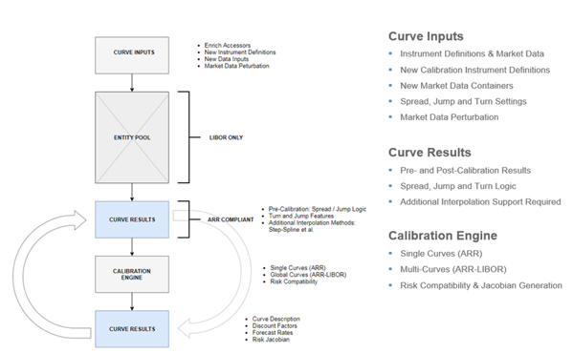

Section E) Entity Pool Static & Market Data
The methods here build up thousands of lines of static and market data. Static data defaults are loaded in from text file config files on start-up and stored in the Property Manager object. This data is only used if not provided to the curve calibration methods. Curve data is taken as input from the end client and any missing data enriched from the Property Manager.
The final curve data to be used for calibration is stored in the Entity or Object Pool. Data is processed on an individual parameter basis, is case sensitive and managed by thousands of lines of poorly written code. We are looking to move away from using this costly and error prone legacy framework.

- LAUpdateStaticDataManager

- setUpOISCurve

- generateSDEMarketData

- generateInitialValue

- LADataProcedure

- estimate

Section F) Curve Calibration
Curve Calibration is performed exclusively within the calcDiscountFactor and calcOISDiscountFactor routines, once thousands of lines of text static and market data has been processed in the Property Manager and Object Pool routines.

- LAPriceYieldGenerator

- estimate

- calcDiscountFactor

- calcOISDiscountFactor

Appendix: Yield Curve Key Parameter Settings
We highlight key parameter settings used in yield curve construction for the OIS, STD Swap, Tenor Basis, Xccy Basis curves respectively.

OIS Curve Settings
CompoundingMethod ARITHMETIC, GEOMETRIC, SIMPLE, FLAT
This parameter specifies the OIS coupon compounding methodology, which includes arithmetic averaging, geometric averaging, simple and flat.

LongTerm.GenerateMethod LOBASIS
This field is used to specify if Libor-OIS spread instruments are to be specified and included as calibration instruments. Simply enter LOBASIS to include and leave blank to not use Libor-OIS spread instruments.
LongTermConvention Example: 3Y
Here we specify a tenor representing the join point for outright OIS and Libor-OIS basis calibration instruments. For example a 3Y tenor would imply that we use outright OIS swaps up to and excluding the 3 year point and Libor-OIS spread instruments from and including the 3 year quotes.
SmoothShortEnd TRUE, FALSE
When using central bank swaps such as ECB swaps or Fed Futures instruments in the outright section we must specify whether we wish to include any short dated OIS swaps that are quoted before central bank swaps such as O/N, T/N, 1W etc. TRUE indicates we wish to include short dated OIS swaps and FALSE excludes them.

STD Swap Curve Settings
AlwaysCalcJoinDate TRUE, FALSE
The Swap curve has a dynamic futures / swap join date when using a hybrid interpolation method such as Linear-Spline interpolation. During calibration a join date is selected to provide the smoothest curve shape over the join as possible. This works well when using curves for pricing, however numerical risk calculations are more stable if we use a fixed join date. This flag allows the end user to control the join date calculation, when TRUE a join date is always dynamically calculated and we optimize for the smoothest curve shape. When set to FALSE we re-use the join date for stable numerical risk calculations. The default value is TRUE.

ApplyTension TRUE, FALSE
When set to TRUE this flag, which is specified within the Futures and FRAs convention blocks, will insert synthetic points to replicate linear interpolation and thereby simulate curve tension. Note the ‘TensionGap’ parameter needs to be set in conjunction with this parameter to control the number of synthetic points used.
GenerateForwardsFromSwapsOnly TRUE / FALSE
Specified within the curve build properties, this parameter manages the calibration of Libor forward rates when futures and swap calibration dates conflict. In the event of a date conflict between futures and swap dates TRUE prioritizes the swaps and FALSE the futures. The default value is TRUE i.e. swaps take priority.
IsTenorAdjust TRUE / FALSE
This flag is used to indicate whether a swap curve includes swap instruments with mixed Libor frequencies are being used simultaneously. For example in AUD curves swaps less than and including the 3 year swap quote with a quarterly floating frequency with AUD3ML as the Libor index and thereafter are semi-annual using AUD6ML.
When set to TRUE mixed Libor swaps are enabled and the swap curve requires tenor basis swap conventions and market data to consolidate and convert the calibration inputs to a single tenor homogenous curve.
LinearSplineJoinDate A Date
An optional field used to specify and override the join date used when using Linear-Spline interpolation. This allows the end user to fully specify which part of the curve should be Linear interpolated and which part should use Spline interpolation. Forward rates are linear before the join date and spline afterwards.
MeanReversion Example: 0%, 1%, 2%
Used within the futures conventions, we enter a number in percent to control futures convexity adjustments. This parameter specifies the mean reversion to be used in the Hull-White 1 factor model. A value of 0% is equivalent to applying the Ho-Lee convexity adjustments.

OptimizePerformance TRUE, FALSE
Controls the Newton-Raphson calibration precision and exit criteria. Used within the swaps conventions section, TRUE optimizes for performance and exits the solver once a single instrument calibrates within precision tolerance, which is acceptable with high precision settings. FALSE ensures that all instruments calibrate within tolerance. The default value is FALSE.

TensionGap Example: 1, 2, 3 … Days
This flag is set in conjunction with the ‘ApplyTension’ flag and controls the frequency in days of how often to insert artificial linear points to the futures or FRAs section of the swap curve. Empirically we find that a tension gap of 2 days works best.

UseConvexAdjustment TRUE, FALSE
This parameter is used in the futures conventions table to allow users to override the model derived Eurodollar futures adjustments and specify absolute convexity adjustments instead. When TRUE we must specify absolute convexity adjustments in the futures data block and when FALSE is specified we must specify Hull-White volatilities, see figure 1 below.

Figure 1: Futures Calibration Data Input
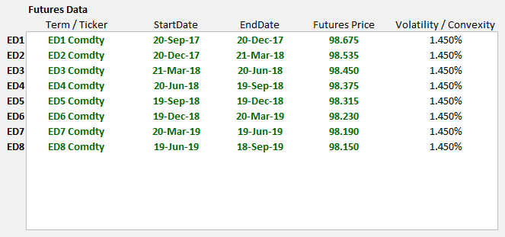

Tenor- & Xccy Basis Curve Settings

isFwdBasis TRUE, FALSE
Specified as part of the curve build properties, this flag controls if Tenor Basis instruments are forward starting. When set to TRUE we must include three additional columns of data within the tenor basis spread table to specify: i) isDateFormat (Boolean) ii) the start date or tenor iii) the end date or tenor for each basis quote as shown in figure 2 below.
Figure 2: Tenor Basis Spread Calibration Data Input
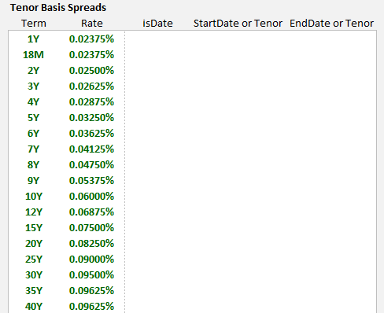
isFwdInter TRUE, FALSE
This parameter is specified within the basis conventions and is used for both Tenor and Xccy Basis curves. Post calibration STD Swap curves store a table of discount factor and forward rate results. Setting this parameter to TRUE interpolates swap curves by forwards using equation (36) below and FALSE will interpolate by discount factors using equation (33).
Within basis curves this flag can only be set to true when the dependency curve is a swap curve. An error will be returned if this flag is set to true and the dependency curve is a basis curve. We should also specify the interpolation method when setting isFwdInter = TRUE using the ‘fwdInterpolation’ flag. The choice of fwdInterpolation must match the interpolation method set in the swap curve for calibration consistency.
We recommend building swap curves using Linear-Spline interpolation and specifying basis curves with isFwdInter set to TRUE and fwdInterpolation set to use Linear-Spline interpolation.
On calibration node points both the Libor forward rate and discount factor tables are synchronized. We summarize these calculations below and highlight that interpolated points can have different values and can cause pricing differences.
The forward / discount factor relationship is summarized mathematically as
$DF\left(t,T\right)≝\frac{1}{1+f*(T-t)}$ (33)
we also know that
$DF\left(t,S\right)*DF\left(S,T\right)=DF\left(t,T\right)$ (34)
combining the above gives
$\frac{1}{1+f*(T-S)}= DF\left(S,T\right)=\frac{DF(t,S)}{DF(t,T)}$ (35)
leading to
$f=\left(\frac{DF(t,T)}{DF(t,S)}-1\right)*\left(\frac{1}{(T-S)}\right)$ (36)
where t<S<T

FixingSource CurveCollection name or ‘ITSELF’ keyword
The fixing source parameter is part of the basis curve build properties. Traditionally all cash fixings are specified as part of the STD swap curve. A fixing table will only be sourced from swap curves when the market id or static data table name set using the ‘STD’ keyword. Furthermore basis curves only calibrate using a cash Libor fixing if the ‘SpotRateTerm’ field is specified, see below.
Additionally basis curves can specify their own Libor fixings if the FixingSource parameter is set using the ITSELF keyword. The fixing source can also point to a STD swap curve in a different curve collection, which is quite useful for curves such as JPY TIBOR where the basis is a spread to JSCC LIBOR but the fixings need to come from a JPY TIBOR curve.

OptimizePerformance TRUE, FALSE
Controls the Newton-Raphson calibration precision and exit criteria. Used within the swaps conventions section, TRUE optimizes for performance and exits the solver once a single instrument calibrates within precision tolerance, which is acceptable with high precision tolerance. FALSE ensures that all instruments calibrate within tolerance. The default value is FALSE.

SpotRateTerm 1M, 3M, 6M, 12M
This parameter is set within the tenor basis conventions input block and specifies which fixing to use from the STD swap curve fixing table. The swap curve containing the fixing data must specify and the STD keyword as its MarketID or StaticDataTable name. Omitting this field will result in no cash Libor fixing being used in basis curve calibration.

FX Forward Curve Settings
The FX Forward curve solves for any CSA discount curve using a combination of standard OIS and Xccy curves. MLIB implies the collateralized discount curve using the FX Forward invariance relationship such as that in (37) solving for the one unknown term.
For example to solve for a discount curve, such as GBP_EURCSA i.e. a GBP discount factor adjusted for EUR collateral posting, we have the following FX Forward relationship
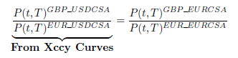 (37)
re-arranging this gives 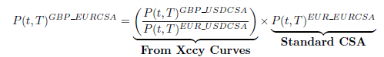 (38)
In MLIB we represent (37) as
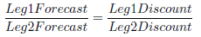 (39)
and likewise (38) is represented as
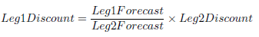 (40)

In MLIB we set-up the FX Forward Curve to represent equation (40) as shown in table 2.
Table 2: FX Forward Constant Settings for GBP_EURCSA
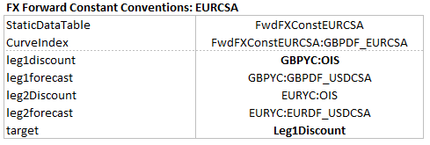
However it is perhaps easier to consider the settings in table 2 as a representation of equation (39), where the target parameter specifies what we are solving for. In this case we solve for the Leg1 discount factor i.e. GBPDF_EURCSA and therefore the leg1 discount term specified i.e. GBPYC:OIS is treated as the initial guess for the analytics solver.
Please note that if we invert equation (39) we achieve the same results, since this mathematically equivalent.

Note that inverting this expression yields the same result.

