|  |  |
| --- | --- |
| **Covid-19 evolution** | |
|  | The virus on a world scale currently continues to spread throughout society, we can see it because the confirmed cases are greater than those recovered and this gap is widening more and more, on the other hand speaking in terms of percentages, the lethality virus is approximately 2.5%, this varies according to the metrics of the country in question, among other things, metrics such as diabetes, old age of the population, etc. As of June 2020, the slope of confirmed cases began to grow, probably due to the arrival of the virus to other continents. |
|  | Europe began with a measurable slope in 2020 April, which then began to decrease and remained so until 2020 July, where with the advance of the European summer, it can be seen how the gap between infected and recovered widened considerably. Speaking very broadly, this will mean the collapse of the health system for countries that cannot support this rapid increase in cases. An analysis would have to be made of each country in question. The virus currently continues to spread throughout European society. |
|  | Confirmed and recovered curves are very close to each other, throughout the evolution of the virus in society. This means that the population is having a similar speed of recovery with respect to the speed that new people are infected. An analysis would have to be made of each country in question since the conditions of countries are very different from each other, specially the South American ones. |
|
|  | Africa began with a considerable slope in May 2020, which then decreased a little but remains with a considerable value, it can be seen how the gap between infected and recovered is widening considerably. This, in general terms, will mean the collapse of the health system for countries that cannot withstand this rapid increase in cases. The virus currently continues to spread throughout African society. |
|  | Rapid increase in April 2020 that coincides with the beginning of the testing, so they must be cases that were already active in society and the real growth of these could not be appreciated. The months that follow until 2020 Aug, Oceania maintained the number of reported cases. But by the beginning of September 2020 the virus began to spread again. The recovered and confirmed curves keep these lines together. |

|  |  |
| --- | --- |
| **TOP 10** | |
|  | Top 10 countries in which the most population died can be appreciated here. This is not a ranking of the total number of deaths infected by covid-19, but it is the total population of a country and how much died from covid-19. The ranking is headed by San Marino, Belgium, Peru, Andorra and Spain. |
|  | Top 10 countries in which more population recovered can be appreciated here. This is not a ranking of the total number of infected by covid-19, but it is the total population of a country, how much is recovered and immune to the covid19 virus. Percentages are really low, so if countries are looking for herd immunity, it will take a long time. The ranking is headed by Andorra, Belgium, Bahrain, Brazil, Argentina, Armenia. |
|  | Top 10 countries in which more population was confirmed with covid19 can be appreciated here. Percentages are really low, so if countries are looking for herd immunity, it will take a long time. The ranking is headed by Andorra, Bahrain, Qatar, Belgium. |
| Considering the total population, we can see that the US together with India and Brazil lead the highest number of registered cases in a country. | |
| If we take into account the number of cases per million, we have that the countries listed change and they are not the same. A more even distribution can be observed in the TOP 10, having a maximum difference of approximately 30%, unlike the graph of total cases, where a maximum difference of up to approximately 70% can be appreciated. | |
|  | |

|  |
| --- |
| **Correlation** |
| High correlation values can’t be seen, this is, they’re usually not greater than 0.1 or lesser than -0.1. Perhaps, this goes to show how devastatingly widespread the effects of this contagious disease is. One approach could be finding countries that are “similar” somehow between themself and try to find correlations between these countries. This is because probably different societies, different ways of behavior, etc, will return different deaths, recovered and confirmed cases to the same metrics (and not in a correlated way). |

Below an in deep correlation analysis can be found. It’s pointed out in advance, that no evidence was found in any metric correlated with covid 19 deaths, recoveries and confirmed cases. Probably as noted above, different societies, different ways of behavior, etc, will return different deaths, recovered and confirmed cases to the same metrics (and not in a correlated way).

**Covid 19 deaths cases correlation**

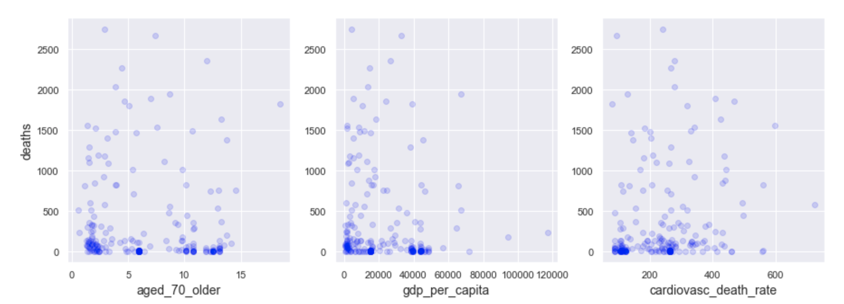

***aged_70_older:*** *Share of the population that is 70 years and older in 2015.*

It is difficult to draw conclusions. We can see that there are many countries with 2% 6% 11% and 13% population 70 years or older that have a low number of registered deaths. However, there are some countries that do have a high number of deaths but they are few and in fact, a clear trend is not observed on which percentage has more deaths.

***gdp_per_capita:*** *Gross domestic product at purchasing power parity (constant 2011 international dollars), most recent year available.*

Most of the countries have gdp less than 20,000 and there is another small majority around 40,000. It seems that the less gdp there are more deaths. But you can also see a large number of countries with low gdp that have as few deaths as countries with higher gdp. The data is not conclusive.

***cardiovasc_death_rate:*** *Death rate from cardiovascular disease in 2017 (annual number of deaths per 100,000 people).*

There is no that allows us to infer a relationship between cardiovasc_death_rate and number of deaths.

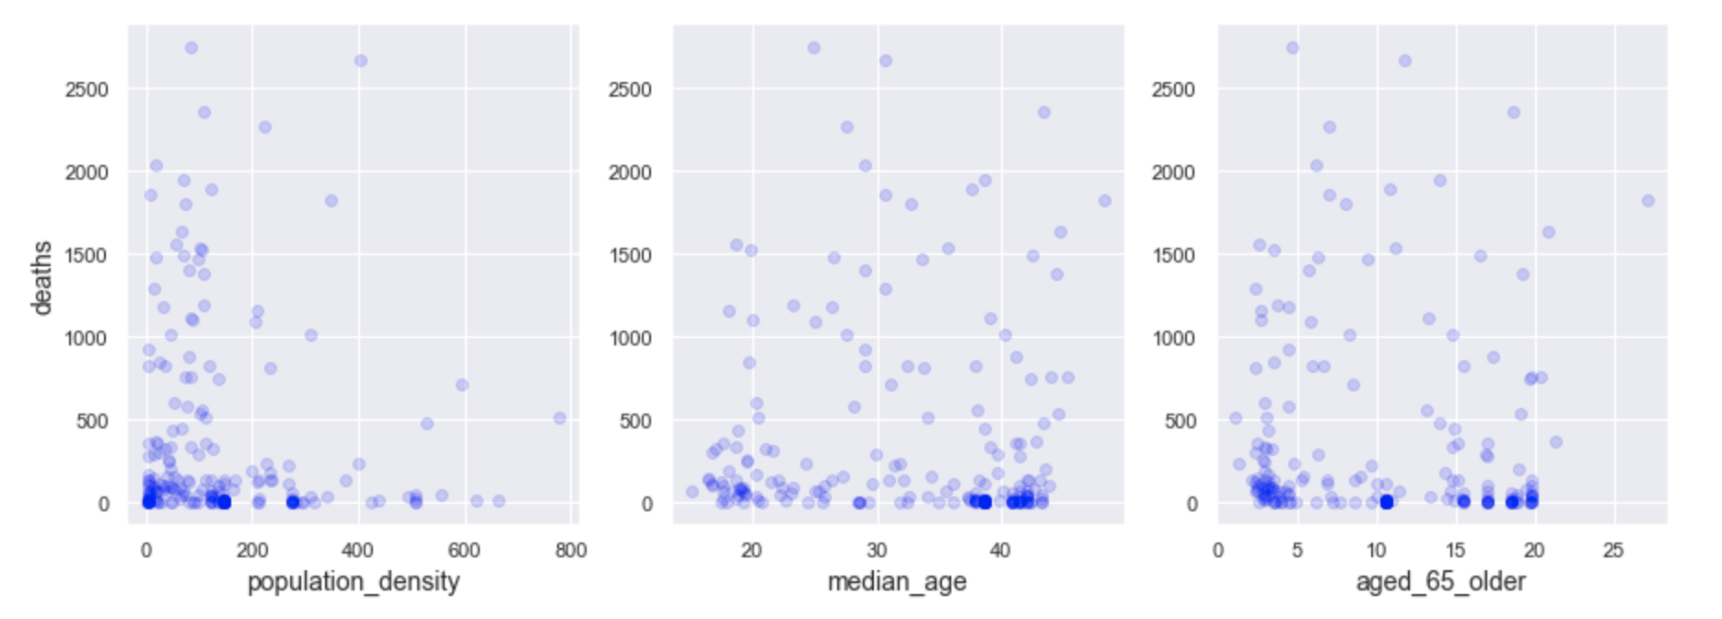

***population_density:*** *Number of people divided by land area, measured in square kilometers, most recent year available.*

Most of the countries have a population_density lower than 200. It seems that the lower the population_density, the greater the number of deaths. But you can also see a large number of countries with low population_density that have as few deaths as countries with higher population_density. The data is not conclusive.

***median_age:*** *Median age of the population.*

There is no that allows us to infer a relationship between median_age and number of deaths.

***aged_65_older:*** *Share of the population that is 65 years and older, most recent year available.*

We can note that there are many countries with a population of less than 5% and between 15% and 20% aged 65 or older that have a low number of registered deaths. However, there are some countries that do have a high number of deaths but there are a few and in fact, a clear trend is not observed on which percentage carries more deaths.

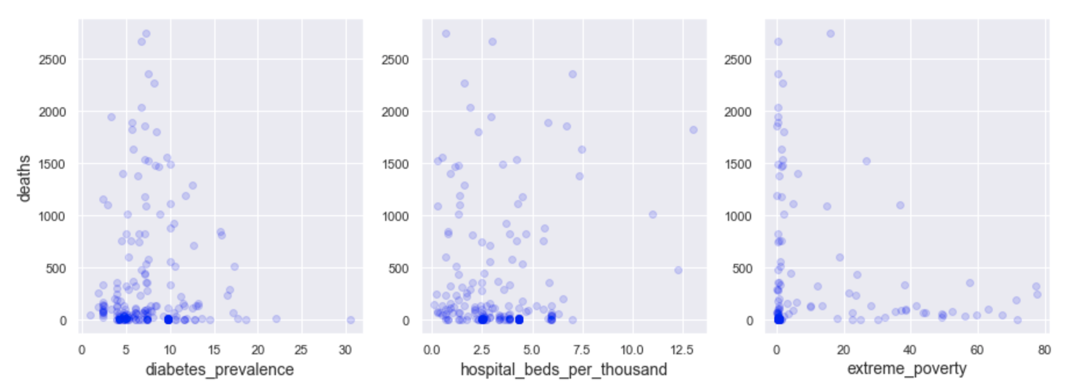

***diabetes_prevalence:*** *Diabetes prevalence (% of population aged 20 to 79) in 2017.*

Most countries have diabetes_prevalence less than 15%. An increase in deaths is observed in countries with diabetes_prevalence between 5% and 15% approx, but also most of the countries between this range of percentages have very low number of deaths. The data is not conclusive.

***hospital_beds_per_thousand:*** *Hospital beds per 1,000 people, most recent year available since 2010.*

Most countries have hospital_beds_per_thousand less than 7.5. An increase in deaths is observed in countries with hospital_beds_per_thousand less than 2.5, but also most of the countries within that range of percentages have very low number of deaths. The data is not conclusive.

***extreme_poverty:*** *Share of the population living in extreme poverty, most recent year available since 2010.*

The greater the population living in poverty, the lower the number of registered deaths. This does not seem to be very informative. It is a possibility that the poorer the population, then the poorer the country, and therefore the less monitoring of the covid-19 has.

**Covid 19 confirmed cases correlation**

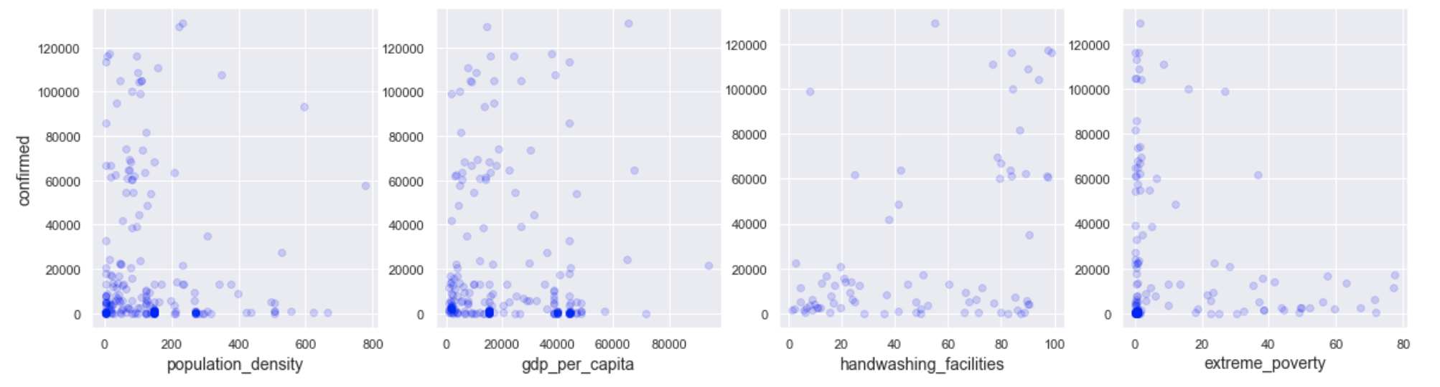

***population_density:*** *Number of people divided by land area, measured in square kilometers, most recent year available.*

Most of the countries have a population_density of less than 200. It seems that the lower the population_density, the greater the number of infections. But you can also see a large number of countries with low population_density that have as few infections as countries with higher population_density. The data is not conclusive.

***gdp_per_capita:*** *Gross domestic product at purchasing power parity (constant 2011 international dollars), most recent year available.*

Most of the countries have gdp less than 20,000 and there is another small majority around 40,000. It seems that the less gdp there are more deaths. But you can also see a large number of countries with low gdp that have as few deaths as countries with higher gdp. The data is not conclusive.

***handwashing_facilities:*** *Share of the population with basic hand washing facilities on premises, most recent year available.*

There is no trend that allows us to infer a relationship between handwashing_facilities and the number of infections.

***extreme_poverty:*** *Share of the population living in extreme poverty, most recent year available since 2010.*

The greater the population living in poverty, the lower the number of registered deaths. This does not seem to be very informative. It is a possibility that the poorer the population, then the poorer the country, and therefore the less monitoring of the covid-19 has.