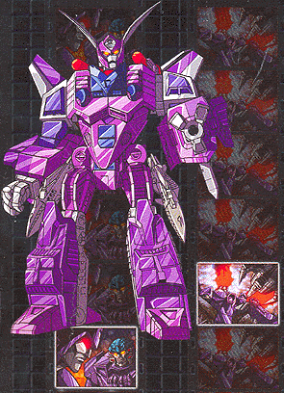Name: Cyclonus
Faction: Decepticon
Gender: Male
Age: Unknown
Alt. Form: Fusion powered Stellar Interceptor
Played by: supercyclonus@yahoo.com

"Loyalty and compassion cannot coexist."

NOTE: Drawn directly from the specifications of the original Decepticon, he has been reformatted and upgraded. Powerful, subtle, and loyal to the extreme, he is the next step in Unicronian technology; he is capable of drawing strength from his enemies' attacks through bleedback receptors mounted in his fists, and he’s highly maneuverable in jet mode due to dual fusion-powered engines and an advanced multi-wing design. In both modes, Cyclonus is armed with oxidizing pulse cannons and independently targetable incendiary missiles. In robot mode as an ultimate weapon he is able to focus the power of his engines through his cannons, destroying whatever stands in his way! Vulnerable only to leaders that would exploit his skills for their own evil purposes, his loyalty is absolute.

PROFILE: Cyclonus is of what many fellow Decepticons would refer to as an "ancient breed," He was a warrior who works best when sworn to the banner of a courageous or especially ruthless warlord. After his reformat through Unicronian technology Cyclonus has become a soldier of few words, one who normally keeps his own counsel. Cyclonus' greatest ambition is to be of service to the Unicron. In a sense, he is a shadowy knight-errant, sustained by quiet nobility that at times seems ill-fitting with the traditional virtues of treachery and conquest.

HISTORY: Reformatted from the original Cyclonus by Unicron, he has been updated and enhanced to unimaginable levels. He posses the memories of the original Cyclonus up to the end of the Victory Series. He has been sent by Unicron, supposedly to destroy the Autobot Matix, and prepare the Earth for energy assimilation. Any other objectives are so far unrevealed.

After several months under Unicron’s dominion several times attempted to destroy the power of the Cybertronians, and yet each time the Autobtos, Maximals, Decepticons and Predacons banded together, foiling his attempts.
Recently Cyclonus absorbed the power of the Maximal (Autobot) Matrix carried by Rodimus Prime, increasing his personal power. (reflected in stats below)

Following these events Cyclonus’ loyalties to unicorn were further shaken by Megatron, ruler of the Predacons, who some how still carries the spark of Galvatron, Cyclonus’ original commander.

Unsure of what orders or which commander to follow, Cyclonus and Scourge, after their last defeat, went into seclusion and have not been heard of.

That is until now . . .

SKILLS: Leadership, Intimidation, sabotage and demolitions, marksmanship, Charisma, Unflappability

WEAPONS: Oxidating pulse cannons, Incendiary missiles, Bleedback Receptors, Fusion Cannon

STATS:

STR: 9
INT: 9
SPD: 10
END: 10
RNK: 9
COU: 9
FPW: 10
SKL: 10

