Legacy
“We create our future out of the seeds of our past.”
Affiliation: Maximal
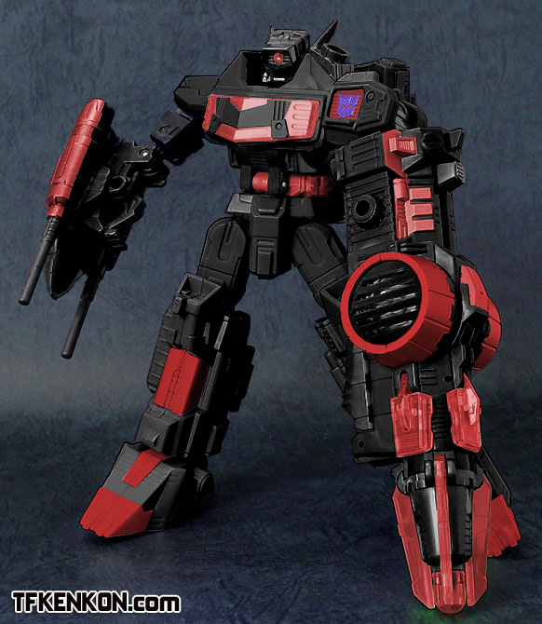
Job/Rank: Guardian
Player: Supercyclonus
Legacy has come from a future where the Maximals and Autobots failed to protect the Ark from the Minions, and lost the war. Infused with the best technology and the sum total of historical, military and technological knowledge of his time he was the last hope to set that things right. He possesses incredible vision and acute hearing make granting him tremendous marksmanship skills. As a military satellite he can send a wide array of information over vast distances and can jam transmissions and defensive grids. In tank mode his treads can crush anything that ends up beneath them, and his powerful Ionic fusion canon can finish off what remains. Protected by shield enhanced armor, he is a force to be reckoned with. Now that the Ark has resisted its initial assault, he has remained behind to assist the Maximals in protecting it.
Beast/Vehicle Mode:
(1) Tank
(2) Military Satellite
Skills:
- Historian
- Engineer
- Tactics
- Logic
- Communication/Intelligence
Weapons:
- Fusion/Ion Energy weapons
- Force Shield

Last seen: Active
1. Please ignore the Decepticon insignia in the picture, this character has no markers indicating faction. Picture by Slayerdarkcross from deviant art.com

