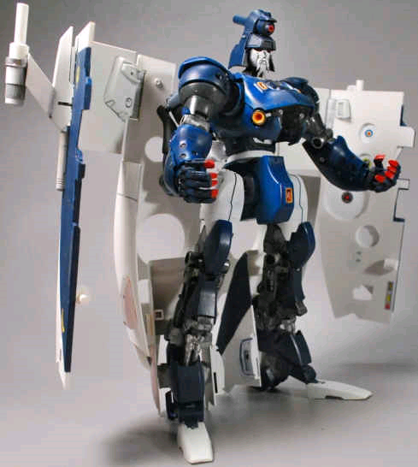
SCOURGE

Allegiance: Decepticon
Function: Sweep Commander
"Desolation follows in my trail."

TECH SPEC BIO: Born from the wreckage of fallen Decepticons, Scourge is fearsome, merciless and implacable hunter. Created by Unicron to be Cyclonus’ second, he leads "The Sweeps", a wolf pack of tracker-terminator's designed to hunt down and eradicate all enemies of Unicron. Scourge possesses powerful high-tech scanning equipment and a disintergater ray that can cut through solid rock. In robot Mode, he carries a laser blaster that shoots short bursts of intense heat. Scourge's only weakness is his arrogance.

Profile: Scourge is the most fearsome and implacable hunter-destroyer created by Unicron. Recreated from the wreckage of fallen decepticons he is far more dangerous than ever. Scourge is leader of "The Sweeps," a specially created wolf pack of tracker-terminators designed by Unicron to hunt down and eradicate Autobots, Maximals and their allies.

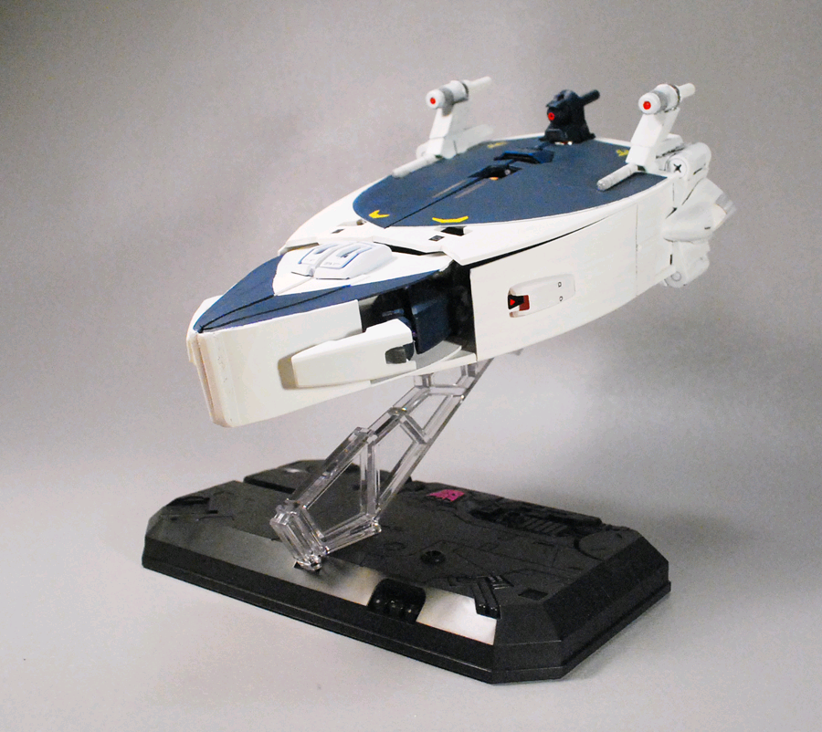
Abilities: Scourge is possessed of scanning and locating equipment, which can detect machine or human presence even if it is as small as an amoeba in the ocean or a wind-up toy in the Sahara desert. And he is merciless and capable of using such weapons as acid rays, which dissolve his targets, laser blasters, disintegrator beams, and assorted demolition and fusion devices in eliminating his prey. He can transform to a scouring vehicle, a marauding automotive mode which handles any terrain and scans for "survivors." In either mode Scourge’s as well as his Sweep’s armor is composed of sensor scattering fields, making them nearly invisible to conventional scanners.

Weaknesses: Scourge's only weakness is his arrogance.

SKILLS: Hunting/Tracking, Intimidation, Interrogation, Crafting traps and decoys, wide variety of lethal and non-lethal weaponry.

WEAPONS: Acid Cannons, Laser blasters, Disintegrator beams, assorted demolition & fusion devices
STATS:

STR: 8
INT: 8
SPD: 8
END: 8
RNK: 8
COU: 8
FPW: 9
SKL: 9

