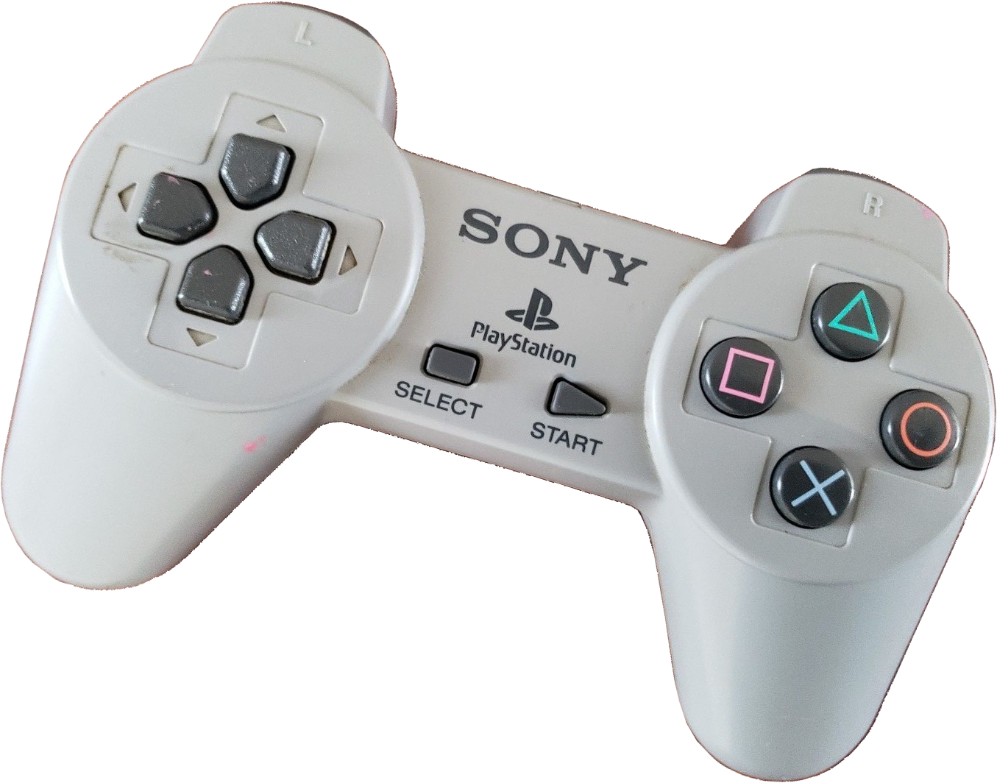
SCPH-1010 & SCPH-1080
When the PlayStation was release in 1994, the only controller available was the SCPH-1010. This controller set the style for most all Sony produced controllers to come. It was meant to be held with two hands and has four sets of buttons located on its top where they were easily operated by a player’s thumbs. There are also four shoulder buttons, two on each side, which are operated by the index and middle fingers of each hand.

In 1996, when the PlayStation moved outside Japan, Sony created a slightly larger controller with a longer cord and which now included an EMI choke at the connector called the SCPH-1080. Other than a slight size increase, there is little functional difference between these two controllers.

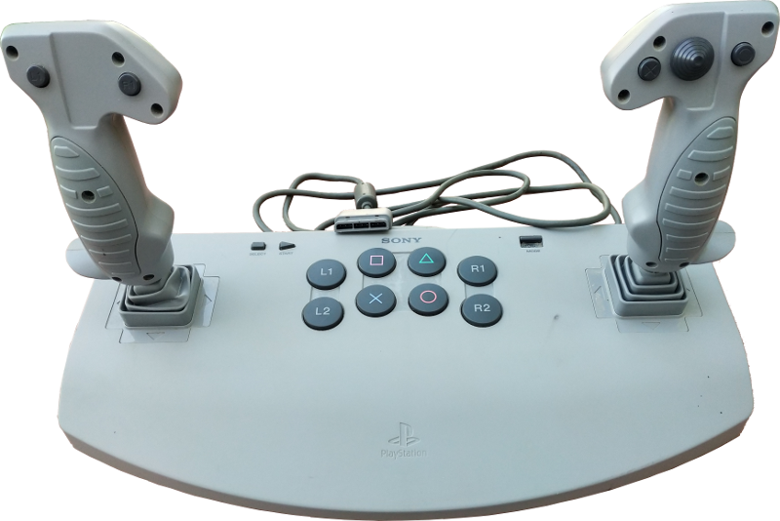
SCPH-1110
The PlayStation Analog Joystick SCPH-1110 is a truly massive controller and was one of the first controllers released by Sony coming to the market in 1996. It can operate in “Analog” mode where it reports the position of the joystick as digital values between -128 and 127 or is can operate in “Digital” mode where it reports the left joystick as arrow buttons and ignores the position of the right joystick entirely. The game controller has a large switch that is used to change between the two modes.

Unlike later Dual Shock and Dual Analog controllers, the Analog Joystick will not enter config mode under command of the PlayStation console. This means the controller cannot be switched between modes by the PlayStation or host. It also means that this controller cannot report it’s model or other information typically exchanged while being configured. However, a PlayStation will try to put the controller into config mode, which is futile. At startup, the PlayStation repeats the attempt to send a 0x43 message twelve times before it apparently decides to give up. When the switch is changed in the middle of a game, this is repeated at the same ~15 millisecond rate used to normal polling which can cause a noticeable pause in control should you try this in a game.

The controller has two complements of eight of the standard PlayStation buttons □, X, ○, ∆, R1, L1, R2, and L2. One set of large buttons is in the middle of the base and another set distributed over the joystick handles. Each button of the same legend returns the same code when pressed. In other words, there is no way to know if, for example whether the X button that was pressed is the one in the center cluster or the X on the right stalk at the thumb.

The location of the arrow keys found on the top left side of most controllers is dependent on the mode of the Analog Joystick. With the mode switch in the “ANALOG” position the hat under the right thumb position reports these buttons. When the mode switch is in the “DIGITAL” position the left joystick reports these buttons depending on how it is moved and the right joystick reports only the □, X, ○, and ∆ buttons and does not report the position of the joystick itself nor the hat.

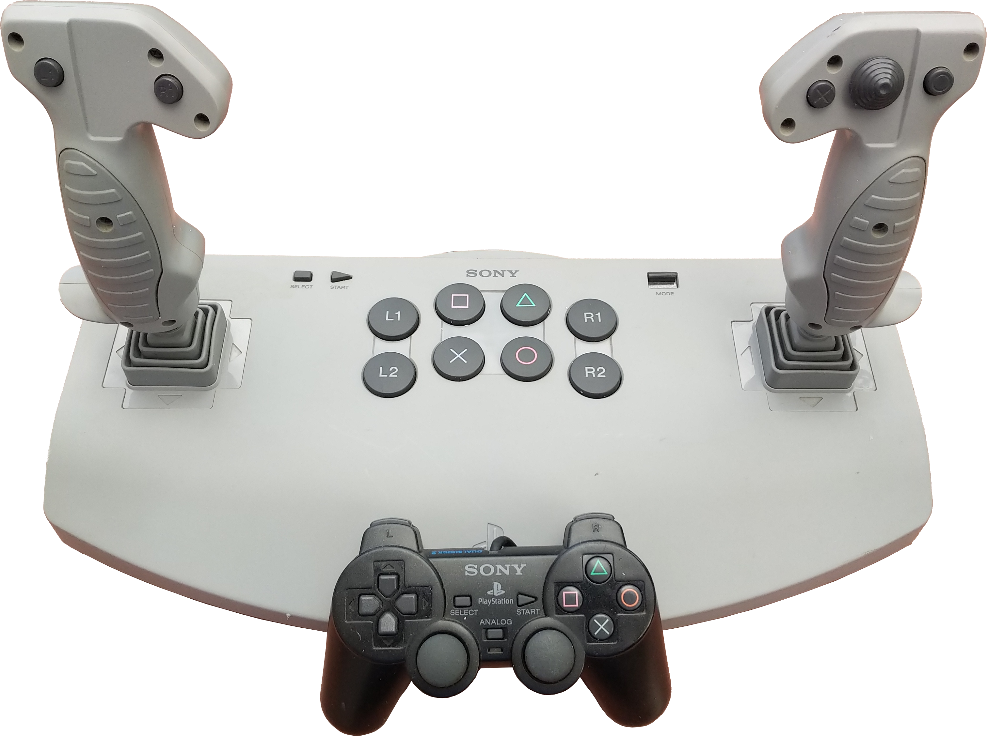
This controller does not report R3 nor L3.

