PlayStation Controller Interface
Version 0.2 – Michael McCormack
mike@artpoe.com

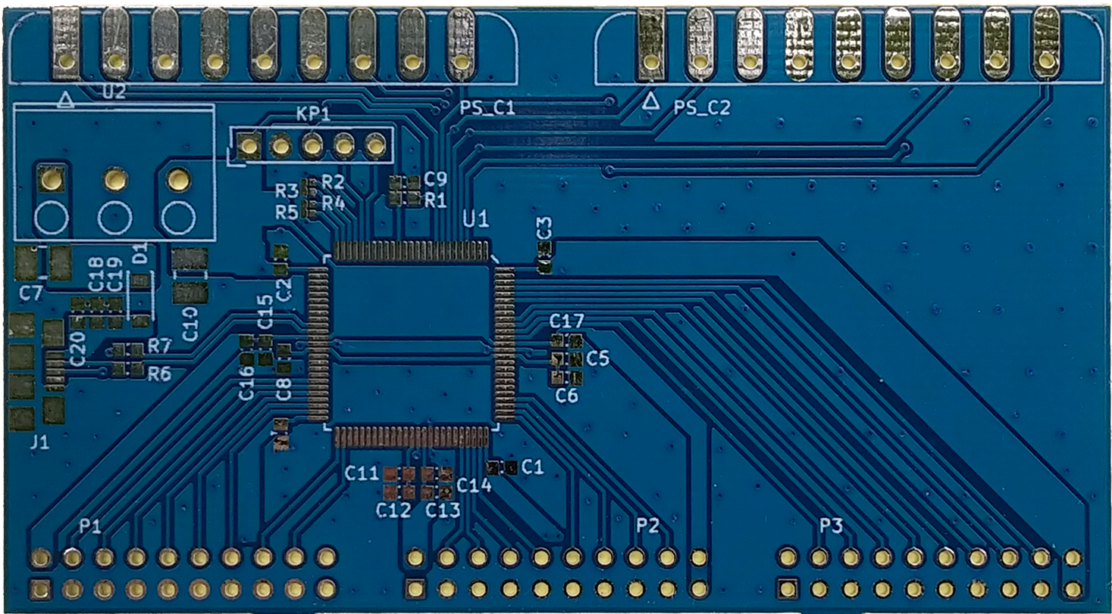

"PlayStation" is a registered trademark or trademark of Sony Interactive Entertainment Inc.

"SONY" is a registered trademark of Sony Corporation.

“FreeRTOS” is a trademark of Amazon Web Services, Inc.

Foreword
The genesis of this project was in support of a FIRST robotics team I was mentoring. The driver station of a typical FIRST team is a Windows based PC and some collection of USB attached joysticks and game controllers. Due to the way the FIRST software operates and the habit of Windows to sometimes change the order of attached devices there is a not infrequent need to reconfigure things in the already short moments between matches. I thought that if I could come up with a way to reduce all the USB peripherals to just one device, its order in the joystick list would always be known.

Cypress provided a starting place with a custom application for a dev kit they gave to FIRST teams. This embedded application relies on analog joysticks and unfortunately these things come in only two flavors – real cheap (and really cheaply made) or real expensive. While looking at wired console controllers I could press into service I caught a glimpse of Sony’s old SCPH-1110 Analog Joystick and I knew I found the solution. Unfortunately, while there was some information on interfacing to the ubiquitous PlayStation dual shock controllers I found nothing useful for the large analog joysticks.

The first two generations of the Sony PlayStation shared the same proprietary controller interface which is not the same as the USB interface adopted in the PS2 on. At the physical layer, this interface is a 3.3V serial interface which is largely interoperable with commercial microcontroller SPI peripheral blocks. At the protocol layer, there are many small differences from one type of controller to the next and not everything works seamlessly without some amount of controller specific tweaks.

The logical USB interface for the project is a composite device consisting of a standard HID required for the joystick and a virtual UART. The UART is as a console interface for debugging and perhaps someday macro support. The HID profile is a standard USB joystick interface overflowing with enough buttons, analog inputs, etc. to support known PlayStation controllers and to support additional sliders and buttons needed by robot drive teams .

FreeRTOS has been selected as the executive for the firmware. This RTOS is licensed under the permissive MIT license and for consistency that license is used for the application code as well. An RTOS is arguably overkill for this project but this firmware will also serve as a starting point for other embedded projects moving forward. Once it is up and running, having a RTOS seems to make things cleaner and easier. I also have been working with and expect to work with FreeRTOS in the future so it makes sense personally too.

This project relies on the work of others who explored the PSx game controller interface. There are at present numerous references on the Internet though many websites that are found on Google no longer exist. It is safe to assume that as time passes the number of reference websites will continue to diminish. To the extend allowed by law I will attempt to capture and share pdf copies of reference material to provide persistent backup of the material used in development. Word of warning though, some references use a voice of authority to provide information which, with study and much wasted time, has proven false . To validate these documents and do my own investigations, I developed a sniffer for the PlayStation interface. This is also documented in this project for your use as you see fit.

Enjoy, and should you care to extend this project, good luck. The most up to date version of this project can generally be found at:
https://github.com/nbxmike/PSOC-Console

Tools
While there are many sources of knowledge about the PlayStation interface on the web, they are not complete, sometimes contradict each other and in some cases they lie. So to create a USB dongle which would operate with PlayStation controllers, I found I needed to investigate the operation of a real PlayStation and its controllers. In particular, I found nothing worked correctly with my SCPH-1110. I have used the following to perform my first person research:
- PlayStation extension cables – these are available for less than three U.S. dollars on a variety of websites. I did not used these as is, they were cut and attached to either my sniffer or logic analyzer.
- Noname Saleae Logic clone – That is the name that the logic analyzer software uses for the cheap Cypress FX2 based USB dongles that I used. This board is not really a clone of the Saleae Logic boards but rather a re-layout of the same chipset with, frankly, some corners cut to reduce cost. The are readily available on the web for less that ten U.S. dollars.
Note – should you choose to use this with the sigrok package below, visit https://sigrok.org/wiki/Fx2lafw to get the firmware needed to operate the interface. This was so obvious to everyone else in the world that it took me a while to find it.
- sigrok protocol analyzer – I use this free bit of software on Linux though it is alleged to run on Windows and Mac. It provides a ton of features though mainly I just use its integrated SPI decoder to help look at stuff. It supports a ton of interface hardware, including the Cypress FX2 based boards mentioned above.
- PSxSniffer – I developed this myself. It is based on the same CY8CKIT-059 hardware that the main project interface is based on. I keep one on hand in addition to the project hardware as the Cypress kit is only ten U.S. dollars and it is just easier to leave it that way. The Cypress project is included in the same workspace as the interface. I also use a python script to capture the data sent by this sniffer, that code is in a directory called “Support” which is part of this project

PlayStation Controller models
Sony has released a number of different controllers over the years. All these controllers interoperate at the hardware level with all PS1/2 consoles. As game software has progressed; however, later games often have dropped support for earlier controllers. It seems too daunting to catalog all Sony and third party controllers, so for the time being the following list of Sony produced controllers are the focus of this project:
- SCPH-1010 (1994) Original controller without joysticks but rather just the four buttons on each top side.
- SCPH-1030 (1994) Mouse
- SCPH-1080 (1996) Slightly larger controller still without joysticks for the North American / European PlayStation release.
- SCPH-1110 (1996) Called the Analog Joystick this was a massive / arcade size controller.
- SCPH-1150 (1997) Dual Analog Controller released in Japan. This controller also included a single rumble motor. This started the LED color named “off” Digital mode (disables joysticks), “red” Analog mode, and “green” Analog Joystick (SCPH-1110) mode monikers
- SCPH-1180 (1997) The Dual Analog Controller for the North American market. There is no rumble on this model (SCPH-1180E for Europe)
- SCPH-1200 (1997) DualShock Analog Controller for all markets which enhanced the rumble by using two rumble motor. This also dropped the “green” Analog Joystick mode.
- SCPH-1090 (1998) Mouse
- SCPH-10010 (2000) DualShock 2 Analog Controller added pressure sensitive buttons which can report a byte related to how hard they are pressed for all except the Start, Select, Analog, L3, and R3 buttons.
- SCPH-10150 (2000) DVD handheld Infrared Remote Control
- SCPH-10160 (2000) IR Receiver for use with the SCPH-10150 remote.
- SCPH-110 (2000) DualShock Controller for PSOne. Other than some cosmetic changes such as the PSOne logo and a slightly different connector this is the same as SCPH-10010.
- SCPH-10420 (2003) DVD Remote Control still uses 10160 receiver
- SCPH-10520 (2007) Analog Controller which appears to be a DualShock 2 controller without rumble motors to reduce cost. It is not well documented on the web so there is limited information at the moment.
Not all these controllers are available for study at the moment, units available to the author are underlined in the list above. Also, frequently Sony released color variants and appended letters to the part numbers above; there will be no attempt to get all color variations. As finances, supply and time coincide more may be studied and this document will be updated accordingly.

Physical Interface
The PlayStation controller interface is largely compatible with the SPI bus used on many microcontrollers. In all public documentation, the major difference between PlayStation and SPI is nomenclature. Since we have not found Sony sourced documentation, this document will use standard SPI nomenclature with the sole reference to vernacular in the following diagram.
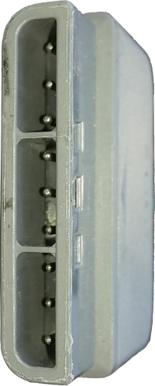
MISO - “Data”
MOSI - “Command”
Motor Power - 7VDC
Ground
3.3VDC
SS - “ATTENTION”
SCLK - “Clock”
Unused
ACKnowledge
1
2
3
4
5
6
7
8
9
P1_7
P1_6
P1_5
P1_4
P1_3
MISO - “Data”
MOSI - “Command”
Motor Power - 7VDC
Ground
3.3VDC
SS - “ATTENTION”
SCLK - “Clock”
Unused
ACKnowledge
1
2
3
4
5
6
7
8
9
Brown
Coral
Yellow
Green

White
Black

Red

Blue

Note: The first column is reflects port used during program development. It should be ignored for most purposes and will eventually get removed.

- MISO – the serial data stream heading to the PlayStation sent by the game controller. Data is latched by the game controller on the rising edge of SCLK. Game Controllers use open drain / collector outputs on this signal, the PlayStation provides a pull-up of apparently 10K Ohms.
- MOSI – the serial data stream leaving the PlayStation received by the game controller. Data is latched by the PlayStation on the rising edge of SCLK.
- Motor Power – 8 VDC in the PlayStation 9000 manual, observed as 7.7 on my PlayStation and 7.9 on my PlayStation 2. PlayStation service manual has an 800mA fuse on the output. This is a constant power source, it is not switched on/off as some consoles do.
- Ground – the return for power and signals. May or may not be isolated from earth ground.
- 3.3VDC – regulated power from the PlayStation. Observed to be on the high side of nominal 3.3V at 3.45 on both a SCPH-1001 and PS2. In the PlayStation 9000 schematics, this is 3.5V on the power supply output but is called 3.3V on the main board though there is no regulation or other cause for the drop. PlayStation 9000 service manual has a 600ma fuse on the output.
- SS – an active low select line that must remain low during the entire packet transfer. Unlike common SPI implementations, the SS signal must not go high with each byte.
- SCLK – the clock for the SPI, data is latched on the rising edge. Clock frequency appears to be nominally 500Khz. There are reports that specific games alter the frequency; specifically Dance Dance Revolution is reported to slow the clock to 250Khz.
- Not populated on many interfaces and no known use (outside of maybe Sony).
- ACKnowledge – ACK is returned from the game controller to the PlayStation with each byte. Pulled high with a 1K resistor at the PlayStation and pulled low by the controller.

The SPI bus transfers data LSB first. Data is transferred as bit fields or bytes, never larger collections, so byte ordering (hi/lo) is irrelevant.

PlayStation Packets
The PlayStation communicates to its attached game controllers in multi byte transfers that form a packet. Each packet is sent between the two devices with SS asserted continuously. A packet starts when SS is driven low and ends when SS is driven high. If the PlayStation were to drive SS high then low again in the middle of a transfer it would end one packet and start another which would of course cause the two ends to get horribly lost. Some SPI systems allow / require SS to toggle with every byte; the PlayStation keeps SS assert the whole packet long.

The PlayStation I have, polls the interface 60 times a second. This is the same as the refresh as North American / Japanese TVs and monitors. I do not have a non-North American PlayStation to see if the poll rate changes when the refresh rate changes to 50Hz; however, the PlayStation development manual is clear that controller messages are sent with each vertical blanking interval so it should change.

Over any SPI bus, data is sent from the master to the slave while simultaneously data is sent from the slave to the master regardless of whether the slave really has data to send – some value will get clocked into the master’s receive circuit. Some slave devices send packets to the master that are responses to the last package sent by the master. In these systems the master is always sending packet N and the slave I always sending response N-1; the Trimanic stepper controllers are one such example. The PlayStation game controllers however respond to the data sent by the PlayStation in the same packet just a little later. While I can’t say for sure, it appears that the controllers and PlayStation exchange a delay byte then the real response data is sent.

A PlayStation packet will always start with the same data fields. The PlayStation starts by sending a command, the game controller starts by sending its operating mode. After these first data elements are received, the two sides send data that is specific to the command from the PlayStation. These commands are documented in later sections.

Common Header
All messages from a PlayStation to a game controller utilize a three byte header. Widely reported on the internet as constant and confirmed through observation, this header can be considered a constant.

PlayStation | MOSI | MISO | Game Controller
Start of Packet | 0x01 | 0xFF | Start of Packet
Command | 0xXX | 0xMN | Mode / Status Bytes
Filler | 0x00 | 0x54 | Filler

The command field is a single byte selected by the host / PlayStation.

The Mode / Status Bytes are two nybbles which are sent by the game controller regardless of the value of the command (since the controller can’t know what that values is yet) which indicate the operating mode of the controller (nybble M) as well as the length (nybble N) in words NOT bytes of the status report as the controller is currently configured. The command send by the host may not require a status report, but the controller has to answer something in these bits and so always tells the host the number of words it would have sent.

Mode Nybble M
Value | Mode | Controllers
0x12 | PS2 Mouse | SCPH-1030
0x2x | Namco NegCon (16-button analog) | SLPH-00001
0x3x | Konami Gun | SLPH-00014
0x4x | 16-button Digital | SCPH-1050, 1080, 1150, 1200, 10010 ...
0x5x | Analog Joystick (Green mode) | SCPH-1110, 1150,1180
0x6x | Namco Gun | SLPH-00034
0x7x | Analog Controller (Red) | SCPH-1150, 1180, 1200, 10010 ...
0x8x | Multi Tap | SCPH-1070, ???
0xFx | Setup Mode | SCPH-1200, 10010 ...

Bit Fields
Several commands share the same bit fields so they are documented here as a convenience.

 | 7 | 6 | 5 | 4 | 3 | 2 | 1 | 0
Buttons 0 | ← | ↓ | → | ↑ | Start |  |  | SEL
Buttons 1 | □ | X | ○ | ∆ | R1 | L1 | R2 | L2
Note: Should the last four symbols of Buttons 1 get mangled by your system fonts, they are Triangle, Circle, X and Square, in increasing bit significance.

Configuration / Button – 0x40
Unconfirmed - Enables pressure reporting for a single button.

Byte | PlayStation | MOSI | MISO | Game Controller
0 | Start of Packet | 0x01 | 0xFF | Start of Packet
1 | Command | 0x40 | 0xMN | Mode / Status Bytes
2 | Filler | 0x00 | 0x54 | Filler
3 | Button # | 0xNN | 0x00 | Constant
4 | Constant | 0x02 | 0x00 | Constant
5 | Constant | 0x00 | 0x02 | Constant
6 | Constant | 0x00 | 0x00 | Constant
7 | Constant | 0x00 | 0x00 | Constant
8 | Constant | 0x00 | 0x54 | Filler

Configuration / Report Capabilities – 0x41
Unconfirmed – The controller returns a bit field of its ability to provide different polling results. It is dependent on the controller’s mode, that is it reports capabilities only in the present context (e.g. it can’t return analog data in digital mode so it does not set those bits).
Byte | PlayStation | MOSI | MISO | Game Controller
0 | Start of Packet | 0x01 | 0xFF | Start of Packet
1 | Command | 0x41 | 0xMN | Mode / Status Bytes
2 | Filler | 0x00 | 0x5A | Filler
3 | Filler | 0x5A | 0xSS | Enabled Reports 0
4 | Filler | 0x5A | 0xTT | Enabled Reports 1
5 | Filler | 0x5A | 0xUU | Enabled Reports 2
6 | Filler | 0x5A | 0x00 | Filler
7 | Filler | 0x5A | 0x00 | Filler
8 | Filler | 0x5A | 0x5A | Filler
When this command is issued, the PlayStation pulls the full number status bytes, though they are not typically valid (seemingly always 00).

Poll & Motors – 0x42
Unconfirmed - The PlayStation sends this message to get the current status of the user input and, when appropriate, set the feedback motors. The motor fields in byte 3 and 4 are dependent on the mapping used in command 0x4D:
- The small motor, normally motor 0, will only turn on for value 0xFF though it is customarily turned off with value 0x00.
- The large motor, normally motor 1, can operate at variable speeds though values less than 0x40 may not be sufficient to turn on the motor.

Byte | PlayStation | MOSI | MISO | Game Controller
0 | Start of Packet | 0x01 | 0xFF | Start of Packet
1 | Command | 0x42 | 0xMN | Mode / Status Bytes
2 | Filler | 0x00 | 0x5A | Filler

Data fields depend on the value of the Status Bytes field and previous configuration commands. If the motors were mapped with a 0x4D Map Motor command, they are used. Analog data is returned only if N ≥ 3; Pressure data only if N ≥ 9.

Byte | PlayStation | MOSI | MISO | Game Controller
3 | Motor 0 | 0xWW | 0xXX | Buttons 0
4 | Motor 1 | 0xYY | 0xXX | Buttons 1
5 | Motor 2 | 0x00 | 0xXX | Right Analog X
6 | Motor 3 | 0x00 | 0xXX | Right Analog Y
7 | Motor 4 | 0x00 | 0xXX | Left Analog X
8 | Motor 5 | 0x00 | 0xXX | Left Analog Y
9 | Filler | 0x00 | 0xXX | → Pressure
10 | Filler | 0x00 | 0xXX | ← Pressure
11 | Filler | 0x00 | 0xXX | ↑ Pressure
12 | Filler | 0x00 | 0xXX | ↓ Pressure
13 | Filler | 0x00 | 0xXX | ∆ Pressure
14 | Filler | 0x00 | 0xXX | ○ Pressure
15 | Filler | 0x00 | 0xXX | X Pressure
16 | Filler | 0x00 | 0xXX | □ Pressure
17 | Filler | 0x00 | 0xXX | L1 Pressure
18 | Filler | 0x00 | 0xXX | R1 Pressure
19 | Filler | 0x00 | 0xXX | L2 Pressure
20 | Filler | 0x00 | 0xXX | R2 Pressure

Configuration & Poll – 0x43
Unconfirmed - The PlayStation seems to always read all of the data in the report when it sends this command though web sources indicate that it can be truncated. As with 0x42 Poll, the number of data fields is specified in the game controller response byte 1. Motor control is not possible with this command.
Byte | PlayStation | MOSI | MISO | Game Controller
0 | Start of Packet | 0x01 | 0xFF | Start of Packet
1 | Command | 0x43 | 0xMN | Mode / Status Bytes
2 | Filler | 0x00 | 0x5A | Filler
3 | Exit Configuration  Enter Configuration | 0x00  0x01 | 0xXX | Buttons 0
4 | Filler | 0x5A | 0xXX | Buttons 1
5 | Filler | 0x5A | 0xXX | Right Analog X
6 | Filler | 0x5A | 0xXX | Right Analog Y
7 | Filler | 0x5A | 0xXX | Left Analog X
8 | Filler | 0x5A | 0xXX | Left Analog Y
9 | Filler | 0x5A | 0xXX | → Pressure
10 | Filler | 0x5A | 0xXX | ← Pressure
11 | Filler | 0x5A | 0xXX | ↑ Pressure
12 | Filler | 0x5A | 0xXX | ↓ Pressure
13 | Filler | 0x5A | 0xXX | ∆ Pressure
14 | Filler | 0x5A | 0xXX | ○ Pressure
15 | Filler | 0x5A | 0xXX | X Pressure
16 | Filler | 0x5A | 0xXX | □ Pressure
17 | Filler | 0x5A | 0xXX | L1 Pressure
18 | Filler | 0x5A | 0xXX | R1 Pressure
19 | Filler | 0x5A | 0xXX | L2 Pressure
20 | Filler | 0x5A | 0xXX | R2 Pressure

Configure Mode – 0x44
Unconfirmed – This command is only valid when the Mode nybble is F; that is the game controller is in configuration mode. The command will set the controller and can also optionally lock the game controller into this mode (i.e. the mode button does not work when the user presses it.)
Sending this command will cause the pressure button sense configuration to revert to the reset state of off (i.e. If you put the game controller into analog mode, enable pressure reporting for buttons then issue a command to put it in analog mode pressure reporting is disabled again.)
Byte | PlayStation | MOSI | MISO | Game Controller
0 | Start of Packet | 0x01 | 0xFF | Start of Packet
1 | Command | 0x44 | 0xMN | Mode / Status Bytes
2 | Filler | 0x00 | 0x5A | Filler
3 | Enter Digital Mode . . . . .  Enter Analog Mode . . . . . | 0x00  0x01 | 0x00 | Filler
4 | Lock if 0x03 ONLY | 0x0X | 0x00 | Filler
5 | Filler | 0x00 | 0x00 | Filler
6 | Filler | 0x00 | 0x00 | Filler
7 | Filler | 0x00 | 0x00 | Filler
8 | Filler | 0x00 | 0x00 | Filler
When this command is issued by a real PlayStation the full number status bytes are read, though they are not typically valid (seemingly always 00).

Query Model – 0x45
Unconfirmed – This command is only valid when the Mode nybble is F; that is the game controller is in configuration mode. Appears to report some form of model number, or according to some a constant value. Data is reported all differently on the web, so more investigation is needed.
Byte | PlayStation | MOSI | MISO | Game Controller
0 | Start of Packet | 0x01 | 0xFF | Start of Packet
1 | Command | 0x45 | 0xMN | Mode / Status Bytes
2 | Filler | 0x00 | 0x5A | Filler
3 | Filler | 0x5A | 0xXX | Model
4 | Filler | 0x5A | 0xXX | numModes
5 | Filler | 0x5A | 0xXX | modeCurOffs
6 | Filler | 0x5A | 0xXX | numActuators
7 | Filler | 0x5A | 0xXX | numActComb
8 | Filler | 0x5A | 0xXX

Byte 3 – 0x01 - Guitar Hero, 0x02 - Dual Shock, 0x03 Wireless & wheels
Byte 5 – In some places, LED status of 00 for off, 01 for on but that is probably human observational bias, more likely digital / analog mode.

Query – 0x46
Unconfirmed – This command is only valid when the Mode nybble is F; that is the game controller is in configuration mode. Appears to report some form of model number, or according to some a constant value. Data is reported all differently on the web, so more investigation is needed.
Byte | PlayStation | MOSI | MISO | Game Controller
0 | Start of Packet | 0x01 | 0xFF | Start of Packet
1 | Command | 0x46 | 0xMN | Mode / Status Bytes
2 | Filler | 0x00 | 0x54 | Filler
3 |  |  | 0xXX
4 |  |  | 0xXX
5 |  |  | 0xXX
6 |  |  | 0xXX
7 |  |  | 0xXX
8 |  |  | 0xXX

Query Combinations – 0x47
Unconfirmed – This command is only valid when the Mode nybble is F; that is the game controller is in configuration mode. Appears to report some form of model number, or according to some a constant value. Data is reported all differently on the web, so more investigation is needed.
Byte | PlayStation | MOSI | MISO | Game Controller
0 | Start of Packet | 0x01 | 0xFF | Start of Packet
1 | Command | 0x47 | 0xMN | Mode / Status Bytes
2 | Filler | 0x00 | 0x54 | Filler
3 |  |  | 0xXX
4 |  |  | 0xXX
5 |  |  | 0xXX
6 |  |  | 0xXX
7 |  |  | 0xXX
8 |  |  | 0xXX

Query – 0x4C
Unconfirmed – This command is only valid when the Mode nybble is F; that is the game controller is in configuration mode. Appears to report some form of model number, or according to some a constant value. Data is reported all differently on the web, so more investigation is needed.
Byte | PlayStation | MOSI | MISO | Game Controller
0 | Start of Packet | 0x01 | 0xFF | Start of Packet
1 | Command | 0x4C | 0xMN | Mode / Status Bytes
2 | Filler | 0x00 | 0x54 | Filler
3 |  |  | 0xXX
4 |  |  | 0xXX
5 |  |  | 0xXX
6 |  |  | 0xXX
7 |  |  | 0xXX
8 |  |  | 0xXX

Configure Motor Map – 0x4D
Unconfirmed – This command is only valid when the Mode nybble is F; that is the game controller is in configuration mode. The Map Motors command determines the function of the command bytes 3 and 4 of the 0x42 Poll command. At power up, all motors are disabled as 0xFF is reported for all previous values. The following are the motor codes:
0x00 – Small motor
0x01 – Large motor
Byte | PlayStation | MOSI | MISO | Game Controller
0 | Start of Packet | 0x01 | 0xFF | Start of Packet
1 | Command | 0x4D | 0xMN | Mode / Status Bytes
2 | Filler | 0x00 | 0x54 | Filler
3 | Motor 0 | 0xNN | 0xPP | Previous Value
4 | Motor 1 | 0xMM | 0xTT | Previous Value
5 | Filler | 0xFF | 0xXX | Previous Value (assumed)
6 | Filler | 0xFF | 0xXX | Previous Value (assumed)
7 | Filler | 0xFF | 0xXX | Previous Value (assumed)
8 | Filler | 0xFF | 0xXX | Previous Value (assumed)
0xNN is always either 0x00 or 0xFF on a real PlayStation
0xMM is always either 0x01 or 0xFF on a real PlayStation

Configure button info – 0x4F
Unconfirmed – This command sends a block of data called button info to the game controller, at least according to the FOSS PS2-SDK source code.
Byte | PlayStation | MOSI | MISO | Game Controller
0 | Start of Packet | 0x01 | 0xFF | Start of Packet
1 | Command | 0x4F | 0xMN | Mode / Status Bytes
2 | Filler | 0x00 | 0x54 | Filler
3 | Button Info 0 | 0xXX | 0x00 | Filler
4 | Button Info 1 | 0xXX | 0x00 | Filler
5 | Button Info 2 | 0xXX | 0x00 | Filler
6 | Button Info 3 | 0xXX | 0x00 | Filler
7 | Filler | 0xFF | 0x00 | Filler
8 | Filler | 0xFF | 0x54 | Filler

A

Controller Initialization
Given the large number of controllers that have been produced for the PlayStation & PlayStation 2 it is not surprising that at startup the console and the game software interrogate the controller interface to determine what is attached. Also not surprisingly, the method to perform this interrogation has progressed as different capabilities have been added to new controllers. While this protocol has progressed, it appears that there are only two basic protocols that are implemented – smart and fixed function.

Consistently, my real PlayStation 2 send the following sequence of commands
- Command 0x61 byte and the PlayStation does not wait for an ACK before it ends the packet.
- A normally formatted Poll & Motor (0x42) command.
- Five repeats of an opening byte (0x01) which the PlayStation waits to be ACKed but the stops before sending the command byte.

When a controller is plugged in AFTER power up, the start sequence is different.
- When nothing is plugged in, the host scans the connector with truncated Poll & Motor (0x42) commands, which is to say the messages are not ACKed and the PlayStation stops after transferring 5 bytes.
- When a SCPH-10010 was plugged in, it responded with 0xFF for all data but did actually ACK the transfers.
- After seeing the ACKed message, the PlayStation proceed to send the sixty repeats of opening byte (0x01) which the PlayStation waits to be ACKed but the stops before sending the command byte.
The PlayStation then proceeds to act normally after this initial sequence. Is this sequence a soft reset? Is it required for successful operation? Testing is on the TODO list to see if that is the case; I also hope to see if this same sequence is repeated on other revisions of the PlayStation as time and resources permit.

Fixed Function
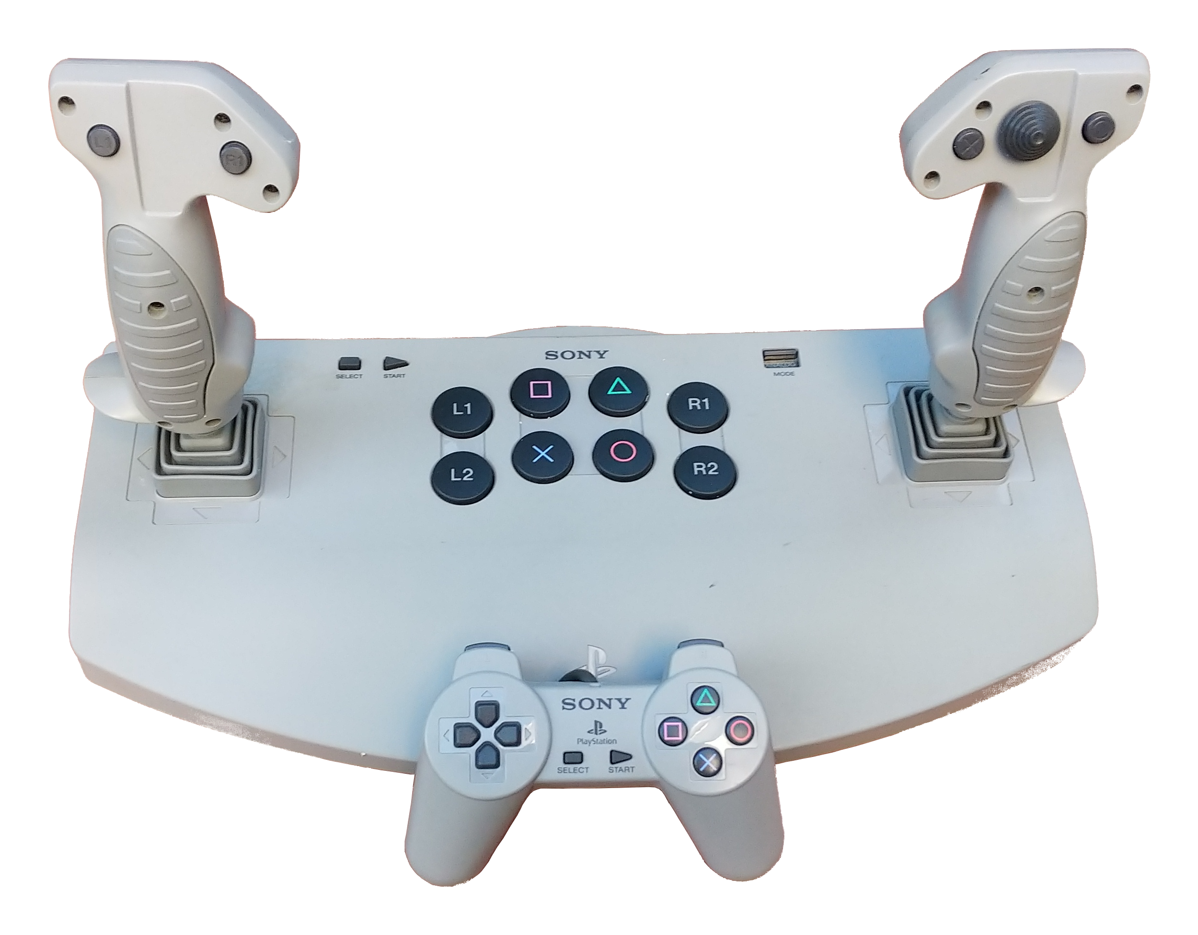
The PlayStation digital Controller (SCPH-1080) and Analog Joystick (SCPC-1110) were the first controllers released by Sony and were fixed function devices. True, the 1110 can change between Analog and Digital via a slide switch,; however, there is no way to programmatically change the switch setting once the user has set it. So these devices can’t be configured, but the commands to interrogate game controllers are only valid when a game controller is in configuration mode. As a result of the unconfigurable nature of these game controllers, they are also unidentifiable.

If you can’t configure, you cannot identify these game controllers. What is the host to do? A real PlayStation tries to configure them and these game controllers fail in a clear way. Looking at the logic analyzer screen capture of a SCPH-1080 attached to a PS2 host:
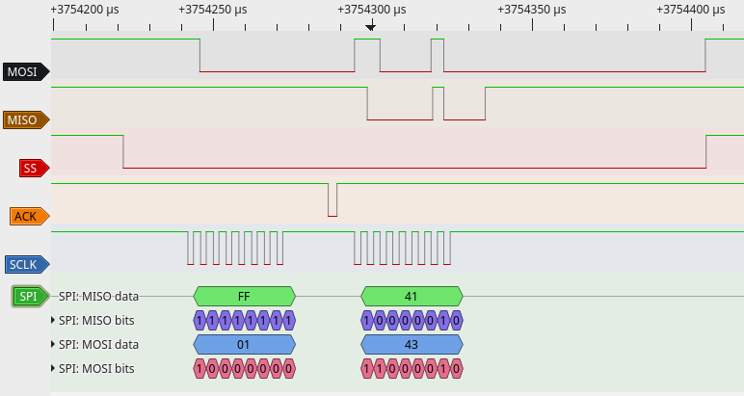
We see the host send the start of an attempt to sent a Configuration & Poll (0x43) message; however the game controllers don’t know what to do with this type of message and do not ACKnowledge the command byte. Without an ACK, the PlayStation will stop the rest of the command. The boot ROM of the PlayStation retries this 10 times, observed games have retried 12 times. Eventually, the host side decides it will never get the game controller to enter configuration and from that point on only sends Poll & Motor (0x42) commands to the game controller.

Numerous test seem to indicate that at least the test PSx consoles I have on hand wait about 40uS for the ACK before giving up. Unexhaustive testing has shown that controllers ACK bytes they will accept within 10uS. An annomoly is that a PSx does not wait for a final ACK for the last byte transferred and/or the controller will not ACK what it thinks is the last byte of a transfer - the time at which the PSx releases SS is very close to the timing when a controller would assert ACK. Regardless whether the PSx stops or the controller does not reply, the PSx release SS about 5-10uS after the final byte and I have never seen event the start of an ACK on my low cost logic analyzer pod.

TODO: using the emulator investigate what happens when the host continues a transaction after the first lack of an ACK.

This behavior, has two impacts on the console emulator. First, to successfully emulate a host the ACK signal is mandatory; you can’t know the game controller is not accepting a command if it does not see the ACKs stop. Second, emulator starts configuration / detection by sending an initial Poll & Motor (0x42) and sets the controller to a default “SCPH-1080” or “SCPH-1110” depending on the Mode Nybble of the response.

UPDATE: The SCPH-1180, which was the first North American hand held analog controller, also does not ACKnowledge the 0x43 Configuration & Poll message. This section will need to get revised based on this information.

The buttons on a digital controller do not support any analog pressure As a result, there is no configuration protocol supported in these devices, but the console can’t know that a fixed function controller is attached unless it tries.

can operate in “Analog” mode where it reports the position of the joystick as digital values between -128 and 127 or is can operate in “Digital” mode where it reports the left joystick as arrow buttons and ignores the position of the right joystick entirely. The game controller has a large switch that is used to change between the two modes.

Unlike later Dual Shock, and maybe the Dual Analog, controllers, the Analog Joystick will not enter config mode. This means the controller cannot be switched between modes by the PlayStation or host. It also means that this controller cannot report it’s model or other information typically exchanged while being configured. However, a PlayStation will try to put the controller into config mode, which is futile.

This inability to change modes or enter config resulted in an interesting discovery, the ACK line is absolutely necessary to emulating the PlayStation with an adapter. When the SCPH-1110 starts up, it returns a 0x41 in digital mode or 0x53 if it is in analog mode when the PlayStation first polls it. However, when the PlayStation sends a type 0x43 Poll-Config message, the SCPH-1110 does not ACKnowledge the Command Byte as shown in the logic analyzer trace:

The PlayStation repeats the attempt to send a 0x43 message twelve times before it apparently decides to give up. When the switch is changed in the middle of a game, this is repeated at the same ~15 millisecond rate used to normal polling.

Also, the controller has two sets of buttons, large buttons in the middle and another set distributed over the joystick handles. Each button returns the same code when pressed. In other words, there is no way to know if, for example whether the R1 button that was pressed is the one in the center cluster or the one on the left stalk at the thumb.

Startup Anomalous Behavior
At startup, the PlayStation will perform a command sequence of 0x45, 0x46:00, 0x46:1, 0x47, 0x4C:0, 0x4C:1. No one seems to know what the data returned is used for. One source reports that 0x45 is a model number but data they observed has not yet been confirmed.

Controllers from the SCPH 1150 / 1180 on change between modes via etiher a user operated press button or under command from the PlayStation hose. Starting with the SCPH-1200 and on the PlayStation can also lock out user changes via software command.

Multitap Adapters

Though not presently under consideration, the following Mutlitap Adapters have been released by Sony:

SCPH-1070 – 1996
SCPH-10090 – December 2003
SCPH-70120 - November 3rd, 2004
SCPH-111

These units appear, based on limited information on the web, to just put together four max packets strung together in one big packet.

Commands by Byte Code

Code | Function
0x40 | Configuration / Button
0x41 | Configuration / Report Capabilities
0x42 | Poll & Motors
0x43 | Configuration & Poll
0x44 | Configure Mode
0x45 | Query
0x46 | Query
0x47 | Query
0x4C | Query
0x4D | Configure Motor Map
0x4F | Configure report data

Arduino PS2 Controller Interface – LINK
Decoding PS2 Wired and Wireless Controller for Interfacing with Pic Micro Controller – LINK

References

USB
Microsoft explanation of USB-IADs – LINK
Intel explanation of USB-IADs – LINK
Cypress explanation of USB-IADs – LINK1, LINK2

PlayStation 1 / 2 Interface
Sony Playstation Controller Port – LINK
A simple description of the physical interface, though inaccurate in regards to ACK
PS2 Command Set by Nathan Scherdin – LINK
Some information on command structures, but inaccurate.
PS1 Pad Interface – LINK
A project page about using a Motorola (now NXP I believe) 68HC11 to interface to a PlayStation controller. Take the text as about half accurate
PlayStation 2 Controller Arduino Library v1.0 – LINK
Apparently functional code for a late model controller that starts in mode 0x7x only. It does not use ACK so can’t work with older controllers.
PSX Controllers – LINK
A project page about using a Motorola 68HC11 to interface to a PlayStation controller.
Playstation.txt by Joshua Walker – LINK
The controller section is very limited.
The analyze infomation of PAD-controler and Memory I/F in PlayStation – LINK
Early document on the interface
Sony Playstation (PSX) joystick controller port pinout – LINK
A project to connect a controller to a PC port.
How to interface Arduino with a Playstation game-port controller – LINK
3.3V to 5V translation hardware for Arduino use, ignores ACK
Interfacing PS2 controller with AVR Bit Bang – LINK
A project to connect a controller to a AVR dev board, ignores ACK.
How PlayStation Works – LINK
Childish description of a PlayStation controller and interface
PSP-Nx-v4 User Guide – LINK
Pretty useless for development but it kept appearing on searches so I captured it so I could ignore it.
Arduino PS2 Controller Interface – LINK
Arduino to two PlayStation controllers
Decoding PS2 Wired and Wireless Controller for Interfacing with Pic Micro Controller – LINK
Really incomplete description of the interface.
Interfacing a PS2 (PlayStation 2) Controller – LINK
One of the best documentation efforts on the web regarding the game controller interface.
Near Future Labs – LINK
Blog post on several PlayStation projects connecting to their hardware and the path of using a logic analyzer to figure stuff out. Not much useful but at least entertaining material on others attempts to use the PlayStation controllers.
Run-Time Library Overview – Part of the “Runtime Library 4.6” (Psy-Q-46) material at PSXDEV Network – LINK
Official Sony documentation on the PlayStation controller data for early controllers. Does not address configuration very well but does drop some hints.
Series 9000 Service Manual – among download material at PSXDEV Network – LINK
Official Sony documentation provides assembly drawing and schematics of the PlayStation console
User Guide, Software Development Tool – among download material at PSXDEV Network – LINK
Official Sony documentation Net Yaroze tools, once over lightly on the controller data structures.

PSOC 5 CY8CKIT-059
The fifth generation of the Cypress PSOC family integrate a small FPGA and a cortex-M3 processor. Development boards for these parts were donated to FIRST Robotics Competition teams and Cypress provided reference firmware to use these boards as the basis for custom USB HID stations for teams. I use some of the pieces and many of the same I/O used in Cypress’s reference design for the PSx interface so that existing expansion boards could be used. One area where my mapping differs from the Cypress one is that the onboard LED is mapped to an output so that it can be useful in my implementation

Firmware is majorly different from the Cypress implementation. Obviously the software needs to interface to the PSx SPI like devices; however, the changes are much more than just an additional interface. The system is running under FreeRTOS with multiple tasks. There is a CLI to the firmware for some documentary operations and diagnostic usage. A separate blinky task is created just to use the onboard LED. Most of these changes are a result of an attempt to make the firmware a better starting place for future PSOC projects.

PSoC 5LP Prototyping Kit GPIO Header (J1)
Pin | Signal | Description | PSx HID Adapter Function
J1_01 | P2.0 | GPIO | Out_7 (Button_9)
J1_02 | P2.1 | GPIO/LED | Out_8 (Button_10)
J1_03 | P2.2 | GPIO/SW | (Button_11)
J1_04 | P2.3 | GPIO | (Button_12)
J1_05 | P2.4 | GPIO | (Button_13)
J1_06 | P2.5 | GPIO | PSx_ACK_0 (Button_14)
J1_07 | P2.6 | GPIO | PSx_ACK_1 (Button_15)
J1_08 | P2.7 | GPIO | PSx_MISO (Button_16)
J1_09 | P12.7 | GPIO/UART_TX | (Output_12)
J1_10 | P12.6 | GPIO/UART_RX | (Output_11)
J1_11 | P12.5 | GPIO | PSx_MOSI(Output_10)
J1_12 | P12.4 | GPIO | PSx_SS_0 (Output_9)
J1_13 | P12.3 | GPIO | PSx_SS_1 (Output_8)
J1_14 | P12.2 | GPIO | PSx_SCLK (Output_7)
J1_15 | P12.1 | GPIO/I2C_SDA
J1_16 | P12.0 | GPIO/I2C_SCL
J1_17 | P1.0 | SWDIO | SWDIO
J1_18 | P1.1 | SWDCLK | SWDCLK
J1_19 | P1.2 | GPIO | (Button_17)
J1_20 | P1.3 | GPIO | (Button_18)
J1_21 | P1.4 | GPIO | (Button_19)
J1_22 | P1.5 | GPIO | (Button_20)
J1_23 | P1.6 | GPIO | (Button_21)
J1_24 | P1.7 | GPIO | (Button_22)
J1_25 | GND | Ground
J1_26 | VDDIO | Power

PSoC 5LP Prototyping Kit GPIO Header (J2)
Pin | Signal | Description | PSx HID Adapter Function
J2_01 | VDD | Power
J2_02 | GND | Ground
J2_03 | RESET | Reset
J2_04 | P0.7 | GPIO | Analog_Dial
J2_05 | P0.6 | GPIO | Analog_Slider
J2_06 | P0.5 | GPIO | Analog_RZ
J2_07 | P0.4 | GPIO/BYPASS CAP | Analog_RY
J2_08 | P0.3 | GPIO/BYPASS CAP | Analog_RX
J2_09 | P0.2 | GPIO/BYPASS CAP | Analog_Z
J2_10 | P0.1 | GPIO | Analog_Y
J2_11 | P0.0 | GPIO | Analog_X
J2_12 | P15.5 | GPIO | Output.5
J2_13 | P15.4 | GPIO/CMOD | Output.4
J2_14 | P15.3 | GPIO/XTAL_IN | Output.3
J2_15 | P15.2 | GPIO/XTAL_OUT | Output.2
J2_16 | P15.1 | GPIO | Output.1
J2_17 | P15.0 | GPIO | Output.0
J2_18 | P3.7 | GPIO | Button.7
J2_19 | P3.6 | GPIOJ2_20P3.5GPIO | Button.6
J2_21 | P3.4 | GPIO | Button.4
J2_22 | P3.3 | GPIO | Button.3
J2_23 | P3.2 | GPIO/BYPASS CAP | Button.2
J2_24 | P3.1 | GPIO | Button.1
J2_25 | P3.0 | GPIO | Button.0
J2_26 | GND | Ground

