Title: Topsoe eREACT™ campaign
Team: Marketing
Background
Topsoe has developed a novel technology eREACT™ for production of low-carbon hydrogen and fuels. The heart of the technology is an innovative electrified reactor design, which can convert a variety of feedstocks into low-carbon hydrogen or other chemicals and fuels.
If you take an example familiar from everyday life, it is equivalent to replacing your gas stove with an induction stove with the electricity being generated from renewable energy sources such as solar and wind.
Now eREACT technology is mature, and our production facilities are ready to serve the market, but competition is increasing, so we need to move fast to position Topsoe as the leading provider within electrified reforming to defend our IP and generate leads for sales. Marketing has therefore been asked to develop a campaign bringing this new technology platform to the market.
eREACT serves as a platform with multiple applications eFuels/eSAF, Hydrogen, Ammonia and Methanol as shown in the figure below.
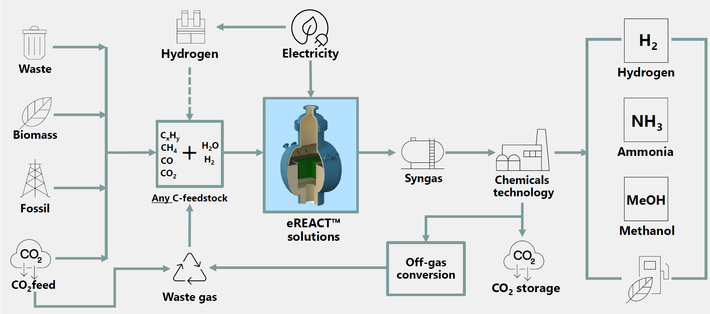
Overall, Topsoe has a strong position in the market of eFuels and good traction in several projects. We have sold eREACT to the German Aerospace Center (DLR) as part of an eSAF demo plant in Germany expected to start-up in 2027, but we’re lacking behind on projects within hydrogen, ammonia and methanol.
As this is a new technology platform, we’re still exploring which customers can benefit from this new solution. It depends on many different factors such as access to low-cost (renewable) electricity, natural gas or biogas prices and incentives for carbon emission reduction and/or regulations.
Short term we see the biggest business potential in revamps of existing plants across hydrogen, methanol and ammonia especially within refineries. Here eREACT can help boost capacity by 20% and reduce CO2 emissions. While refineries already have running plant/businesses it’s usually easier for them to get the funding.
Secondly grassroot projects within hydrogen where natural gas is constrained, for production of blue hydrogen (our technology SynCOR is still preferable to large scale production) and in the production of renewable fuels.
More than 99% of global hydrogen production is still derived from fossil fuels, particularly natural gas which accounts for 76%. To produce hydrogen from natural gas, steam methane reforming (SMR) is the most widespread route today resulting in high carbon intensity production.
eREACT offers a low-carbon alternative to conventional reforming reactors such as SMR. By incorporating renewable electricity into e.g. hydrogen production, you can produce close to carbon neutral (more than 99%) hydrogen.
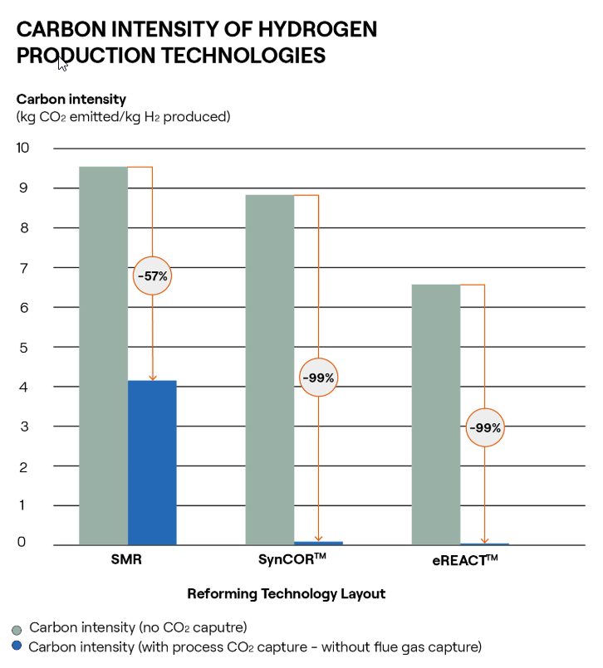
Some of the key benefits of eREACT when it comes to hydrogen production:
- Reduces natural gas consumption by 30-40% compared to conventional SMR for hydrogen production
- CO2 emissions reduction by up to >99% compared to SMR
- Ultra-low carbon intensity of 0-0.2 kg CO2/kg H2
- Eliminates all flue gas from the hydrogen production process
- Simpler plant design lowering engineering and OPEX
- Minimize plant footprint – 100x smaller than a conventional SMR
Objectives:
- Business objectives in 2026:
  - 13 paid studies (5 within eSAF, 8 within hydrogen, ammonia & methanol)
  - Backlog on supply of catalyzed hardware 3 MW (same size as DLR)
  - Secure eREACT™ competitiveness
- Campaign objectives:
  - Increase general awareness around eREACT and its different applications
  - Differentiate ourselves from the increasing number of competitors
  - Educate our customers and potential customers on the benefits of electrified reactors and how projects can look
  - Create MQLs for sales (emphasis on hydrogen, ammonia and methanol)

Target group insights:
These are the target customers we’re looking to talk to, but it’s important to be aware that we’re still in the process of refining our go-to-market strategy and development of our standard eREACT offerings based on ongoing feedback

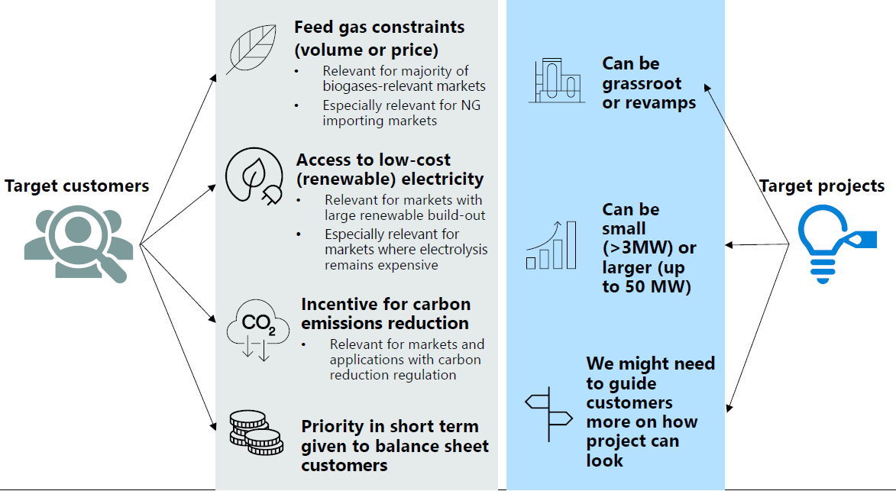

Key stakeholders in Topsoe:
- Lars Martiny, Head of eREACT
- 2 Product Line Directors Sandra Winter-Madsen (eFuels) and Adam Kadhim (Hydrogen, Ammonia and Methanol)
Background/insights
Topsoe’s main advantage is our experience and competence across the entire value chain from syngas production to the production of derivatives such as ammonia and methanol. Our many years of experience give the customers confidence and security when they need to take Final Investment Decisions (FID).
Topsoe claims to have the widest portfolio of reforming technologies - eREACT adds one more.
Additionally, 1/3 of hydrogen is produced using Topsoe solutions globally (based on data in IEA’s Global Hydrogen Review 2025)
Competitors:
We’re working on a competitor analysis to get to know their strengths and weaknesses better. One of the major competitors is Sypox and they are also doing a lot of campaigns in the market right now. They are collaboration with a company called Clariant who are delivering the catalysts to the Sypox technology. Clariant is one of Topsoe’s major competitors on the catalysts side. Link

Key deliverables
We need a campaign bringing this new technology platform eREACT to the market creating short term leads to sales already in 2026 and at the same time works at the foundation for positioning Topsoe as the market leader within this area over the coming years.
- Value proposition and message house (eREACT platform)
- Creative concept (eREACT platform)
- Recommendations for a campaign plan for Hydrogen/Ammonia and Methanol application that includes the full customer journey – attract, convert, nurture and sales enablement
The campaign must follow our Corporate Visual Identify guidelines available in our brand portal - link

Project timeline and milestones
- Message house and creative concept approved by April 30 (Ready for Internal Sales meeting May 7)
- Campaign plan approved by May 20th
- Campaign soft launch June/July – major launch August/September

Additional Information:
First-of a kind paper in Science published in 2019 - link
eSAF demonstration plant for DLR - link
eFuels technology - link
eREACT for hydrogen production - link
Brochure on eREACT for hydrogen – link
Video about our test plant in Foulum where eREACT is used in the production of syngas from biomass. This plant has recently produced the first batch of eSAF - link

