Paper 2: Correlation Coefficients based on ESHM20

Introduction / Motivation
- The role that the correlation between IMs plays in seismic risk analysis and ground motion selection
- Short overview of our project goals and why we need correlation coefficients
  - Ground motion selection for sites in Europe
  - Ground motion selection specifically considers ground motions from different tectonic region types (active shallow crust, subduction in-slab, subduction interface) plus the specific Vrancea deep seismic zone.
  - Correlation coefficients are best determined using GMMs derived from the same set of records that you are using for the correlation coefficients. Kohrangi et al. [2018]. Therefore, it makes sense to use the ESM database and the ESHM20 GMMs
  - Needs to match the Ims in out case PGA, SA(0.025 to 8s), significant duration and AvgSA[0,3s] and AvgSA[0,6s]. Explain here why these IMs
  - Review of the common correlation coefficients.
    - Summarise the reviewed studies (9).
    - Highlight that some studies show significant differences between subduction settings compared to active shallow crust, while others do not.
    - The review shows that there is no study that has published these coefficients for the GMMs used in the ESHM20 project.
    - Check if there are correlation coefficients for the Vrancea region… But given the variation in subduction correlation values we can’t with any real level of confidence just choose an existing correlation model and use it.
    - Acknowledge that Graeme has already implemented a model in OpenQuake although it has not been published.
- Structure of this paper.

Ground-Motion Database
- Summary of the database used, when it was accessed and what sort of filtering I did to get the final number of records.
- I have 4 different databases:
  - ASC, SSlab, Sinter, and Vrancea
- Add some plots that visually summarise the database e.g. Mw vs. Rjb

Intensity Measures and Ground-Motion Models (GMMs)
- Description (and if needed a justification) of the GMMs used.
- All GMMs are already implemented in OpenQuake

Data Processing and Analysis

Calculation of Residuals
- Describe the calculation of the residuals
  - Predictions using GMMs from OpenQuake compared with the values from the database.
  - Mixed effects regression model used to get the residuals using the lme4 package in R
- Assumptions related to Rake for significant duration GMM
- Assumptions about distance metrics and all other metrics
- Report the standard deviations of the residuals
  - Plot
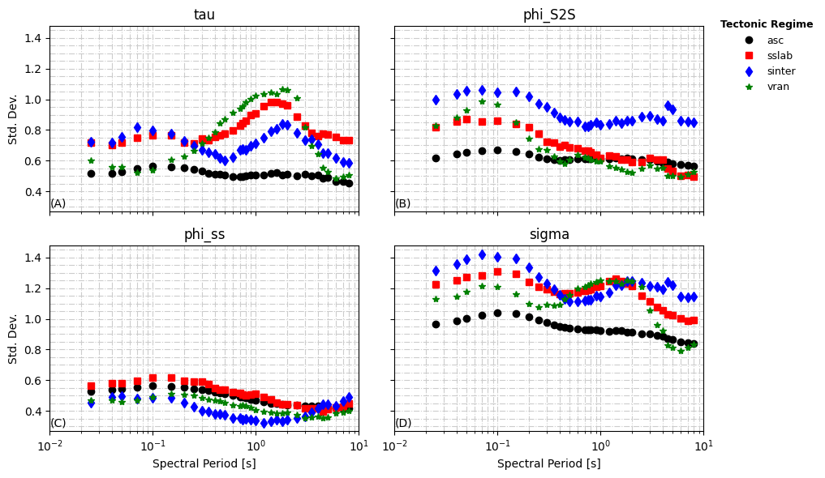
  - See if you can compare these to the ESHM20 project
  - Justify why we kept going
    - We used accepted GMMs
    - We did use lme4 instead of the nonlinear weighting version which would probably increase the dispersion… but by that much?
    - Probably needs to be discussed with Graeme again

Calculation of the Correlation between Residuals
- Equations for total correlation is the combination of the correlations of all three
- Figure showing the concept similar to:
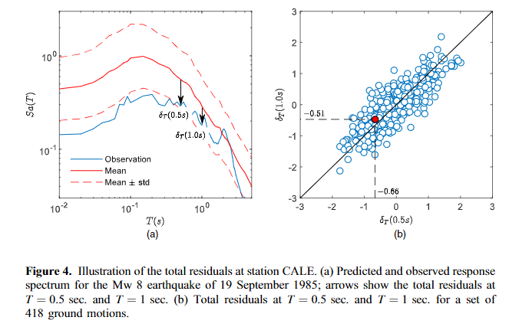

Results and Discussion

Correlation Coefficients

SA inter-period Correlations
similar to:
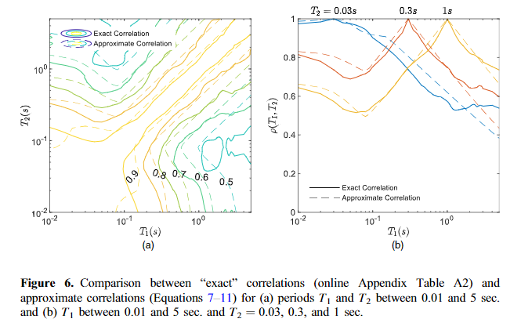
- Results compared to other studies
  - SA. Matches HTG20 nicely which uses ESM records for Italy only. Significantly higher correlations than widely used models like BJ08 and BB17. ASO24/BJ08/BB17 use NGA-West 1/2 records. AKK14 uses RESORCE Records (European but a different set)
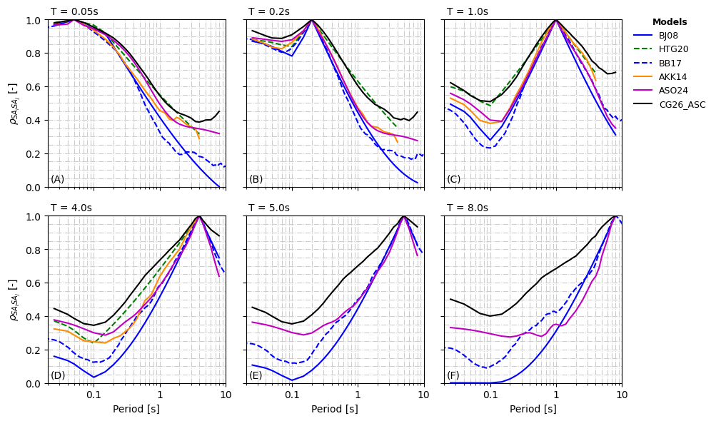
- Subduction Slab/Interface and Vrancea deep seismic zone
  - Our results are somewhat higher than the other studies. Particularly for short short periods although to longer periods or interface model is not far off interface models of CAN20 and JC19. In all cases our models are very different from the NGA-Sub project and AGA16
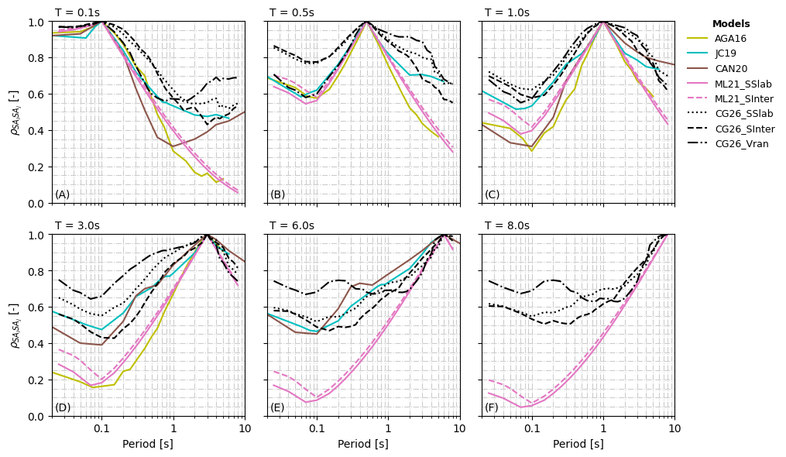

PGA and RSD595 with SA(T1)
  - PGA: Correlation with PGA is higher than for BB17 for active shallow crust. It is ~ the same as HTG20 up to a period of about 1s and then it deviates. The subduction and Vrancea correlations are much stronger than the NGA-Sub database.
  - RSD595: ASC, SSlab, and Sinter all seem to fall within the bounds of other published models. Vrancea looks very different and the correlation does not vary much at all -0.3 to -0.4
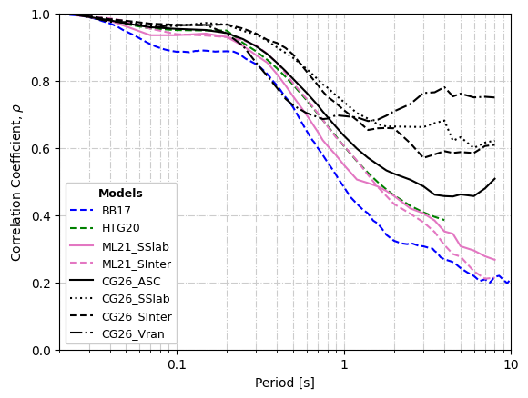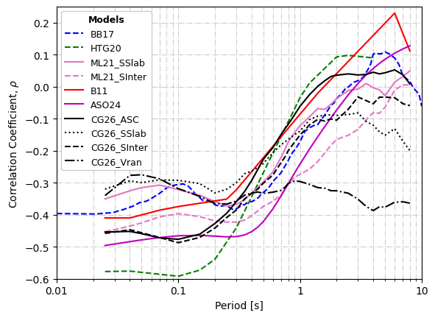

AvgSA[0,3] and AvgSA[0,6] with SA(T1)
  - New results no comparison. ASO24 uses a different definition and can’t really be compared. Although the shape is similar
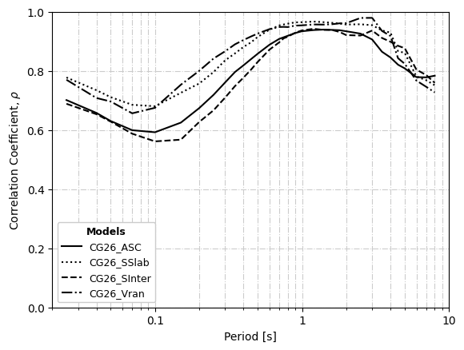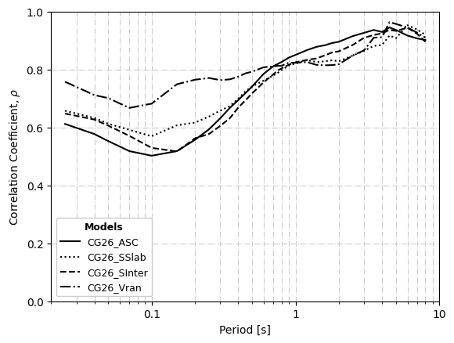

Other Correlations
- Table of correlation values for all the remaining combinations that are don’t use the period.

Impact of Correlation Coefficients on Conditional Spectra
- The results of the previous section show that there are substantial differences in the correlation models between studies. It may suggest as JC19 that region specific may indeed be the way to go…
- But what practical effect do the varying correlation coefficients have on conditional spectra. like Baker and Bradley [2017]
  - Using each of my correlation models and a selection of other models for several different earthquake scenarios and several different conditioning periods
  - Compare the results. Are they significantly different? If yes then region and tectonic-specific correlation models are needed and our work is valuable because we clearly show that there is a difference between ESM records and global or other regional sets. If not then it probably doesn’t matter much what model you use.

Dependence on Magnitude and Distance
- Not done and I would try to avoid it because we need to redo the calculations on different subsets of the data. Although it would be useful new information for our subduction dataset and could be compared to the NGA-Sub database coefficients

Conclusion

References

