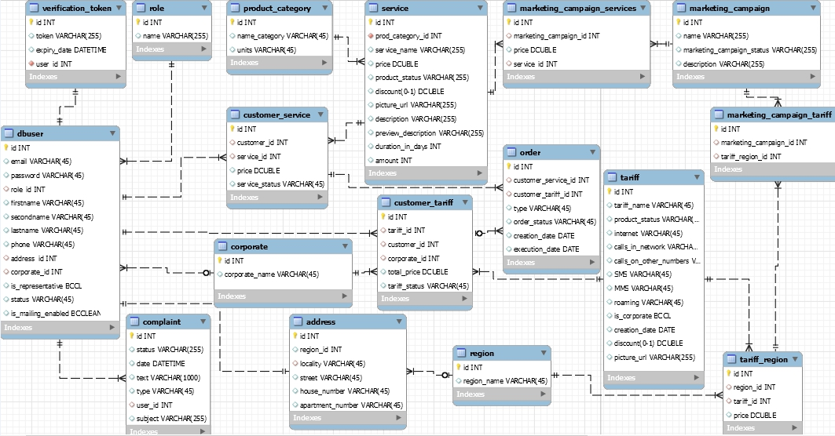

|  |  |  |  |
| --- | --- | --- | --- |
| **Name of table** | **dbuser** | | |
| **Purpose of table** | Represents every user in the system (customer and a regular user as well) | | |
| **Primary key** | *id* | | |
| **Name of field** | **Data type and field length** | **Constraints** | **Full description of field** |
| ***id*** | INT | PRIMARY KEY NOT NULL | User's id |
| ***email*** | VARCHAR(45) | NOT NULL | User's emailUser's password |
| **password** | VARCHAR(45) | NOT NULL | User's password |
| **role_id** | INT | NOT NULL | Reference to "role" table |
| **firstname** | VARCHAR(45) |  | User's first name |
| **secondname** | VARCHAR(45) |  | User's second name |
| **lastname** | VARCHAR(45) |  | User's last name |
| **phone** | VARCHAR(45) |  | User's phone |
| **address_id** | INT |  | Client address used to define suitable products for him |
| **corporate_id** | INT |  | Corporation which user belongs to. NULL if user is not a corporate one |
| **is_representative** | BOOLEAN |  | Represents the fact whether user is representative |
| **status** | VARCHAR(45) | NOT NULL | User account status |
| **is_mailing_enabled** | BOOLEAN |  | Represents the fact whether user has agreed for advertisement email reception |
| **Additional constraints for table** | FOREIGN KEY (role_id) REFERENCES role(id) | | Field “role_id” can include only values defined in field “id” of “role” table |
| FOREIGN KEY (address_id) REFERENCES address(id) | | Field “address_id” can include only values defined in field “id” of “address” table |
| FOREIGN KEY (corporate_id) REFERENCES corporate(id) | | Field “corporate_id” can include only values defined in field “id” of “corporate” table |

|  |  |  |  |
| --- | --- | --- | --- |
| **Name of table** | **address** | | |
| **Purpose of table** | Represents the addresses of all customers/corporates | | |
| **Primary key** | *id* | | |
| **Name of field** | **Data type and field length** | **Constraints** | **Full description of field** |
| **id** | INT | PRIMARY KEY NOT NULL UNIQUE | Address' id |
| **region_id** | INT |  | Reference to "region" table |
| **locality** | VARCHAR(255) |  | Customer's or corporation's location |
| **street** | VARCHAR(255) |  | Customer's or corporation's street |
| **house_number** | VARCHAR(255) |  | Customer's or corporation's house number |
| **apartment_number** | VARCHAR(255) |  | Customer's or corporation's apartment number |
| **Additional constraints for table** | FOREIGN KEY (region_id) REFERENCES region(id) | | Field “region_id” can include only values defined in field “id” of “region” table |

|  |  |  |  |
| --- | --- | --- | --- |
| **Name of table** | **role** | | |
| **Purpose of table** | Represents a role for each user in the system (customer and a regular user as well) | | |
| **Primary key** | *id* | | |
| **Name of field** | **Data type and field length** | **Constraints** | **Full description of field** |
| **id** | INT | PRIMARY KEY NOT NULL UNIQUE | Role's id |
| **name** | VARCHAR(255) |  | Role's name |

|  |  |  |  |
| --- | --- | --- | --- |
| **Name of table** | **corporate** | | |
| **Purpose of table** | Represents every corporation in the system | | |
| **Primary key** | *id* | | |
| **Name of field** | **Data type and field length** | **Constraints** | **Full description of field** |
| **id** | INT | PRIMARY KEY NOT NULL UNIQUE | Corporate's id |
| **corporate_name** | VARCHAR(255) |  | Corporation's name |