**Name: Nai-Fan Chen NetID: nc41**

**Task1:**

On a5KDtrainingV2.txt

('Task1:', [('applicant', 11393), ('and', 2), ('attack', 3107), ('protein', 433), ('car', 4017)])

On a5KDtestingV2.txt

[('applicant', 14389), ('and', 2), ('attack', 4485), ('protein', 462), ('car', 2924)]

**Task2:**

This is the logistic function with regularization.

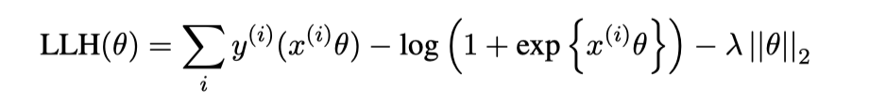

This is the derivative function.

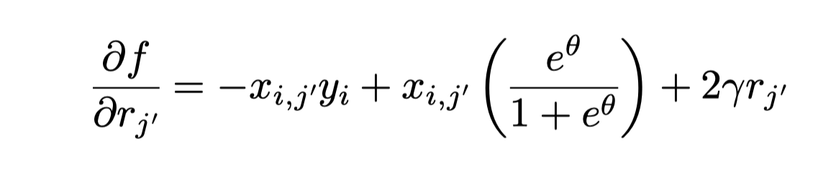

Update:

Weight -= learning_rate*gradient.

Keep updating until the difference of the loss between every two iterations becomes very small.

**On a5KDtrainingV2.txt:**

obesity

obese

morbidly

overweight

movi

bariatric

orlistat

hyperphagia

ewl

snacking

sadi

bmi

plication

malabsorptive

worksite

weight

tssc

kj

almonds

tiffin

wize

childcare

kilograms

sibutramine

teenagers

agb

kindergarten

philips

vbg

jib

seminars

overeating

roux

polycystic

hypocaloric

inflating

abstract

satiation

ovary

hypothalamic

tripled

kcal

pizza

mentors

soda

outdoors

banding

iom

idf

jejunal

**On a5KDtestingV2:**

obesity

obese

bmi

morbid

weight

morbidly

eating

ghrelin

overweight

lifestyle

bariatric

dietitian

epidemic

banding

dispersion

orlistat

norwood

sleeve

flegal

buffet

calmm

leicester

transection

labs

glycaemia

alarming

advice

binge

ameliorated

anovulation

intragastric

hypothesizes

graders

fructose

leptin

tv

lean

metabolically

jejunum

endocannabinoids

employers

anecdotally

television

wanting

enteroendocrine

depots

pyy

putative

clapp

learners

**Task3**

**The weight is trained on a5KDtrainingV2.txt**

**Predict on a5KDtestingV2.txt**

F1:0.600522193211

The F1 score is lower than the small dataset because there are many ‘0’ labels in the big training data. Therefore, the obesity data is not large enough to predict whether it is obesity or not. On the other hand, the not obesity data is very large and we can train our model to predict the sample that is not obesity very accurately. That is to say, the data is very unbalanced. If our data can contain more obesity samples, the model can predict it better. Moreover, because of the skewed data, the machine just predicts that all data is not obesity and the accuracy will be pretty well. That is, the loss will be still small if we have false negative since the positive obesity sample in the training data is the very small partition.

**False Positive example:**

'0NCT02347267'

'0NCT01150981'

’0NCT00564798'

The above three cases contain the words like ‘obesity’, ‘calories’… The weight of each document will be high and fool the machine to get the positive result. These documents just describe something else but contain the word with heavy weight. Hence, the model will get confused whether it is obesity or not.

**The weight is trained on a5KDtestingV2.txt**

**Predict on a5KDsmallsetV2.txt**

F1:0.8688569101276133

The F1 score is higher than the big training set since the data is not skewed seriously but a little. Due to the reason, the true positive is much larger than the false positive number. That is, the model is accurate in small dataset.

**False Positive example:**

'0NCT02574949'

'0NCT02318745'

'0NCT02423304'

The reason is the same I write above. Although I might be able to get rid of these case by picking an appropriate threshold, it is difficult to cover them all because TFIDF is the only weight we can use to predict our result. TFIDF just use the frequency of words to compute the score but do not care about context. If we can use RNN or LSTM, we might be able to get better result.