Product Type: Content Management
Title: L3Harris_QuickScale_User_Guide.docx
Estimated Completion Time: Varies

Table of Contents
1.0 COPYRIGHT 2
2.0 Purpose 2
3.0 Setup & Configuration 2
3.1 Installation 2
3.2 Setting Configuration 2
3.3 Configuring Hot Keys 3
4.0 Usage 4
4.1 QuickScale Basic Toolbar 4
4.2 QuickScale Basic Hotkey Toolbar 5
4.3 QuickScale Advanced Hotkey Toolbar 5
4.4 Troubleshooting 5
5.0 External Version Tracker 6
6.0 Record of Change 6

COPYRIGHT
Copyright © 2020, L3Harris Technologies
L3Harris Proprietary Software
The release of the documentation, and software solely for the purpose of the JANUS Effort.

The following document, and software shall not be released to any other entity or to any entity including those listed above, for purposes other than the JANUS effort, without express permission from L3Harris Technologies.

Purpose
The scale widget’s purpose is to improve the speed that an analyst can set scales of data. During an editing session, an analyst is expected make a multitude of decisions setting scale, especially in network situations. The L3Harris Scale Widget is designed to allow analyst to quickly set the scale after they’ve made their decision, so they may move on to the next scale decision.

Setup & Configuration

Installation
To install the L3Harris QuickScale widget double click on the QuickScale.esriAddin and follow ESRI’s instructions. This will add three new toolbars to your ArcMap window. Right clicking and adding the following three toolbars to your ArcMap is recommended:

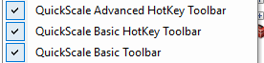

Setting Configuration
To edit the settings for L3Harris’ QuickScale, enter the setup menu by pressing the settings button:


Once opened you can configure two options, the Scale Column and the Scale List. The Scale Column should be set to the name of the column where the scale information will be saved, in TDS7 this is zi026_ctuu. The Scale List you can set by entering in the scale bands in the order that you want them displayed from first to last option. They must be entered as a comma separated list.
An example:
500000, 250000, 100000, 50000, 24000, 12500
This setting will be preserved through MXDs & ArcMap Sessions.

Configuring Hot Keys
To configure hotkeys for the L3Harris QuickScale Widget, first enter Customize Mode. This an option under Customize -> Customize Mode
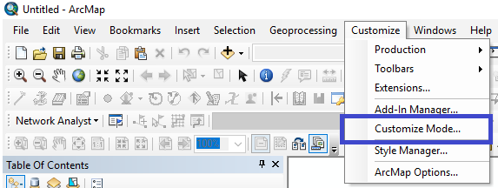

While in the customize window, do the following to setup hotkeys:

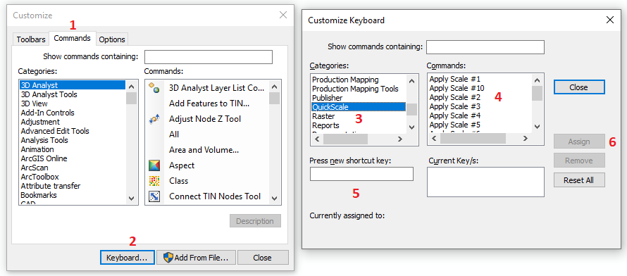

- Select the Commands Tab (1)
- Select the Keyboard button (2)
- Scroll down in the Categories menu box to QuickScale (3)
- For Each command you want to create a hotkey for:
  - Select the command in the right hand window (4)
  - Press the new shortcut key (Using Shift, Alt, Ctrl as modifiers if desired) (5)
  - Select Assign (6)
- Repeat Step d.

Usage
Note: L3Harris recommends toggling the selectabilities of layers that are being used as reference to prevent accidental scale manipulation.
All methods of using the QuickScale Widget require being in an edit session.
There are three ways to use the L3Harris QuickScale widget

QuickScale Basic Toolbar
To open the QuickScale Basic window, select the QuickScale Widget button on the QuickScale Basic toolbar. This will open a new floating window. This is useful for users who do not wish to setup hotkeys or find themselves wanting to verify scales or quickly edit a small region.

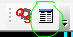

In the floating window you will be presented with all the Scale List scales setup in the configuration step. By selecting features, the feature counts on the right side of the window will calculate, reporting back the number of features at various scales. By selecting one of the “Scale” buttons, it will set the Scale Column to that value.

In the example below, clicking the “250,000” button forces all 391 selected features to be scaled to 250,000.
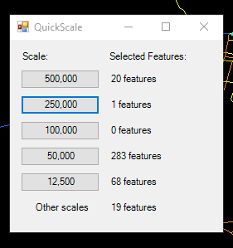

QuickScale Basic Hotkey Toolbar
The QuickScale Basic Hotkey Toolbar is a self-contained toolbar. It is recommended that before using this toolbar, users setup a hotkey for the Apply Picked Scale action. This usage is ideal when scanning through an AOI and setting many features to the same scale. For example, building a 500k network.

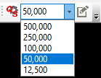

In the Scale Picker drop down, users will select their desired scale, then, after selecting features, they will either press the Apply Picked Scale button, or press the assigned hotkey.

QuickScale Advanced Hotkey Toolbar
The QuickScale Advanced Hotkey Toolbar is designed to be setup with most, or all the scale bands being assigned hotkeys. This is covered in the setup section of this document. This is useful for analysts who do not wish to travel to and from a toolbar to adjust scale and are applying a lot of different scale values to the data.



Scale 1 is the first scale in Scale List, and each scale after that up to 10 will have an option.

Troubleshooting
For internal support contact Ben Heuser
For external support contact JANUS-GUIDANCE@L3Harris.com

External Version Tracker
Reference | Version
Arcmap / ArcCatalog | 10.5

Record of Change

Author | PTR# | Date | Version | Description of Change | PR1 Name | PR1 Date | PR2 Name | PR2 Date
Zane Kullman and Ben Heuser | 156 | 20200626 | 20200626 | New user guide for new tool that improves speed of setting features’ scale while editing. | Zane Kullman | 20200626 | Tim Ransom,  H. Alex. | 20200702

