**Better Browse Features**



Better Browse Features is a tool that allows users to navigate through a selection of features one at a time. This tool improves on Data Reviewer’s Browse Features in the following ways:   
-Pans to each feature instead of zooms  
-Allows manual input of a number to seek to  
-Consistently orders features from session to session  
-Does not require the Data Reviewer extension  
-Does not stop working when ImageConnect metadata layers are present in the MXD  
 **User Instructions**Add the tool to the ArcMap interface:-Click Customize > Customize Mode. Click the Commands Tab.  
-In the column on the left, click the Add-In Controls category.  
-In the column on the right, drag and drop the Better Browse Features tool onto any toolbar.  
 **Step 1:** Select any number of features.

**Step 2:** Click the Better Browse Features button  and the tool window will open.  
  
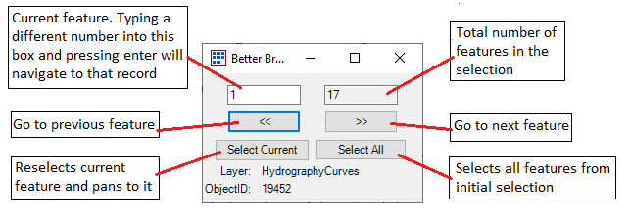  
  
-If the feature associated with a record was not found, the left text box will become yellow when it is browsed to.

-------  
Please contact me with any questions, feedback, or bugs encountered.   
Tyler Johnson in Teams or tmjohnson@wiser.team