**Clone Features Pro  
**

This is a set of tools to ease copying attributes between features. It is a total rework of the old Clone Features.  
Specialized buttons are included for copying required attributes between TDS transportation or hydro features. When using these buttons, all metadata and vital attribution of target features (ZI026_CTUU, SBB, RLE, geoname info, etc.) is retained when the copied attributes are applied.

**The Buttons**For copying all attributes of any feature:  Set Feature Template – Select one feature of any type and click this button to set the template.  
 Apply Clone – Select other features and click this button. Any features in the selection from the same feature class will have all attributes of the template copied to them.  
Note: Unlike ArcMap’s command Copy Attributes, these buttons will still function if the copied feature is deleted. The copied attributes will also not be overwritten if Copy/Paste is used on something else.  
  
**Hydrography Tools:**  
 Click this button to open the Clone Hydro Pro menu seen below.  
-After opening the menu, select a river.   
-Click the Clone Hydro button to obtain its attributes. Adjust them if desired using the dropdown menus.   
-Next, select any number of river, ditch, and aqueduct features.  
-Click Apply Clone to have the template attributes applied to any valid features in the selection. The FCODE will be updated where necessary. All metadata and situational attributes will be retained for each target feature (ZI026_CTUU, CDA, LOC, geoname fields, etc.)  
Note: In the menu, any template attributes populated with noInformation or Other are highlighted yellow as a warning.

 Downgrade Selection to Ditch – This button is also available in the menu above. It will downgrade any selected rivers and aqueducts to ditches while retaining all necessary attribution. It does not require a clone template to function.

**Transportation Tools:  
** Click this button to open the Clone Trans Pro menu seen below.  
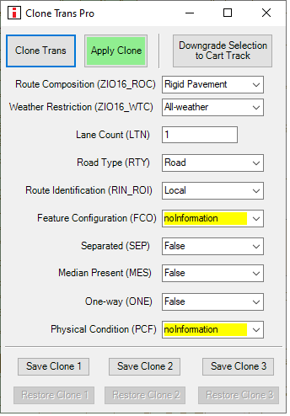  
-After opening the menu, select a road.  
-Click the Clone Trans button to obtain its attributes. Adjust them if desired using the dropdown menus.   
-Next, select any number of road or cart track features.  
-Click Apply Clone to have the template attributes applied to any valid features in the selection. The FCODE will be updated where necessary. All metadata and situational attributes will be retained for each target feature (ZI026_CTUU, SBB, RLE, geoname fields, etc.)  
Note: In the menu, any template attributes populated with noInformation or Other are highlighted yellow as a warning. Three buttons are also included at the bottom for saving and restoring road templates.

 Downgrade Selection to Cart Track – This button is also available in the menu above. It will downgrade any selected roads to cart tracks while retaining all necessary attribution. It does not require a clone template to function.  
Note: If the downgraded transportation is supporting a bridge, it will be made all-weather.   
  
 Quick Clone Trans – Selecting a road and clicking this button will create a clone template with the primary attributes seen in the menu above; however, there is no menu interface.  
  
 Quick Apply Trans Clone – This will copy the Quick Clone Trans template to any roads and cart tracks in the selection while retaining all situational and metadata attributes.  
  
-------  
Please contact with any questions, feedback, or bugs encountered.   
Tyler Johnson in Teams or tmjohnson@wiserco.com