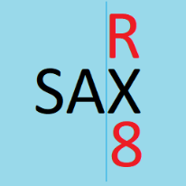

**SAX RX8 Compensator**

The SAX_RX8 Compensator adds a button to populate the SAX_RX8 attribute with “X1” for all selected features. This button can be hotkeyed.

**Step 1:** Install the SAX_RX8 Compensator by double-clicking the add-in file in Windows Explorer and choosing Install Add-In from the pop-up.

**Step 2:** Open ArcMap with the data to be compensated.

**Step 3:** If necessary, add the SAX_RX8 Compensator to the interface. This can be done by going to Customize > Customize Mode > click the Commands tab > Type sax in the top search bar > Drag the button into any toolbar

This button can also be hotkeyed. To do this:  
1. Click the “Keyboard…” button at the bottom of the Customize menu shown above   
2. Type “sax” in the top search bar  
3. Click “Populate SAX_RX8” in the right column  
4. Click the Input box in the bottom left   
5. Press desired hotkey or combination (ex. Ctrl + A)  
6. Click the Assign button on the right  
**Note:** If the key combination pressed does not appear in the bottom right Current Key/s window after clicking Assign, it is an input ArcMap will not allow to be hotkeyed. Most [ctrl + key] or [ctrl + shift + key] combinations are valid. The grave accent ` (key left of 1) is one of the few keys ArcMap accepts as a hotkey without modifiers.

**Step 4**: Start an editing session. Select features to be compensated and activate the button via hotkey or click 