Toeplitz Attack Log
Intro: This attack is to form the second paper of my PhD
Aim: To recover secret key material on the final process of QKD, privacy amplification, specifically attacking the commonly used Toeplitz hashing algorithm.
Scope: Toeplitz hashing can be implemented in either a naive fashion of simple matrix multiplication. This could be used but not likely for performance reasons. A FFT based approach is more likely to be used. We want to demonstrate an attack on both approaches.
Work done to date: In my note book I have outlined an attack on the iterative matrix multiplication algorithm version. The power analysis attack should recover the key if Eve can reliably distinguish the output of a.b=c, where a is known. If a=0 and c is high (how). If a=1 and c power is high, then b=1, if c power is low, then b=0. Need to give more time to this attack to make sure it works, also, dot products are not likely used, more likely bitwise AND operations (& in python).

Friday 7th February
Have implemented a FFT algorithm that outputs the hash value. Need to go back and verify that the output is in fact correct for this. The FFT algorithm implimented works over floating point complex numbers. This is an assumption that I have not verified, but have seen nothing to dispute this.
I have deconstructed the FFT implementation such that I can introduce a Hamming weight model for the step in the FFT where the input vector is multiplied to the “e” value. The hamming weight model records the value of the registers that contains the FFT value for a given frequency. That is, the register that eventually contains the output vector. Each time a value in the vector is updated, the Hamming weight of the new value in the register is recorded.
This seems to work well. I have re-arranged the typical order of operations of FFT calculation to show the ability of the HW model. (Frequency is in the inner loop rather than sample point). This is equivalent in terms of power, up to the point of re-arangement of traces.
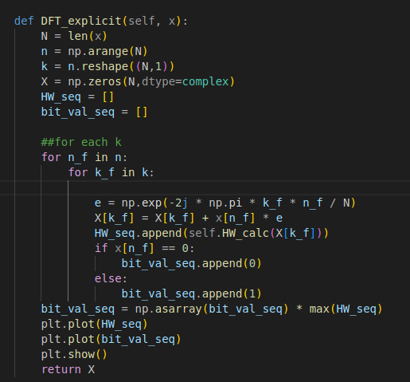

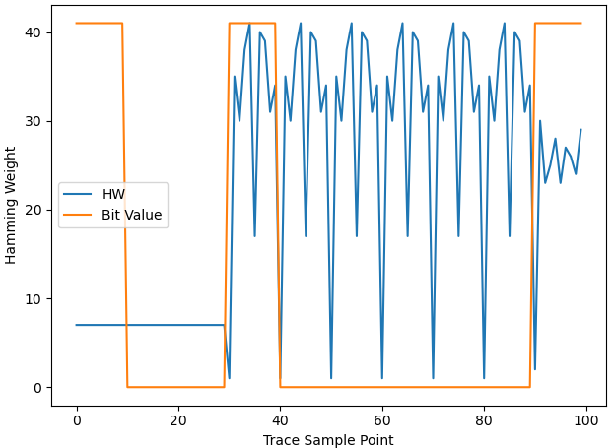

The figure shows HW in blue and x[n_f] (secret key value) value in orange (high → 1, low → 0). Assuming X is initiated as an all 0 vector (HW=0), from sample point 0, 10 (sample points associated with x[0], we can see HW is roughly 10. This implies HW has increased, impling x[0] == 1. If x[0] == 0, then x[0]*e=0, therefore X is not updated, hence no chance in HW across the register. HW remains constant up to sample point 30, implying x[1], x[2] is 0. We see a new trace profile for x[3], meaning HW has changed across X register. This is only possible if x[3] = 1. The trace profile is repeated, showing how the HW across the X register. (If we were to measure the HW difference, the difference in HW would be 0 here) for bits x[4]-x[8], implying bit values of 0. At x[9], the trace profile changes, implying x[9] = 1.
The orange line is not known to Eve, but by looking at the power traces, the values can be inferred.

Thoughts at EOD: Need to figure out where the calculation mismatch between FFT solution and naive solution is. Check circulant matrix and extraction of key from output vector.
Verify the use of floating point numbers. Seems very expensive for the calculation at hand. Better idea here will give more realistic HW model.
Put together a guessing function given only the power HW traces. Make work for modified order of operations and real order of operations. Allow for noise in power trace.
Once thats done, put into hardware?

Tuesday 11th February
Big change of the day was updating the code from a DFT algorithm to the FFT recursive algorithm that actually prefroms at O(nlogn). I don’t see this affecting recovery of key much. If we assume that recursion is done sequentially and when FFT turns into actually computing on a small DFT is known to Eve, Eve should be able to recover the key portion associated with the recursive step.
Successfully able to include padding in the FFT/IFFT such that non power of 2 inputs can be used, which is almost certainly required. Can clearly see speed up is working using FFT to hash.
Tomorrow I should start work on the Hamming Weight classifier.
I terms of getting this on hardware the, I think a C implementation is justified. Use no compiler optimisations and ensure seirel computation as it is a proof of concept. If results are positive, then this can be a paper in itself. A FPGA based attack on the same thing is also worth looking into. With respect to a C implementation, floating point numbers seem to be in use, so the hamming weight model in python should be a valid model.
Spent some time looking for other attacks on Toeplitz/FFT. I havent found much so far. The closest thing is on Code based PQC, where Quasi-Cyclic matrices are used, where the syndrome calculation is attack with power analysis. Not sure how relevant this actually is. In terms of FFT attacks, I can not find much, however I am pretty sure I remember Ayesha talking about Zying making SCA resistant FFT/NTT.
I should consider implimenting a NTT version of the DFT. I am not sure how much of a difference it would make to the HW model. It could be a trivial difference to my work.
I think if I can prove that for the smallest size DFT that is carried out within the FFT recursion, by recovering the key from one DFT, the whole key can be recovered. Thereofore, I will focus my work on recovering key from a single DFT trace.
Compare idea of attack to the butterfly implementation to see if it still would work.

Wednesday 12th February
I have made the HW guessing function. I could try putting this into hardware now on the chipwhispers as a direct conversion.
I think I have an issue with the implementation I am using though, I should make it more like the butterfly code and go from there.
After looking further into the butterfly (Decimate in Time) approach, I think that the SCA required could be more advanced. Not impossible however. Needs further research and thought.
The recursive approach still seems very much viable and worth doing as a proof of it’s vulnerabilty.

Monday 3rd March
Working on the DIT FFT as the main focus of research now, the recursive version is just not widely used in practice. Came across arguments for using FFT over NTT, FFT has much better preformance.
Currently working on SCA power attack on DIT using chipwhisperer. Showing signs of success. For an 8 bit FFT, recovering the key is possible,

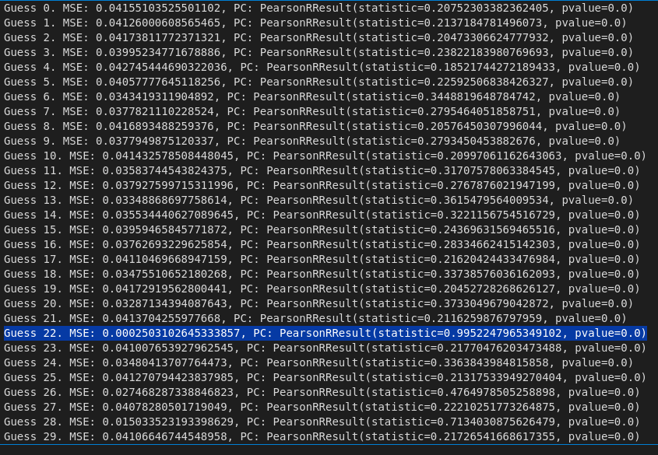
The figure shows mean squared error and pearson coeff for of the hypothesis trace against the target trace. In this experiment, we simply used an exhaustive search for the key out of the key space. It should be possible to do the same for a 16-bit FFT, it will take more time.
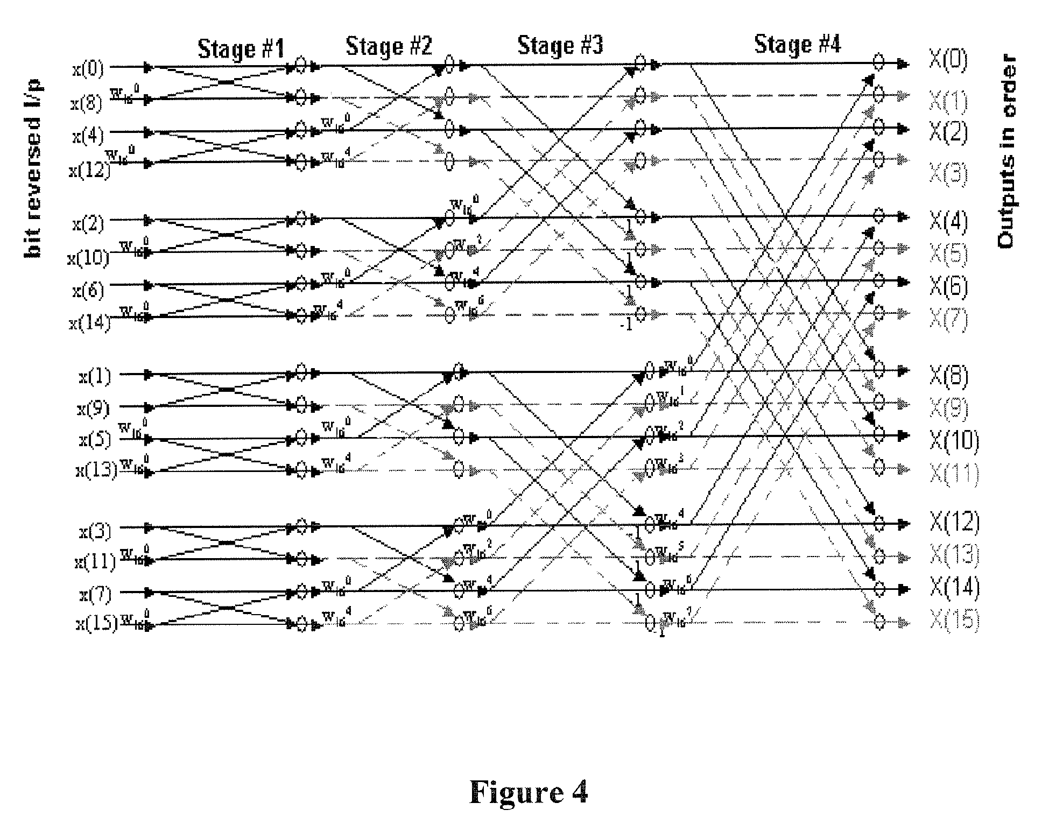
My aim of the work is to get a scalable method for large FFT sizes to allow key recovery. One way to do this would be to use the butterfly stucture of the FFT. That is, for the first 8 bits processed by the FFT, look only at the traces corresponding to them (operations in red box). This should be possible if we know the FFT butterfly loop code and assume no random ordering. CW segmented feature may work with this, but need to figure it out first.
If the first 8 bits can be recovered looking only at their corresponding traces, repeating for the next 8 bits and so on until the full key is found is the method. I am concerned that power consumption from operations outside of the red box would have an impact upon the power consumption of the traces within. If the leakage is from the x register hamming weight, then this may be the case.
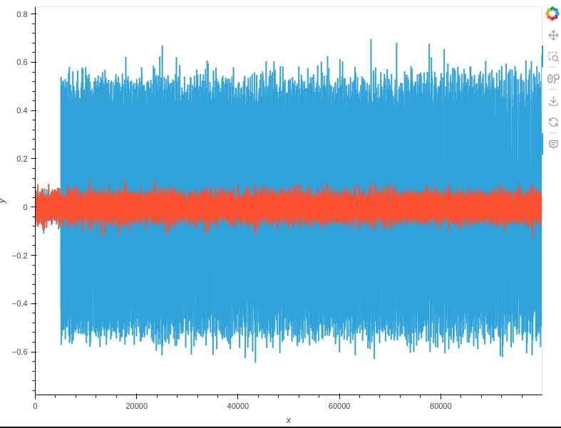
Figure shows power difference between target trace and two key guesses. Red is correct guess, blue is incorrect.

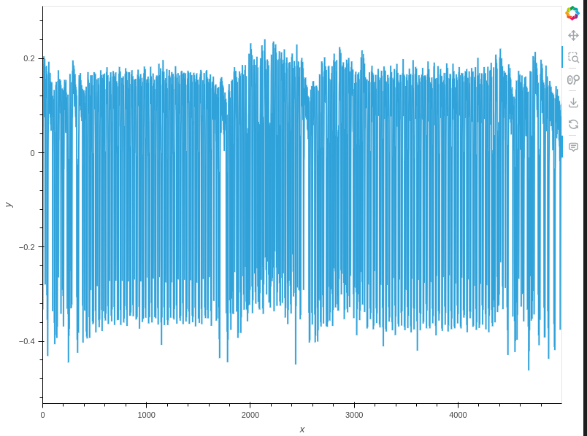

The power trace above shows the power consumption for the listed firmware code for the butterfly operation. Inside the red box shows the actual butterfly operation, while the two surrounding regions correspond to “NOP” power consumptions. The target board is known to produce this result in the case of NOP. We will hence use a sample length of 1600 samples per segment
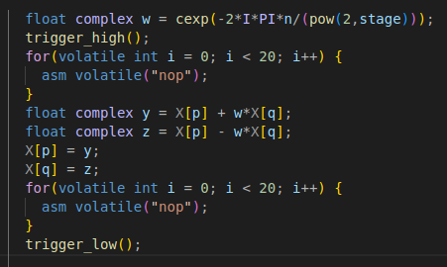

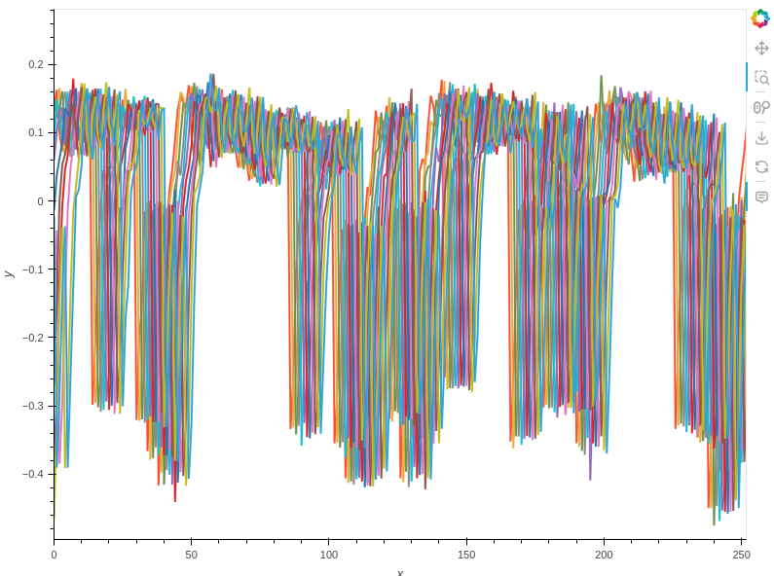
The segmented mode has seemingly introduced a syncronisation error. Next step is to fix this as outlined in the turorials.

After resyncronisation.
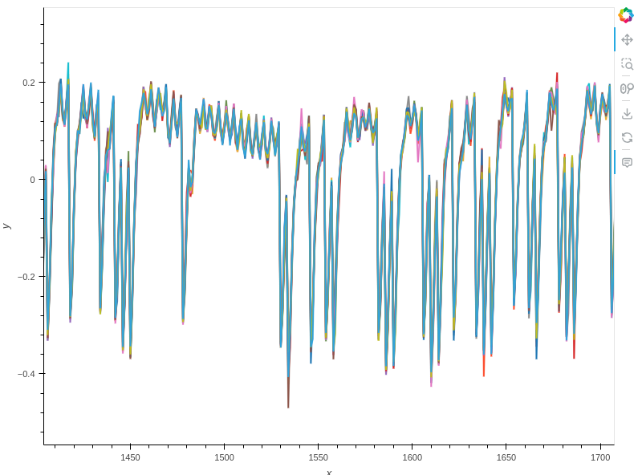
Going to attempt the brute force test again, using concatenated segments only. Will attempt with segmented segements after. Does still work. However, with samples of size 1600 results were much less convincing than for longer trace of 3000, this is counter to what I thought would happen. I thought after ~1600 we were only looking at random power post operation. Maybe multiplications with w != 1 are causing longer samples.
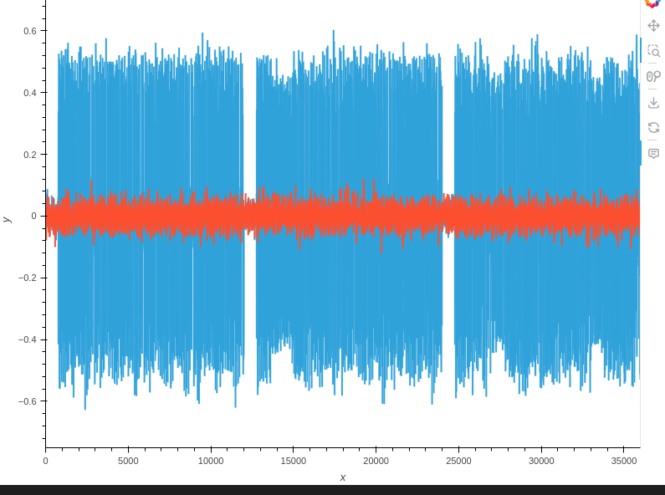
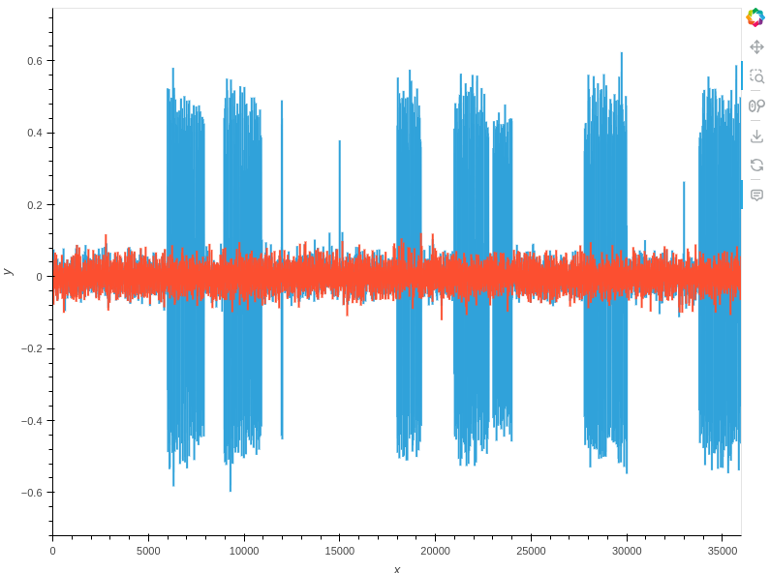

Left trace shows difference between target trace and incorrect dissimilar result in blue and correct result in red. Right trace shows incorrect next most similar guess in blue and correct guess in red.

Wednesday 5th March
Meeting with Mia was okay. She had the thought that this work had likely been done already and to consult Ayesha about it. She was confused about my how my attack works, explanation was probably not up to scratch. Plan to look at the AES attack book and get a solid basis for my attack and my wording.

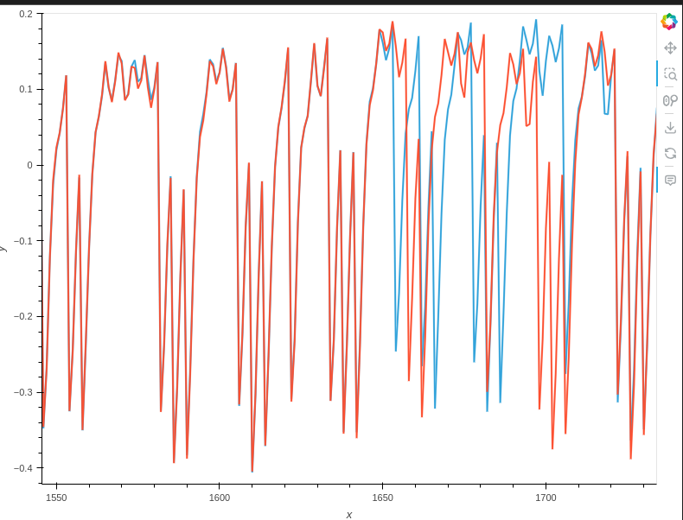
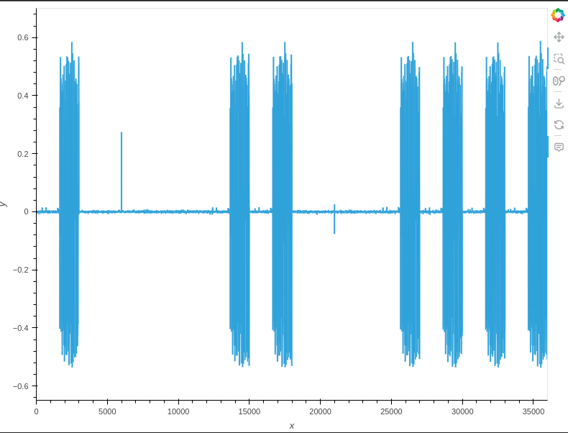

Plot showing the difference in the average power traces (left) and overlayed average power traces (right) for input 00000 (red) and 10000 (blue) for 100 samples of each. The spikes in the left show a difference in power trace corresponding to the 1st, 5th, 6th, 9th-12th butterfly operations. This is consistent with where operations differ

