We plan to build a GUI version of Monopoly where you have to solve problems and play mini-games in certain scenarios, like going to jail for example. Our graphics will resemble a monopoly board. Instead of the usual properties, there will be intellectual property and data structures to buy.

The user will start the game by having each player choose a game piece. The state will be autosaved to a file and the user will be able to restore their games on launch. The computer will have its own banker so that someone does not need to take that role. It will be a turn-by turn based game where a die appears at the beginning of every turn and the user can click it to roll it and move the number of squares on the die.

We will have a Property class and a one dimensional array of properties, an ArrayList of players, and an integer in the Player class for their position on the board. We will put everything in panels on a JFrame. The first JPanel will be the game board itself, updating with data from the Property classes. The next panel will include all of the property cards and buttons. We will use Math.random() every turn to roll a die for the user.

This screen will be displayed when the user opens the game.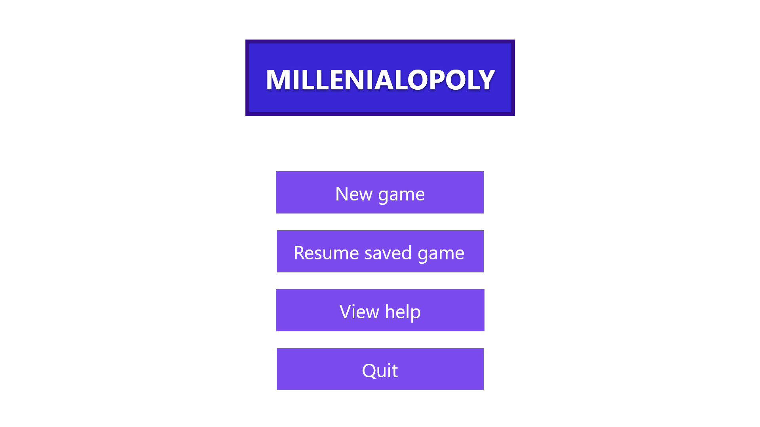The following screen will be shown when the user intends to start a game. They will be able to choose a game piece to represent them. They will also be able to name their game.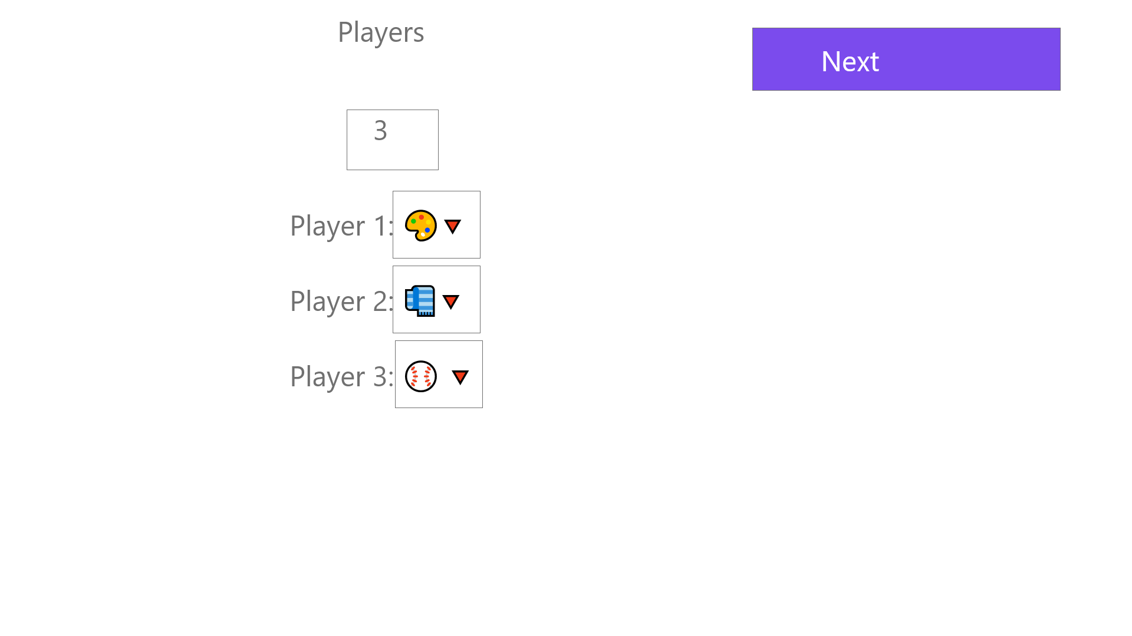

The following screen will be shown when the user is in the middle of playing the game. The die will roll at the beginning of the user’s turn and it will move them to the spot that they reached. If they land on a spot which requires them to pick up a card, the appropriate deck will appear and the user will be able to click on it to choose a random card. If the user clicks on the properties you own deck, it will take the user to a separate screen which shows all of their property cards laid out.