A Blockchain-Based Chain of Custody System for Digital Forensics
Ashish Nadadur Chakravarthi  anadadur@asu.edu  SCAI, Arizona State University  Tempe, Arizona, USA | Kruthi Tirunagari  ktirunag@asu.edu  SCAI, Arizona State University  Tempe, Arizona, USA |  | Sree Sai Harshitha Nanjyala  snanjyal@asu.edu  SCAI, Arizona State University  Tempe, Arizona, USA
Sri Sai Chetana Reddy Janagan  sjanagan@asu.edu  SCAI, Arizona State University  Tempe, Arizona, USA | Shashank Gadipally  sgadipal@asu.edu  SCAI, Arizona State University  Tempe, Arizona, USA
Abstract—Maintaining evidence integrity is critical to digital forensics and criminal investigations. Existing evidence management systems rely on centralized databases and manual logging processes that are vulnerable to tampering, unauthorized access, and errors in the chain of custody (CoC). This paper presents Forensic Chainguard, a blockchain-based forensic evidence integrity system that preserves authenticity, transparency, and accountability across the entire evidence lifecycle. Built on Hyperledger Fabric, the system immutably records evidence creation, check-in, transfer, and removal events on a distributed ledger. Evidence images are stored off-chain, while cryptographic hashes are stored on-chain to detect tampering. Role-based access control is enforced by smart contracts, preventing unauthorized operations and ensuring that actions align with forensic workflows. Experimental testing demonstrates successful end-to-end evidence management with real-time tamper detection and verifiable chain-of-custody events.  Keywords— Blockchain, Hyperledger Fabric, Digital Forensics, Chain of Custody, Evidence Integrity, Smart Contracts, Role-Based Access Control, Tamper Detection, Distributed Ledger Technology, Forensic Evidence Management.  Introduction  Digital evidence is an essential component of modern criminal investigations, civil litigation, and cybersecurity incident response. Traditional evidence management relies heavily on paper documentation, manual handoffs, and centralized storage systems. These approaches create weak points that can undermine the admissibility of evidence in court. Lost logs, unauthorized modifications, and ambiguous handling histories can cast doubt on an entire investigation.  Blockchain technology offers an attractive solution due to its immutability, distributed trust model, and cryptographic guarantees. Instead of relying on a central authority, blockchain's decentralized ledger provides a tamper-proof |  | record of all interactions with evidence. When combined with smart contracts, blockchain enables automated enforcement of workflows such as evidence creation, check-in, transfer, and removal.  In this work, we present Forensic Chainguard, a permissioned blockchain system using Hyperledger Fabric to secure evidence metadata and lifecycle events. Our system integrates a web frontend, a Node.js backend, and custom chaincode. The design provides verifiable integrity for evidence files, authenticated access based on forensic roles, and traceable chain-of-custody updates.  - Literature Review  Several studies highlight the limitations of centralized forensic evidence management:  - Paper-based and centralized digital systems are prone to human error, unauthorized modification, and accidental deletion. Traditional CoC logs often lack cryptographic safeguards [1].  - Chain-of-custody disputes in legal cases frequently arise due to incomplete or inconsistent tracking records [2].  - Blockchain-based forensic frameworks have been proposed, such as using Ethereum for timestamping or IPFS for distributed storage; however, public blockchains introduce privacy and cost concerns [3].  - Permissioned blockchains like Hyperledger Fabric provide fine-grained access control, low latency, pluggable membership services, and modular consensus, making them suitable for forensic applications [4].  Compared to these works, our system implements event-based lifecycle management, role-validated smart contracts, and cryptographic image integrity verification of verification, providing a practical, end-to-end forensic workflow.

Architecture

System Components
The system consists of three main layers:
1. Frontend (HTML/JavaScript UI): Users submit evidence, view metadata, verify integrity, and trigger lifecycle actions.
2. Backend (Node.js + Fabric SDK):
- Handles API requests
- Computes SHA-256 hashes of evidence images
- Stores images locally
- Interacts with the blockchain network
3. Blockchain Network (Hyperledger Fabric)
- Two organizations (Org1 and Org2)
- Channel: forensic-chainguard
- Chaincode: chainguard
- Stores evidence records and lifecycle events. Please do not revise any of the current designations.

Data Storage Model
- On-chain data:
  - Evidence metadata
  - Role and user performing the action
  - Hash of evidence image
  - Lifecycle events

- Off-chain data:
  - Actual evidence images stored in the backend server filesystem

This hybrid approach balances immutability with storage efficiency.

Identity and Membership

The network uses Fabric's cryptogen tool to generate static MSP identities for Org1 and Org2.
User1@Org1 is used as the application identity.

Roles such as Forensic Technician, Evidence Manager, and Viewer are not part of the certificate; instead, they are enforced through smart contract logic, a typical pattern in prototype systems.

Implementation Details

Smart Contract Logic

The chaincode defines:
- Evidence structure (evidenceId, caseIdHash, imageHash, imageFilename, timestamps, role, custodian)
- Lifecycle events (Created, Checked-In, Transferred, Removed)
- Event emission via composite keys
- On-chain role validation
A new evidence ID can only be created once; subsequent interactions use lifecycle actions.

Stakeholder Interactions

Stakeholder | Actions
Forensic Technician | Create, Check-In evidence
Evidence Manager | All actions including Transfer and Remove
Viewer/Analyst | Read-only queries

These interactions reflect typical forensic workflows.

Transactions / Events
- CreateEvidence → initializes evidence record
- CheckInEvidence → updates custodian and logs event
- TransferEvidence → enforces manager role
- RemoveEvidence → marks evidence as removed
- GetEvidenceEvents → fetches CoC timeline

Immutability
Fabric ensures:
- Append-only ledger
- No retroactive modification of past blocks
- Cryptographic verification via signatures and endorsements

Storage
- Images stored in the backend uploads/ directory
- On-chain SHA-256 hash ensures integrity verification.
- Smart contract stores metadata only

CLI/Interface
Fabric CLI allows:
- Invoking chaincode
- Querying evidence
- Viewing state history
The UI provides a user-friendly interface for demo purposes.

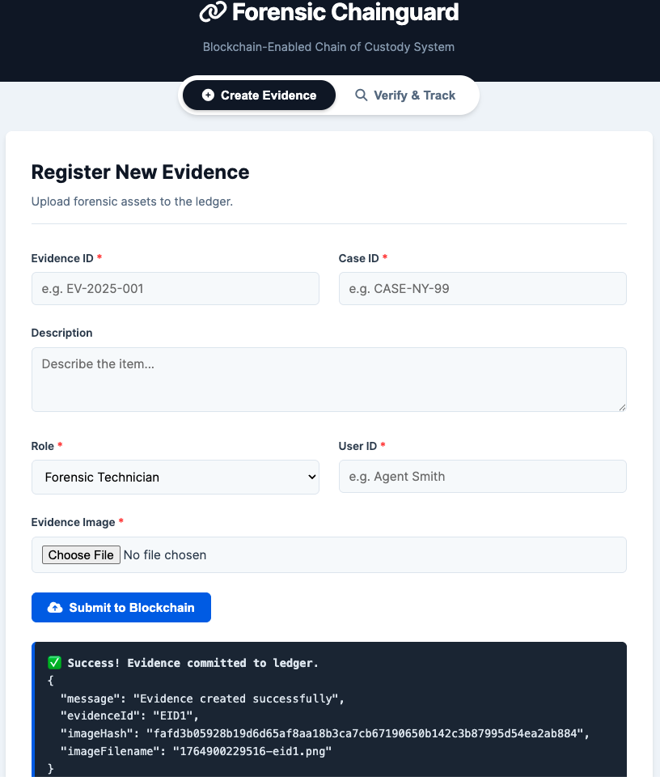
Fig. 1. Evidence Creation in Ledger

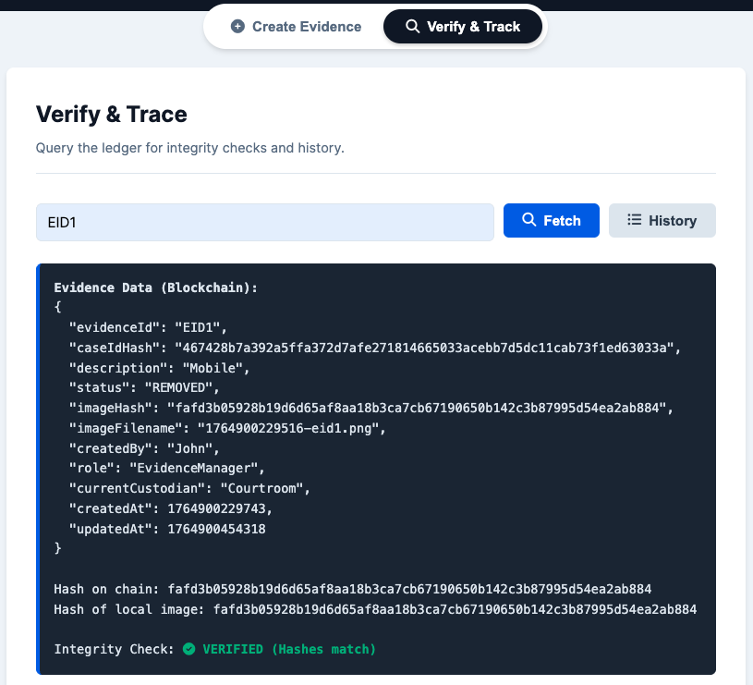
Fig. 2. Verification of Transaction and Integrity (Non-tampered evidence)

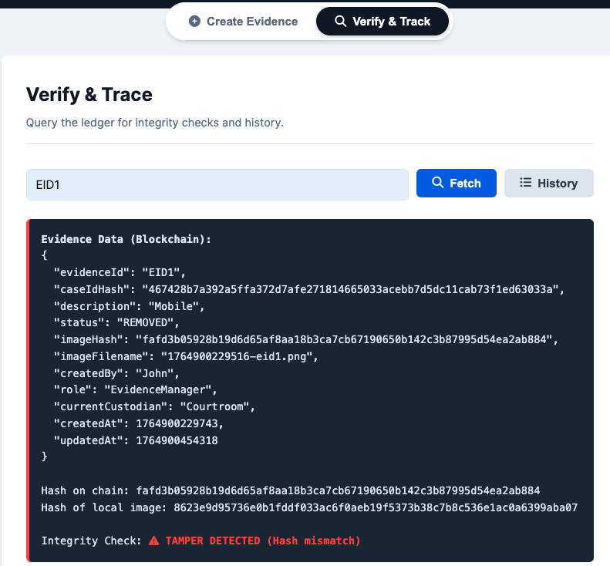
Fig. 3. Verification of Transaction and Integrity (Tampered evidence)

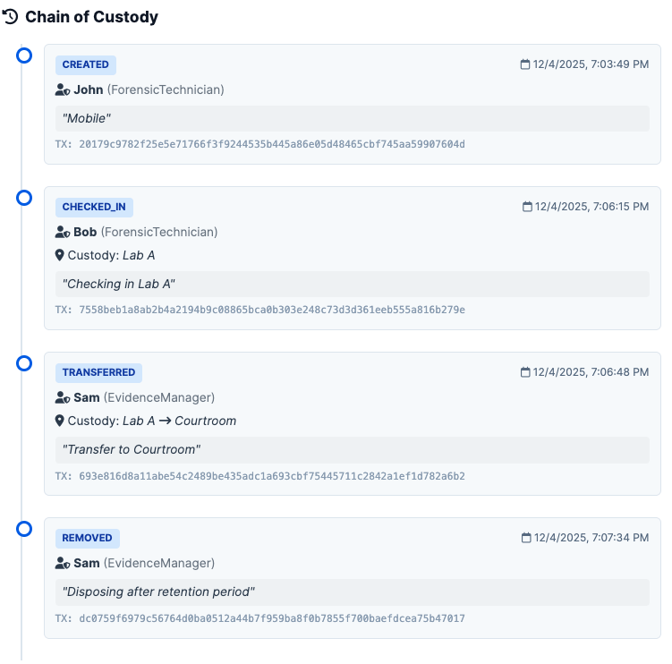
Fig. 4. Chain of custody of evidence

Results

Functional Outcomes
- Successful creation of evidence with metadata and stored image hash

- Real-time tamper detection when the stored file is modified

- Accurate and chronological event timeline

- Enforcement of role-based permissions

- Robust traceability across lifecycle operations

Performance
- Event retrieval is fast due to efficient composite key scans
- Hash computation is negligible relative to network latency.

Demo Scenarios

Create evidence with an authenticated role
- View evidence + integrity verification

Replace image -> system detects tampering

Add lifecycle actions

View complete chain-of-custody timeline

Analysis

Scalability
Hyperledger Fabric supports horizontal scaling by adding peers and orderers.
However:
- Huge image files remain impractical on-chain
- Off-chain storage may need distributed solutions (IPFS, cloud buckets)

Data Management
- On-chain data provides auditability
- Off-chain data allows for storing large files efficiently
- Integrity link via hash ensures both layers remain synchronized

Privacy
Fabric channels provide data isolation between organizations.
Only members of the forensic-chainguard channel can access evidence.

Regulatory Implications
Blockchain-backed evidence management can strengthen:
- Court admissibility
- Digital chain-of-custody compliance (NIJ/NIST standards)
- Auditing for law enforcement agencies

Comparison to Traditional Systems

Feature | Traditional | Blockchain-based
Tamper Detection | None / weak | Cryptographically guaranteed
Transparency | Limited | Fully traceable
Auditability | Manual | Automated, immutable
Custody Tracking | Often ambiguous | Event-based, verifiable
Single Point of Failure | Yes | No

Future Work
- Integrate Fabric CA to issue identities with embedded role attributes.
- Support multi-factor authentication for sensitive actions.
- Encrypt off-chain files or store them in IPFS / cloud storage
- Add automated alerting for suspicious activity.
- Implement organization-specific access policies.
- Support mobile capture applications for field technicians

Contributions
Member | Contribution
Kruthi Tirunagari | Blockchain & Security Specialist
Ashish Nadadur Chakravarthi | Blockchain & Smart Contract Developer
Shashank Gadipally | System Admin
Sree Sai Harshitha Nanjyala | Frontend & Smart Contract Developer
Sri Sai Chetana Reddy Janagan | Testing & Validation

References

[1] National Institute of Justice, “Digital Evidence: Standards and Best Practices,” NIJ, 2020.
[2] Casey, E., “Digital Evidence and Computer Crime,” Academic Press, 2019.
[3] Liang, X. et al., “A Blockchain-Based Framework for Data Sharing With Fine-Grained Access Control,” IEEE IoT Journal, 2017.
[4] Hyperledger Fabric Documentation, “Core Concepts,” Linux Foundation, 2023.
[5] Yli-Huumo, J. et al., “Where is current research on blockchain technology?—A systematic review,” IEEE Access, 2016.

