LS Vision User guide.

LS Vision was built on top of the Vega-Lite grammar / syntax. It uses an Angular directive as an interface with Vega-Lite and chart creation. It simplifies the Vega-Lite grammar. Below shows the input parameters of this directive.

    // Vega-Lite configuration of chart.

// Either this or lsConfig need to be used

    @Input() config: Coordinate;

    // Configuration with LS-Chart syntax.

// Either this or @config need to be used

    @Input() lsConfig: LsConfig;

    // Vega defined theme

    @Input() theme;

    // Object to be used as data

    @Input() data;

    // Predefined chart type

    @Input() chartType: string;

Example usage of the directive

<div visionChart [lsConfig]="bar" [data]="barData" [chartType]="'simpleBar'"></div>

To render your chart, you define your chart configuration (for plain Vega-Lite configurations use config parameter, for LS-Vision simplified grammar use lsConfig), define your chart type, and define your data. Default Vega-Lite chart types work out of the box with minimal configuration and can be specified with the chartType property. The possible chart types:

|  |  |  |
| --- | --- | --- |
| stackedBar | simpleBar | horizontalBar |
| groupedBar | Areachart | Donut |
| Pie | pieLabels | lineChart |
| multiseriesLine | Scatterplot | scatterplotColored |
| Histogram | Heatmap | Stream |
| box |  |  |

Examples of each of these charts appear later in the document.

Below is an example of a Vega Lite configuration for a grouped bar chart.

export const oldGroupedBar = {

  $schema: 'https://vega.github.io/schema/vega-lite/v4.json',

  transform: [

    {

      filter: 'datum.year == 2000'

    },

    {

      calculate: 'datum.sex == 2 ? \'Female\' : \'Male\'',

      as: 'gender'

    }

  ],

  width: {

    step: 12

  },

  mark: 'bar',

  encoding: {

    column: {

      field: 'age',

      type: 'ordinal',

      spacing: 10

    },

    y: {

      aggregate: 'sum',

      field: 'people',

      title: 'population',

      axis: {

        grid: false

      }

    },

    x: {

      field: 'gender',

      axis: {

        title: ''

      }

    },

    color: {

      field: 'gender',

      scale: {

        range: [

          '#675193',

          '#ca8861'

        ]

Below is the configuration of an LS-Vision chart configuration

export const groupedbar: LsConfig = {

    column: {

        field: 'age',

    },

    y: {

        field: 'people',

        title: 'population',

    },

    x: {

        field: 'sex',

        title: '',

    },

    color: {

        field: 'sex',

        range: ['#675193', '#ca8861'],

    },

};

In the LS-Vision configuration the x and y axes map to LsAxis objects that have properties to configure features and behavior relating to the axes. Above, the “field” property refers to the attribute for objects in the json data array to pull from and map onto the chart. The “title” property refers to the text written for the title of each axis. Note: these axes have been moved from the Vega-Lite encoding object to the root configuration object to simplify object nesting.

The color object specifies which field to use for coloring. It treats each unique value in this field as a group and creates a color for each. In the data, the “sex” field shown has two values which are mapped to colors. The “range” attribute of the color object allows us to specify the two colors that the values will be mapped to. As a note this object has also been simplified and moved from the encoding object in the root configuration object for simplification.

As a note, the transform object in LS-Vision is not allowed as all data transformations must be performed on the data outside the directive.

**Chart Configuration for LS-Charts**

export interface LsConfig {

    // Y Axis

    x?: LsAxis;

    // X Axis

    y?: LsAxis;

    // Grouping by color

    color?: LsColor;

    // Bar chart color

    fill?: string;

    // For line chart points

    point?: Point;

    // For scatterplot point shapes

    shape?: Field;

    // For grouped columns

    column?: Column;

    // Bubble chart

    size?: Field;

    // For circular plots

    circular?: CircularPlots;

    height?: number;

    width?: number;

    title?: string;

    description?: string;

    // Multiplier for text size

    textSizeMult?: number;

}

**LS-Axis for x / y axes**

export interface LsAxis  {

    // Name of the property on the json object data to pull values and plot

    field: string;

    // Number of bins, if not provided, skip binning

    bins?: number | boolean;

    // If false hide the grid marks on the chart

    grid?: boolean;

    // For time plots, this will plot by year, yearmonth, etc

    timeUnit?: string;

    // Title of the axis

    title?: string;

    // Formats the title (useful for time),`datum.value` or %Y

    titleFormat?: string;

    // If you want to change the type

    type?: string;

}

export interface Column {

    field: string;

    // Space between groups. TODO: implement this

    spacing?: number;

}

export interface LsColor {

    field: string;

    // Ordered list of colors to map

    range?: string[];

    // Ordered list of values to map to colors

    domain?: string[];

    // Title for the legend, if value is null, don't show legend

    legend?: string;

}

export interface Field {

    field: string;

}

export interface CircularPlots {

    innerRadius?: number;

    outerRadius?: number;

    textRadius?: number;

    // Field for specifying text labels

    text?: string;

    theta: string;

}

export interface Point {

    filled?: boolean;

    fill?: string;

}

Bar Chart

Directive Usage

<div visionChart [lsConfig]="bar" [data]="barData" [chartType]="'simpleBar'"></div>

Configuration object “bar”

{

    "height": "200",

    "width": "200",

    "title": "My Bar Graph",

    "description": "This is a bar chart",

    "x": {"field": "a", "title": "My Property A"},

    "y": {"field": "c", "title": "My Attribute C"}

  }

Data object barData

 {

    "values": [

      {"a": "A", "c": 28}, {"a": "B", "c": 55}, {"a": "C", "c": 43},

      {"a": "D", "c": 91}, {"a": "E", "c": 81}, {"a": "F", "c": 53},

      {"a": "G", "c": 19}, {"a": "H", "c": 87}, {"a": "I", "c": 52}

    ]

  }

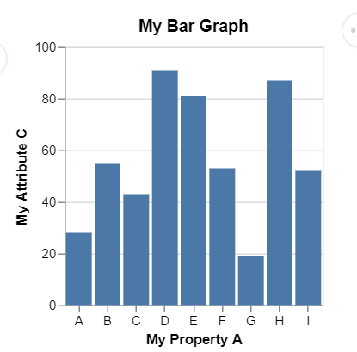

Above is a simple bar graph that defines a height, width, title, and x / y axes for the chart. The default of the x axis is grouped by values in property “a”. By default this axis is “ordinal” in that even if numbers are provided here, they will be treated like a category rather than numerical values.

Line Chart (Without X Grid lines)

Directive Usage

<div visionChart [lsConfig]="line" [data]="lineData" [chartType]="'lineChart'"></div>

Configuration object “line”

{

  "title": "test",

  "description": "Google's stock price over time.",

  "x": {"field": "date", "grid": false},

  "y": {"field": "price"},

  "textSizeMult": 1.3

}

Sample Data “lineData”

 [

    { "symbol": "AAPL", "date": "Jan 1 2000", "price": 39.81 },

    { "symbol": "AAPL", "date": "Feb 1 2000", "price": 36.35 },

    ...

    { "symbol": "AAPL", "date": "Jan 1 2010", "price": 192.06 },

    { "symbol": "AAPL", "date": "Feb 1 2010", "price": 204.62 },

    { "symbol": "AAPL", "date": "Mar 1 2010", "price": 223.02 }

  ]

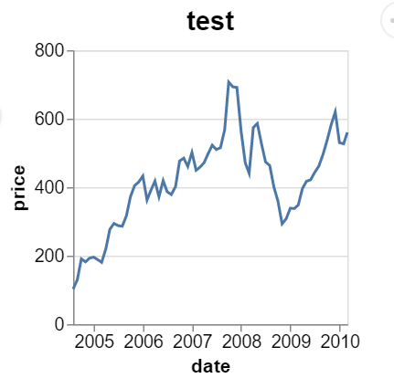

Above is a simple line chart. The x axis defaults to type “temporal”. Here the “date” field is read in, processed as a date, and graphed by year. If you want a numerical value or “quantitative” type you can override this value by providing the “type” attribute on the axis. Once the type is “quantitative” the values graphed will be processed as numbers. In addition “textSizeMult” is a multiplier that sets text size.

Pie Chart (Text Size Multiplier)

Directive Usage

<div visionChart [lsConfig]="pie" [data]="pieData" [chartType]="'pie'"></div>

Configuration object “pie”

{

  "width": 275,

  "description": "A simple pie chart with embedded data.",

  "circular": {

    "outerRadius": 150,

    "theta": "value"

  },

  "color": {"field": "category", "legend": "my legend"},

  "textSizeMult": 1

  }

Data object “pieData”

[

   {"category": 1, "value": 4},

   {"category": 2, "value": 6},

   {"category": 3, "value": 10},

   {"category": 4, "value": 3},

   {"category": 5, "value": 7},

   {"category": 6, "value": 8}

]

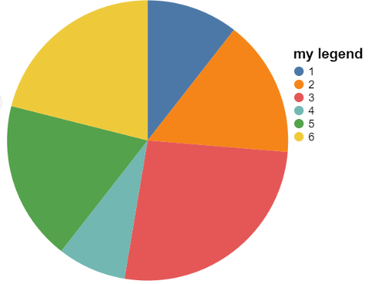

The above pie chart defines a circular chart by using the “circular” object. The property “outterRadius” defines the radius of the pie chart, “theta” represents the filed defining the pie wedges, and on the “color” object, the “legend” property defines the title for the lengnd for the pie wedges.

Scatterplot

Directive Usage

<div visionChart [lsConfig]="scatter" [data]="scatterData" [chartType]="'scatterplot'"></div>

Configuration object “scatter”

{

  "x": {"field": "Horsepower"},

  "y": {"field": "Miles_per_Gallon"}

}

Data object “scatterData”

[

   {

      "Name":"chevrolet chevelle malibu",

      "Miles_per_Gallon":18,

      "Cylinders":8,

      "Displacement":307,

      "Horsepower":130,

      "Weight_in_lbs":3504,

      "Acceleration":12,

      "Year":"1970-01-01",

      "Origin":"USA"

   },

…

]

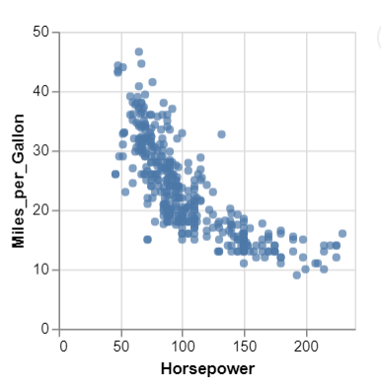

Above is a simple scatterplot with x / y axes defined. These axes are defaulted to the “quantitative” type and is processed as numbers.

Histogram

Directive Usage

<div visionChart [lsConfig]="histogram" [data]="histogramData" [chartType]="'histogram'"></div

Configuration object “histogram”

{

  "x": {

    "bins": "20",

    "field": "IMDB_Rating"

  }

}

Data object “histogramData”

[{"Title":"The Land Girls","US_Gross":146083,"Worldwide_Gross":146083,"US_DVD_Sales":null,"Production_Budget":8000000,"Release_Date":"Jun 12 1998","MPAA_Rating":"R","Running_Time_min":null,"Distributor":"Gramercy","Source":null,"Major_Genre":null,"Creative_Type":null,"Director":null,"Rotten_Tomatoes_Rating":null,

"IMDB_Rating":6.1,"IMDB_Votes":1071}

…

]

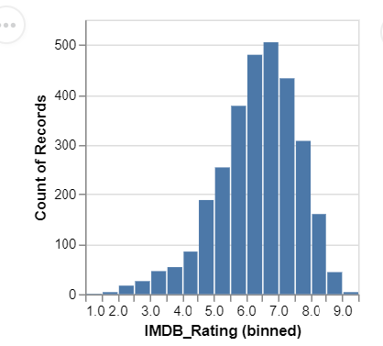

For histograms, the user need only define a single axis for binning. The number of bins is provided by the axis’ “bins” property and the

Horizontal Bar with Red Fill (you can do it through the more advanced type property)

<div visionChart [lsConfig]="horizontal" [data]="barData" [chartType]="'horizontalBar'"></div>

Configuration object “horizontal”

{

    "height": "200",

    "width": "200",

    "title": "My Bar Graph",

    "fill": "red",

    "y": {"field": "a", "title": "My Property A"},

    "x": {"field": "c", "title": "My Attribute C"}

  }

Data object barData

 {

    "values": [

      {"a": "A", "c": 28}, {"a": "B", "c": 55}, {"a": "C", "c": 43},

      {"a": "D", "c": 91}, {"a": "E", "c": 81}, {"a": "F", "c": 53},

      {"a": "G", "c": 19}, {"a": "H", "c": 87}, {"a": "I", "c": 52}

    ]

  }

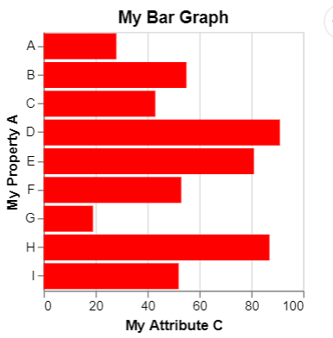

This horizontal bar chart defaults the x axis as “quantitative” and to be processed as numbers. The y axis is expected to be a group and is defaulted to “ordinal”. Also, the “fill” attribute is depicted here which changes the color of all of the bars to red.

Stacked Bar Chart (Aggregates, might want to construct a different datasource that doesn’t aggregate)

<div visionChart [lsConfig]="stacked" [data]="stackedData" [chartType]="'stackedBar'"></div>

{

  "x": {

    "timeUnit": "month",

    "field": "date",

    "title": "Month of the year"

  },

  "color": {

    "field": "weather",

    "domain": ["sun", "fog", "drizzle", "rain", "snow"],

    "range": ["#e7ba52", "#c7c7c7", "#aec7e8", "#1f77b4", "#9467bd"],

    "legend": "Weather typesdf"

  }

}

[

    {

      "date": "2012-01-01",

      "precipitation": 0,

      "temp_max": 12.8,

      "temp_min": 5,

      "wind": 4.7,

      "weather": "drizzle"

    },

...

}

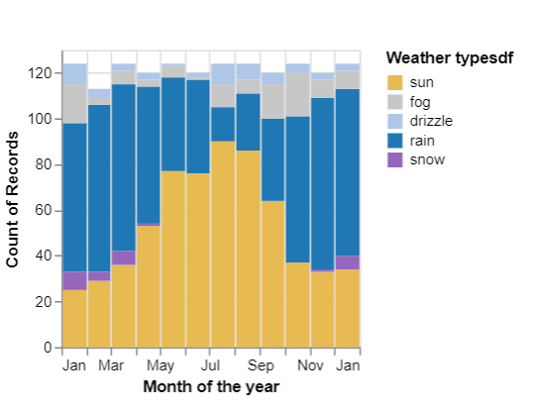

The above chart depicts a stacked bar graph. This graph has a number of important defaults. Note that there is no explicit y axis. This is because it is defaulted to an aggregate of ‘count’ in Vega Lite terms. This means the y axis is counted by aggregating values. In addition the timeUnit is set to “month”. This means that it separates the time line by month. Then it aggregates all of the different types on “weather”, which defined in the color object, counts the records for the individual months, then colors the stacks based on the weather type. It is important to note here that the use of domain in the color object here denotes the values of weather to be mapped to colors. These items match up in order with the “range” attribute which lists the colors that the values map to.

Grouped Bar

<div visionChart [lsConfig]="groupedBar" [data]="groupedData" [chartType]="'groupedBar'"></div>

{

      "column": {

        "field": "age"

      },

      "y": {

         "field": "people",

        "title": "population"

      },

      "x": {

        "field": "sex",

        "title": ""

      },

      "color": {

        "field": "sex",

        "range": ["#675193", "#ca8861"]

      }

  }

[

{"year":1850,"age":0,"sex":1,"people":1483789},

{"year":1850,"age":0,"sex":2,"people":1450376},

{"year":1850,"age":5,"sex":1,"people":1411067},

{"year":1850,"age":5,"sex":2,"people":1359668}

...

]

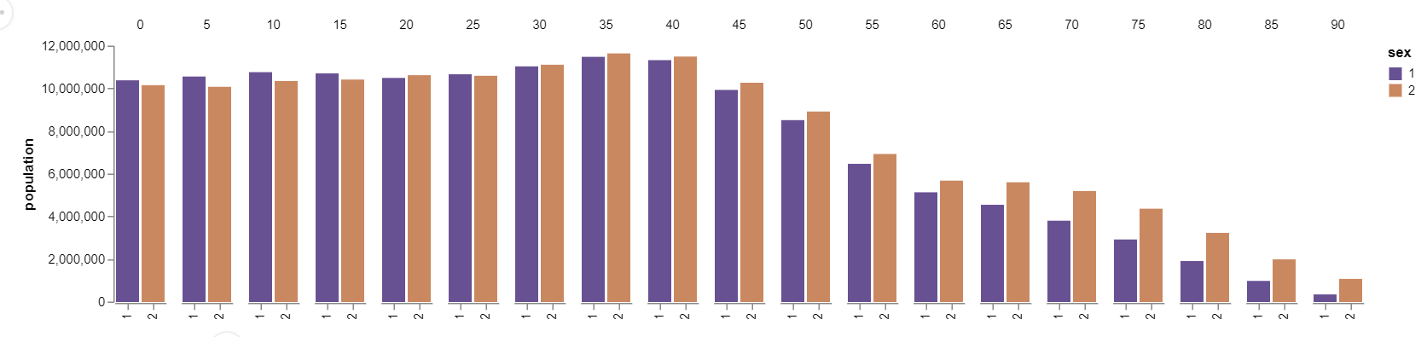

The above grouped bar chart shows

Area Chart Time

<div visionChart [lsConfig]="area" [data]="areaData" [chartType]="'areachart'"></div>

{

  "x": {

    "field": "date", "timeUnit": "yearmonth"

  },

  "y": {

    "field": "count",

    "title": "total count"

  }

}

[

    {

        "series": "Government",

        "year": 2000,

        "month": 1,

        "count": 430,

        "rate": 2.1,

        "date": "2000-01-01T08:00:00.000Z"

    },

...

]

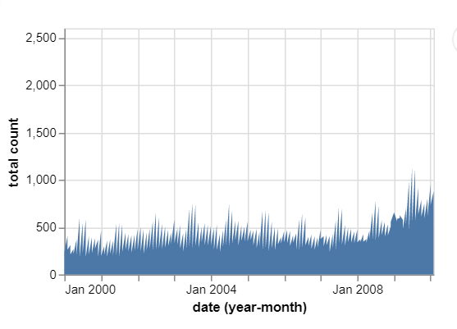

Above depicts an area chart. The x axis is defaulted to “temporal” in Vega-Lite terms. The field “date” is processed as a date, and the “timeUnit” is set to “yearmonth” so the date labels along the x axis show month and year.

Area Number

<div visionChart [lsConfig]="areaNumber" [data]="areaData" [chartType]="'areachart'"></div>

{

  "x": {

    "field": "count", "type": "quantitative", "title": "test for numbers"

  },

  "y": {

    "field": "count",

    "title": "total count"

  }

}

[

    {

        "series": "Government",

        "year": 2000,

        "month": 1,

        "count": 430,

        "rate": 2.1,

        "date": "2000-01-01T08:00:00.000Z"

    },

...

]

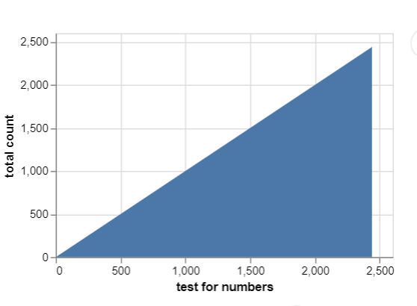

Above is an area chart that has both axes as numerical, or “quantitative” values. The y axis defaults to quantitative where, as specified by the previous chart, the x axis is defaulted to temporal. In order to change the x axis to “quantitative” the type must be specified.

Pie Chart with labels (Text radius)

<div visionChart [lsConfig]="pieLabels" [data]="donutData" [chartType]="'pieLabels'"></div>

{

  "description": "A simple pie chart with labels.",

  "circular": {

    "outerRadius": 80,

    "textRadius": 90,

    "text": "category",

    "theta": "value"

  },

  "color": {"field": "category", "type": "nominal"},

  "textSizeMult": 1.2

}

[

      {"category": 1, "value": 4},

      {"category": 2, "value": 6},

      {"category": 3, "value": 10},

      {"category": 4, "value": 3},

      {"category": 5, "value": 7},

      {"category": 6, "value": 8}

    ]

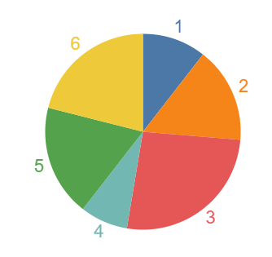

The above is a pie chart with labels for each pie wedge. The pure Vega-Lite configuration that produces this chart is rather complicated. Here, you need only provide an “outerRadius” for the pie chart and a “textRadius” to define how far the text will be from the center. Then define the json attribute for the label text and the property that defines the angle for each wedge, “theta”.

Donut (Inner Radius)

<div visionChart [lsConfig]="donut" [data]="donutData" [chartType]="'donut'"></div>

{

  "description": "A simple donut chart with embedded data.",

  "circular": {

“outerRadius": 150,

    "innerRadius": 50,

    "theta": "value"

  },

  "color": {"field": "category"}

}

[

      {"category": 1, "value": 4},

      {"category": 2, "value": 6},

      {"category": 3, "value": 10},

      {"category": 4, "value": 3},

      {"category": 5, "value": 7},

      {"category": 6, "value": 8}

    ]

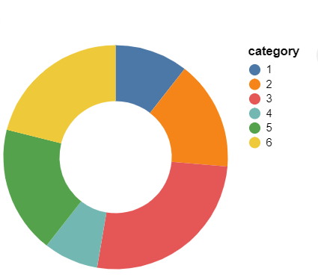

Here a donut chart is drawn. To create the donut hole, one must provide the “innerRadius” for the hole along with the outerRadius for the edge of the circle.

Line with points

<div visionChart [lsConfig]="linePoints" [data]="multiseriesData" [chartType]="'multiseriesLine'"></div>

{

  "description": "Stock prices of 5 Tech Companies over Time.",

  "x": {

    "timeUnit": "year",

    "field": "date"

  },

  "point": {

    "fill": "white",

    "filled": false

  },

  "y": { "field": "price"},

  "color": {"field": "symbol"}

  }

[

    {

      "symbol": "MSFT",

      "date": "Jan 1 2000",

      "price": 39.81

    },

    {

      "symbol": "MSFT",

      "date": "Feb 1 2000",

      "price": 36.35

    },

...

]

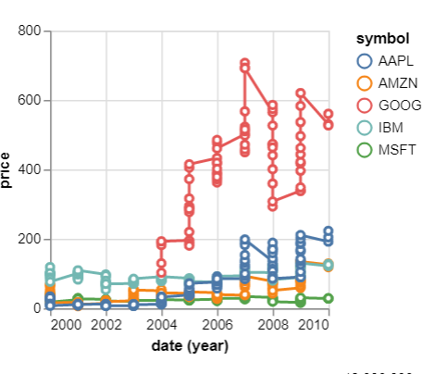

The line chart with points defines those points via the “point” object. The user must provide the “fill” color and if it is “filled”.

Multiseries

<div visionChart [lsConfig]="multiseries" [data]="multiseriesData" [chartType]="'multiseriesLine'"></div>

{

  "description": "Stock prices of 5 Tech Companies over Time.",

  "title": "Line Chart",

  "x": {"field": "date"},

  "y": {"field": "price"},

  "color": {"field": "symbol"}

}

[

    {

      "symbol": "MSFT",

      "date": "Jan 1 2000",

      "price": 39.81

    },

    {

      "symbol": "MSFT",

      "date": "Feb 1 2000",

      "price": 36.35

    },

...

]

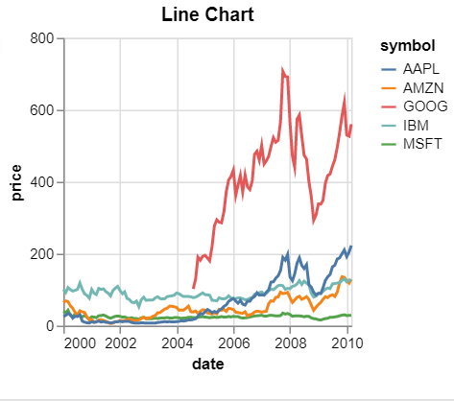

Scatter plot (Shapes and Colors)

<div visionChart [lsConfig]="scatterColor" [data]="scatterData" [chartType]="'scatterplotColored'"></div>

{

  "description": "A scatterplot showing horsepower and miles per gallons.",

  "x": {"field": "Horsepower"},

  "y": {"field": "Miles_per_Gallon"},

  "color": {"field": "Origin"},

  "shape": {"field": "Origin"}

}

[

   {

      "Name":"chevrolet chevelle malibu",

      "Miles_per_Gallon":18,

      "Cylinders":8,

      "Displacement":307,

      "Horsepower":130,

      "Weight_in_lbs":3504,

      "Acceleration":12,

      "Year":"1970-01-01",

      "Origin":"USA"

   },

...

]

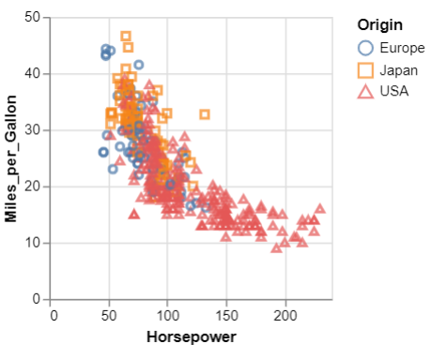

The scatterplot above makes use of the “shape” object. As like the color object, the shape object separates all of the values in the specified attribute into distinct groups. Above, the “Origin” attribute on all of the data has only three values. Those are each given a shape and plotted in the chart and shown in the legend.

Heatmap

<div visionChart [lsConfig]="heatmap" [data]="histogramData" [chartType]="'heatmap'"></div>

{

  "width": 300,

  "height": 200,

    "x": {

      "bins":60,

      "field": "IMDB_Rating"

    },

    "y": {

      "bins": 40,

      "field": "Rotten_Tomatoes_Rating"

    }

}

[{"Title":"The Land Girls","US_Gross":146083,"Worldwide_Gross":146083,"US_DVD_Sales":null,"Production_Budget":8000000,"Release_Date":"Jun 12 1998","MPAA_Rating":"R","Running_Time_min":null,"Distributor":"Gramercy","Source":null,"Major_Genre":null,"Creative_Type":null,"Director":null,"Rotten_Tomatoes_Rating":null,"IMDB_Rating":6.1,"IMDB_Votes":1071}

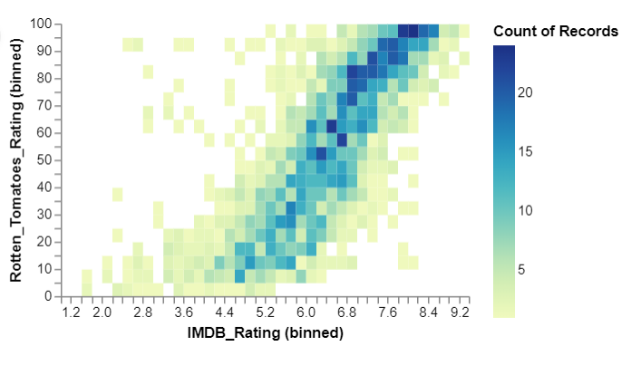

Above is a heatmap or a two dimensional histogram. As stated before, the bins attribute determines how many bins will be created along the axis. In a heatmap both axes have binning and the intensity of the color denotes how many fall in that bin.

<div visionChart [lsConfig]="stream" [data]="areaData" [chartType]="'stream'"></div>

{

  "x": {

    "field": "date", "timeUnit": "yearmonth"

  },

  "y": {

    "field": "count",

    "title": "total count"

  }

}

[

    {

        "series": "Government",

        "year": 2000,

        "month": 1,

        "count": 430,

        "rate": 2.1,

        "date": "2000-01-01T08:00:00.000Z"

    },

...

]

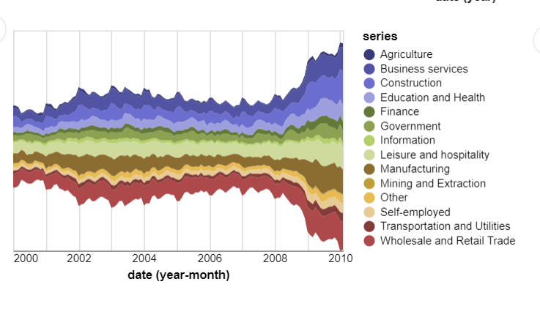

The graph drawn above is a stream graph. The x axis is defaulted to “temporal” and the y axis is defaulted to aggregate type “sum” in Vega Lite terms. It is also has the property “stack” set to “center” by default to center the different streams along the y axis. In addition it has a specific color scheme set by default.

<div visionChart [lsConfig]="box" [data]="groupedData" [chartType]="'box'"></div>

{

    "description": "A vertical 2D box plot showing median, min, and max in the US population distribution of age groups in 2000.",

      "x": {"field": "age"},

      "y": {

        "field": "people",

        "title": "population"

      }

  }

[

    {

        "series": "Government",

        "year": 2000,

        "month": 1,

        "count": 430,

        "rate": 2.1,

        "date": "2000-01-01T08:00:00.000Z"

    },

...

]

