export interface LsConfig {

    // Y Axis

    x?: LsAxis;

    // X Axis

    y?: LsAxis;

    // Grouping by color

    color?: LsColor;

    // Bar chart color

    fill?: string;

    // For line chart points

    point?: Point;

    // For scatterplot point shapes

    shape?: Field;

    // For grouped columns

    column?: Column;

    // Bubble chart

    size?: Field;

    // For circular plots

    circular?: CircularPlots;

    height?: number;

    width?: number;

    title?: string;

    description?: string;

    // Multiplier for text size

    textSizeMult?: number;

}

export interface LsAxis  {

    // Name of the property on the json object data to pull values and plot

    field: string;

    // Number of bins, if not provided, skip binning

    bins?: number | boolean;

    // If false hide the grid marks on the chart

    grid?: boolean;

    // For time plots, this will plot by year, yearmonth, etc

    timeUnit?: string;

    // Title of the axis

    title?: string;

    // Formats the title (useful for time),`datum.value` or %Y

    titleFormat?: string;

    // If you want to change the type

    type?: string;

}

export interface Column {

    field: string;

    // Space between groups. TODO: implement this

    spacing?: number;

}

export interface LsColor {

    field: string;

    // Ordered list of colors to map

    range?: string[];

    // Ordered list of values to map to colors

    domain?: string[];

    // Title for the legend, if value is null, don't show legend

    legend?: string;

}

export interface Field {

    field: string;

}

export interface CircularPlots {

    innerRadius?: number;

    outerRadius?: number;

    textRadius?: number;

    // Field for specifying text labels

    text?: string;

    theta: string;

}

export interface Point {

    filled?: boolean;

    fill?: string;

}

Bar Chart

Directive Usage

<div visionChart [lsConfig]="bar" [data]="barData" [chartType]="'simpleBar'"></div>

Configuration object “bar”

{

    "height": "200",

    "width": "200",

    "title": "My Bar Graph",

    "description": "This is a bar chart",

    "x": {"field": "a", "title": "My Property A"},

    "y": {"field": "c", "title": "My Attribute C"}

  }

Data object barData

 {

    "values": [

      {"a": "A", "c": 28}, {"a": "B", "c": 55}, {"a": "C", "c": 43},

      {"a": "D", "c": 91}, {"a": "E", "c": 81}, {"a": "F", "c": 53},

      {"a": "G", "c": 19}, {"a": "H", "c": 87}, {"a": "I", "c": 52}

    ]

  }

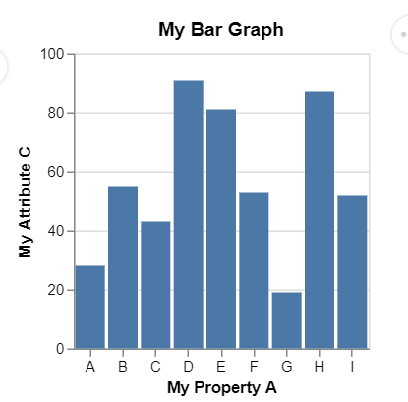

Line Chart (Without X Grid lines)

Directive Usage

<div visionChart [lsConfig]="line" [data]="lineData" [chartType]="'lineChart'"></div>

Configuration object “line”

{

  "title": "test",

  "description": "Google's stock price over time.",

  "x": {"field": "date", "grid": false},

  "y": {"field": "price"},

  "textSizeMult": 1.3

}

Sample Data “lineData”

 [

    { "symbol": "AAPL", "date": "Jan 1 2000", "price": 39.81 },

    { "symbol": "AAPL", "date": "Feb 1 2000", "price": 36.35 },

    ...

    { "symbol": "AAPL", "date": "Jan 1 2010", "price": 192.06 },

    { "symbol": "AAPL", "date": "Feb 1 2010", "price": 204.62 },

    { "symbol": "AAPL", "date": "Mar 1 2010", "price": 223.02 }

  ]

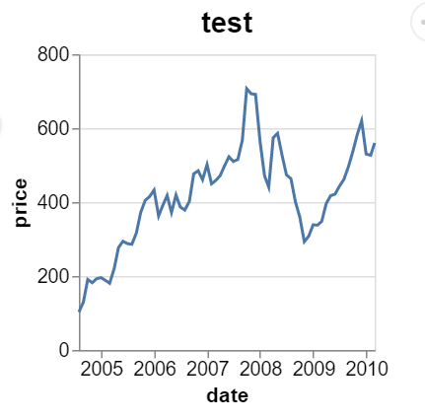

Pie Chart (Text Size Multiplier)

Directive Usage

<div visionChart [lsConfig]="pie" [data]="pieData" [chartType]="'pie'"></div>

Configuration object “pie”

{

  "width": 275,

  "description": "A simple pie chart with embedded data.",

  "circular": {

    "outerRadius": 150,

    "theta": "value"

  },

  "color": {"field": "category", "legend": "my legend"},

  "textSizeMult": 1

  }

Data object “pieData”

[

   {"category": 1, "value": 4},

   {"category": 2, "value": 6},

   {"category": 3, "value": 10},

   {"category": 4, "value": 3},

   {"category": 5, "value": 7},

   {"category": 6, "value": 8}

]

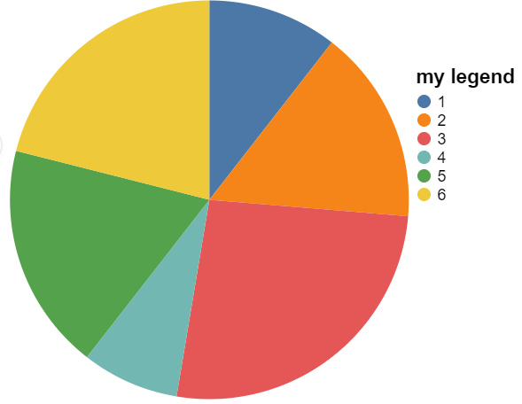

Scatterplot

Directive Usage

<div visionChart [lsConfig]="scatter" [data]="scatterData" [chartType]="'scatterplot'"></div>

Configuration object “scatter”

{

  "x": {"field": "Horsepower"},

  "y": {"field": "Miles_per_Gallon"}

}

Data object “scatterData”

[

   {

      "Name":"chevrolet chevelle malibu",

      "Miles_per_Gallon":18,

      "Cylinders":8,

      "Displacement":307,

      "Horsepower":130,

      "Weight_in_lbs":3504,

      "Acceleration":12,

      "Year":"1970-01-01",

      "Origin":"USA"

   },

…

]

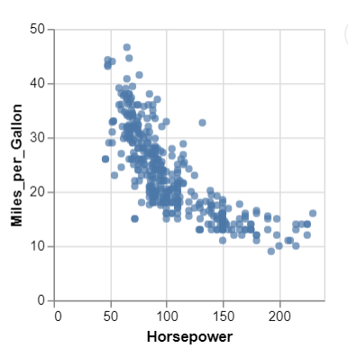

Histogram

Directive Usage

<div visionChart [lsConfig]="histogram" [data]="histogramData" [chartType]="'histogram'"></div

Configuration object “histogram”

{

  "x": {

    "bins": "20",

    "field": "IMDB_Rating"

  }

}

Data object “histogramData”

[{"Title":"The Land Girls","US_Gross":146083,"Worldwide_Gross":146083,"US_DVD_Sales":null,"Production_Budget":8000000,"Release_Date":"Jun 12 1998","MPAA_Rating":"R","Running_Time_min":null,"Distributor":"Gramercy","Source":null,"Major_Genre":null,"Creative_Type":null,"Director":null,"Rotten_Tomatoes_Rating":null,

"IMDB_Rating":6.1,"IMDB_Votes":1071}

…

]

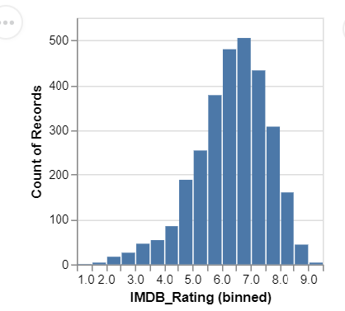

Horizontal Bar with Red Fill (you can do it through the more advanced type property)

{

    "height": "200",

    "width": "200",

    "title": "My Bar Graph",

    "fill": "red",

    "y": {"field": "a", "title": "My Property A"},

    "x": {"field": "c", "title": "My Attribute C"}

  }

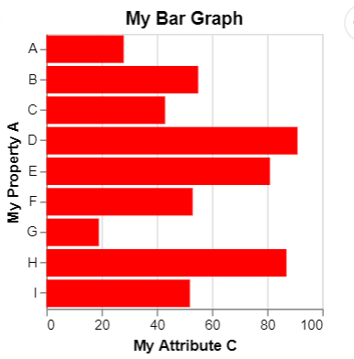

Stacked Bar Chart (Aggregates, might want to construct a different datasource that doesn’t aggregate)

{

  "x": {

    "timeUnit": "month",

    "field": "date",

    "title": "Month of the year"

  },

  "color": {

    "field": "weather",

    "domain": ["sun", "fog", "drizzle", "rain", "snow"],

    "range": ["#e7ba52", "#c7c7c7", "#aec7e8", "#1f77b4", "#9467bd"],

    "legend": "Weather typesdf"

  }

}

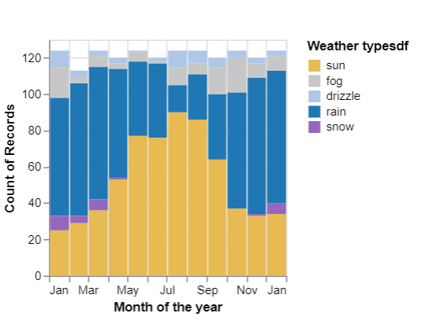

Grouped Bar

{

      "column": {

        "field": "age"

      },

      "y": {

         "field": "people",

        "title": "population"

      },

      "x": {

        "field": "sex",

        "title": ""

      },

      "color": {

        "field": "sex",

        "range": ["#675193", "#ca8861"]

      }

  }

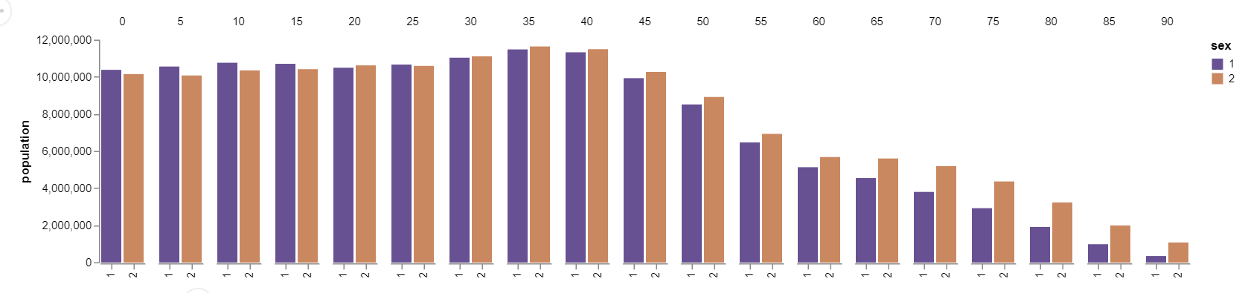

Area Chart Time

{

  "x": {

    "field": "date", "timeUnit": "yearmonth"

  },

  "y": {

    "field": "count",

    "title": "total count"

  }

}

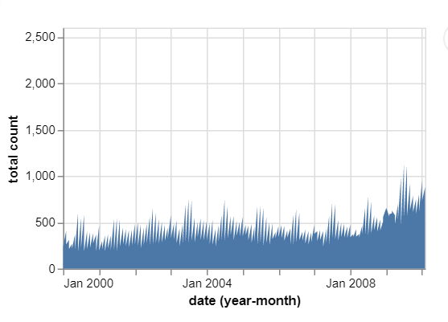

Area Number

{

  "x": {

    "field": "count", "type": "quantitative", "title": "test for numbers"

  },

  "y": {

    "field": "count",

    "title": "total count"

  }

}

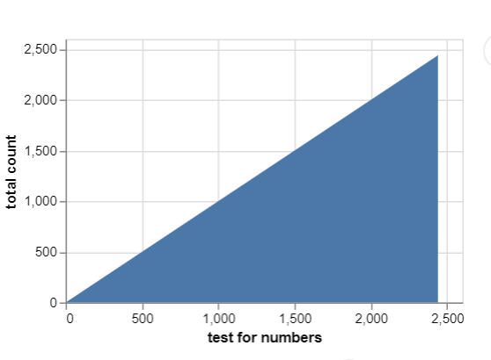

Pie Chart with labels (Text radius)

{

  "description": "A simple pie chart with labels.",

  "circular": {

    "outerRadius": 80,

    "textRadius": 90,

    "text": "category",

    "theta": "value"

  },

  "color": {"field": "category", "type": "nominal"},

  "textSizeMult": 1.2

}

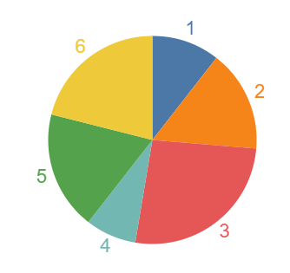

Donut (Inner Radius)

{

  "description": "A simple donut chart with embedded data.",

  "circular": {

“outerRadius": 150,

    "innerRadius": 50,

    "theta": "value"

  },

  "color": {"field": "category"}

}

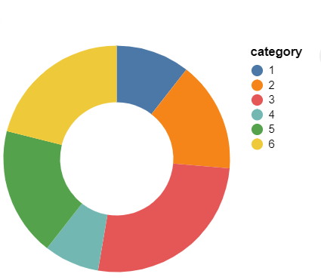

Line with points

{

  "description": "Stock prices of 5 Tech Companies over Time.",

  "x": {

    "timeUnit": "year",

    "field": "date"

  },

  "point": {

    "fill": "white",

    "filled": false

  },

  "y": { "field": "price"},

  "color": {"field": "symbol"}

  }

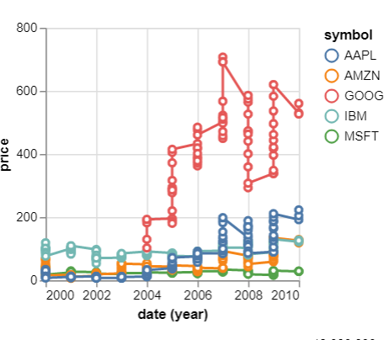

Multiseries

{

  "description": "Stock prices of 5 Tech Companies over Time.",

  "title": "Line Chart",

  "x": {"field": "date"},

  "y": {"field": "price"},

  "color": {"field": "symbol"}

}

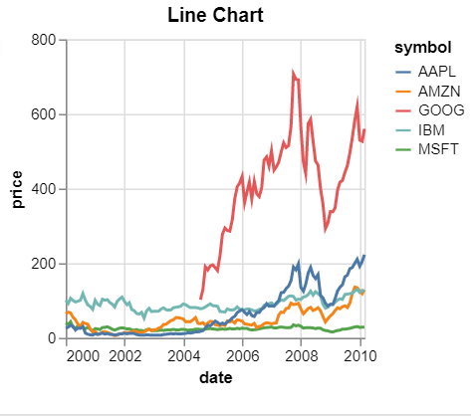

Scatterplot

{

  "x": {"field": "Horsepower"},

  "y": {"field": "Miles_per_Gallon"}

}



Scatter plot (Shapes and Colors)

{

  "description": "A scatterplot showing horsepower and miles per gallons.",

  "x": {"field": "Horsepower"},

  "y": {"field": "Miles_per_Gallon"},

  "color": {"field": "Origin"},

  "shape": {"field": "Origin"}

}

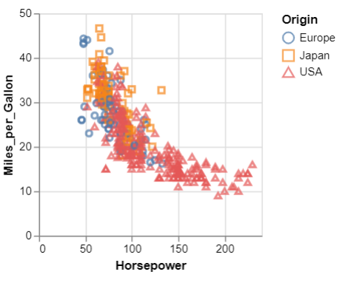

Histogram

{

  "x": {

    "bins": "20",

    "field": "IMDB_Rating"

  }

}



Heatmap

{

  "width": 300,

  "height": 200,

    "x": {

      "bins":60,

      "field": "IMDB_Rating"

    },

    "y": {

      "bins": 40,

      "field": "Rotten_Tomatoes_Rating"

    }

}

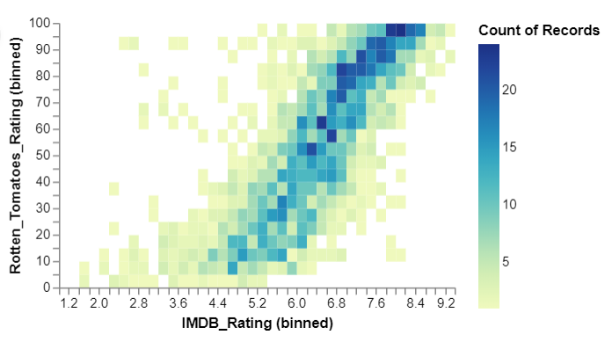

{

  "x": {

    "field": "date", "timeUnit": "yearmonth"

  },

  "y": {

    "field": "count",

    "title": "total count"

  }

}

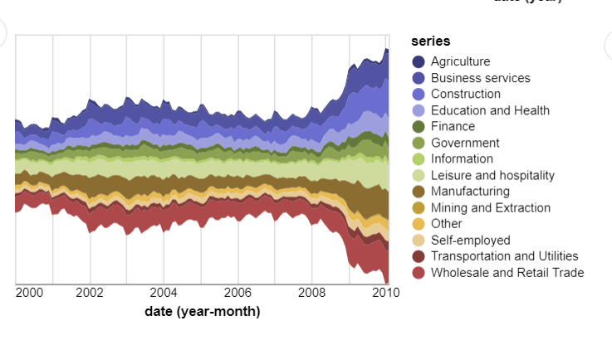

{

    "description": "A vertical 2D box plot showing median, min, and max in the US population distribution of age groups in 2000.",

      "x": {"field": "age"},

      "y": {

        "field": "people",

        "title": "population"

      }

  }

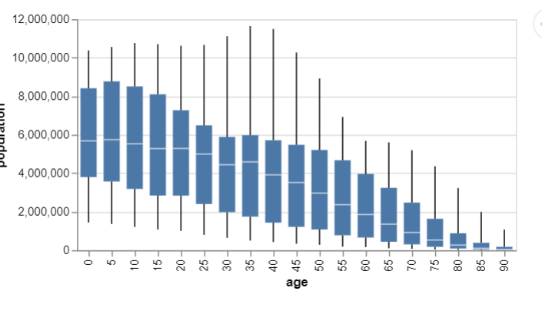

Directive Usage

<div visionChart [lsConfig]="stacked" [data]="stackedData" [chartType]="'stackedBar'"></div>

<div visionChart [lsConfig]="bar" [data]="barData" [chartType]="'simpleBar'"></div>

<div visionChart [lsConfig]="horizontal" [data]="barData" [chartType]="'horizontalBar'"></div>

<div visionChart [lsConfig]="groupedBar" [data]="groupedData" [chartType]="'groupedBar'"></div>

<div visionChart [lsConfig]="area" [data]="areaData" [chartType]="'areachart'"></div>

<div visionChart [lsConfig]="areaNumber" [data]="areaData" [chartType]="'areachart'"></div>

<div visionChart [lsConfig]="donut" [data]="donutData" [chartType]="'donut'"></div>

<div visionChart [lsConfig]="pie" [data]="donutData" [chartType]="'pie'"></div>

<div visionChart [lsConfig]="pieLabels" [data]="donutData" [chartType]="'pieLabels'"></div>

<div visionChart [lsConfig]="line" [data]="lineData" [chartType]="'lineChart'"></div>

<div visionChart [lsConfig]="linePoints" [data]="multiseriesData" [chartType]="'multiseriesLine'"></div>

<div visionChart [lsConfig]="multiseries" [data]="multiseriesData" [chartType]="'multiseriesLine'"></div>

<div visionChart [lsConfig]="scatter" [data]="scatterData" [chartType]="'scatterplot'"></div>

<div visionChart [lsConfig]="scatterColor" [data]="scatterData" [chartType]="'scatterplotColored'"></div>

<div visionChart [lsConfig]="histogram" [data]="histogramData" [chartType]="'histogram'"></div>

<div visionChart [lsConfig]="heatmap" [data]="histogramData" [chartType]="'heatmap'"></div>

<div visionChart [lsConfig]="stream" [data]="areaData" [chartType]="'stream'"></div>

<div visionChart [lsConfig]="box" [data]="groupedData" [chartType]="'box'"></div>

<div visionChart [lsConfig]="bubble" [data]="scatterData" [chartType]="'bubble'"></div>