Instructions for installing OSIRIS on a Macintosh®

This document covers the following topics:
- Installing OSIRIS
- Copying the Test Analysis folder
- Copying the OsirisXSL folder

Once you have downloaded OSIRIS and opened the .dmg file there are six icons:

- 00_Read_This_First – this file
- Osiris-2.11 – the OSIRIS software to be installed
- OsirisXSL – A folder containing XSLT (Extensible Stylesheet Language Transformation) files which can be optionally used for exporting analyzed data from OSIRIS
- System Applications Folder – Double clicking this icon will open the Applications folder used by all users of this Macintosh in Finder. We recommend that you install OSIRIS there on a Macintosh used by more than one user.
(Not recommended for a network installation.)

- User Applications Folder – Double clicking this icon will open the Applications folder for the current user in Finder. We recommend that you install OSIRIS there on a system where only one user will be using OSIRIS.
- Test Analysis – This folder contains test files that can be analyzed by OSIRIS. This is recommended if you are new to OSIRIS and plan to do the tutorial

Installing OSIRIS

To install OSIRIS, click and drag the program icon to the desired location. The following paragraphs suggest locations for installation along with instructions:

Single user on this Macintosh
Double-click the User Applications Folder. The following notification may appear:
“User Applications Folder” is an application downloaded from the internet. Are you sure you want to open it? Click Open. When the Applications window opens in Finder, click (hold) and drag the OSIRIS icon to this window as shown below:
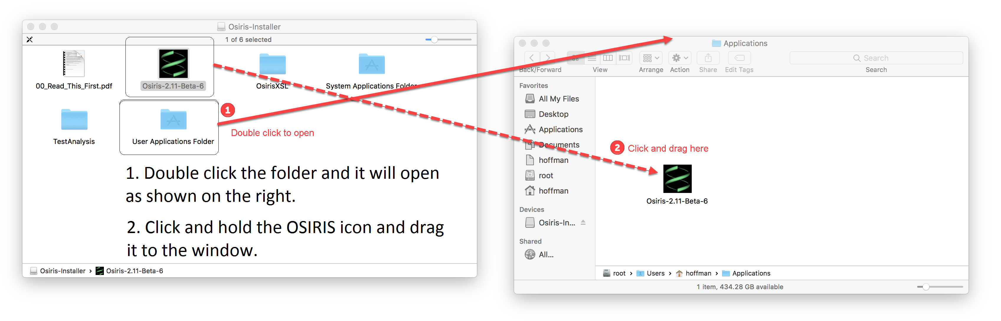

Multiple users on this Macintosh
This is the same as “Single user on this Macintosh” described above, except that you will double click the Systems Applications Folder instead, and it requires administrative privileges. You will receive a notification as shown below:
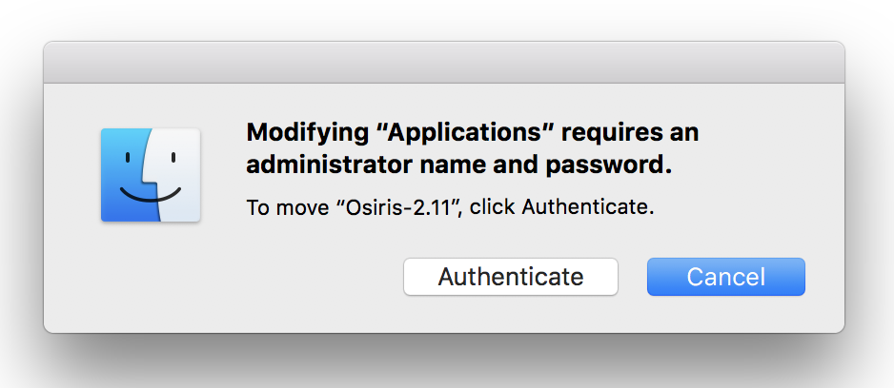
After clicking on “Authenticate” the following window will appear to prompt for an administrator user name and password as shown below:
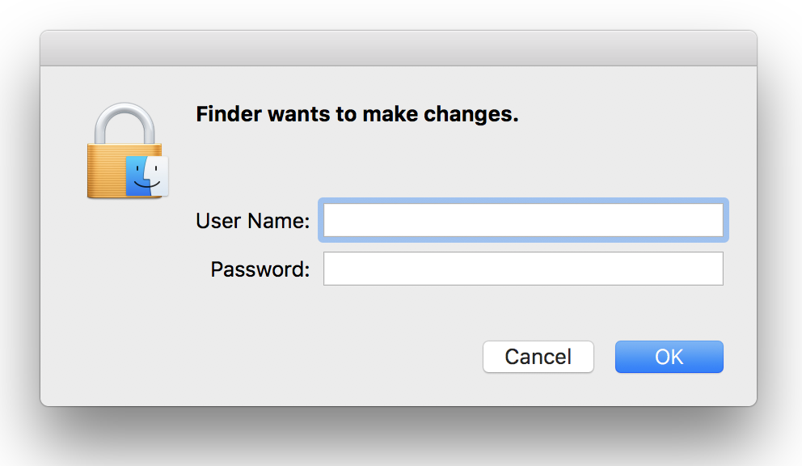
Once you correctly enter your user name and password OSIRIS will be installed in the system applications folder.

Network installation
Network installation for multiple Macintosh computers sharing the same settings:
Select and open a folder on a network drive where you want to share OSIRIS and its settings. Then click and drag the OSIRIS icon to that folder. If the shared folder is on the local machine, it is recommended that OSIRIS is run for the first time on a different computer on the network in order to initialize site settings that will be accessible by all computers on the network. This is described in detail in the User’s Guide.

Copying the Test Analysis folder

If you plan to use the OSIRIS tutorial in the User’s Guide, you will need the Test Analysis folder. This can be copied anywhere, but for a single user, it is recommended that it be placed in your Documents folder.

Copying the OsirisXSL folder

This folder contains sample XSLT files that are used for exporting data. The recommended location is the Osiris-Files folder that is created when running OSIRIS. To see this folder, run OSIRIS after it is installed. From the Tools menu on the menu bar, select “Show site settings folder…” as shown below.

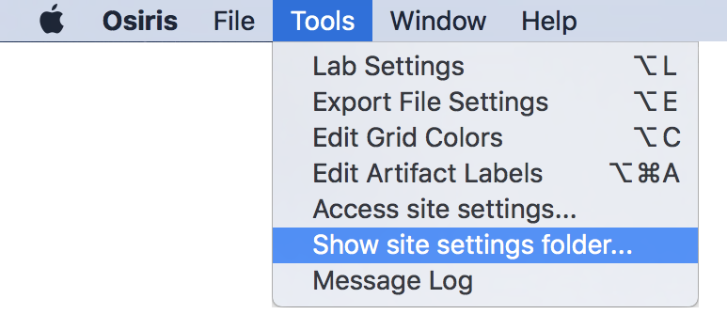
The parent folder will appear with a folder named “Osiris-Files” selected:
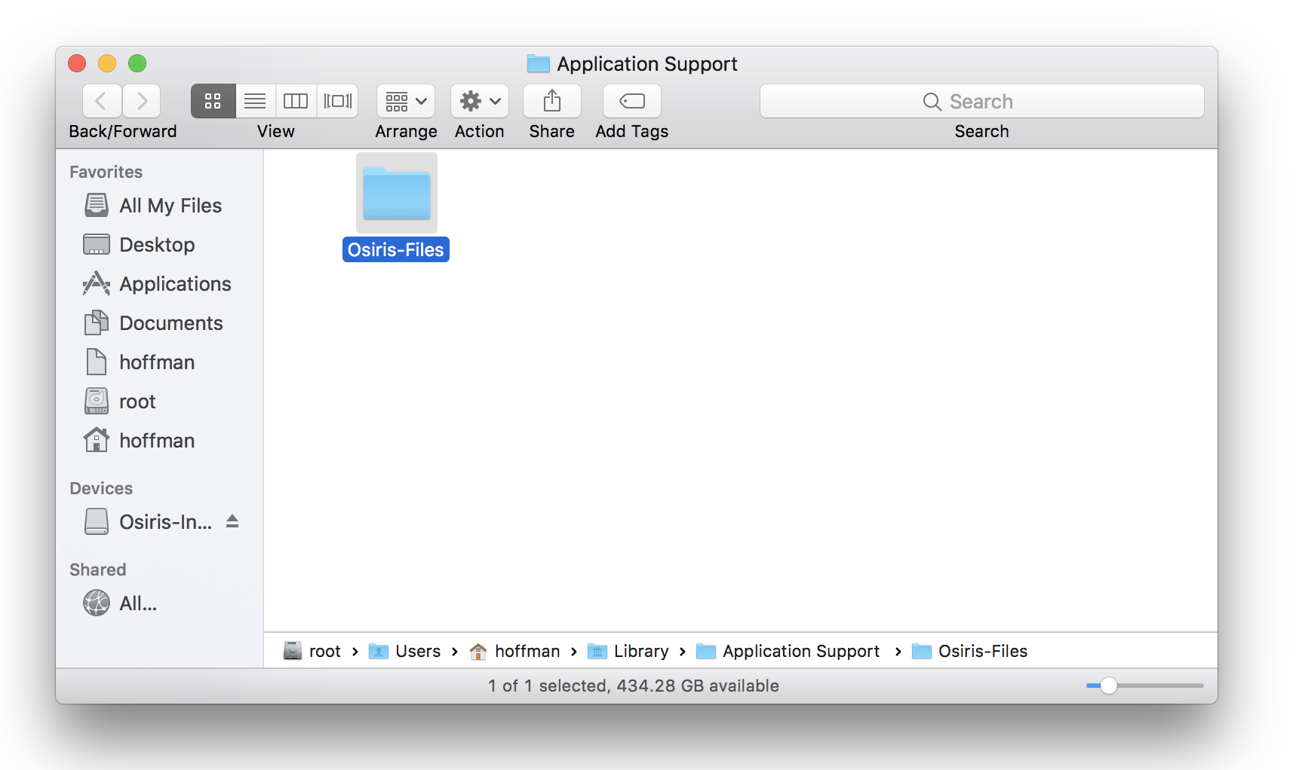
Double-click to open this folder and drag the OsirisXSL folder to this location.

