OSIRIS Windows Installation

**The following instructions should resolve problems with OSIRIS installation on Microsoft Windows. We are currently working on simplifying OSIRIS installation.**

# Recommended file and location to install OSIRIS

|  |  |
| --- | --- |
| **Usage** | **Location** |
| Single user on one Windows**®** 8 or 10 computer | Install using the .zip file in the user's Documents directory. |
| Single user without  Administrator privileges on one Windows**®** 7 computer | Install using the .zip file in the user's Documents directory. |
| Single user with Administrator privileges on one Windows**®** 7 computer | Install using the .msi installer in the default  *C:\Program Files(x86)\NCBI\Osiris* directory.  This may require the Administrator password on most Windows 7 and higher operating systems. |
| Multiple users on one Windows**®** computer | Install using the .msi installer file in the default directory. Requires Administrator privileges and changing directory  permissions. |
| Network, multiple Windows**®** computers, and  multiple users | Install using the .zip file. Control authorization to change lab settings by modification of permissions to the *\site* folder in the  installation directory. |

### There are two options for downloading the Windows**®** version of OSIRIS, a .zip file or an .msi installer file. Installation of the .zip file is simpler.

Advantages of using the .zip file:

* Simpler installation – does not require Administrator privileges.

#### Disadvantages of the .zip file:

* When upgrading, it is more complex to retain previous settings and requires more care.
* The user must create their own program shortcut and add it to the Start menu if desired.
* If users want to open OSIRIS analysis files by double clicking, they must create the program association.

### Advantages of using the .msi installer file:

* The program can be easily uninstalled for an upgrade without erroneously losing any settings.
* The program appears on the "Start" menu,
* An icon is created on the desktop,
* The user can double-click an OSIRIS analysis file in Windows Explorer and it will open in OSIRIS.

#### Disadvantages of the .msi installer

* Installation and upgrade requires Administrator privileges on most Windows7 and higher operating systems

### If multiple OSIRIS versions will be installed on the same PC at the same time for evaluation or testing, the .zip file can be used for simultaneous installation of different versions.

Windows® 7 and Windows XP

|  |  |
| --- | --- |
| For a single user running Windows® 7 and earlier, OSIRIS can be installed using the .zip file | |
| downloads without Administrator privileges. | Some Windows® 7 computers may now require |

Administrator privileges to install the .msi download, due to operating system updates.

For multiple users on a single computer, the installation should be performed with Administrator privileges using the .msi download. See “Multiple Users” below.

Windows® 8 or 10

|  |
| --- |
| The .zip file is recommended for a single user because of problems encountered when installing |
| without Administrator privileges. |

# Installation using the .zip file

### Download the OSIRIS .zip file from our [home page](https://www.ncbi.nlm.nih.gov/osiris/) and save it to your Downloads folder.

1. Unzip the file in a directory named *Osiris* in the desired location.

# Installation using the .msi installer file

### Download OSIRIS from our [home page](https://www.ncbi.nlm.nih.gov/osiris/) and save it to your Downloads folder.

1. Determine the location where you want to install OSIRIS (see the chart above) and note the directory file path if Installing with the .msi file download.
2. If using a .zip file download, unzip the file in a directory named *Osiris* in the desired location.

If using an .msi file download, double click the .msi file follow the instructions and type, copy/paste, or browse to the desired location path name:

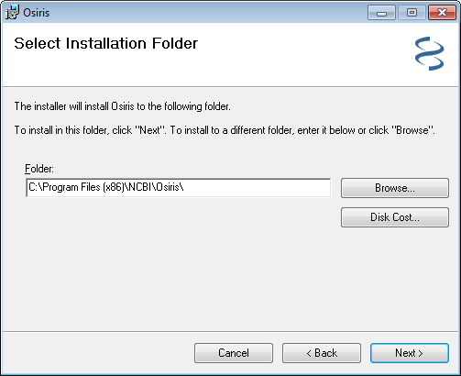

## Multiple Users

When there are multiple OSIRIS users on Windows® either on a single computer, or on a network, users may find that they cannot change the Laboratory and Export Settings if they run the program without administrator privileges. To fix this, you must change the *Osiris\site* folder permissions to give users Write permission. The Laboratory Settings can be protected from unauthorized changes by limiting Write permissions of the *\site* folder to authorized personnel. All OSIRIS users must have Read permission. If the *\site* folder has not yet been created, create it in the OSIRIS installation directory. The user can do this in the program by running OSIRIS as an administrator (right-click the program and select run as administrator) then creating a custom lab setting.

The *\site* folder is in the OSIRIS installation folder. If the installation folder location is not known, run OSIRIS and from the menu bar, select Tools, then Message log. The first line in the Message log window indicates where the main program, OsirisAnalysis.exe is installed. The *\ site* folder is a subdirectory of this folder.

To change *\site* folder permissions, log in as Administrator, open the OSIRIS installation directory in Windows Explorer, right-click the *\site* folder, select Properties, select Security, click Edit, select the users or groups whose permissions you want to change. (See https://msdn.microsoft.com/en-us/library/bb727008.aspx or https://docs.microsoft.com/enus/previous-versions/windows/it-pro/windows-server-2008-R2- and-2008/cc754344(v=ws.11) for additional details.)

## Upgrading

When upgrading OSIRIS for Windows® with an .msi download, the new version should be installed in the same location (folder) as the previous version in order to retain any custom Laboratory Settings. When adding a new version of OSIRIS while keeping an older version intact, the .zip file download should be used. To transfer the settings from the older version, the

*\site* folder from that previous version should be **copied** to the new version. Any modifications to the lab settings made afterward will only affect the OSIRIS version in which the modifications were made.