Exploration of Data for an Individual Block

N.M. Tarr

2023-10-10

# Purpose

This document details and demonstrates code that provides information about the data available for an individual block. Questions of block status will likely be season-specific, so this demo is organized by season.

First, specify a block of interest.

block <- "35079H1SE"

Get identifying information about the block

blocks <- get_blocks(spatial = TRUE)  
block_info <- blocks %>%   
 filter(ID_BLOCK_CODE == block) %>%  
 select(c("ID_BLOCK_CODE", "ID_BLOCK", "ID_EBD_NAME", "ECOREGION"  
 ))  
print(block_info %>% data.frame())

## ID_BLOCK_CODE ID_BLOCK ID_EBD_NAME ECOREGION  
## 1 35079H1SE CHAPEL HILL-SE Chapel Hill SE P  
## wkt  
## 1 POLYGON ((-79.00001 35.8750...

Highlight the block on a map

# Make a simple map  
ggplot() +  
 geom_sf(data = blocks, fill = "lightgrey", color = "darkgrey") +  
 geom_sf(data = block_info, fill = "purple", color = "purple") +  
 ggtitle("", subtitle = "")

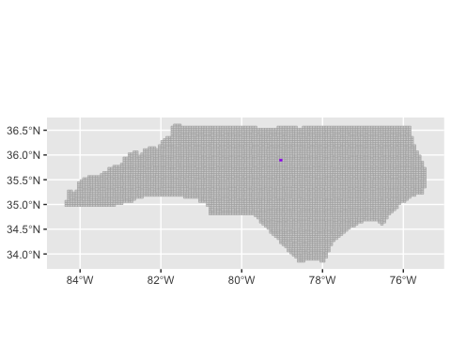

Get a list of species predicted by National GAP to occur in the block in each season.

preds <- block_predicted_spp(block = block, source = "GAP")  
predicted_summer <- preds$summer  
predicted_winter <- preds$winter

## Summer/Breeding Season

Breeding season dates vary by species, but we need to choose a single start and end date. Therefore, look at some calculated start and end dates (excluding outliers) for common, early, and late breeders to inform a choice in dates. The flock of interest is in the Piedmont, so focus on Piedmont dates.

The Northern Cardinal seems to breed as soon as possible given weather and is very common.

print(calculate_breeding_dates(species = "Northern Cardinal",  
 basis = c("confirmed", "probable"),  
 quantiles = c(0.05, 0.95),  
 year = 2023,  
 year_day = FALSE))

## $statewide  
## [1] "03-17" "07-30"  
##   
## $coastal_Plain  
## [1] "03-18" "07-27"  
##   
## $piedmont  
## [1] "03-11" "08-02"  
##   
## $mountains  
## [1] "03-22" "07-26"

The American Goldfinch is a later breeder.

print(calculate_breeding_dates(species = "American Goldfinch",  
 basis = c("confirmed", "probable"),  
 quantiles = c(0.05, 0.95),  
 year = 2023,  
 year_day = FALSE))

## $statewide  
## [1] "04-03" "08-15"  
##   
## $coastal_Plain  
## [1] "04-18" "08-04"  
##   
## $piedmont  
## [1] "04-01" "08-18"  
##   
## $mountains  
## [1] "04-06" "08-13"

The Carolina Wren seems to breed several times per year if possible.

print(calculate_breeding_dates(species = "Carolina Wren",  
 basis = c("confirmed", "probable"),  
 quantiles = c(0.05, 0.95),  
 year = 2023,  
 year_day = FALSE))

## $statewide  
## [1] "03-19" "08-03"  
##   
## $coastal_Plain  
## [1] "03-20" "07-31"  
##   
## $piedmont  
## [1] "03-18" "08-07"  
##   
## $mountains  
## [1] "03-19" "08-07"

Based on the results of the breeding date calculations, it seems that March 11 - August 18 is a good choice for the Piedmont. Get species lists from the Atlas Cache for the time period between those days.

start_day <- 70  
end_day <- 230  
observed_summer <- block_spp_lists(block = block, start_day = start_day,   
 end_day = end_day, within = TRUE)

Which species were predicted to occur during summer but have not been observed?

print(setdiff(predicted_summer, observed_summer$all))

## [1] "American Kestrel" "Barn Owl" "Cattle Egret"   
## [4] "Cooper's Hawk" "Common Nighthawk" "Chuck-will's-widow"   
## [7] "Dickcissel" "Eastern Screech-Owl" "Eurasian Collared-Dove"  
## [10] "Great Horned Owl" "Grasshopper Sparrow" "Horned Lark"   
## [13] "Hooded Merganser" "Kentucky Warbler" "Least Bittern"   
## [16] "Loggerhead Shrike" "Northern Bobwhite" "Purple Martin"   
## [19] "Swainson's Warbler"

Which species were not predicted to occur but were then observed?

print(setdiff(observed_summer$all, predicted_summer))

## [1] "Ruby-crowned Kinglet" "White-throated Sparrow"   
## [3] "Yellow-rumped Warbler" "Eastern Phoebe"   
## [5] "Golden-crowned Kinglet" "Red-winged Blackbird"   
## [7] "Swamp Sparrow" "Winter Wren"   
## [9] "Yellow-bellied Sapsucker" "Coopers Hawk"   
## [11] "Dark-eyed Junco" "Black-throated Green Warbler"  
## [13] "Purple Finch" "Brown Creeper"   
## [15] "Common Loon" "Hermit Thrush"   
## [17] "Pine Siskin" "Red-breasted Nuthatch"   
## [19] "Savannah Sparrow" "Blue-headed Vireo"   
## [21] "Great Egret" "Black-throated Blue Warbler"   
## [23] "Northern Waterthrush" "Rose-breasted Grosbeak"   
## [25] "Yellow Warbler" "Blackpoll Warbler"   
## [27] "Evening Grosbeak" "American Bittern"   
## [29] "Bald Eagle" "Cape May Warbler"   
## [31] "Palm Warbler" "Gray-cheeked Thrush"   
## [33] "Veery" "Swainsons Thrush"   
## [35] "Mallard (Domestic type)" "Bay-breasted Warbler"   
## [37] "Magnolia Warbler" "Chestnut-sided Warbler"   
## [39] "Orange-crowned Warbler" "Northern Harrier"   
## [41] "Rusty Blackbird" "Lincolns Sparrow"   
## [43] "Fox Sparrow" "Baltimore Oriole"   
## [45] "Blue-winged Warbler" "Solitary Sandpiper"   
## [47] "Common Raven" "Spotted Sandpiper"   
## [49] "Sedge Wren"

Which species have been observed, but not coded as probable or confirmed during summer?

print(setdiff(observed_summer$all, union(observed_summer$probable, observed_summer$confirmed)))

## [1] "Common Grackle" "Northern Flicker"   
## [3] "Yellow-rumped Warbler" "Cedar Waxwing"   
## [5] "Double-crested Cormorant" "Golden-crowned Kinglet"   
## [7] "Killdeer" "Winter Wren"   
## [9] "Yellow-bellied Sapsucker" "Eastern Meadowlark"   
## [11] "Field Sparrow" "Mallard"   
## [13] "Belted Kingfisher" "Dark-eyed Junco"   
## [15] "Sharp-shinned Hawk" "Black-throated Green Warbler"   
## [17] "Northern Rough-winged Swallow" "Purple Finch"   
## [19] "Brown Creeper" "Common Loon"   
## [21] "Hermit Thrush" "Pine Siskin"   
## [23] "Red-breasted Nuthatch" "Wood Duck"   
## [25] "Savannah Sparrow" "Blue-headed Vireo"   
## [27] "Great Egret" "Black-throated Blue Warbler"   
## [29] "Northern Waterthrush" "Prairie Warbler"   
## [31] "Rose-breasted Grosbeak" "Worm-eating Warbler"   
## [33] "Yellow Warbler" "Blackpoll Warbler"   
## [35] "Evening Grosbeak" "American Bittern"   
## [37] "Bald Eagle" "Cape May Warbler"   
## [39] "Palm Warbler" "Gray-cheeked Thrush"   
## [41] "Veery" "Yellow-billed Cuckoo"   
## [43] "Swainsons Thrush" "Mallard (Domestic type)"   
## [45] "Bay-breasted Warbler" "Green Heron"   
## [47] "Magnolia Warbler" "Yellow-breasted Chat"   
## [49] "House Sparrow" "Chestnut-sided Warbler"   
## [51] "Broad-winged Hawk" "Orange-crowned Warbler"   
## [53] "Rock Pigeon" "Northern Harrier"   
## [55] "Rusty Blackbird" "Lincolns Sparrow"   
## [57] "American Woodcock" "Fox Sparrow"   
## [59] "Baltimore Oriole" "Orchard Oriole"   
## [61] "Blue-winged Warbler" "Solitary Sandpiper"   
## [63] "Common Raven" "Spotted Sandpiper"   
## [65] "Tree Swallow" "Sedge Wren"

Get a summary of how many species have been submitted for each breeding category.

print(spp_count_summary(observed_summer, predicted_summer))

## highest_category species_count percent_of_observed percent_of_predicted  
## 1 observed 36 27 34  
## 2 possible 30 22 29  
## 3 probable 24 18 23  
## 4 confirmed 45 33 43  
## 5 sum 135 100 129

Summarize the duration of effort in hours.

print(summarize_duration(block = block, summarize_by = "year", start_day = start_day,  
 end_day = end_day, within = TRUE))

## # A tibble: 3 × 3  
## # Groups: year [3]  
## year diurnal_hours nocturnal_hours  
## <int> <dbl> <dbl>  
## 1 2021 173. 0.6  
## 2 2022 199 0   
## 3 2023 174. 1.1

## Winter

Assign start and end days to for winter. The concept of winter regarding birds is more ambiguous than summer, so use the NCBA winter start and end days.

start_day <- 59  
end_day <- 305

Get species lists from the Atlas Cache for the time period between those days.

observed_winter <- block_spp_lists(block = block, start_day = start_day,   
 end_day = end_day, within = FALSE)

Which species were predicted to occur during winter but have not been observed?

print(setdiff(predicted_winter, observed_winter$all))

## [1] "Acadian Flycatcher" "American Redstart"   
## [3] "Barn Owl" "Barn Swallow"   
## [5] "Blue Grosbeak" "Broad-winged Hawk"   
## [7] "Cattle Egret" "Chimney Swift"   
## [9] "Cliff Swallow" "Cooper's Hawk"   
## [11] "Common Nighthawk" "Common Yellowthroat"   
## [13] "Chuck-will's-widow" "Dickcissel"   
## [15] "Eastern Kingbird" "Eastern Meadowlark"   
## [17] "Eastern Screech-Owl" "Eastern Wood-Pewee"   
## [19] "Eurasian Collared-Dove" "Great Crested Flycatcher"   
## [21] "Green Heron" "Grasshopper Sparrow"   
## [23] "Horned Lark" "Hooded Warbler"   
## [25] "Indigo Bunting" "Kentucky Warbler"   
## [27] "Least Bittern" "Loggerhead Shrike"   
## [29] "Louisiana Waterthrush" "Northern Bobwhite"   
## [31] "Northern Parula" "Northern Rough-winged Swallow"  
## [33] "Orchard Oriole" "Ovenbird"   
## [35] "Prairie Warbler" "Prothonotary Warbler"   
## [37] "Purple Martin" "Red-eyed Vireo"   
## [39] "Ruby-throated Hummingbird" "Scarlet Tanager"   
## [41] "Summer Tanager" "Swainson's Warbler"   
## [43] "Tree Swallow" "White-eyed Vireo"   
## [45] "Worm-eating Warbler" "Wild Turkey"   
## [47] "Wood Thrush" "Yellow-breasted Chat"   
## [49] "Yellow-billed Cuckoo" "Yellow-throated Vireo"   
## [51] "Yellow-throated Warbler"

Which species were not predicted to occur but were then observed?

print(setdiff(observed_winter$all, predicted_winter))

## [1] "Swamp Sparrow" "White-throated Sparrow"   
## [3] "Brown Creeper" "Eastern Phoebe"   
## [5] "Hermit Thrush" "Pied-billed Grebe"   
## [7] "Red-winged Blackbird" "Ruby-crowned Kinglet"   
## [9] "Rusty Blackbird" "Winter Wren"   
## [11] "Yellow-rumped Warbler" "Lincolns Sparrow"   
## [13] "Yellow-bellied Sapsucker" "Dark-eyed Junco"   
## [15] "Golden-crowned Kinglet" "Common Raven"   
## [17] "Blue-headed Vireo" "Coopers Hawk"   
## [19] "Purple Finch" "Savannah Sparrow"   
## [21] "Fox Sparrow" "Ring-billed Gull"   
## [23] "Wilsons Snipe" "Red-breasted Nuthatch"   
## [25] "Palm Warbler" "Bald Eagle"   
## [27] "American Wigeon" "Northern Shoveler"   
## [29] "Northern Harrier"

Get a summary of how many species have been submitted for each breeding category. Reports of breeding during the winter dates reflects upon the quality or appropriateness of the records and/ or the winter start and end dates.

print(spp_count_summary(observed_winter, predicted_winter))

## highest_category species_count percent_of_observed percent_of_predicted  
## 1 observed 53 64 50  
## 2 possible 18 22 17  
## 3 probable 11 13 10  
## 4 confirmed 1 1 1  
## 5 sum 83 100 78

Which species have been confirmed breeding during winter?

print(observed_winter$confirmed)

## [1] "American Crow"

Which species have been reported possibly breeding during winter?

print(observed_winter$possible)

## [1] "Song Sparrow" "White-throated Sparrow" "Carolina Wren"   
## [4] "Eastern Phoebe" "Northern Cardinal" "Pine Warbler"   
## [7] "American Robin" "American Crow" "American Goldfinch"   
## [10] "Blue Jay" "Barred Owl" "Carolina Chickadee"   
## [13] "Chipping Sparrow" "Dark-eyed Junco" "Downy Woodpecker"   
## [16] "Eastern Bluebird" "Eastern Towhee" "Field Sparrow"   
## [19] "Hairy Woodpecker" "Northern Flicker" "Pileated Woodpecker"   
## [22] "Red-bellied Woodpecker" "Red-headed Woodpecker" "Swamp Sparrow"   
## [25] "Tufted Titmouse" "Coopers Hawk"

Which species have been reported probably breeding during winter?

print(observed_winter$probable)

## [1] "White-throated Sparrow" "Carolina Wren" "American Woodcock"   
## [4] "Red-headed Woodpecker" "Pileated Woodpecker" "House Finch"   
## [7] "Red-tailed Hawk" "Eastern Bluebird" "Barred Owl"   
## [10] "Red-shouldered Hawk" "Downy Woodpecker"

## Year-round

Get all the checklists from the block of interest.

checklists <- get_checklists(block = block) %>%  
 to_EBD_format() %>%  
 auk_unique(checklists_only = TRUE)

Summarize duration of effort in hours by month.

print(summarize_duration(block = block, summarize_by = "month", start_day = 1,  
 end_day = 365, within = TRUE))

## # A tibble: 12 × 3  
## # Groups: month [12]  
## month diurnal_hours nocturnal_hours  
## <chr> <dbl> <dbl>  
## 1 Jan 57.9 2   
## 2 Feb 35.6 1.5  
## 3 Mar 107 1.1  
## 4 Apr 171. 0   
## 5 May 153. 0   
## 6 Jun 59.6 0.6  
## 7 Jul 52.6 0   
## 8 Aug 24.3 0   
## 9 Sep 18.6 2.1  
## 10 Oct 26.7 3.2  
## 11 Nov 50.8 0   
## 12 Dec 26.6 1.8

Plot observations by week.

lists_by_week(checklists)

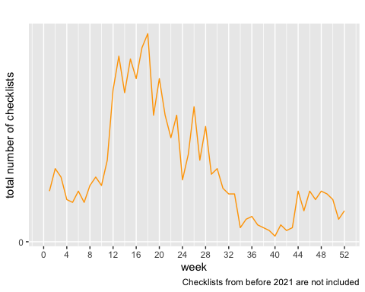

Summarize checklist distance.

show(effort_distance_boxplot(checklists))

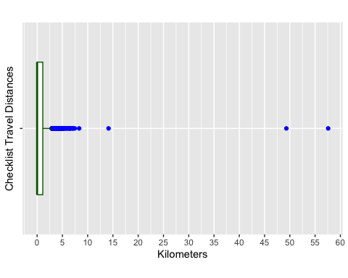

Summarize duration

show(duration_minutes_boxplot(checklists))

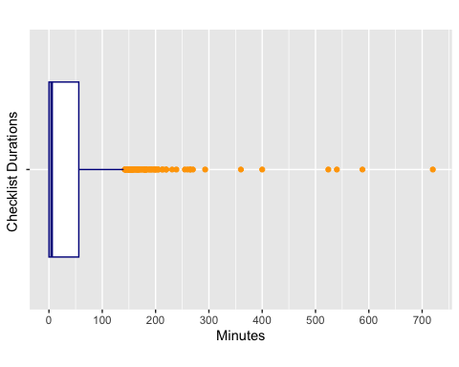

duration_distance_table(checklists)

## min median max mean sd count  
## duration (hours) 0 0.08333333 12.000 0.5901459 1.020456 1348  
## distance (km) 0 0.00000000 57.582 0.8580423 2.483011 1348

Summarize start times.

show(start_time_boxplot(checklists))

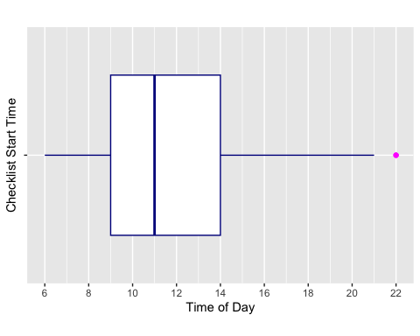

Summarize locality type.

show(locality_type_pie(checklists))

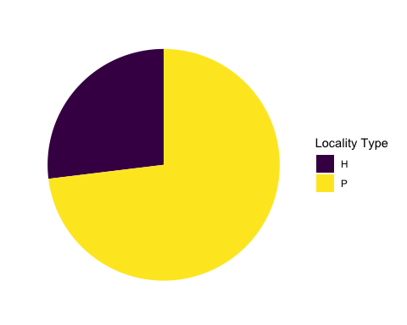

Summarize protocol in a table.

protocol_table(checklists)

## # A tibble: 3 × 4  
## protocol_type number percentage duration_hours  
## <chr> <int> <dbl> <dbl>  
## 1 Incidental 407 30.2 0   
## 2 Stationary 438 32.5 122.  
## 3 Traveling 503 37.3 673.

Summarize protocol in a figure.

protocol_table(checklists)

## # A tibble: 3 × 4  
## protocol_type number percentage duration_hours  
## <chr> <int> <dbl> <dbl>  
## 1 Incidental 407 30.2 0   
## 2 Stationary 438 32.5 122.  
## 3 Traveling 503 37.3 673.

Summarize checklist completeness.

complete_checklist_table(checklists)

## # A tibble: 2 × 4  
## all_species_reported number percentage duration_hours  
## <lgl> <int> <dbl> <dbl>  
## 1 FALSE 412 30.6 5.68  
## 2 TRUE 936 69.4 790.

Summarize observations per year.

show(year_bar(checklists))

