demo_species_stats

N.M. Tarr

2023-10-9

# Purpose

This document demonstrates species-level data summaries that are available from the NCBA code repository.

Identify a species and get the observations.

species <- "Black-throated Green Warbler"  
  
observations <- get_observations(species = species, project = "EBIRD_ATL_NC",   
 EBD_fields_only = FALSE) %>%  
 to_EBD_format() %>%  
 auk_unique()

Plot the coordinates.

# Get spatial data frame of observations  
obs.spatial <- records_as_sf(records_df = observations,   
 kind = "observations", method = "points")  
  
# Make a simple map  
ggplot(data = counties_NC()) +  
 geom_sf() +  
 geom_sf(data = obs.spatial, size = 4, shape = 20,   
 crs = st_crs(6542), colour = "darkred", fill = NA) +   
 ggtitle(paste(species, "Record Coordinates"), subtitle = "")

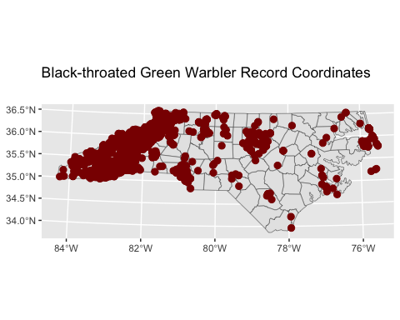

Plot the footprints.

# Get spatial data frame of observations  
obs.spatial <- records_as_sf(records_df = observations,   
 kind = "observations", method = "point-radius")  
  
# Make a simple map  
ggplot(data = counties_NC()) +  
 geom_sf() +  
 geom_sf(data = obs.spatial, size = 4, shape = 20,   
 crs = st_crs(6542), colour = "darkred", fill = NA) +   
 ggtitle(paste(species, "Record Footprints"), subtitle = "")

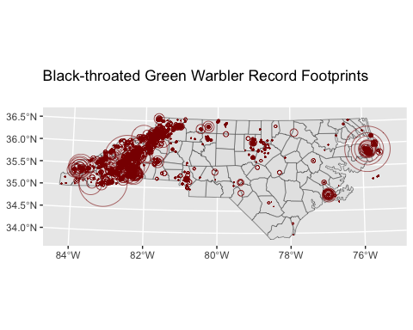

Map the highest reported breeding code by block with needed blocks identified.

show(map_needed_highest(species = "Black-throated Green Warbler"))

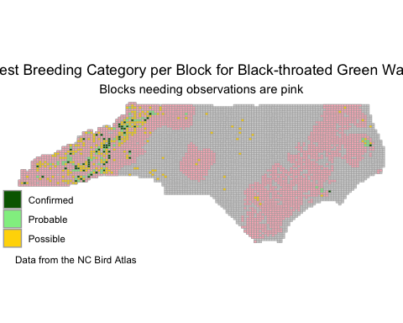

Get a boxplot of breeding phenology

breeding_boxplot(species = species, data = observations, type = "ecoregional",   
 drop = FALSE, lump = breeding_codes())

