Exploration of Data for an Individual Block

N.M. Tarr

2023-10-05

Identify an observer.

observer <- "obsr1000095"

Get all of their checklists.

checklists.obs <- get_checklists(database = "AtlasCache", observer = observer,   
 project = NULL) %>%  
 to_EBD_format() %>%  
 auk_unique(checklists_only = TRUE)

View the checklist records. They could also be saved with to.csv().

#View(checklists.obs)

Plot the checklist locations as points.

sf <- records_as_sf(checklists.obs, kind = "checklists", method = "points")  
  
# Make a simple map  
ggplot(data = counties_NC()) +  
 geom_sf() +  
 geom_sf(data = sf, size = 4, shape = 20,   
 crs = st_crs(6542), colour = "darkred") +   
 ggtitle(paste("Coordinates of Checklists from", observer), subtitle = "")

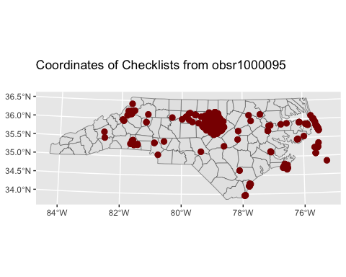

Plot the checklist locations as uncertainty buffers.

sf <- records_as_sf(checklists.obs, kind = "checklists", method = "point-radius")  
  
# Make a simple map  
ggplot(data = counties_NC()) +  
 geom_sf() +  
 geom_sf(data = sf, size = 4, shape = 20,   
 crs = st_crs(6542), colour = "darkred") +   
 ggtitle(paste("Uncertainty Buffers of Checklists from", observer),   
 subtitle = "")

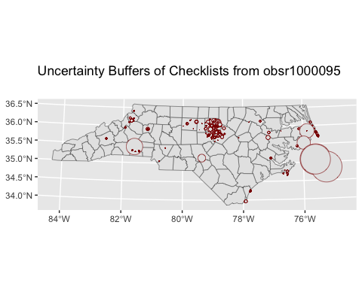

Summarize the protocol type of the checklists.

protocol_table(checklists.obs)

## # A tibble: 3 × 4  
## protocol_type number percentage duration_hours  
## <chr> <int> <dbl> <dbl>  
## 1 Incidental 55 3.66 0   
## 2 Stationary 320 21.3 85.6  
## 3 Traveling 1128 75.0 1219.

show(protocol_type_pie(checklists.obs))

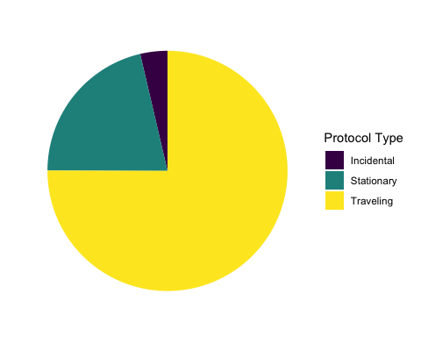

Summarize the breakdown of complete vs. incomplete checklists.

complete_checklist_table(checklists.obs)

## # A tibble: 2 × 4  
## all_species_reported number percentage duration_hours  
## <lgl> <int> <dbl> <dbl>  
## 1 FALSE 59 3.93 0.3  
## 2 TRUE 1444 96.1 1304.

Summarize the distance and duration of checklists.

duration_distance_table(checklists.obs)

## min median max mean sd count  
## duration (hours) 0 0.500 8.450 0.8677423 0.9856763 1503  
## distance (km) 0 1.207 46.671 1.6026407 2.9008790 1503

show(effort_distance_boxplot(checklists.obs))

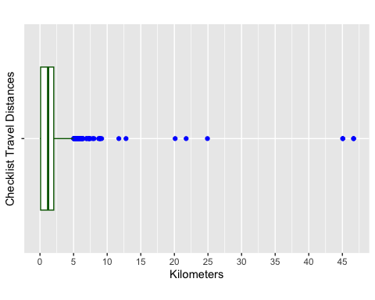

show(duration_minutes_boxplot(checklists.obs))

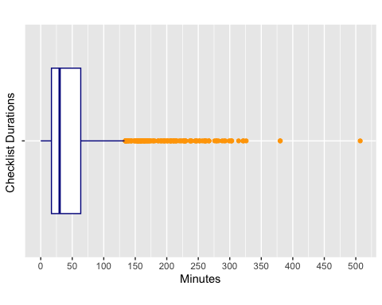

Get all the observer’s observations.

observations <- get_observations(observer = observer, project = NULL) %>%  
 to_EBD_format() %>%  
 auk_unique()

How many species have they reported?

print(length(unique(observations$common_name)))

## [1] 330

How many breeding codes have they reported in priority and non-priority block types?

observer_priority_by_breeding(observer = observer, data = "species")

## block_type confirmed probable possible observed  
## 1 priority 33 40 53 201  
## 2 non-priority 43 56 75 259  
## 3 either 53 65 80 276

How many blocks have they reported confirmation of breeding from?

observer_priority_by_breeding(observer = observer, data = "blocks")

## block_type confirmed probable possible observed  
## 1 priority 8 5 9 20  
## 2 non-priority 22 20 36 83  
## 3 either 30 25 45 103

How many complete checklists have they submitted from priority blocks versus non-priority blocks?

observer_complete_by_priority(observer = observer, data = "checklists")

## block_type complete incomplete  
## 1 priority 561 34  
## 2 non-priority 428 13  
## 3 either 989 47

From how many blocks have they submitted complete checklists?

observer_complete_by_priority(observer = observer, data = "blocks")

## # A tibble: 2 × 3  
## block_type complete incomplete  
## <chr> <int> <int>  
## 1 priority 19 4  
## 2 non-priority 80 10

Get all the checklists from the observer of interest.

checklists <- get_checklists(observer = observer) %>%  
 to_EBD_format() %>%  
 auk_unique(checklists_only = TRUE)

Plot observations by week.

lists_by_week(checklists)

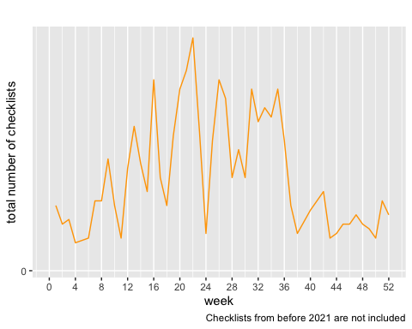

Summarize checklist distance.

show(effort_distance_boxplot(checklists))

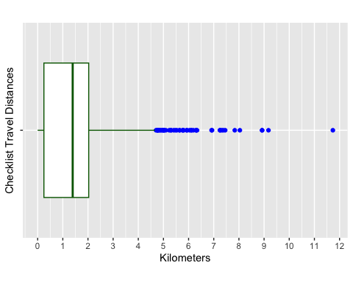

Summarize duration

show(duration_minutes_boxplot(checklists))

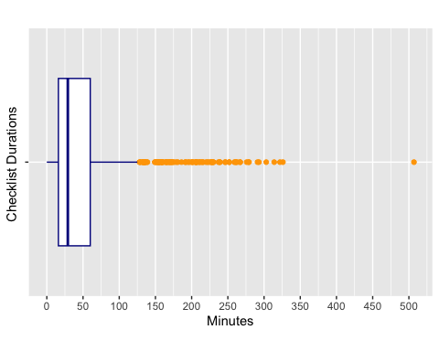

duration_distance_table(checklists)

## min median max mean sd count  
## duration (hours) 0 0.4833333 8.450 0.8469595 0.9820371 1036  
## distance (km) 0 1.3930000 11.734 1.5204903 1.5128143 1036

Summarize start times.

show(start_time_boxplot(checklists))

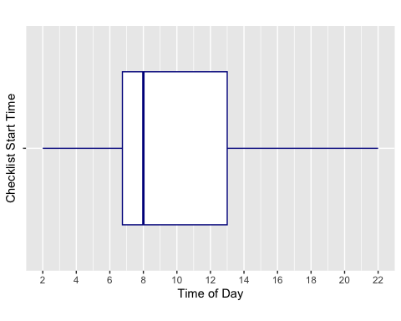

Summarize locality type.

show(locality_type_pie(checklists))

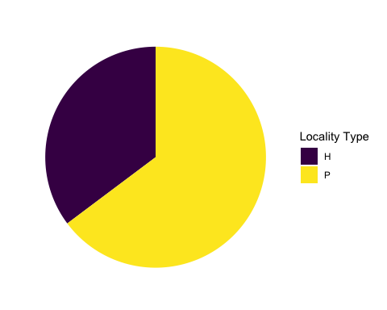

Summarize protocol in a table.

protocol_table(checklists)

## # A tibble: 3 × 4  
## protocol_type number percentage duration_hours  
## <chr> <int> <dbl> <dbl>  
## 1 Incidental 43 4.15 0   
## 2 Stationary 189 18.2 42.7  
## 3 Traveling 804 77.6 835.

Summarize protocol in a figure.

show(protocol_type_pie(checklists))

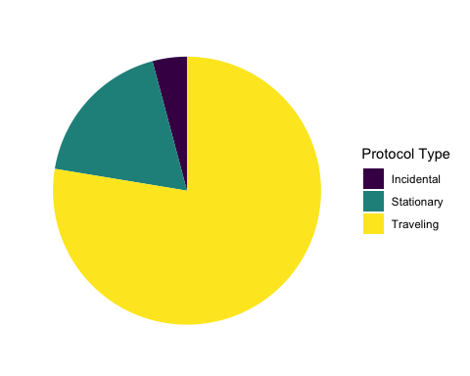

Summarize checklist completeness.

complete_checklist_table(checklists)

## # A tibble: 2 × 4  
## all_species_reported number percentage duration_hours  
## <lgl> <int> <dbl> <dbl>  
## 1 FALSE 47 4.54 0.3  
## 2 TRUE 989 95.5 877.

Summarize observations per year.

show(year_bar(checklists))

