MODEL YEAR 2027 · HABITATION REFERENCE
Weinsberg Layout Reference
Every current UK Weinsberg layout, with the manufacturer's own floorplan and the habitation detail the automated pipeline does not collect. Built to be read beside the FMLV data-entry form, and to be marked up.
29 layouts · 14 motorhomes · 15 campervans · Surveyed 3 September 2026
The drawing decides
Where Weinsberg's spec table and their floorplan disagree, the drawing wins. It has already settled two layouts here — see the CaraHome.
No left or right
These renders are left-hand drive and UK vehicles are not, so nothing below says nearside or offside. Side, rear and corner are safe; left and right flip.
The code carries the bed
Weinsberg's layout codes are descriptive: E single beds, F French bed, Q transverse, D double, K children, G garage, H high roof.

CaraCore
3 layouts · A-class
WASHROOM Mid, two compartments facing each other: a shower cubicle one side, toilet and basin the other separate_shower_toilet
KITCHEN Mid, along one side: 3-burner hob, round sink, tall fridge alongside side_kitchen
LOUNGE Front, side settee plus a small bench and the two swivelled cab seats front_lounge
650 MF
Row 1
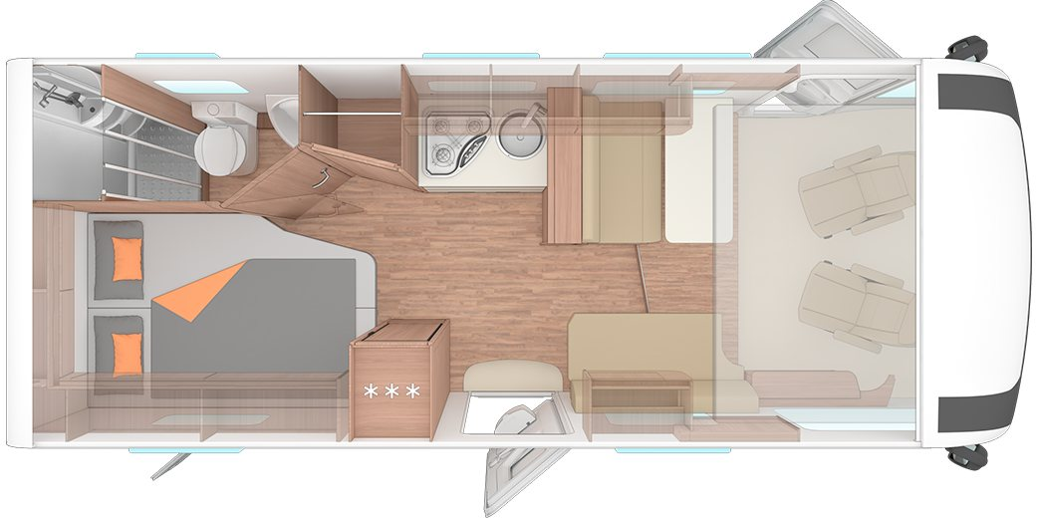
Weinsberg's own layout plan · caracore-650mf.png
BERTHS | LENGTH | GUIDE PRICE | REAR GARAGE
5 | 6,990 mm | £88,995 | yes
REAR BED French double 201 x 133/103, fore and aft with the near foot corner cut away
BED TYPES fixed_bed · drop_down_bed · make_up_beds
SLEEPING AREA sleeping_area_both
REFRIGERATION fridge freezer fridge_freezer
MICROWAVE no
Drop-down bed over the front lounge, standard and counted in Beds.
Front lounge also makes up a bed, 209 x 106.
Dedicated rear garage: the price list makes 'Garage door <W> x <H> cm' standard on every layout of this range, with published opening dimensions, which is the external hatch test the requester set for Dethleffs.
Standard load capacity 150 kg, 250 kg a GBP 1,165 option.
Fridge 142 l, drawn with the three-star freezer symbol on WEINSBERG's own floorplan.
Microwave: the word appears ZERO times in every WEINSBERG document read — all six UK price lists and both MY2027 catalogues.
Weaker than a Dethleffs-style negative, because no oven is listed either, so these documents may simply not enumerate cooking appliances beyond the hob.
Heating is a TRUMA Combi 4 or Combi 6 on every layout, which is blown air.
650 MEG
Row 2
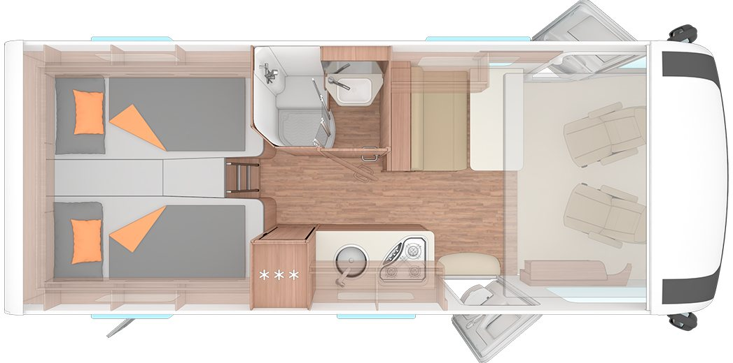
Weinsberg's own layout plan · caracore-650meg.png
BERTHS | LENGTH | GUIDE PRICE | REAR GARAGE
4 | 6,990 mm | £89,985 | yes
REAR BED Twin single beds 2 x 201 x 87, with an infill to make one double
BED TYPES fixed_separate_beds · drop_down_bed · make_up_beds
SLEEPING AREA sleeping_area_both
REFRIGERATION fridge freezer fridge_freezer
MICROWAVE no
Drop-down bed over the front lounge, standard and counted in Beds.
No made-up front bed on this layout (the front bed row reads a dash); the make-up entry is the infill between the singles.
Dedicated rear garage: the price list makes 'Garage door <W> x <H> cm' standard on every layout of this range, with published opening dimensions, which is the external hatch test the requester set for Dethleffs.
Standard load capacity 150 kg, 250 kg a GBP 1,165 option.
Fridge 142 l, drawn with the three-star freezer symbol on WEINSBERG's own floorplan.
Microwave: the word appears ZERO times in every WEINSBERG document read — all six UK price lists and both MY2027 catalogues.
Weaker than a Dethleffs-style negative, because no oven is listed either, so these documents may simply not enumerate cooking appliances beyond the hob.
Heating is a TRUMA Combi 4 or Combi 6 on every layout, which is blown air.
700 MEG
Row 3
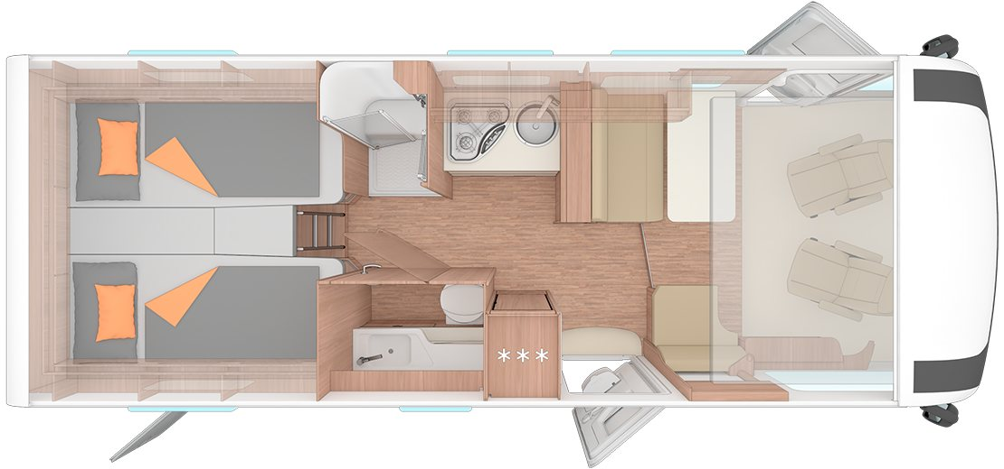
Weinsberg's own layout plan · caracore-700meg.png
BERTHS | LENGTH | GUIDE PRICE | REAR GARAGE
5 | 7,410 mm | £92,485 | yes
REAR BED Twin single beds 2 x 201 x 87, with an infill to make one double
BED TYPES fixed_separate_beds · drop_down_bed · make_up_beds
SLEEPING AREA sleeping_area_both
REFRIGERATION fridge freezer fridge_freezer
MICROWAVE no
Drop-down bed over the front lounge, standard and counted in Beds.
Front lounge also makes up a bed, 209 x 106/50.
Dedicated rear garage: the price list makes 'Garage door <W> x <H> cm' standard on every layout of this range, with published opening dimensions, which is the external hatch test the requester set for Dethleffs.
Standard load capacity 150 kg, 250 kg a GBP 1,165 option.
Fridge 142 l, drawn with the three-star freezer symbol on WEINSBERG's own floorplan.
Microwave: the word appears ZERO times in every WEINSBERG document read — all six UK price lists and both MY2027 catalogues.
Weaker than a Dethleffs-style negative, because no oven is listed either, so these documents may simply not enumerate cooking appliances beyond the hob.
Heating is a TRUMA Combi 4 or Combi 6 on every layout, which is blown air.

CaraHome
3 layouts · Coachbuilt, over-cab bed
WASHROOM Mid, one room divided by a swivel wall: toilet one side, shower tray the other separate_shower_toilet
KITCHEN Mid, along one side: hob, round sink, tall fridge alongside side_kitchen
LOUNGE Front, dinette plus the two swivelled cab seats, under the alcove front_lounge
600 DKG
Row 4
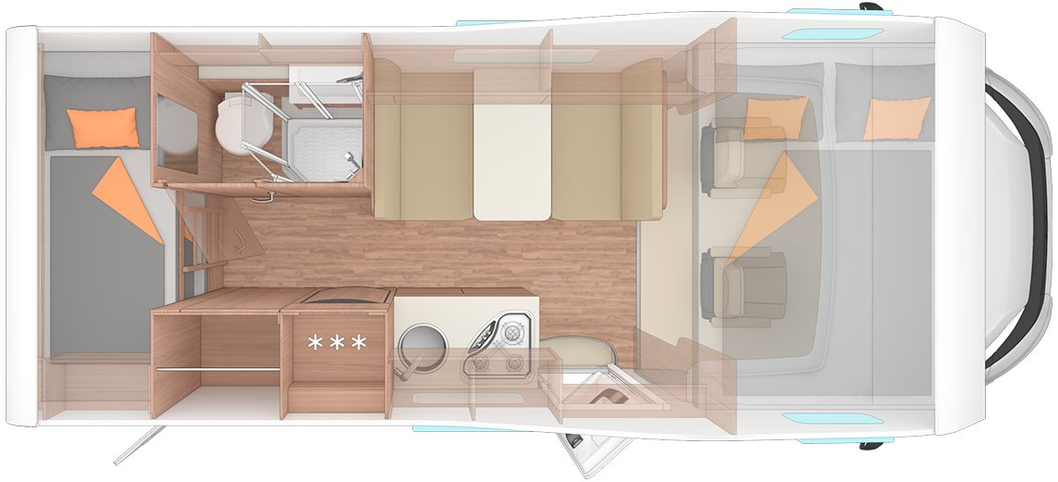
Weinsberg's own layout plan · carahome-600dkg.png
BERTHS | LENGTH | GUIDE PRICE | REAR GARAGE
6 | 6,450 mm | £71,585 | yes
REAR BED Rear bunk beds 211 x 74 and 194 x 76, one above the other
BED TYPES fixed_bunks · fixed_bed · make_up_beds
SLEEPING AREA sleeping_area_both
REFRIGERATION fridge freezer fridge_freezer
MICROWAVE no
CHECK
The rear bunks are the children's berths, so a reviewer may prefer sleeping_area_separate_childrens_area — the drawing does not clearly show a door to that compartment, so the safer 'both' is recorded.
Alcove double 210 x 140 over the cab, standard.
Front dinette makes up 184 x 100.
Layout code DKG reads D double, K Kinder (children), G garage.
Dedicated rear garage: the price list makes 'Garage door <W> x <H> cm' standard on every layout of this range, with published opening dimensions, which is the external hatch test the requester set for Dethleffs.
Standard load capacity 150 kg, 250 kg a GBP 1,165 option.
Fridge 177 l, drawn with the three-star freezer symbol on WEINSBERG's own floorplan.
Microwave: the word appears ZERO times in every WEINSBERG document read — all six UK price lists and both MY2027 catalogues.
Weaker than a Dethleffs-style negative, because no oven is listed either, so these documents may simply not enumerate cooking appliances beyond the hob.
Heating is a TRUMA Combi 4 or Combi 6 on every layout, which is blown air.
650 DG
Row 5
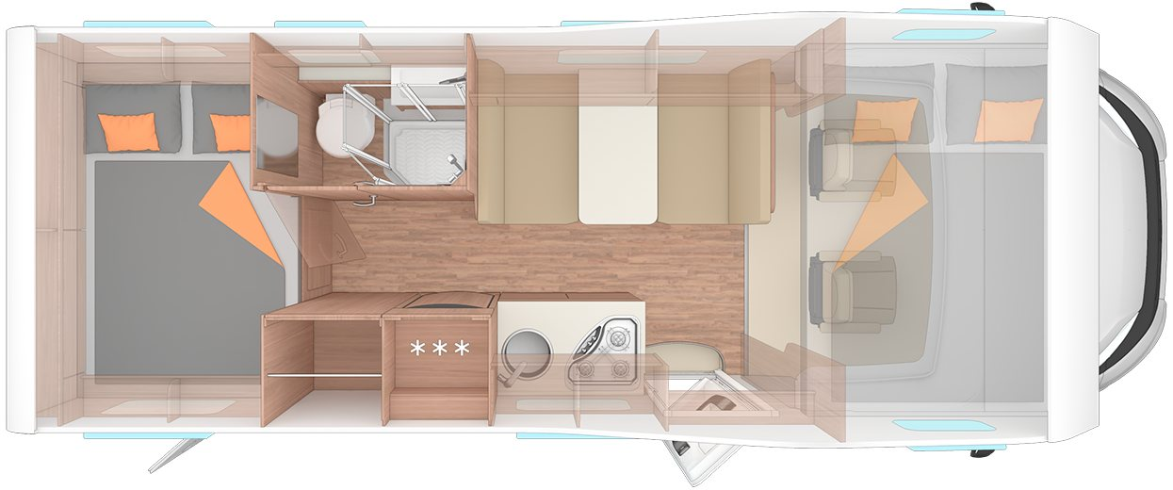
Weinsberg's own layout plan · carahome-650dg.png
BERTHS | LENGTH | GUIDE PRICE | REAR GARAGE
6 | 6,990 mm | £73,985 | yes
REAR BED Transverse double 210 x 141/135 across the rear, one corner cut away
BED TYPES transverse_bed · fixed_bed · make_up_beds
SLEEPING AREA sleeping_area_both
REFRIGERATION fridge freezer fridge_freezer
MICROWAVE no
CHECK
TRAP: WEINSBERG's own 'Single bed' and 'Transverse bed' marker rows are SWAPPED between the 650 DG and the 650 MEG in this price list, so the rear bed here is recorded from the drawing instead — the rear-bed dimensions, the drawing and the layout code all agree with each other against the markers, D being a double and E being Einzelbetten (single beds) in WEINSBERG's own naming.
Alcove double 210 x 140 over the cab, standard.
Front dinette makes up 184 x 120.
Dedicated rear garage: the price list makes 'Garage door <W> x <H> cm' standard on every layout of this range, with published opening dimensions, which is the external hatch test the requester set for Dethleffs.
Standard load capacity 150 kg, 250 kg a GBP 1,165 option.
Fridge 177 l, drawn with the three-star freezer symbol on WEINSBERG's own floorplan.
Microwave: the word appears ZERO times in every WEINSBERG document read — all six UK price lists and both MY2027 catalogues.
Weaker than a Dethleffs-style negative, because no oven is listed either, so these documents may simply not enumerate cooking appliances beyond the hob.
Heating is a TRUMA Combi 4 or Combi 6 on every layout, which is blown air.
650 MEG
Row 6
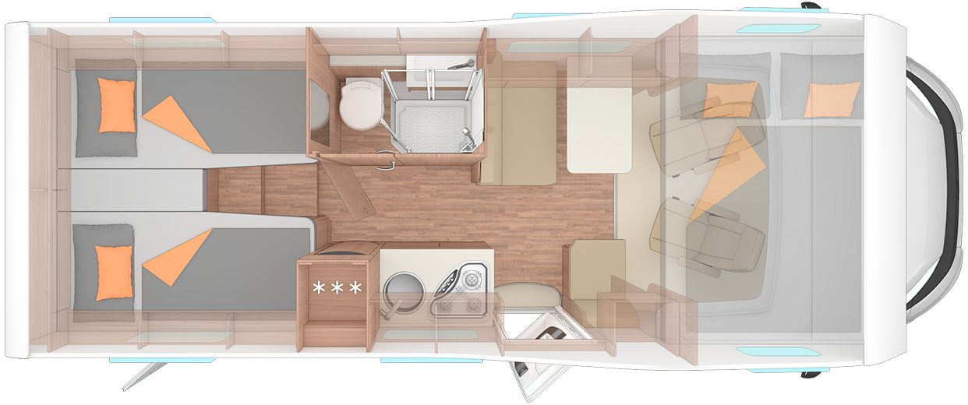
Weinsberg's own layout plan · carahome-650meg.png
BERTHS | LENGTH | GUIDE PRICE | REAR GARAGE
5 | 6,990 mm | £73,995 | yes
REAR BED Twin single beds 190 x 87 and 201 x 87, with an infill
BED TYPES fixed_separate_beds · fixed_bed · make_up_beds
SLEEPING AREA sleeping_area_both
REFRIGERATION fridge freezer fridge_freezer
MICROWAVE no
CHECK
TRAP: WEINSBERG's own 'Single bed' and 'Transverse bed' marker rows are SWAPPED between the 650 DG and the 650 MEG in this price list, so the rear bed here is recorded from the drawing instead — the rear-bed dimensions, the drawing and the layout code all agree with each other against the markers, D being a double and E being Einzelbetten (single beds) in WEINSBERG's own naming.
Alcove double 210 x 140 over the cab, standard.
Front dinette makes up 184 x 120.
Dedicated rear garage: the price list makes 'Garage door <W> x <H> cm' standard on every layout of this range, with published opening dimensions, which is the external hatch test the requester set for Dethleffs.
Standard load capacity 150 kg, 250 kg a GBP 1,165 option.
Fridge 142 l, drawn with the three-star freezer symbol on WEINSBERG's own floorplan.
Microwave: the word appears ZERO times in every WEINSBERG document read — all six UK price lists and both MY2027 catalogues.
Weaker than a Dethleffs-style negative, because no oven is listed either, so these documents may simply not enumerate cooking appliances beyond the hob.
Heating is a TRUMA Combi 4 or Combi 6 on every layout, which is blown air.

CaraSuite
5 layouts · Coachbuilt, low profile
WASHROOM Mid, two compartments facing each other: a shower cubicle one side, toilet and basin the other separate_shower_toilet
KITCHEN Mid, along one side: 3-burner hob, round sink, tall fridge alongside side_kitchen
LOUNGE Front, side settee plus the two swivelled cab seats front_lounge
650 MF
Row 7
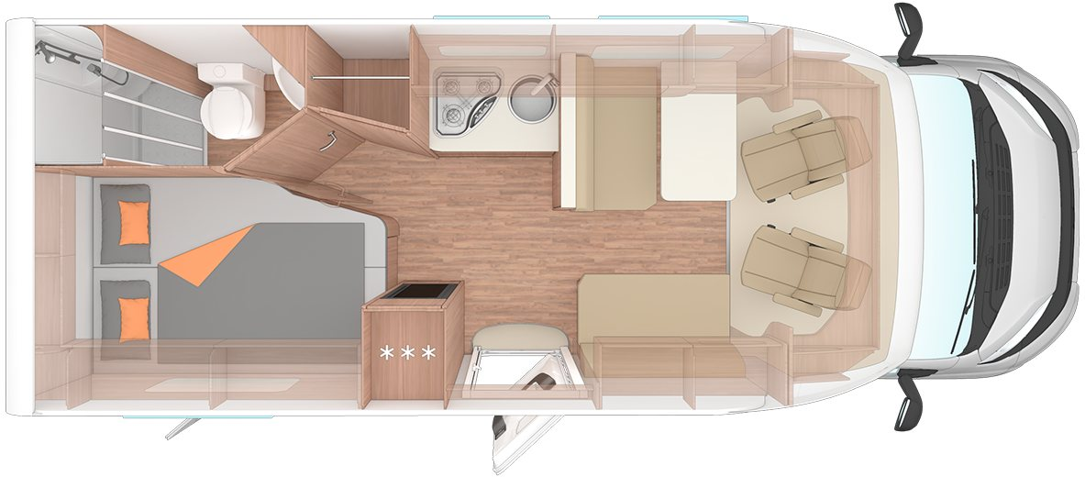
Weinsberg's own layout plan · carasuite-spicy-650mf.png
BERTHS | LENGTH | GUIDE PRICE | REAR GARAGE
3 | 6,990 mm | £72,285 | yes
REAR BED French double 201 x 133/103, fore and aft with the near foot corner cut away
BED TYPES fixed_bed · make_up_beds
SLEEPING AREA sleeping_area_both
REFRIGERATION fridge freezer fridge_freezer
MICROWAVE no
A lifting bed over the front lounge is published with a size on every layout of this range but is NOT counted in Beds (Beds 3 against Max. number of beds 5), so it is an option and is left out of the bed types per the base-vehicle rule.
Front lounge makes up 210 x 123/110.
Dedicated rear garage: the price list makes 'Garage door <W> x <H> cm' standard on every layout of this range, with published opening dimensions, which is the external hatch test the requester set for Dethleffs.
Standard load capacity 150 kg, 250 kg a GBP 1,165 option.
Fridge 133 l, drawn with the three-star freezer symbol on WEINSBERG's own floorplan.
Microwave: the word appears ZERO times in every WEINSBERG document read — all six UK price lists and both MY2027 catalogues.
Weaker than a Dethleffs-style negative, because no oven is listed either, so these documents may simply not enumerate cooking appliances beyond the hob.
Heating is a TRUMA Combi 4 or Combi 6 on every layout, which is blown air.
650 MG
Row 8
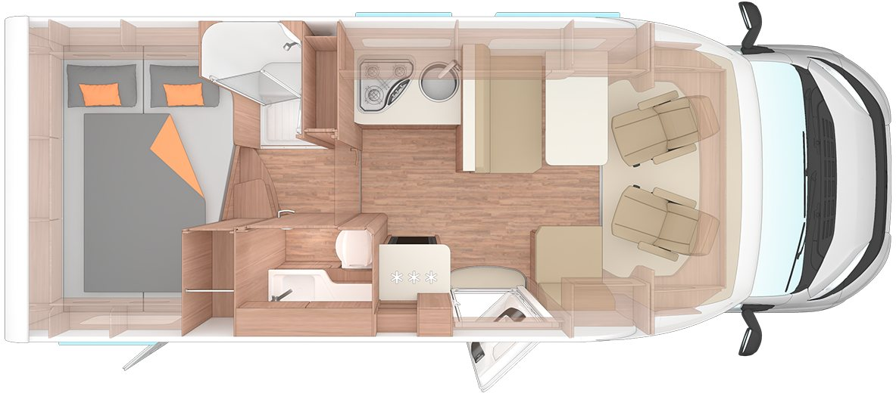
Weinsberg's own layout plan · carasuite-spicy-650mg.png
BERTHS | LENGTH | GUIDE PRICE | REAR GARAGE
3 | 6,990 mm | £72,285 | yes
REAR BED Transverse double 210 x 135/123 across the rear
BED TYPES transverse_bed · make_up_beds
SLEEPING AREA sleeping_area_both
REFRIGERATION fridge freezer fridge_freezer
MICROWAVE no
A lifting bed over the front lounge is published with a size on every layout of this range but is NOT counted in Beds (Beds 3 against Max. number of beds 5), so it is an option and is left out of the bed types per the base-vehicle rule.
Front lounge makes up 210 x 123/72.
Dedicated rear garage: the price list makes 'Garage door <W> x <H> cm' standard on every layout of this range, with published opening dimensions, which is the external hatch test the requester set for Dethleffs.
Standard load capacity 150 kg, 250 kg a GBP 1,165 option.
Fridge 133 l, drawn with the three-star freezer symbol on WEINSBERG's own floorplan.
Microwave: the word appears ZERO times in every WEINSBERG document read — all six UK price lists and both MY2027 catalogues.
Weaker than a Dethleffs-style negative, because no oven is listed either, so these documents may simply not enumerate cooking appliances beyond the hob.
Heating is a TRUMA Combi 4 or Combi 6 on every layout, which is blown air.
650 MEG
Row 9
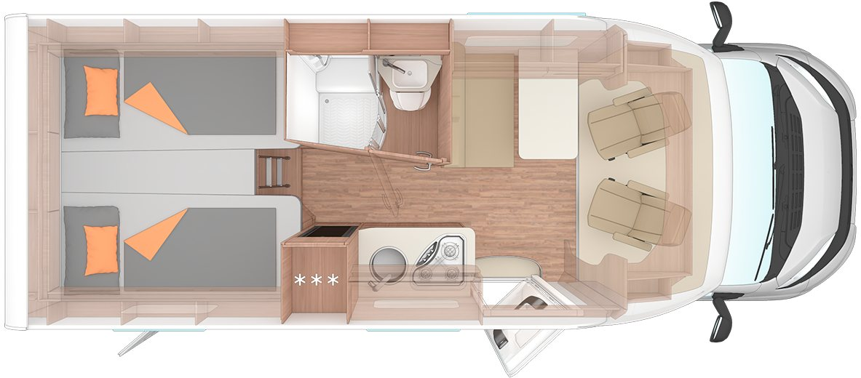
Weinsberg's own layout plan · carasuite-spicy-650meg.png
BERTHS | LENGTH | GUIDE PRICE | REAR GARAGE
2 | 6,990 mm | £72,295 | yes
REAR BED Twin single beds, 200 x 92 each
BED TYPES fixed_separate_beds · make_up_beds
SLEEPING AREA sleeping_area_rear
REFRIGERATION fridge freezer fridge_freezer
MICROWAVE no
A lifting bed over the front lounge is published with a size on every layout of this range but is NOT counted in Beds (Beds 2 against Max. number of beds 4), so it is an option and is left out of the bed types per the base-vehicle rule.
No made-up front bed on this layout.
The make-up entry is the infill between the singles.
Dedicated rear garage: the price list makes 'Garage door <W> x <H> cm' standard on every layout of this range, with published opening dimensions, which is the external hatch test the requester set for Dethleffs.
Standard load capacity 150 kg, 250 kg a GBP 1,165 option.
Fridge 142 l, drawn with the three-star freezer symbol on WEINSBERG's own floorplan.
Microwave: the word appears ZERO times in every WEINSBERG document read — all six UK price lists and both MY2027 catalogues.
Weaker than a Dethleffs-style negative, because no oven is listed either, so these documents may simply not enumerate cooking appliances beyond the hob.
Heating is a TRUMA Combi 4 or Combi 6 on every layout, which is blown air.
700 MEG
Row 10
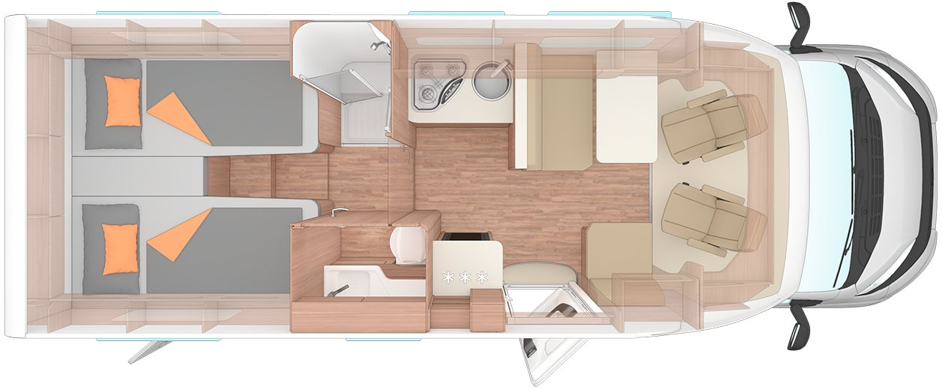
Weinsberg's own layout plan · carasuite-spicy-700meg.png
BERTHS | LENGTH | GUIDE PRICE | REAR GARAGE
3 | 7,410 mm | £74,995 | yes
REAR BED Twin single beds, 200 x 92 each
BED TYPES fixed_separate_beds · make_up_beds
SLEEPING AREA sleeping_area_both
REFRIGERATION fridge freezer fridge_freezer
MICROWAVE no
A lifting bed over the front lounge is published with a size on every layout of this range but is NOT counted in Beds (Beds 3 against Max. number of beds 5), so it is an option and is left out of the bed types per the base-vehicle rule.
Front lounge makes up 210 x 118/58.
Dedicated rear garage: the price list makes 'Garage door <W> x <H> cm' standard on every layout of this range, with published opening dimensions, which is the external hatch test the requester set for Dethleffs.
Standard load capacity 150 kg, 250 kg a GBP 1,165 option.
Fridge 133 l, drawn with the three-star freezer symbol on WEINSBERG's own floorplan.
Microwave: the word appears ZERO times in every WEINSBERG document read — all six UK price lists and both MY2027 catalogues.
Weaker than a Dethleffs-style negative, because no oven is listed either, so these documents may simply not enumerate cooking appliances beyond the hob.
Heating is a TRUMA Combi 4 or Combi 6 on every layout, which is blown air.
700 DX
Row 11
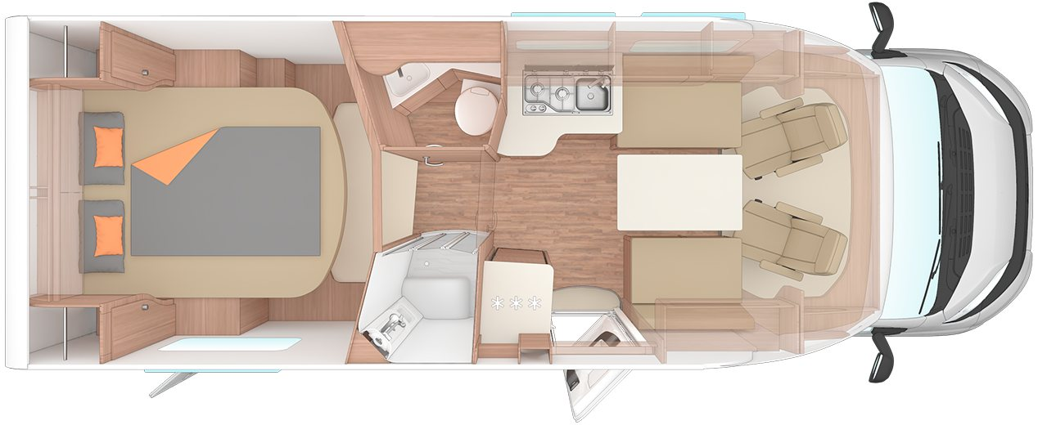
Weinsberg's own layout plan · carasuite-spicy-700dx.png
BERTHS | LENGTH | GUIDE PRICE | REAR GARAGE
2 | 7,470 mm | £75,995 | yes
REAR BED Island double 196 x 162, set clear of the rear wall with walk-round space at the foot
BED TYPES island_bed · make_up_beds
SLEEPING AREA sleeping_area_both
REFRIGERATION fridge freezer fridge_freezer
MICROWAVE no
A lifting bed over the front lounge is published with a size on every layout of this range but is NOT counted in Beds (Beds 2 against Max. number of beds 4), so it is an option and is left out of the bed types per the base-vehicle rule.
Front lounge makes up 212 x 102/92.
WEINSBERG call this row 'Queen-size bed' rather than using their island wording; the drawing shows walk-round access on both sides and at the foot, with a wardrobe in each rear corner, which is an island bed.
Dedicated rear garage: the price list makes 'Garage door <W> x <H> cm' standard on every layout of this range, with published opening dimensions, which is the external hatch test the requester set for Dethleffs.
Standard load capacity 150 kg, 250 kg a GBP 1,165 option.
Fridge 150 l, drawn with the three-star freezer symbol on WEINSBERG's own floorplan.
Microwave: the word appears ZERO times in every WEINSBERG document read — all six UK price lists and both MY2027 catalogues.
Weaker than a Dethleffs-style negative, because no oven is listed either, so these documents may simply not enumerate cooking appliances beyond the hob.
Heating is a TRUMA Combi 4 or Combi 6 on every layout, which is blown air.

CaraCompact
3 layouts · Coachbuilt, low profile
WASHROOM Rear corner, one room with a swivel wall that turns it into the shower; basin on the corridor side side_shower_toilet
KITCHEN Mid, along one side: hob, round sink, tall fridge alongside side_kitchen
LOUNGE Front, half-dinette plus the two swivelled cab seats front_lounge
580 MEG Edition PEPPER
Row 12
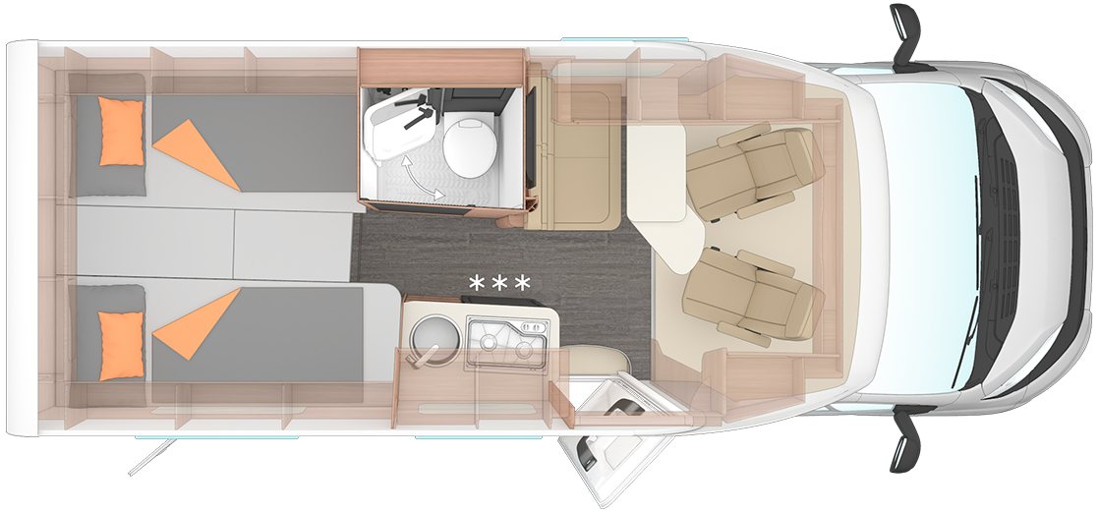
Weinsberg's own layout plan · caracompact-pepper-580meg.png
BERTHS | LENGTH | GUIDE PRICE | REAR GARAGE
2 | 6,380 mm | £69,695 | yes
REAR BED Twin single beds 190 x 82 and 210 x 75
BED TYPES fixed_separate_beds · make_up_beds
SLEEPING AREA sleeping_area_rear
REFRIGERATION fridge freezer fridge_freezer
MICROWAVE no
No drop-down or lifting bed on this range and no made-up front bed: Beds and Max. number of beds both read 2, so the front dinette is not a berth.
The make-up entry is the infill between the singles.
Dedicated rear garage: the price list makes 'Garage door <W> x <H> cm' standard on every layout of this range, with published opening dimensions, which is the external hatch test the requester set for Dethleffs.
Standard load capacity 150 kg, 250 kg a GBP 1,165 option.
Fridge 83 l, drawn with the three-star freezer symbol on WEINSBERG's own floorplan.
Microwave: the word appears ZERO times in every WEINSBERG document read — all six UK price lists and both MY2027 catalogues.
Weaker than a Dethleffs-style negative, because no oven is listed either, so these documents may simply not enumerate cooking appliances beyond the hob.
Heating is a TRUMA Combi 4 or Combi 6 on every layout, which is blown air.
600 MF Edition PEPPER
Row 13
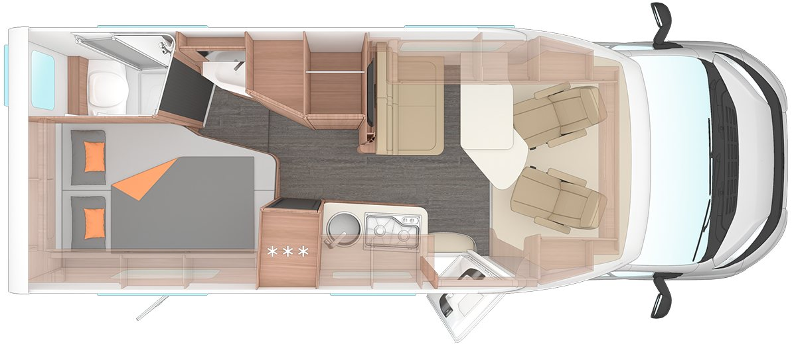
Weinsberg's own layout plan · caracompact-pepper-600mf.png
BERTHS | LENGTH | GUIDE PRICE | REAR GARAGE
2 | 6,750 mm | £70,745 | yes
REAR BED French double 201 x 140, fore and aft with the near foot corner cut away
BED TYPES fixed_bed
SLEEPING AREA sleeping_area_rear
REFRIGERATION fridge freezer fridge_freezer
MICROWAVE no
No drop-down or lifting bed on this range and no made-up front bed: Beds and Max. number of beds both read 2. Dedicated rear garage: the price list makes 'Garage door <W> x <H> cm' standard on every layout of this range, with published opening dimensions, which is the external hatch test the requester set for Dethleffs.
Standard load capacity 150 kg, 250 kg a GBP 1,165 option.
Fridge 153 l, drawn with the three-star freezer symbol on WEINSBERG's own floorplan.
Microwave: the word appears ZERO times in every WEINSBERG document read — all six UK price lists and both MY2027 catalogues.
Weaker than a Dethleffs-style negative, because no oven is listed either, so these documents may simply not enumerate cooking appliances beyond the hob.
Heating is a TRUMA Combi 4 or Combi 6 on every layout, which is blown air.
600 MEG Edition PEPPER
Row 14
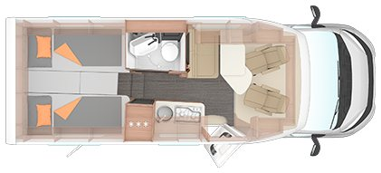
Weinsberg's own layout plan · caracompact-pepper-600meg.png
BERTHS | LENGTH | GUIDE PRICE | REAR GARAGE
2 | 6,750 mm | £71,455 | yes
REAR BED Twin single beds, 2 x 200 x 82
BED TYPES fixed_separate_beds · make_up_beds
SLEEPING AREA sleeping_area_rear
REFRIGERATION fridge freezer fridge_freezer
MICROWAVE no
CHECK
TRAP: Weinsberg's full-size day and night assets in this layout's own folder are a DIFFERENT vehicle's drawing — their drawn content is 2.148 wide-to-tall against this layout's 2.285, a 6.0% mismatch that tracks a different length.
No drop-down or lifting bed on this range and no made-up front bed: Beds and Max. number of beds both read 2. The make-up entry is the infill between the singles.
Dedicated rear garage: the price list makes 'Garage door <W> x <H> cm' standard on every layout of this range, with published opening dimensions, which is the external hatch test the requester set for Dethleffs.
Standard load capacity 150 kg, 250 kg a GBP 1,165 option.
Fridge 153 l, drawn with the three-star freezer symbol on WEINSBERG's own floorplan.
Microwave: the word appears ZERO times in every WEINSBERG document read — all six UK price lists and both MY2027 catalogues.
Weaker than a Dethleffs-style negative, because no oven is listed either, so these documents may simply not enumerate cooking appliances beyond the hob.
Heating is a TRUMA Combi 4 or Combi 6 on every layout, which is blown air.
The correct low-resolution overview drawing is kept instead.

CaraBus
14 layouts · Campervan, high top
WASHROOM Mid, one compact room with a swivel toilet and a basin; the room doubles as the shower side_shower_toilet
KITCHEN Mid, along one side: 2-burner hob, sink, fridge alongside side_kitchen
LOUNGE Front, bench plus the two swivelled cab seats front_lounge
540 MQ Edition FIRE
Row 15
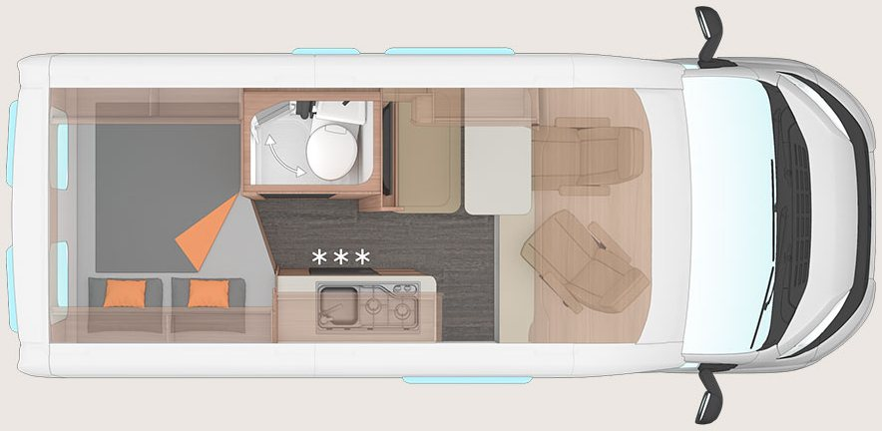
Weinsberg's own layout plan · carabus-fire-540mq.jpg
BERTHS | LENGTH | GUIDE PRICE | REAR GARAGE
2 | 5,410 mm | £63,494 | no
REAR BED Transverse double 194 x 140/125 across the rear
BED TYPES transverse_bed · make_up_beds
SLEEPING AREA sleeping_area_rear
REFRIGERATION fridge freezer fridge_freezer
MICROWAVE no
The WEINSBERG pop-up roof KOMFORT is an option here (GBP 5,516), not standard, so its 135 x 200 bed is excluded from the berths and the body type stays a plain high top.
The front seating group makes up a spare bed, 145 x 70.
NOT a rear garage.
The only rear-storage row is '552964-10 Large variable storage space in the rear', standard on all seven with hint H181 'Garage height 135 cm' — under-bed space loaded through the rear doors, with no external hatch and no published opening.
Per the requester's Dethleffs decision of 2 September 2026 that is storage, not a garage.
Fridge 75 l, drawn with the three-star freezer symbol on WEINSBERG's own floorplan.
Microwave: the word appears ZERO times in every WEINSBERG document read — all six UK price lists and both MY2027 catalogues.
Weaker than a Dethleffs-style negative, because no oven is listed either, so these documents may simply not enumerate cooking appliances beyond the hob.
Heating is a TRUMA Combi 4 or Combi 6 on every layout, which is blown air.
600 MQ Edition FIRE
Row 16
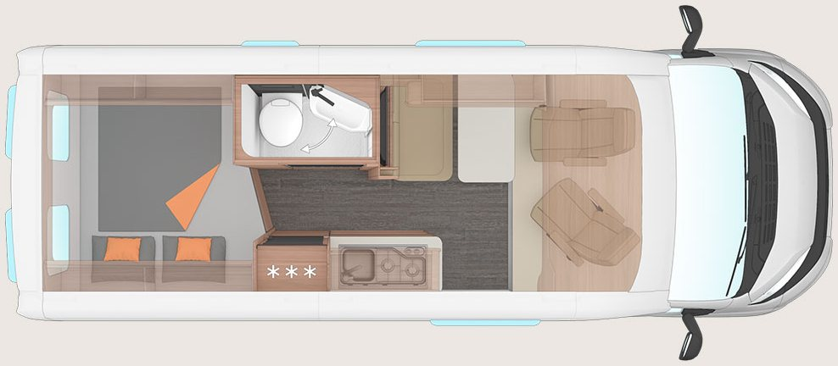
Weinsberg's own layout plan · carabus-fire-600mq.jpg
BERTHS | LENGTH | GUIDE PRICE | REAR GARAGE
3 | 5,990 mm | £65,295 | no
REAR BED Transverse double 194 x 152/140 across the rear
BED TYPES transverse_bed · make_up_beds
SLEEPING AREA sleeping_area_rear
REFRIGERATION fridge freezer fridge_freezer
MICROWAVE no
The WEINSBERG pop-up roof KOMFORT is an option here (GBP 5,516), not standard, so its 135 x 200 bed is excluded from the berths and the body type stays a plain high top.
The front seating group makes up a spare bed, 180 x 70.
NOT a rear garage.
The only rear-storage row is '552964-10 Large variable storage space in the rear', standard on all seven with hint H181 'Garage height 135 cm' — under-bed space loaded through the rear doors, with no external hatch and no published opening.
Per the requester's Dethleffs decision of 2 September 2026 that is storage, not a garage.
Fridge 95 l, drawn with the three-star freezer symbol on WEINSBERG's own floorplan.
Microwave: the word appears ZERO times in every WEINSBERG document read — all six UK price lists and both MY2027 catalogues.
Weaker than a Dethleffs-style negative, because no oven is listed either, so these documents may simply not enumerate cooking appliances beyond the hob.
Heating is a TRUMA Combi 4 or Combi 6 on every layout, which is blown air.
600 ME Edition FIRE
Row 17
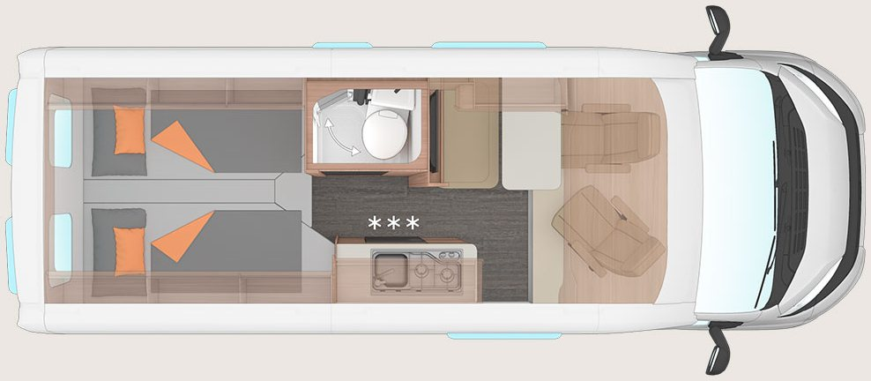
Weinsberg's own layout plan · carabus-fire-600me.jpg
BERTHS | LENGTH | GUIDE PRICE | REAR GARAGE
2 | 5,990 mm | £66,585 | no
REAR BED Twin single beds 180 x 85 and 200 x 85
BED TYPES fixed_separate_beds · make_up_beds
SLEEPING AREA sleeping_area_rear
REFRIGERATION fridge freezer fridge_freezer
MICROWAVE no
The WEINSBERG pop-up roof KOMFORT is an option here (GBP 5,516), not standard, so its 135 x 200 bed is excluded from the berths and the body type stays a plain high top.
The front seating group makes up a spare bed, 145 x 70.
NOT a rear garage.
The only rear-storage row is '552964-10 Large variable storage space in the rear', standard on all seven with hint H181 'Garage height 135 cm' — under-bed space loaded through the rear doors, with no external hatch and no published opening.
Per the requester's Dethleffs decision of 2 September 2026 that is storage, not a garage.
Fridge 75 l, drawn with the three-star freezer symbol on WEINSBERG's own floorplan.
Microwave: the word appears ZERO times in every WEINSBERG document read — all six UK price lists and both MY2027 catalogues.
Weaker than a Dethleffs-style negative, because no oven is listed either, so these documents may simply not enumerate cooking appliances beyond the hob.
Heating is a TRUMA Combi 4 or Combi 6 on every layout, which is blown air.
600 DQ Edition FIRE
Row 18
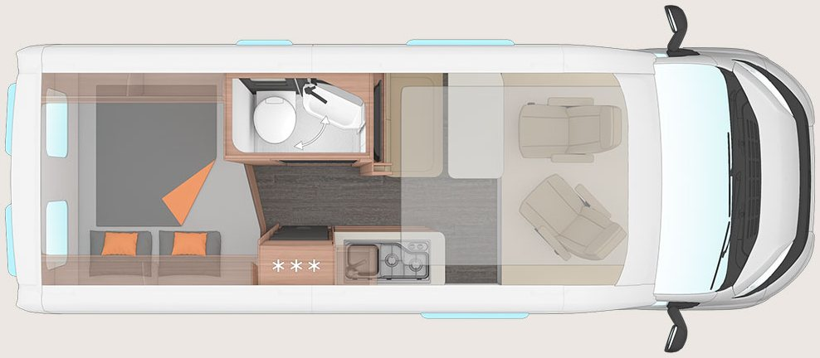
Weinsberg's own layout plan · carabus-fire-600dq.jpg
BERTHS | LENGTH | GUIDE PRICE | REAR GARAGE
5 | 5,990 mm | £72,494 | no
REAR BED Transverse double 194 x 152/140 across the rear
BED TYPES transverse_bed · drop_down_bed · make_up_beds
SLEEPING AREA sleeping_area_both
REFRIGERATION fridge freezer fridge_freezer
MICROWAVE no
Lifting bed 176 x 130 over the front lounge, standard.
The pop-up roof is not available on this layout.
The front seating group makes up a spare bed, 180 x 70.
NOT a rear garage.
The only rear-storage row is '552964-10 Large variable storage space in the rear', standard on all seven with hint H181 'Garage height 135 cm' — under-bed space loaded through the rear doors, with no external hatch and no published opening.
Per the requester's Dethleffs decision of 2 September 2026 that is storage, not a garage.
Fridge 95 l, drawn with the three-star freezer symbol on WEINSBERG's own floorplan.
Microwave: the word appears ZERO times in every WEINSBERG document read — all six UK price lists and both MY2027 catalogues.
Weaker than a Dethleffs-style negative, because no oven is listed either, so these documents may simply not enumerate cooking appliances beyond the hob.
Heating is a TRUMA Combi 4 or Combi 6 on every layout, which is blown air.
600 MQH Edition FIRE
Row 19
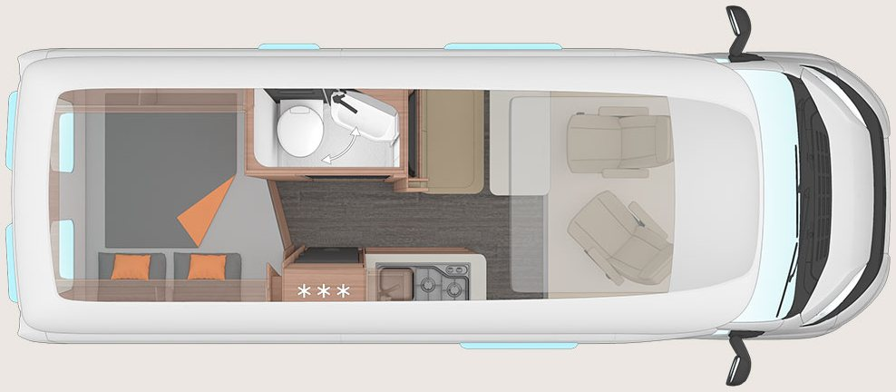
Weinsberg's own layout plan · carabus-fire-600mqh.jpg
BERTHS | LENGTH | GUIDE PRICE | REAR GARAGE
5 | 5,990 mm | £72,985 | no
REAR BED Transverse double 194 x 152/140 across the rear
BED TYPES transverse_bed · drop_down_bed · make_up_beds
SLEEPING AREA sleeping_area_both
REFRIGERATION fridge freezer fridge_freezer
MICROWAVE no
The high roof carries an EasySlide bed 200 x 130, standard — recorded as a drop-down bed, which is the closest FMLV value.
This is the 312 cm GRP high-roof body; the pop-up roof is not available on it.
The front seating group makes up a spare bed, 180 x 70.
NOT a rear garage.
The only rear-storage row is '552964-10 Large variable storage space in the rear', standard on all seven with hint H181 'Garage height 135 cm' — under-bed space loaded through the rear doors, with no external hatch and no published opening.
Per the requester's Dethleffs decision of 2 September 2026 that is storage, not a garage.
Fridge 95 l, drawn with the three-star freezer symbol on WEINSBERG's own floorplan.
Microwave: the word appears ZERO times in every WEINSBERG document read — all six UK price lists and both MY2027 catalogues.
Weaker than a Dethleffs-style negative, because no oven is listed either, so these documents may simply not enumerate cooking appliances beyond the hob.
Heating is a TRUMA Combi 4 or Combi 6 on every layout, which is blown air.
630 ME Edition FIRE
Row 20
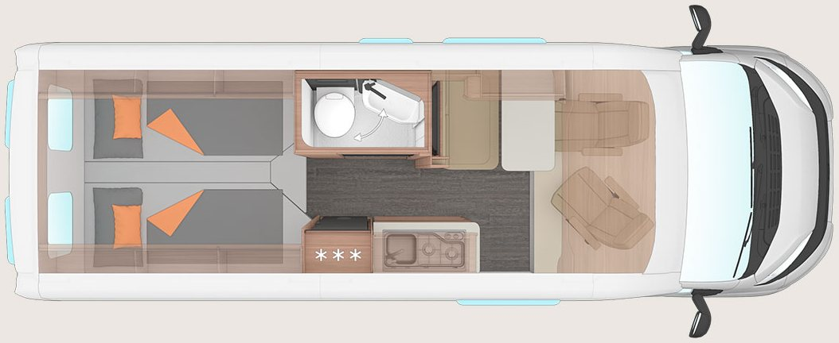
Weinsberg's own layout plan · carabus-fire-630me.jpg
BERTHS | LENGTH | GUIDE PRICE | REAR GARAGE
3 | 6,360 mm | £74,289 | no
REAR BED Twin single beds 195 x 85 and 200 x 85
BED TYPES fixed_separate_beds · drop_down_bed · make_up_beds
SLEEPING AREA sleeping_area_both
REFRIGERATION fridge freezer fridge_freezer
MICROWAVE no
Drop-down bed over the front lounge, standard.
The WEINSBERG pop-up roof KOMFORT is an option here (GBP 5,516), not standard, so its 135 x 200 bed is excluded from the berths and the body type stays a plain high top.
The front seating group makes up a spare bed, 180 x 70.
NOT a rear garage.
The only rear-storage row is '552964-10 Large variable storage space in the rear', standard on all seven with hint H181 'Garage height 135 cm' — under-bed space loaded through the rear doors, with no external hatch and no published opening.
Per the requester's Dethleffs decision of 2 September 2026 that is storage, not a garage.
Fridge 95 l, drawn with the three-star freezer symbol on WEINSBERG's own floorplan.
Microwave: the word appears ZERO times in every WEINSBERG document read — all six UK price lists and both MY2027 catalogues.
Weaker than a Dethleffs-style negative, because no oven is listed either, so these documents may simply not enumerate cooking appliances beyond the hob.
Heating is a TRUMA Combi 4 or Combi 6 on every layout, which is blown air.
630 MEG Edition FIRE
Row 21
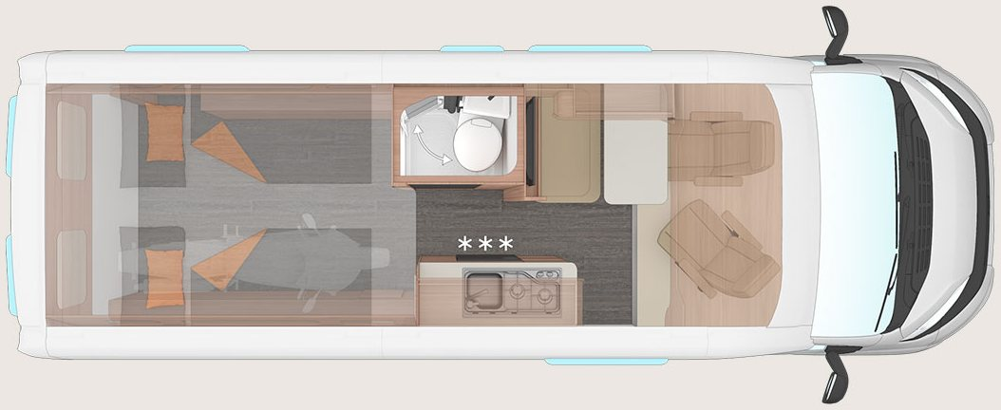
Weinsberg's own layout plan · carabus-fire-630meg.jpg
BERTHS | LENGTH | GUIDE PRICE | REAR GARAGE
2 | 6,360 mm | £70,295 | yes
REAR BED Twin single beds over the rear garage, 170 x 193/206
BED TYPES fixed_separate_beds · make_up_beds
SLEEPING AREA sleeping_area_rear
REFRIGERATION fridge freezer fridge_freezer
MICROWAVE no
CHECK
Recorded YES, and this is the one to check: the 630 MEG is the [OUTLAW], whose page calls it a 'separate rear garage' with 'room for two motorcycles or one quad bike' and a 'gas-tight door' from the living area, whose drawing shows a motorcycle inside it, and whose price list adds two options unique to this layout ('102785 Checker plate for garage floor' and '103460 Low garage height') plus airline rails and lashing eyes — but it is still loaded through the rear doors rather than an external side hatch, so the LETTER of the requester's Dethleffs test says no while its REASON (is this just the space under the bed?) says yes.
This is the [OUTLAW] layout: the beds sit over a separate rear compartment reached through a gas-tight door, with a motorcycle drawn in it on WEINSBERG's own plan.
The pop-up roof is not available on this layout.
The front seating group makes up a spare bed, 145 x 70.
Fridge 75 l, drawn with the three-star freezer symbol on WEINSBERG's own floorplan.
Microwave: the word appears ZERO times in every WEINSBERG document read — all six UK price lists and both MY2027 catalogues.
Weaker than a Dethleffs-style negative, because no oven is listed either, so these documents may simply not enumerate cooking appliances beyond the hob.
Heating is a TRUMA Combi 4 or Combi 6 on every layout, which is blown air.
540 MQ GREY Edition FIRE
Row 22

Weinsberg's own layout plan · carabus-grey-fire-540mq.jpg
BERTHS | LENGTH | GUIDE PRICE | REAR GARAGE
2 | 5,410 mm | £63,494 | no
REAR BED Transverse double 194 x 140/125 across the rear
BED TYPES transverse_bed · make_up_beds
SLEEPING AREA sleeping_area_rear
REFRIGERATION fridge freezer fridge_freezer
MICROWAVE no
The WEINSBERG pop-up roof KOMFORT is an option here (GBP 5,516), not standard, so its 135 x 200 bed is excluded from the berths and the body type stays a plain high top.
The front seating group makes up a spare bed, 145 x 70.
NOT a rear garage.
The only rear-storage row is '552964-10 Large variable storage space in the rear', standard on all seven with hint H181 'Garage height 135 cm' — under-bed space loaded through the rear doors, with no external hatch and no published opening.
Per the requester's Dethleffs decision of 2 September 2026 that is storage, not a garage.
Fridge 75 l, drawn with the three-star freezer symbol on WEINSBERG's own floorplan.
Microwave: the word appears ZERO times in every WEINSBERG document read — all six UK price lists and both MY2027 catalogues.
Weaker than a Dethleffs-style negative, because no oven is listed either, so these documents may simply not enumerate cooking appliances beyond the hob.
Heating is a TRUMA Combi 4 or Combi 6 on every layout, which is blown air.
600 MQ GREY Edition FIRE
Row 23

Weinsberg's own layout plan · carabus-grey-fire-600mq.jpg
BERTHS | LENGTH | GUIDE PRICE | REAR GARAGE
3 | 5,990 mm | £65,295 | no
REAR BED Transverse double 194 x 152/140 across the rear
BED TYPES transverse_bed · make_up_beds
SLEEPING AREA sleeping_area_rear
REFRIGERATION fridge freezer fridge_freezer
MICROWAVE no
The WEINSBERG pop-up roof KOMFORT is an option here (GBP 5,516), not standard, so its 135 x 200 bed is excluded from the berths and the body type stays a plain high top.
The front seating group makes up a spare bed, 180 x 70.
NOT a rear garage.
The only rear-storage row is '552964-10 Large variable storage space in the rear', standard on all seven with hint H181 'Garage height 135 cm' — under-bed space loaded through the rear doors, with no external hatch and no published opening.
Per the requester's Dethleffs decision of 2 September 2026 that is storage, not a garage.
Fridge 95 l, drawn with the three-star freezer symbol on WEINSBERG's own floorplan.
Microwave: the word appears ZERO times in every WEINSBERG document read — all six UK price lists and both MY2027 catalogues.
Weaker than a Dethleffs-style negative, because no oven is listed either, so these documents may simply not enumerate cooking appliances beyond the hob.
Heating is a TRUMA Combi 4 or Combi 6 on every layout, which is blown air.
600 ME GREY Edition FIRE
Row 24

Weinsberg's own layout plan · carabus-grey-fire-600me.jpg
BERTHS | LENGTH | GUIDE PRICE | REAR GARAGE
2 | 5,990 mm | £66,585 | no
REAR BED Twin single beds 180 x 85 and 200 x 85
BED TYPES fixed_separate_beds · make_up_beds
SLEEPING AREA sleeping_area_rear
REFRIGERATION fridge freezer fridge_freezer
MICROWAVE no
The WEINSBERG pop-up roof KOMFORT is an option here (GBP 5,516), not standard, so its 135 x 200 bed is excluded from the berths and the body type stays a plain high top.
The front seating group makes up a spare bed, 145 x 70.
NOT a rear garage.
The only rear-storage row is '552964-10 Large variable storage space in the rear', standard on all seven with hint H181 'Garage height 135 cm' — under-bed space loaded through the rear doors, with no external hatch and no published opening.
Per the requester's Dethleffs decision of 2 September 2026 that is storage, not a garage.
Fridge 75 l, drawn with the three-star freezer symbol on WEINSBERG's own floorplan.
Microwave: the word appears ZERO times in every WEINSBERG document read — all six UK price lists and both MY2027 catalogues.
Weaker than a Dethleffs-style negative, because no oven is listed either, so these documents may simply not enumerate cooking appliances beyond the hob.
Heating is a TRUMA Combi 4 or Combi 6 on every layout, which is blown air.
600 DQ GREY Edition FIRE
Row 25

Weinsberg's own layout plan · carabus-grey-fire-600dq.jpg
BERTHS | LENGTH | GUIDE PRICE | REAR GARAGE
5 | 5,990 mm | £72,494 | no
REAR BED Transverse double 194 x 152/140 across the rear
BED TYPES transverse_bed · drop_down_bed · make_up_beds
SLEEPING AREA sleeping_area_both
REFRIGERATION fridge freezer fridge_freezer
MICROWAVE no
Lifting bed 176 x 130 over the front lounge, standard.
The pop-up roof is not available on this layout.
The front seating group makes up a spare bed, 180 x 70.
NOT a rear garage.
The only rear-storage row is '552964-10 Large variable storage space in the rear', standard on all seven with hint H181 'Garage height 135 cm' — under-bed space loaded through the rear doors, with no external hatch and no published opening.
Per the requester's Dethleffs decision of 2 September 2026 that is storage, not a garage.
Fridge 95 l, drawn with the three-star freezer symbol on WEINSBERG's own floorplan.
Microwave: the word appears ZERO times in every WEINSBERG document read — all six UK price lists and both MY2027 catalogues.
Weaker than a Dethleffs-style negative, because no oven is listed either, so these documents may simply not enumerate cooking appliances beyond the hob.
Heating is a TRUMA Combi 4 or Combi 6 on every layout, which is blown air.
600 MQH GREY Edition FIRE
Row 26

Weinsberg's own layout plan · carabus-grey-fire-600mqh.jpg
BERTHS | LENGTH | GUIDE PRICE | REAR GARAGE
5 | 5,990 mm | £72,985 | no
REAR BED Transverse double 194 x 152/140 across the rear
BED TYPES transverse_bed · drop_down_bed · make_up_beds
SLEEPING AREA sleeping_area_both
REFRIGERATION fridge freezer fridge_freezer
MICROWAVE no
The high roof carries an EasySlide bed 200 x 130, standard — recorded as a drop-down bed, which is the closest FMLV value.
This is the 312 cm GRP high-roof body; the pop-up roof is not available on it.
The front seating group makes up a spare bed, 180 x 70.
NOT a rear garage.
The only rear-storage row is '552964-10 Large variable storage space in the rear', standard on all seven with hint H181 'Garage height 135 cm' — under-bed space loaded through the rear doors, with no external hatch and no published opening.
Per the requester's Dethleffs decision of 2 September 2026 that is storage, not a garage.
Fridge 95 l, drawn with the three-star freezer symbol on WEINSBERG's own floorplan.
Microwave: the word appears ZERO times in every WEINSBERG document read — all six UK price lists and both MY2027 catalogues.
Weaker than a Dethleffs-style negative, because no oven is listed either, so these documents may simply not enumerate cooking appliances beyond the hob.
Heating is a TRUMA Combi 4 or Combi 6 on every layout, which is blown air.
630 ME GREY Edition FIRE
Row 27

Weinsberg's own layout plan · carabus-grey-fire-630me.jpg
BERTHS | LENGTH | GUIDE PRICE | REAR GARAGE
3 | 6,360 mm | £74,289 | no
REAR BED Twin single beds 195 x 85 and 200 x 85
BED TYPES fixed_separate_beds · drop_down_bed · make_up_beds
SLEEPING AREA sleeping_area_both
REFRIGERATION fridge freezer fridge_freezer
MICROWAVE no
Drop-down bed over the front lounge, standard.
The WEINSBERG pop-up roof KOMFORT is an option here (GBP 5,516), not standard, so its 135 x 200 bed is excluded from the berths and the body type stays a plain high top.
The front seating group makes up a spare bed, 180 x 70.
NOT a rear garage.
The only rear-storage row is '552964-10 Large variable storage space in the rear', standard on all seven with hint H181 'Garage height 135 cm' — under-bed space loaded through the rear doors, with no external hatch and no published opening.
Per the requester's Dethleffs decision of 2 September 2026 that is storage, not a garage.
Fridge 95 l, drawn with the three-star freezer symbol on WEINSBERG's own floorplan.
Microwave: the word appears ZERO times in every WEINSBERG document read — all six UK price lists and both MY2027 catalogues.
Weaker than a Dethleffs-style negative, because no oven is listed either, so these documents may simply not enumerate cooking appliances beyond the hob.
Heating is a TRUMA Combi 4 or Combi 6 on every layout, which is blown air.
630 MEG GREY Edition FIRE
Row 28

Weinsberg's own layout plan · carabus-grey-fire-630meg.jpg
BERTHS | LENGTH | GUIDE PRICE | REAR GARAGE
2 | 6,360 mm | £70,295 | yes
REAR BED Twin single beds over the rear garage, 170 x 193/206
BED TYPES fixed_separate_beds · make_up_beds
SLEEPING AREA sleeping_area_rear
REFRIGERATION fridge freezer fridge_freezer
MICROWAVE no
CHECK
Recorded YES, and this is the one to check: the 630 MEG is the [OUTLAW], whose page calls it a 'separate rear garage' with 'room for two motorcycles or one quad bike' and a 'gas-tight door' from the living area, whose drawing shows a motorcycle inside it, and whose price list adds two options unique to this layout ('102785 Checker plate for garage floor' and '103460 Low garage height') plus airline rails and lashing eyes — but it is still loaded through the rear doors rather than an external side hatch, so the LETTER of the requester's Dethleffs test says no while its REASON (is this just the space under the bed?) says yes.
This is the [OUTLAW] layout: the beds sit over a separate rear compartment reached through a gas-tight door, with a motorcycle drawn in it on WEINSBERG's own plan.
The pop-up roof is not available on this layout.
The front seating group makes up a spare bed, 145 x 70.
Fridge 75 l, drawn with the three-star freezer symbol on WEINSBERG's own floorplan.
Microwave: the word appears ZERO times in every WEINSBERG document read — all six UK price lists and both MY2027 catalogues.
Weaker than a Dethleffs-style negative, because no oven is listed either, so these documents may simply not enumerate cooking appliances beyond the hob.
Heating is a TRUMA Combi 4 or Combi 6 on every layout, which is blown air.

X-Pedition
1 layout · Campervan, high top
WASHROOM Mid, one variable room — WEINSBERG's own words are 'variable bathroom solution', fully usable as a shower side_shower_toilet
KITCHEN Mid, along one side, with the fridge alongside side_kitchen
LOUNGE Front, multifunction dinette plus the two swivelled cab seats front_lounge
600 MQ
Row 29
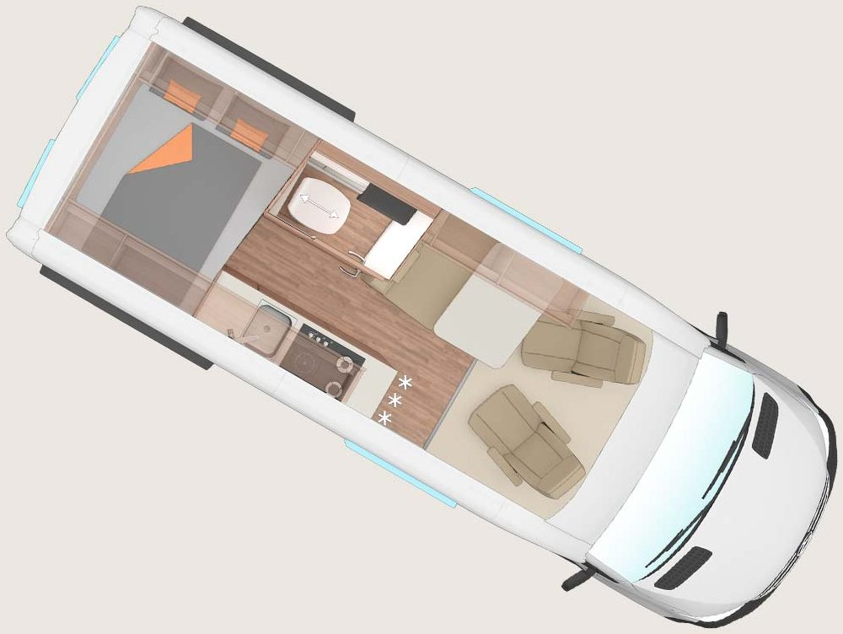
Weinsberg's own layout plan · x-pedition-600mq.jpg
BERTHS | LENGTH | GUIDE PRICE | REAR GARAGE
2 | 5,940 mm | £102,490 | no
REAR BED Transverse double 198 x 140 across the rear
BED TYPES transverse_bed
SLEEPING AREA sleeping_area_rear
REFRIGERATION fridge freezer fridge_freezer
MICROWAVE no
Beds and Max. number of beds both read 2, so nothing else is a berth.
Specification read from the European campervan price list, the only document that carries it; the X-PEDITION's own microsite disagrees on length and height and is not used.
NOT a rear garage.
The only rear-storage row is '552964-10 Large variable storage space in the rear', standard on all seven with hint H181 'Garage height 135 cm' — under-bed space loaded through the rear doors, with no external hatch and no published opening.
Per the requester's Dethleffs decision of 2 September 2026 that is storage, not a garage.
Fridge 84 l, drawn with the three-star freezer symbol on WEINSBERG's own floorplan.
Microwave: the word appears ZERO times in every WEINSBERG document read — all six UK price lists and both MY2027 catalogues.
Weaker than a Dethleffs-style negative, because no oven is listed either, so these documents may simply not enumerate cooking appliances beyond the hob.
Heating is a TRUMA Combi 4 or Combi 6 on every layout, which is blown air.

Colophon
Generated from data/weinsberg-2027-habitation-layouts.csv, which is the only file to edit by hand — this document, the HTML reference page and its PDF are all rebuilt from it. The numbers in the facts tables come from the Weinsberg adapter, so they match what the pipeline proposes for review.
Sources: the six UK price lists linked from Weinsberg's own range pages ('List price in GBP including 20% VAT'), their layout-plan pages, and for the X-Pedition the European campervan price list plus the UK campervan index card. Prices are the manufacturer's recommended retail including VAT and excluding registration, delivery and transport — not on-the-road. Full write-up in docs/adapters/weinsberg.md.
Built with python-docx, which is deliberately NOT a project dependency: run the builder isolated with `uv run --with python-docx --no-project`.

