Lap 6 – Nguyễn Công Cường

**1/ Remote destop**

wandertour.ddns.net:3310

username: 102200013

password: 102200013

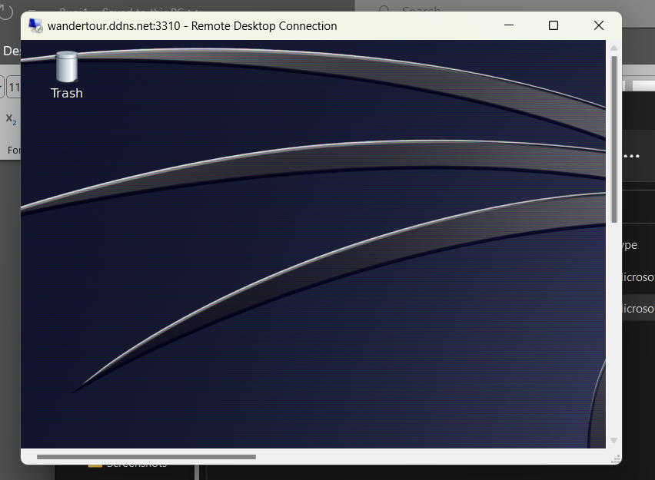

**2/ Sử dụng công cụ dmitry:**

**-i xem ip**

**-e xem email**

**-w**

**-p xem cổng tcp**

**-s xem subdomain**

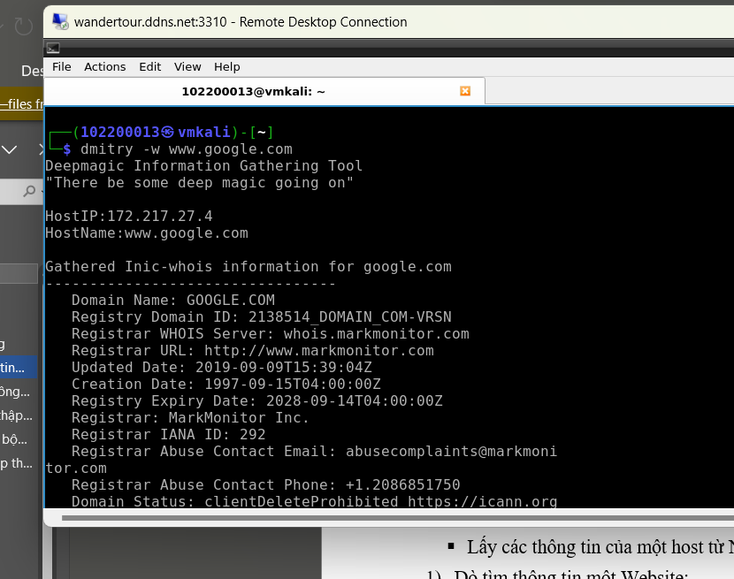

**3/Công cụ Whois (Thu nhap thong tin may chu)**

**4/ Công cụ theHarvester**

**5/ Công cụ sslscan:**

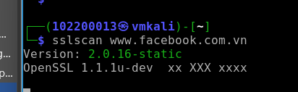

**6/ Công cụ DNSenum:**

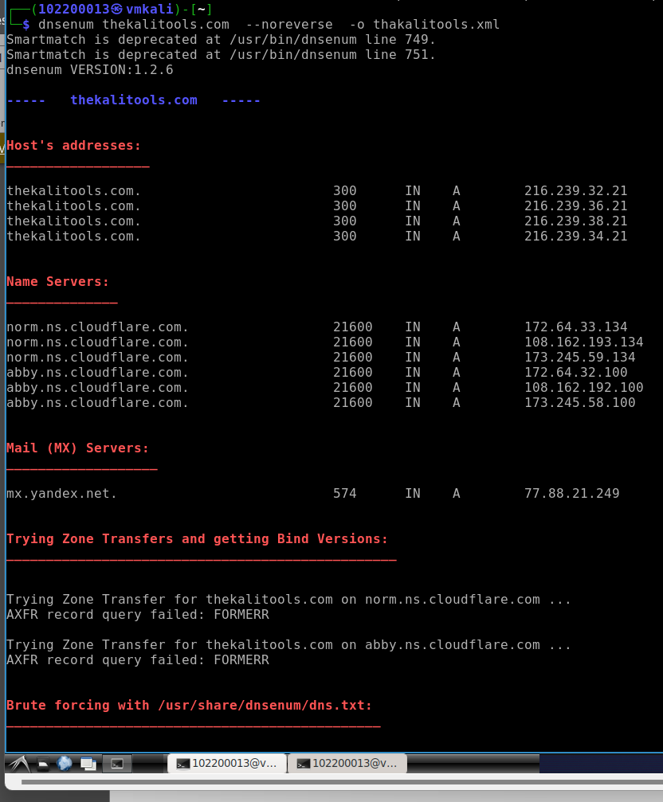

**7/ Sudo nmap**

**8/ Uniscan**

**9/ nkito -h**

**10/ Skipfish**

**11/amap**

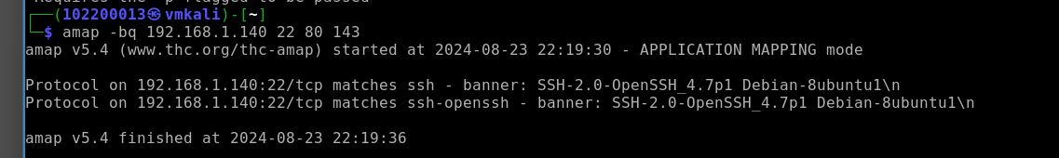

**12/ gobuster**

**13/ Sitadel**

**14/ medusas**

**15/ sqlmap**

