Kịch bản 1 quét bằng NewScan Dashboard

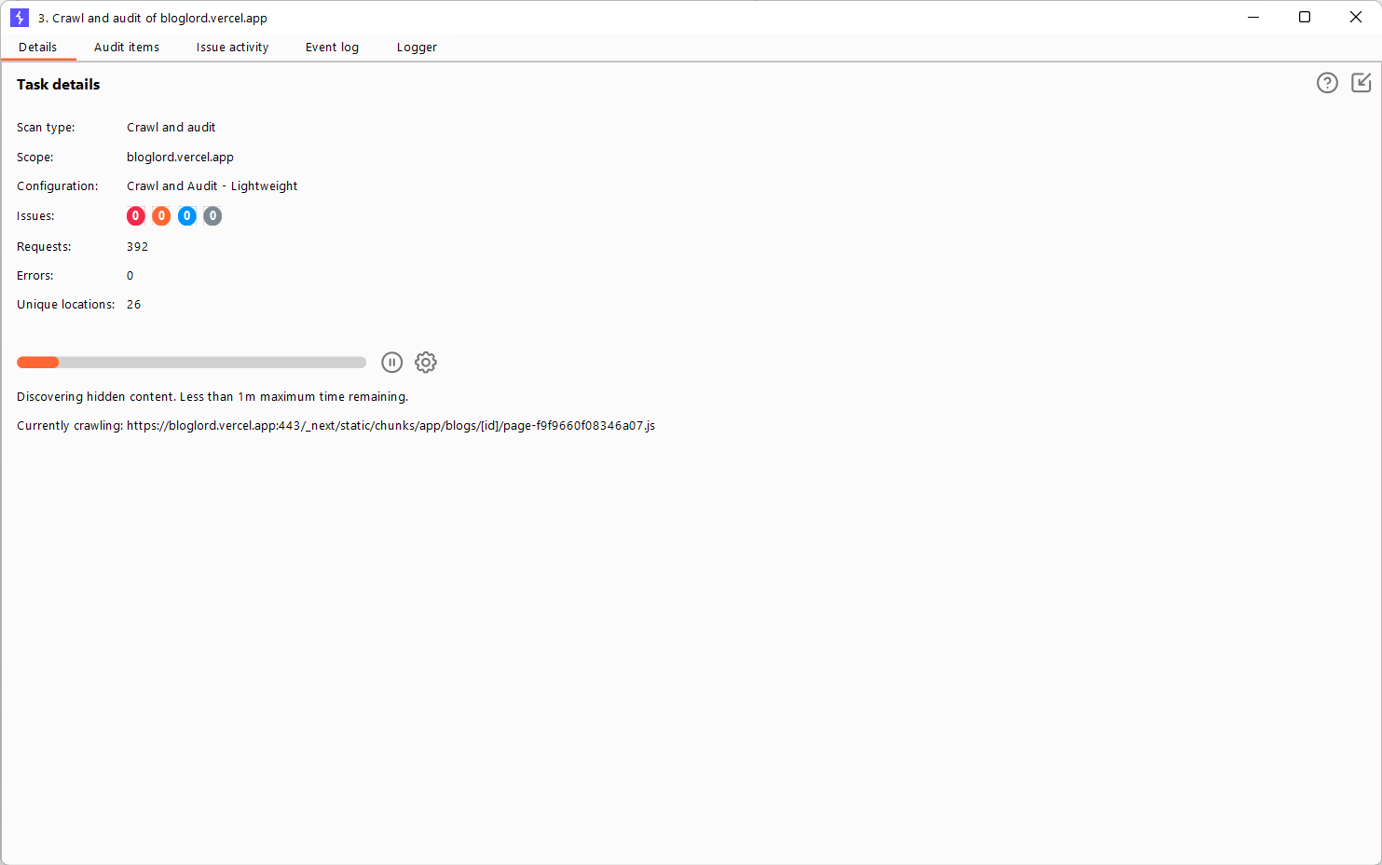

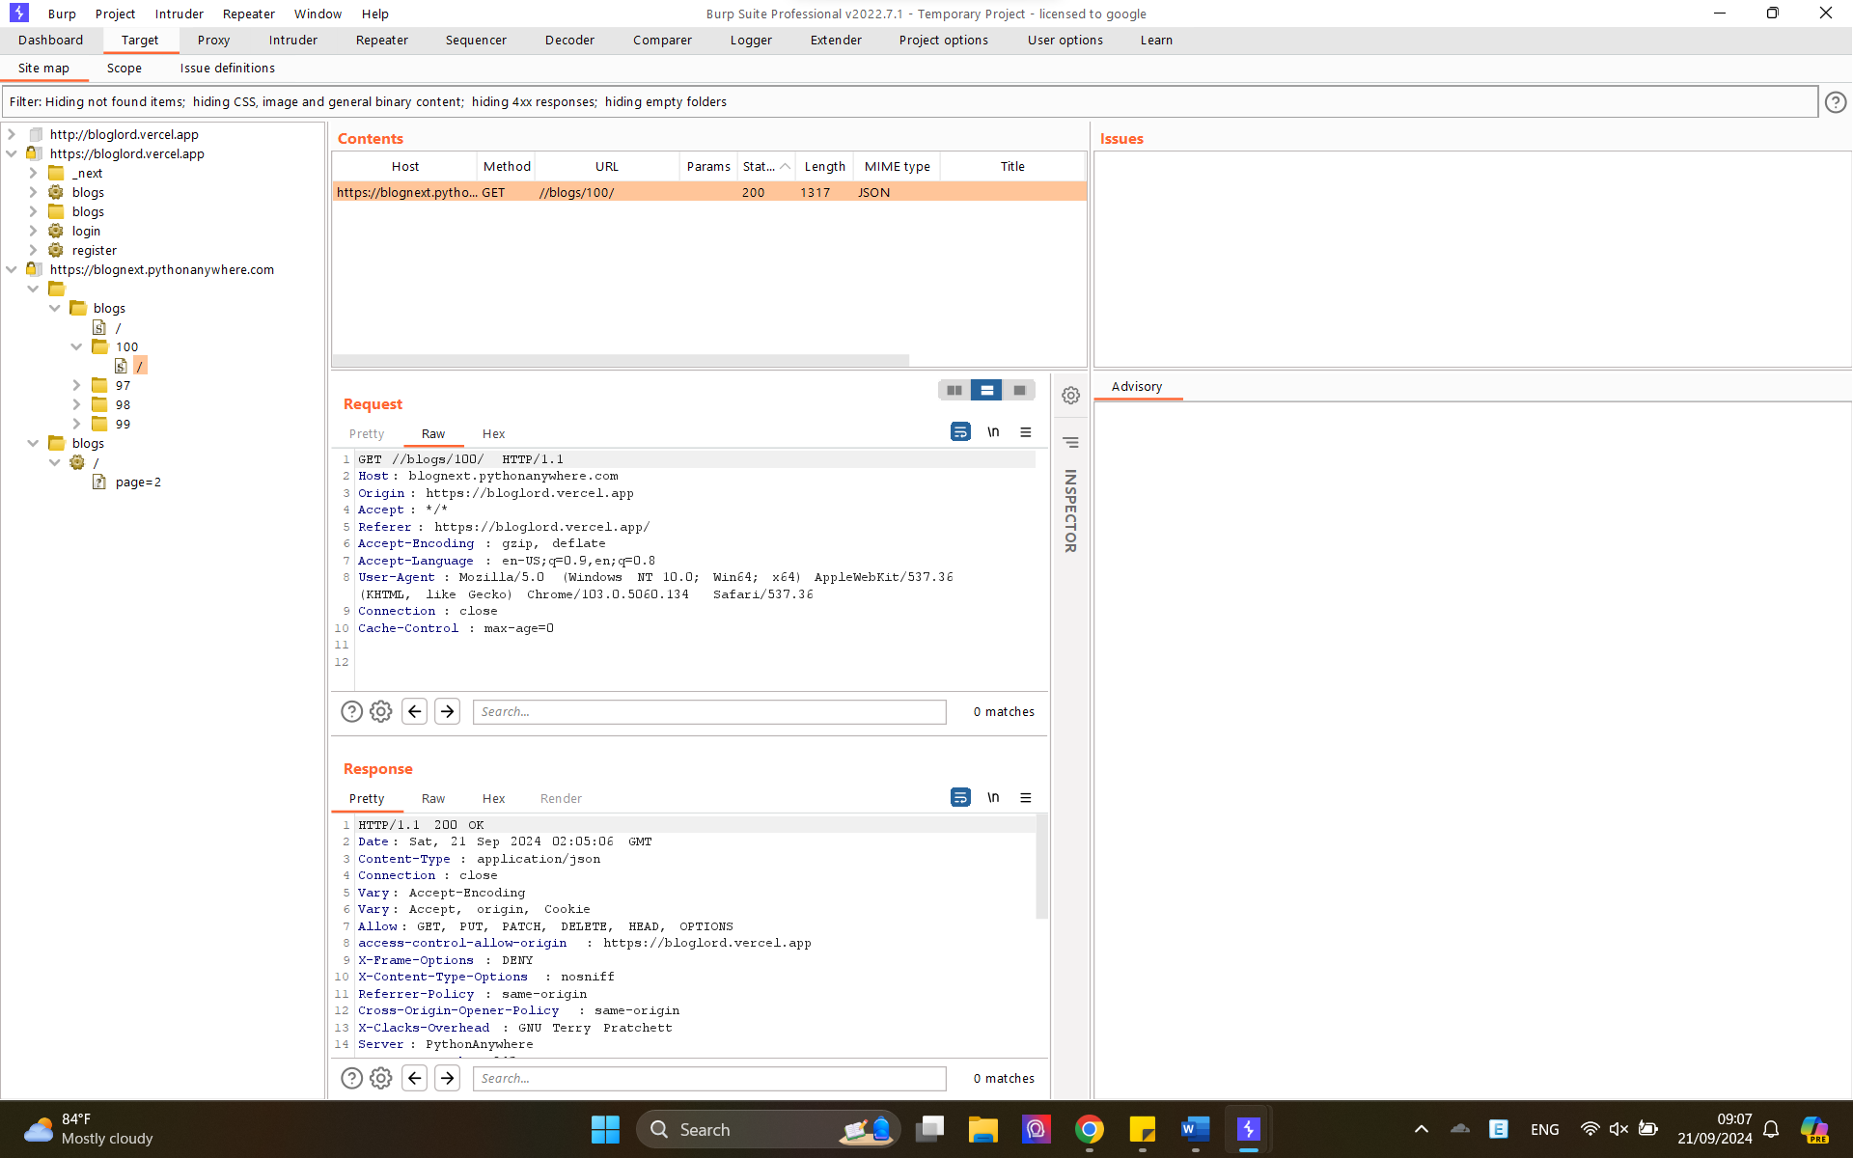

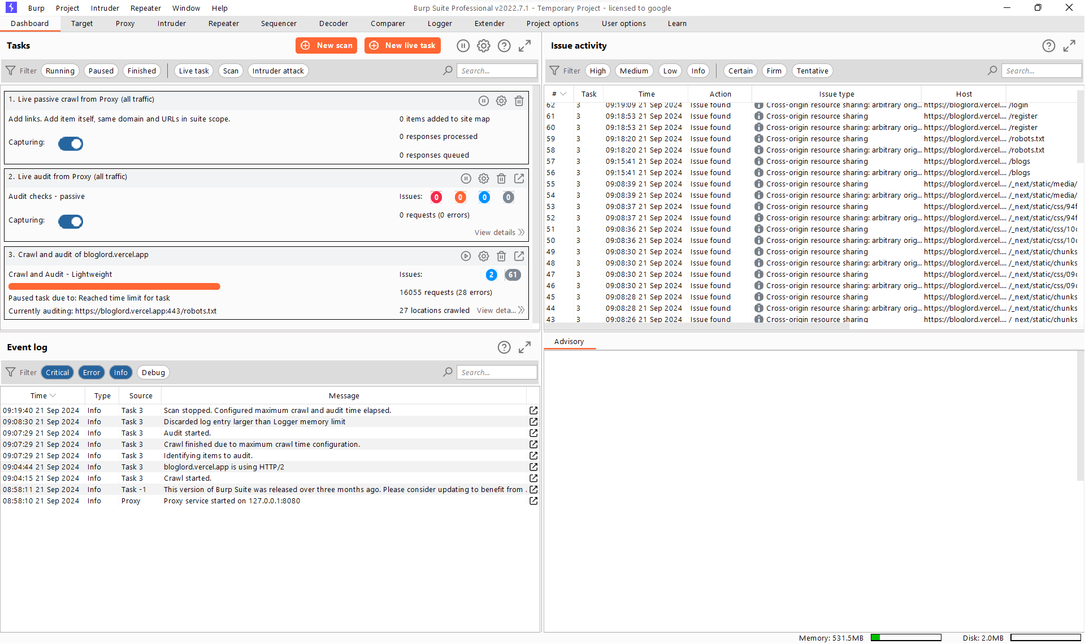

Kịch bản 2 quét bằng proxy

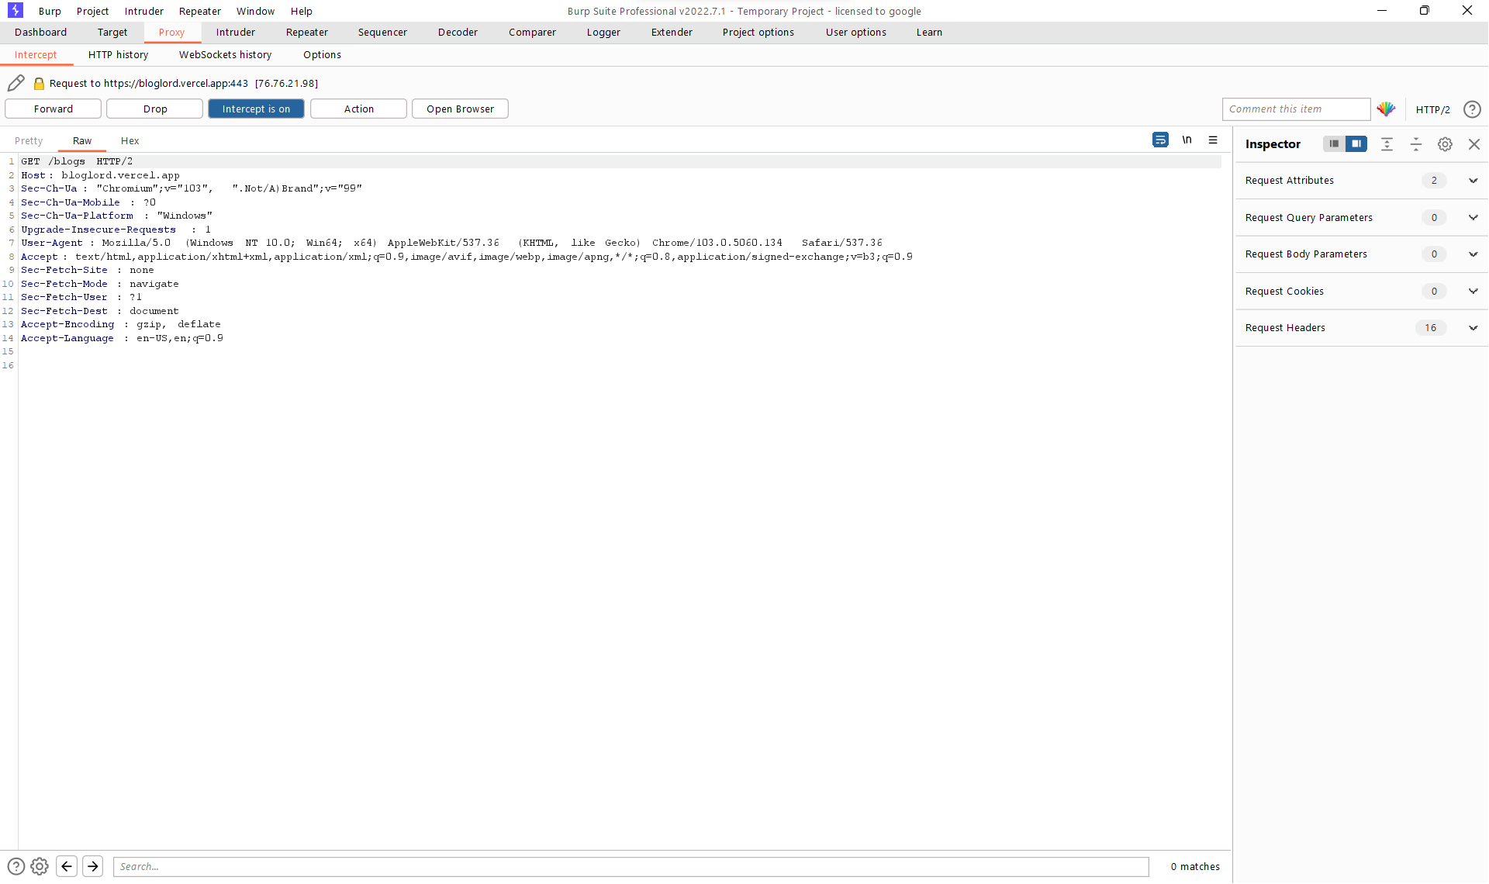

Attack Sniper

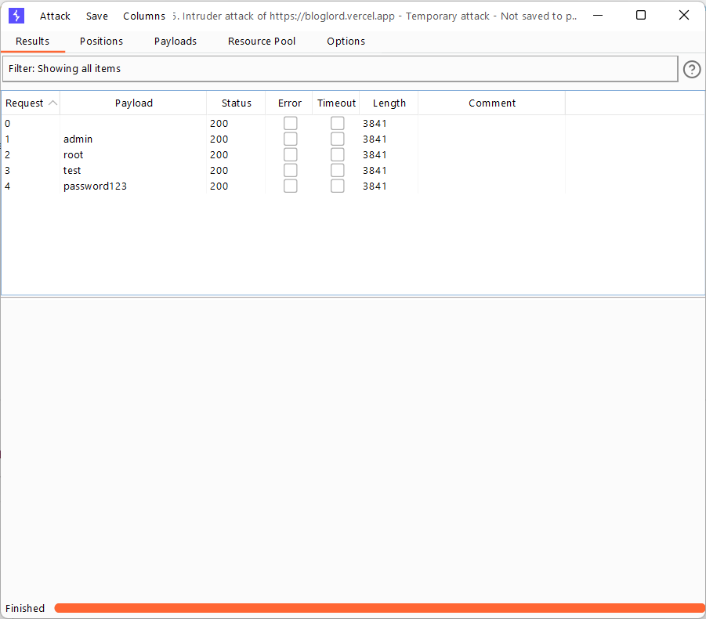

POST //login HTTP/1.1

Host: blognext.pythonanywhere.com

Content-Length: 42

Sec-Ch-Ua: "Chromium";v="103", ".Not/A)Brand";v="99"

Sec-Ch-Ua-Mobile: ?0

User-Agent: Mozilla/5.0 (Windows NT 10.0; Win64; x64) AppleWebKit/537.36 (KHTML, like Gecko) Chrome/103.0.5060.134 Safari/537.36

Sec-Ch-Ua-Platform: "Windows"

Content-Type: application/json

Accept: \*/\*

Origin: https://bloglord.vercel.app

Sec-Fetch-Site: cross-site

Sec-Fetch-Mode: cors

Sec-Fetch-Dest: empty

Referer: https://bloglord.vercel.app/

Accept-Encoding: gzip, deflate

Accept-Language: en-US,en;q=0.9

Connection: close

{"username":"123123","password":"3123132"}