Nic Chiolerio: Assignment 9

Introduction:

CHAOSS is an open source software to help people track the “health” of any open source software. This can help people that are contributing / investing into a project to predict the sustainability of the software. CHAOSS can help teams track who is putting in the most effort into a project.

Software product overview:

In order to do this, the CHAOSS community is developing metrics, methodologies and software for expressing open source project health and sustainability. This should improve the transparency and actionability of open source project health and sustainability, thus allowing relevant stakeholders to make more informed decisions regarding open source project engagement.

The project aims to:

* Establish standard implementation-agnostic metrics for measuring community activity, contributions, and health
* Produce integrated open source software for analyzing software community development
* Build reproducible project health reports/containers

System Use (actor survey):

OSS (open source software) dev = A user who is a programmer working on or with an open source software and would like to use CHAOSS to observe the health of the program.

Businessperson = A user who may not be a programmer, but is a relevant stakeholder in some sort of open source software and would like to use CHAOSS

CHAOSS dev = A user who is a programmer and is either committing code or participating in the creative process of developing CHAOSS. A CHAOSS dev could theoretically act as an OSS dev if they were wanting to use augur to check the health of the CHAOSS project

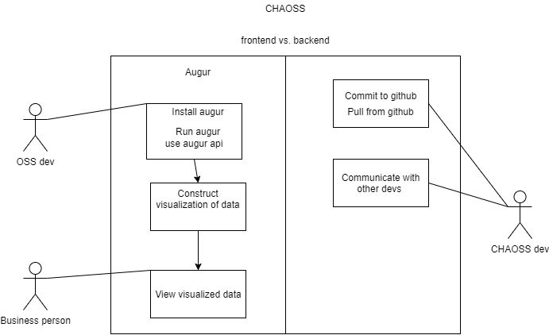

System Requirements (2 use cases, system functional specification, list nonfunctional requirements):

Use case 1: An OSS dev creates a visualization of their software’s development to see how healthy the software is.

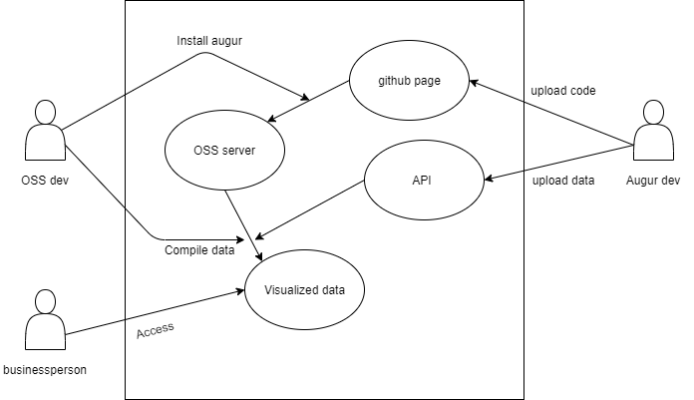

Use case 2: a developer wishes to commit code to augur, in order to improve the product

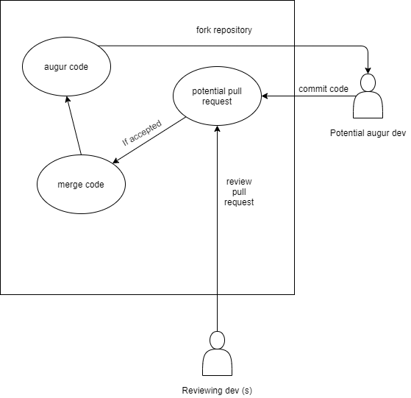

Functional specification:

Storage- the software is to run on a server and could potentially measure massive programs, it should have and be able to utilize a large amount of storage.

Server-side software- The user installing augur should provide all the necessary info about the server they are running augur on (name, host, port, user, password). The server should be a PostgreSQL 10+ database.

Features: CHAOSS is to come up with metrics to measure the health of open source software and allow stakeholders in open source software to make better decisions about their software

Nonfunctional requirements:

Reliability- With the program available from GitHub or any other open source software source, augur should be available for use and be working 24/7. The maximum bug/defect should be .25 for 1000 lines of code.

CHAOSS should comply with all regulations of open source software under the terms of the MIT License as published by the Open Source Initiative.

Design Constraints (at least 5):

- potentially limited / poor source material if the project being measured has poor documentation or if data has been lost.

- a need to determine if data about a given software is genuine or not.

- augur will have to interface with various server hardware and software over time

- augur will need updated since programming technique/practices will evolve/change over time

- augur will be based in python

Purchased Components (at least 1):

With this being open source, everyone will be developing independent on their own machine, but for development the team could get a test server to run everything on

Interfaces (at least 1):

After login, you are taken to a page which has all the three vertically aligned boxes. The page is mainly an overview of the software and those who made it.

Organizing data by a metric would be something like, organizing data by the total commits of all devs over a time.

Organizing data by a user would be looking at everything pertaining to a user, their commits, comments, etc.

