**Homework Week 1.**

**January 24, 2019**

**Nancy Carrico**

1. What are three conclusions we can make about Kickstarter campaigns given the provided data?

* The most abundant category of projects was ‘theatre’, which had the highest number of successfully funded projects. However, the category with the highest success rate was the ‘music’ category.
* The ‘plays’ subcategory had the highest number of projects overall with ~65% success rate.
* There is a slight trend of less projects being successful towards the end of the year compared to the beginning of the year, when looking at the percentage of successful projects by month.

2. What are some of the limitations of this dataset?

* Most of the data is from US and GB, so this data would not be able to tell us much about the success of projects in other countries.
* Most of the data was from three years, 2014-2016. There was a significant drop in the success rate of projects as the number of projects increased by ~3-fold in year 2014. Lumping conclusions for all the years may be slightly misleading and may need to just look at the more recent three years only.

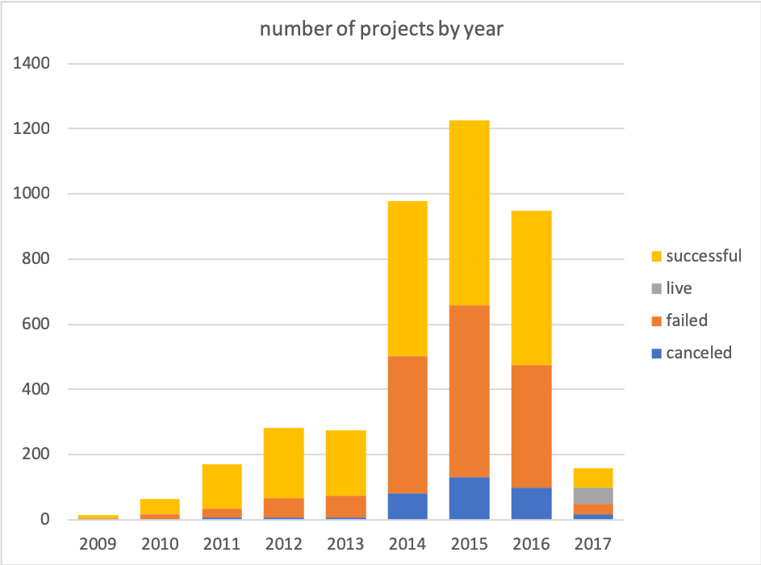

3. What are some other possible tables/graphs that we could create?

* Whether the ‘Staff Pick’ projects had a higher success rate
* ‘Percent Funded’ by Category or Subcategory
* ‘Percent Funded’ by target goal
* ‘Average Donation’ by Category or Subcategory
* ‘Average Donation’ by year or country