**General**

Human activities have a profound impact on every part of the world's oceans, making sustainable planning and management of marine spaces an essential priority. However, a significant portion of marine environments is adversely affected by human-induced factors (Halpern et al., 2015). Marine Spatial Planning (MSP) has emerged as a topic of growing significance within scientific and policy circles and is being implemented across the globe. Despite its widespread adoption, MSP still encounters various challenges—conceptual and practical—that stem from political, institutional, social, economic, scientific, and environmental complexities. Efforts are underway worldwide to develop marine area plans, extending from coastal zones to open ocean regions, to promote sustainable ocean governance and management.

Known by various terms such as ocean planning, marine planning, ocean zoning, and maritime spatial planning, this approach is most commonly referred to as Marine Spatial Planning (MSP). Its primary focus lies in organizing the spatial and temporal distribution of human activities within marine areas to minimize conflicts and enhance compatibility, both among different uses and between human activities and the environment (Ehler & Douvere, 2009). MSP has been recognized for moving away from the traditional sector-specific management approach, instead embracing an integrated, coordinated process aimed at balancing development objectives with conservation goals (Santos et al., 2019).

**Marine Spatial Planning (MSP)**

MSP focuses on organizing and managing human activities in marine areas, both spatially and temporally, to meet ecological, economic, and social objectives (Ehler et al., 2019). The aim of MSP is to analyze and assign marine spaces for various uses in a way that minimizes conflicts among activities, optimizes benefits, and supports the resilience of marine ecosystems (UNESCO-IOC, 2021). It is important to note that MSP governs human activities within marine environments but does not directly manage marine ecosystems or their individual components. It allows for the designation of specific marine zones for particular purposes—such as conservation or development—or for specific uses, like offshore aquaculture, wind energy farms, or resource extraction.

Advocates of MSP argue that the current approaches to managing the world's oceans and seas are insufficient to address the growing pressures from both traditional and emerging maritime activities. Increasing demands on marine resources necessitate a more structured and comprehensive approach. Spatial planning provides a solution by assigning designated areas for fixed activities, such as aquaculture, pipelines, or wind farms, as well as areas for mobile activities, such as fishing and shipping, and regions dedicated to the protection of marine biodiversity. This "place-based" strategy offers significant advantages over the previously dominant, fragmented regulation of individual sectors, as noted by Gilliland and Laffoley (2008). By implementing a coordinated framework, MSP facilitates the sustainable management and use of marine spaces while fostering conservation.

**Evolution of MSP**

Marine Spatial Planning (MSP) has increasingly been recognized as an essential approach for advancing ecosystem-based management over the years (Douvere, 2008). By providing an integrated framework, MSP moves away from the traditional sectoral approach to address multiple goals, including achieving economic and ecological sustainability and resolving conflicts in marine environments (Agardy et al., 2011). Defined as "a process of analyzing and allocating portions of the three-dimensional marine spaces to specific uses, to achieve ecological, economic, and social objectives that are usually specified through the political process," MSP typically results in a comprehensive plan or vision for a marine region (Ehler and Douvere, 2007). The overarching aim of MSP is to strike a balance between development needs and the imperative of environmental conservation (Douvere, 2008).

In areas where disputes arise between different users and the environment, MSP has proven to be an effective tool for managing competing demands on marine space. Originating as a management approach for the Great Barrier Reef Marine Park in Australia, MSP has since been implemented in other marine regions, such as the Florida Keys, Channel Islands, Wadden Sea, North Sea, Irish Sea, and Baltic Sea. Although MSP does not replace Marine Protected Areas (MPAs), it integrates them into a broader strategy that balances ecological, social, and economic objectives. MPAs remain vital tools for managing marine ecosystems, but their planning can be incorporated into larger MSP and ocean zoning initiatives, allowing MSP to harness MPAs' benefits while addressing potential limitations (Agardy et al., 2011).

In recent decades, MSP has gained widespread adoption, particularly in marine areas shared by multiple countries, such as European seas, to achieve both economic and environmental goals. More recently, several Asian countries have also embraced MSP as a method for promoting ecosystem-based management of marine areas. Over the past two decades, MSP has become a key instrument for sustainable development, supporting goals like fostering a "blue economy" or "blue growth" and conserving biodiversity in coastal and oceanic regions. This place-based approach to planning has established itself as a critical framework for reconciling human activities with marine ecosystem health worldwide.

**Need of MSP**

For various human activities such as maritime transportation, offshore renewable energy, oil and gas extraction, aquaculture, and waste disposal, many countries allocate specific marine zones or areas. However, this zoning is often carried out on a sector-by-sector basis, with limited or no consideration of how one activity might impact others or the surrounding marine environment. As a result, two major types of conflicts arise: conflicts between different human uses (user-user conflicts) and conflicts between human uses and the marine environment (user-environment conflicts).

These conflicts hinder the ocean's ability to provide crucial ecosystem services, which are fundamental to supporting human life and the planet's biodiversity. These services can be classified into "provisioning services," which include resources like food, freshwater, and raw materials; "regulating services," such as climate regulation, water purification, disease control, and pollination; "cultural services," encompassing recreation, tourism, spiritual, aesthetic, and educational benefits; and "supporting services," which involve soil formation, nutrient cycling, and primary production.

In this context, decision-makers often find themselves reacting to issues after they occur, rather than proactively shaping activities to create a sustainable future for marine environments. Marine Spatial Planning (MSP), by contrast, adopts a forward-looking approach. It provides a framework to address these conflicts effectively and enables decision-makers to implement management strategies that safeguard essential ecosystem services while balancing various human uses.

The environmental and commercial significance of oceanic regions can vary significantly. Factors such as the distribution of species, habitats, ecosystems, populations, mineral resources, and wind energy potential differ across time and space. Effective marine management depends on planners and managers who understand and account for this spatial and temporal variability. MSP places a strong emphasis on recognizing and mapping these distributions to enable informed decision-making and sustainable ocean governance..

**Benefits of MSP**

Marine Spatial Planning (MSP) is a comprehensive and multi-dimensional approach that seeks to balance economic, social, and environmental goals across all ocean uses, rather than solely focusing on the creation of marine protected areas. Although MSP originally emerged in the context of marine conservation, it differs significantly from conservation planning. MSP is discussed extensively in academic and policy literature, highlighting its potential to improve marine ecosystem management, minimize ecosystem degradation, reduce conflicts, and serve as a practical framework for long-term, ecosystem-based management (Portman, 2011; Kidd and Shaw, 2014).

While MSP is designed to encourage participation from diverse stakeholders, it often receives strong support from environmental government agencies, which tend to prioritize perspectives rooted in natural sciences. MSP is particularly valuable in addressing two critical types of conflicts: those between competing maritime activities (use-use conflicts) and those between human activities and the marine ecosystem's goods and services (use-environment conflicts).

As a forward-looking process, MSP provides a structured framework for resolving disputes and fostering sustainable coexistence among various ocean users, ensuring the continued provision of essential ecosystem services. It offers a pathway to harmonize development needs with environmental stewardship, promoting a balanced and sustainable future for marine spaces.

Some of the specific benefits of using MSP are summarized below (Ehler & Douvere, 2009):

1. **Ecological/ Environmental Benefits**
2. Identification of biological and ecological important areas
3. Biodiversity objectives incorporated into planned decision-making
4. Identification and reduction of conflicts between human use and nature
5. Allocation of space for biodiversity and nature conservation
6. Establish context for planning a network of marine protected areas
7. Identification and reduction of the cumulative effects of human activities on marine ecosystems
8. **Economic Benefits**
   * 1. Greater certainty of access to desirable areas for new private sector investments, frequently amortized over 20-30 years
     2. Identification of compatible uses within the same area of development
     3. Reduction of conflicts between incompatible uses
     4. Improved capacity to plan for new and changing human activities, including emerging technologies and their associated effects
     5. Better safety during operation of human activities
     6. Promotion of the efficient use of resources and space
     7. Streamlining and transparency in permit and licensing procedures
9. **Social Benefits**
   * 1. Improved opportunities for community and citizen participation
     2. Identification of impacts of decisions on the allocation of ocean space (e.g., closure areas for certain uses, protected areas) for communities and economies onshore (e.g., employment, distribution of income)”
     3. Identification and improved protection of cultural heritage
     4. Identification and preservation of social and spiritual values related to ocean use (e.g., the ocean as an open space)

**MSP and Blue Economy**

The goal of Marine Spatial Planning (MSP) is to organize and manage the use of maritime resources and space while balancing environmental, economic, and social goals. MSP tries to allocate space in a way that minimizes conflicts and maximizes benefits by taking into account a variety of activities, including fisheries, energy generation, shipping, tourism, etc. On the other hand, the term "blue economy" describes how ocean resources are used sustainably for economic development, better quality of life, and employment while maintaining the health of ocean ecosystems. Similar to MSP; fisheries, aquaculture, maritime transportation, renewable energy, and tourism are just a few of the diverse economic sectors that are included in blue economy. The blue economy and MSP are closely related because MSP may assist the growth of blue economy sectors and ensure the sustainable use of ocean resources. MSP can lessen conflicts between various sectors and advance the sustainable use of maritime resources by offering a framework for decision-making. By ensuring it is socially and environmentally responsible, this can aid in the growth of the blue economy. Overall, MSP and the blue economy are closely related because MSP may aid in the sustainable use and development of ocean resources, which is crucial for the blue economy's long-term existence.

**Step – by- step approach to MSP**

In general, MSP is a procedure that results in the creation of a plan for a particular marine area. Maps depicting the local sea conditions and activities typically make up the plan. However, future activities that are planned are included, and their implementation strategy (Jay, 2017). The plan may also contain directives for potential future applications. The establishment of effective governance of planning, implementation and review process is a fundamental step to develop sound MSP (Qiu and Jones, 2013). The Intergovernmental Oceanographic Commission (IOC) released a guide detailing the process of setting up and using MSP (Ehler & Douvere 2009). The IOC handbook offers a thorough description of MSP and mainly emphasis on outlining a coherent flow of actions that are all necessary to accomplish the desired goals and objectives for marine areas. On the other hand, there isn't a single, accepted procedure for carrying out MSP; instead, practices vary depending on geographic regions, marine pressures, legal requirements, planning cultures, and other factors. This illustrates how terrestrial planning is done, which varies from country to country. The IOC guide for MSP outlines a ten-step process that will demonstrate how MSP might start operating in a particular region. Using the IOC guide as a model, Countries can modify and customize the strategy based on their requirements and needs (Nairobi Convention, WIOMSA and CSIR, 2017) which also provides a comprehensive overview of MSP and primarily outlines the measures that must be taken in order to accomplish the desired aims and objectives for maritime regions.

The IOC guide for MSP outlines a ten-step process that will demonstrate how MSP might start operating in a particular region. Each step is further divided down into independent tasks and actions. The connections between the steps are depicted in Figure 2.1. Similar to the ICZM approach, this MSP shows a systematic process starting at Step 1, “Identifying Need and Establishing Authority” the planners can work their way through the process step by step until Step 10, "Adapting the Marine Spatial Management Process”. It should also e noted that, stakeholder engagement is integrated into the overall process, which will help the planners to understand the logical procedures for organizing, creating, executing, assessing, and modifying MSP (Jay, 2017).

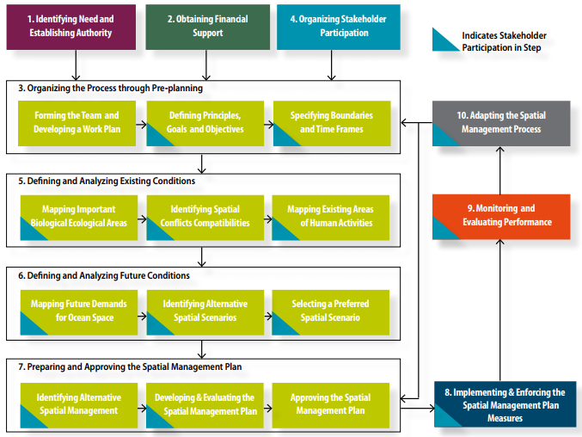

Figure 2.1 Step by step approach to Marine Spatial Planning (Ehler and Douvere, 2009)

MSP is a multifaceted process crucial for effective ocean management, involving key steps and tasks outlined in the IOC handbook (UNEP, 2017). While no universal MSP procedure exists, countries can adapt the framework based on their specific needs and requirements. In collaboration across the Ministry of Earth Sciences (MoES), a seven-step framework tailored for the Indian region has been adopted, as depicted in Figure 2.1. This framework provides a systematic guide for MSP in the Indian region, facilitating sustainable ocean management and governance.

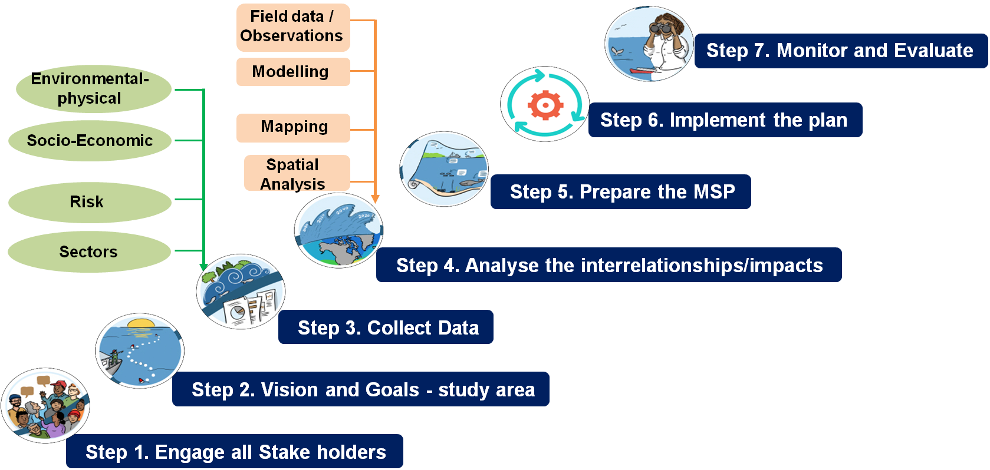

Figure 2.2 Marine Spatial Planning framework for Indian regions

*Step 1:* *Stakeholder Engagement:* Stakeholder engagement is a key component of the Marine Spatial Planning (MSP) process, ensuring that the diverse interests and concerns of various groups are effectively incorporated into planning efforts. Successful MSP depends on strong stakeholder participation, as highlighted in research by Fletcher et al. (2011), Kidd and Shaw (2013), Kidd and McGowan (2013), Kidd and Shaw (2014), and Portman (2015). While MSP typically follows a participatory planning framework, the degree and type of stakeholder involvement can vary across different regions and contexts.

The preparation of MSP often involves activities such as workshops, public consultations, and stakeholder meetings to engage a wide range of participants, including local communities, fishermen, tourism operators, environmental organizations, academic institutions, and government entities. These platforms allow stakeholders to share their perspectives, contribute traditional knowledge, and take part in decision-making processes. Engagement efforts may include participatory mapping exercises, where fishermen identify critical fishing areas and biodiversity hotspots, and tourism operators highlight zones suitable for sustainable tourism development. Environmental organizations and academic experts contribute insights on conservation priorities and ecological assessments. Government agencies play a vital role in facilitating discussions on regulatory and policy alignment.

This inclusive and transparent approach helps to mitigate potential conflicts and fosters trust and collaboration among stakeholders. By integrating local insights and maintaining ongoing dialogue, the MSP framework can be customized to address the specific social, economic, and ecological circumstances of a region. Active stakeholder involvement enhances the credibility and acceptance of MSP initiatives, supporting more sustainable and resilient outcomes for the blue economy.

*Step 2:* *Identifying Visions and Goals:* Defining clear visions and goals for the study area is a foundational step in effective Marine Spatial Planning (MSP). This process requires active collaboration between stakeholders and the MSP team to ensure that diverse perspectives and priorities are adequately represented. Engaging stakeholders in this phase not only fosters a sense of ownership but also promotes alignment with local, social, economic, and environmental contexts. By working together to establish a shared vision, participants can guide the development of a coherent and inclusive MSP framework that balances conservation objectives with sustainable resource use, paving the way for more resilient outcomes. As emphasized by Tailor et al. (2021), such collaborative goal-setting is essential for achieving the long-term success of MSP initiatives.

*Step 3:* *Collect Data:* Establishing a detailed and comprehensive spatial database is a critical foundation for Marine Spatial Planning (MSP), as it provides the baseline necessary for effective decision-making and sustainable management of marine areas. This process involves the collection of a wide range of data from multiple sources, including government departments, research institutions, and other relevant organizations. The data gathered is then cross-verified through extensive field visits, stakeholder consultations, and collaborative efforts to ensure its accuracy and reliability. Marine ecosystems, being dynamic, complex, and inherently multi-sectoral, present unique challenges in this process. Their ever-changing characteristics, combined with the intricate interplay of ecological, economic, and social factors, make them particularly difficult to map, record, and measure. Additionally, the involvement of numerous stakeholders and departments often leads to overlapping responsibilities and fragmented data ownership, further complicating efforts to create a unified spatial database.

Despite these challenges, obtaining reliable and up-to-date information—both spatial and non-spatial—is essential. For instance, spatial data might include maps of critical habitats, fishing zones, or shipping lanes, while non-spatial data could cover policy frameworks, economic activities, and traditional knowledge. Tailor et al. (2021) emphasize that the accuracy and relevance of such data directly influence the effectiveness of the MSP process. Addressing data gaps, resolving inconsistencies among custodians, and fostering collaboration among stakeholders are therefore key priorities to ensure the successful development of marine spatial plans tailored to the needs and conditions of a given region.

*Step 4:* *Analyze Interrelationships/Impacts:* Analyzing interrelationships and impacts is a critical step in the Marine Spatial Planning (MSP) process, as it provides a comprehensive understanding of how various factors interact and influence each other within the marine environment. This phase begins by defining and analyzing both current conditions and potential future scenarios, encompassing ecological, socioeconomic, and political dimensions. Ecological factors might include marine biodiversity, habitat connectivity, and environmental stressors, while socioeconomic considerations could involve local livelihoods, economic activities, and community well-being. Political factors, such as regulatory frameworks, governance structures, and policy objectives, also play a crucial role in shaping outcomes.

In this step, potential conflicts and synergies between different uses and stakeholders are carefully identified. For instance, there may be conflicts between industrial fishing activities and conservation efforts, or synergies between sustainable tourism and biodiversity protection. These interrelationships are critical for evaluating trade-offs and aligning goals across sectors.

To support this analysis, alternative future scenarios are developed and assessed. These scenarios explore how different management strategies, economic developments, or environmental changes could impact the marine area over time. Each scenario is carefully evaluated to identify its potential benefits, risks, and feasibility, allowing for an informed and balanced decision-making process. Ultimately, this analysis helps in selecting a spatial vision for the future that reflects the region's ecological, social, and economic priorities while ensuring long-term sustainability. By systematically understanding interrelationships and weighing future possibilities, this step ensures that MSP frameworks are both adaptive and resilient to changing conditions.

*Step 5:* *Prepare the MSP:* The development of the Marine Spatial Plan represents a critical phase in the Marine Spatial Planning (MSP) process, as it translates the overarching spatial vision into actionable, spatially explicit strategies. This step involves identifying and defining specific management activities within the marine area and organizing these activities through a structured ocean zoning system. The goal is to allocate marine spaces efficiently, balancing ecological conservation, resource use, and socio-economic priorities, while minimizing conflicts among competing interests.

Ocean zoning provides a framework that assigns specific zones for various activities, such as fishing, aquaculture, tourism, shipping, renewable energy production, and conservation. For example, certain areas might be designated as marine protected areas (MPAs) to safeguard critical habitats and biodiversity, while other zones may prioritize sustainable resource extraction or recreational use. The zoning process ensures that activities are spatially separated or harmonized based on their compatibility, reducing the risk of overexploitation and ecosystem degradation.

This phase also requires extensive input from stakeholders and integration of scientific data to ensure the zoning system is both equitable and evidence-based. Factors such as ecological sensitivity, economic potential, and cultural significance are analyzed to create a plan that aligns with the region’s unique needs. Additionally, the Marine Spatial Plan incorporates adaptive management principles, allowing for periodic updates and modifications in response to evolving conditions, such as climate change or shifting human activities.

By defining clear spatial boundaries and management actions, the Marine Spatial Plan serves as a vital tool for achieving the desired spatial vision. It establishes a structured approach to managing marine resources and activities, promoting sustainability and long-term resilience in marine ecosystems while supporting economic growth and community well-being. This systematic and proactive planning process forms the cornerstone of effective MSP initiatives.

*Step 6:* *Implement the Plan:* Upon formal adoption of the marine spatial plan, it becomes crucial to initiate its implementation. This phase not only involves carrying out the plan's management activities but also holds responsible entities accountable for ensuring compliance with the plan's requirements.

*Step 7:* *Monitor and Evaluate:* Establishing a performance monitoring and evaluation program is essential at this stage, involving the collection, assessment, examination, and reporting of relevant data (Ehler & Douvere, 2009). The results guide modifications to the planning process using an adaptive management approach, incorporating lessons learned (Douvere & Ehler, 2011; Santos et al., 2014).

**Some important things to remember when doing MSP**

* MSP is used to plan and manage human activities in marine areas, not marine ecosystems  
  or components of ecosystems
* MSP does not lead to a one-time plan. It is a continuing, iterative process that learns and adapts over time
* These 10 steps are not simply a linear process that moves sequentially from step to step. Many feedback loops should be built into the process;
  + Analyses of existing and future conditions will change as new information is identified and incorporated in the planning process
  + Stakeholder participation will change the planning process as it develops over time
* Comprehensive MSP provides an integrated framework for management that provides a guide for, but does not replace, single-sector planning.