By: **Nadeen Ali** - 22110361

**Multi-Omics Data Integration for Downstream Analysis & Biomarker Discovery**

Technical Report

Course: Bioinformatics – Spring 2024/2025

Course Instructor: Dr. Rami Al-Ouran

Table of Contents

**1 – Introduction & Overview** 4

**2 – Dataset Description** 4

**3 – Preprocessing (First Notebook)** 5

Saving Files 5

Reading Files 5

Removing Missing Values 6

Filtering Low Quality Data 6

Finding Common Samples (Patients) 7

Outlier Detection 8

**4 – MOFA Object Creation** 10

Entry Point 10

Reading Data 11

Disabling Scaling Views 11

Passing Data 11

Model Configuration 12

Training Options 12

Running and Saving Model 12

**5 – Downstream Analysis** 12

Mapping Features to Genes 12

Plotting Weights, Both Views (Rna and Mutation) 13

Weights Ranked 14

Variance Explained 15

Factors’ Correlation 16

Factors and Features Heatmap 17

Weights Dot Plot (RNA) 18

Weight Dot Plot (Mutation) 19

Scatterplot, Scaled Weights 19

Revising Heatmap (10 Features) 21

Highest Genes in Each Factor 22

**6 – Pathways and Ontologies** 22

**References** 23

# **1 – Introduction & Overview**

This project aims to collect and study data regarding the TCGA-STAD project, focusing on **stomach adenocarcinoma**, the *most* common type of stomach cancer causing digestive issues and abdominal pain [1][2], to discover potential biomarkers which are *clear* indicators of the cancer’s presence.

To do this, two types of omics data were used from the *same* patients:

1. **RNA-seq:** Measures gene expressions
2. **Mutation data:** binary values indicating gene mutation status (0 = no mutation exists, 1 = mutation does exist)

Each dataset was cleaned, preprocessed, and visualized *independently* before applying MOFA+, an AI based python library for multi-omics data integration, to combine the views (datasets) for further and deeper biological analysis to identify key pathways and ontologies that may be involved in stomach cancer.

# **2 – Dataset Description**

As mentioned above in the Introduction & Overview section, this data is collected focusing on the *most* common stomach cancer - stomach adenocarcinoma found from the website **LinkedOmics**. During the initial analysis, 3 datasets were used. Here are some of their details before diving into section 3 detailing all the steps:

1. **Rna-seq**

* Shape *before* preprocessing: 20,225 rows x 415 columns
* Shape *after* preprocessing: 205 rows (patients) x 19112 columns (genes)
* After MOFA+ integration: used as **view0**

1. **Mutation data**

* Shape *before* preprocessing: 13724 rows x 393 columns
* Shape *after* preprocessing: 205 rows (patients) x 1068 columns (genes)
* After MOFA+ integration: used as **view1**

1. **Clinical data**

* Shape *before* preprocessing: 15 rows x 443 columns
* Shape *after* preprocessing: 205 rows (patients) x 14 columns (clinical features)
* Only used for high level analysis and *not* integrated into MOFA+

*Note* that all datasets **have the same number of samples (patients)** after preprocessing. This is to ensure that we are comparing all data across the *same* patients for consistent, accurate, and interpretable results.

# **3 – Preprocessing (First Notebook)**

### Saving Files

* Used gzip to open rna-seq and mutation data

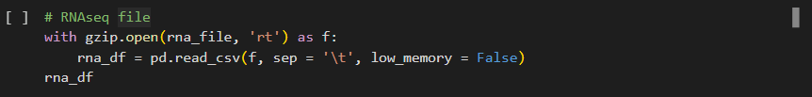

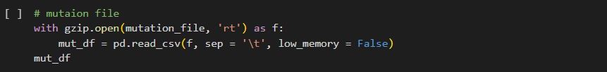

* While clinical data did not need any extra functions to open



### Reading Files

* Problem 1: First column contained gene and clinical data was named ‘attrib_name’
* Solution 1: Renamed column to ‘gene’ and ‘clinical_data’ as fit based on df
* Problem 2: Index was not set correctly
* Solution 2: Set ‘gene’ and ‘clinical data’ as indices
* Problem 3: Samples were columns and features were rows
* Solution 3: Transposed so samples became rows and features were columns
* Optional: Set new index name (rows, patients) to ‘sample_id’
* Printed head to make sure all changes are as needed

### Removing Missing Values

* Checking no null values in datasets
* Problem: Founds 505 null values in clinical data
* Solution: Dropped them
* Check none left

### Filtering Low Quality Data

* Problem: Not *all* data in the datasets are crucial: some genes for examples are rarely expressed or rarely mutated
* Solution (rna-seq): Genes *must* be expressed in at least 20% of samples
* Result: Small change, but regardless is a change

* Solution (mutation data): Genes *must* be mutated in a at least 5% of samples
* Result: Huge change noticed (thus why only 5% taken and not more)

### Finding Common Samples (Patients)

* Problem: Data has been cleaned, but the rows (samples or patients) are *still* not in common across all 3 datasets
* Solution: Must filter all 3 datasets based on found common samples by using & in a set (to avoid duplicated sample ids)
* Results: Samples *shrunk* to 205 across all 3 datasets

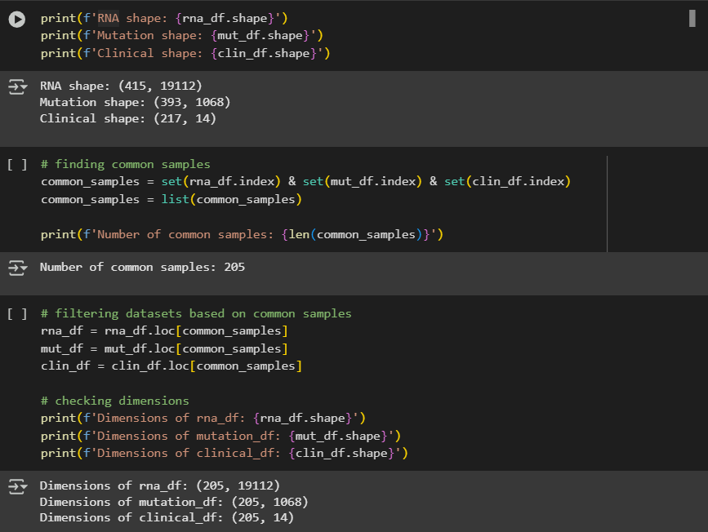

### Outlier Detection

* Problem: Outliers are extreme values that deviate from the rest of the data and can throw off analysis and results especially when integrating datasets.
* Solution: Applying dimensionality reduction and outlier detection using PCA, TSNE (with PCA), *and* UMAP (also with PCA)
* **PCA** applied first to reduce noise and capture *most* important variation in rna-seq
* **TSNE** applied to preserve *local* structure
* **UMAP** applied to preserve a balance between *both* local and global structures
* Result: Not much variance found, with highest (PC1) at below 14% **only**.

* As expected due to low explaining variance, no clear outliers were shown across all 3 dimensionality reduction methods.

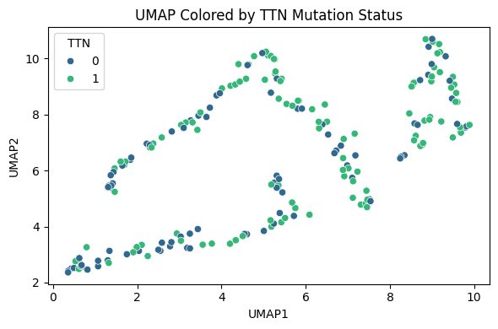

* Double Checking: Using IsolationForest to fit on PCA to ensure *no* aggressive outliers exist indeed.
* Result: 5% show not many outliers, 10% begins to show seemingly normal points as *outliers*, thus being too aggressive.
* **Decision: No outliers, thus no removal of any data**

* Observation: When colouring PCA, TSNE, *and* UMAP plots by different variables (mutations, clinical data), the structure and pattern of plot remains the same
* **Is it a problem? No.** Could mean mutation and clinical data are *not* primary drivers of expression data (later proven in MOFA integration)
* Suggests that latent factors drive data.
* Any groups or clusters noticed? Yes, ***slightly***. Very similar across all plots
* Very rough clusters, but still existing.
* Meaning: Samples (patients) that are like each other, showing similar behaviour
* How: Similar gene expressions, mutations, biological responses, etc.
* What Next: Using MOFA data integration to uncover latent variables explaining separation between groups.

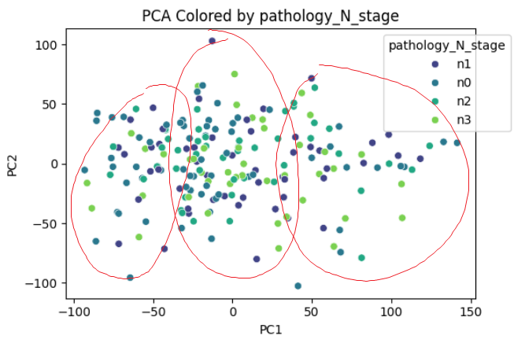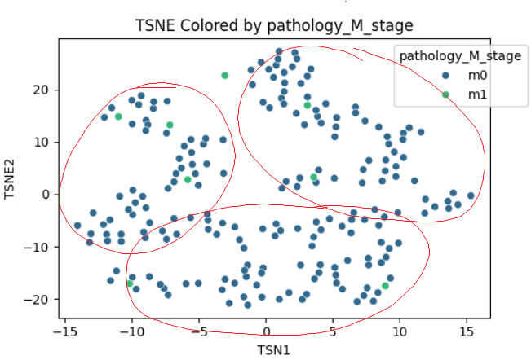

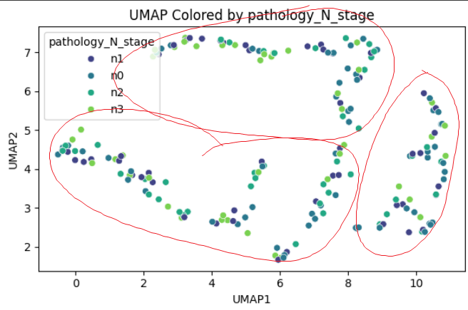

## **4 – MOFA Object Creation**

* Purpose: Building the MOFA+ models that’ll learn latent, shared patterns across multi-omics data (rna-seq *and* mutation data)

### Entry Point

* Creation of the object to set up MOFA+



### Reading Data

* Loading data to pass onto MOFA object later
* Transposing so rows = patients and columns = genes





### Disabling Scaling Views

* Views (rna-seq and mutation data) are *not* scaled
* Why? Rna-seq is *already* normalized, and mutation data is binary



### Passing Data

* Converting pandas df to matrices for MOFA compatibility
* Transposing *inside* data setup: columns *must* be equal
* Rna-seq data assigned ‘gaussian’ likelihood due to its continuous data
* Mutation data assigned ‘bernoulli’ likelihood due to its binary values (0s and 1s)
* View Names: view0 = rna data, view1 = mutation data

### Model Configuration

* factors = 10: number of latent (hidden) factors model learns to explain variation across omics data (rna and mutation)

### Training Options

### Running and Saving Model

* .hdf5 file format for downstream analysis (covered in next section)

## **5 – Downstream Analysis**

### Mapping Features to Genes

* Problem: MOFA did not pick up gene names during training
* Solution: Created a function that maps feature names to gene names from original dfs

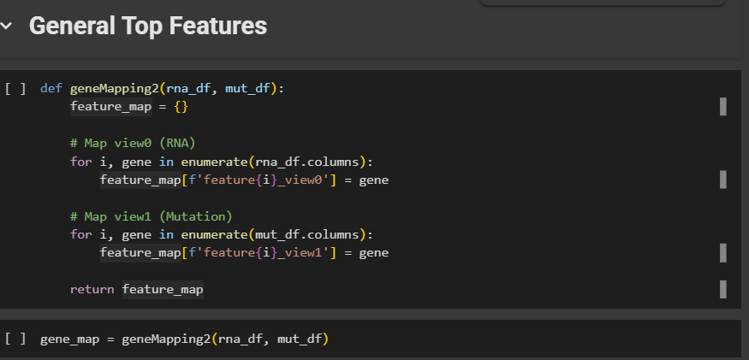

### Plotting Weights, Both Views (Rna and Mutation)

* Rna view (view0) sees strong features from factors 1 – 4 *mainly* (our focus it seems)
* Mutation view (view1) is quite weak without strong features on any factors

### Weights Ranked

* This plot shows a factors’ strongest features
* X axis = feature rank
* Y axis = feature’s weight
* For example: Factor 1 shows *very strong* features. So do factors 2, 3, *and* 4 (again, our focus lining up as expected)

### Variance Explained

* As mentioned, view1 (mutation) is not indicative of any driving factors.
* *However*, factor 1 is driving view0 (rna) *incredibly strong*.
* Factors 2 and 3 very *lightly* follow on driving the rna view.

### Factors’ Correlation

* This plot shows the relationship between factors with one another.
* Shows *weak* correlation, thus meaning no overlap between factors.
* Can be a good thing as it means factors show distinct biological information (no redundancy in data or genes)

### Factors and Features Heatmap

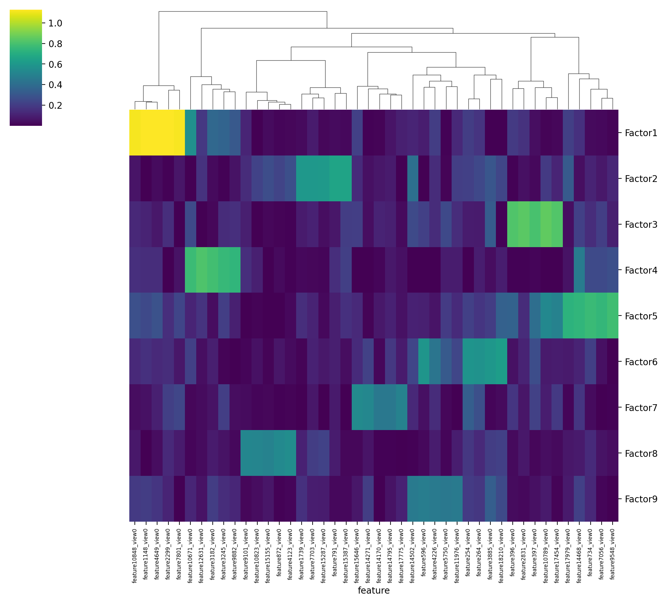

* Once again, another heatmap but this time showing the relationship between factors and features.
* Order of seemingly strongest relationships based on brightness:
  + Factor 1 🡪 Factor 3 🡪 Factor 4 🡪 Factor 5 🡪 Factor 2 🡪 remaining are weak.
  + Factor 5 a new focus added? Potentially

### Weights Dot Plot (RNA)

* Plots above further proves that factor 5 *may indeed* be a new added focus

### Weight Dot Plot (Mutation)

* *Only* factor 1 has strong coloured dots: but *still*, values are insignificant with highest being slightly above 0.08 so we ignore it.

### Scatterplot, Scaled Weights

* This compares the density and direction of 2 factors’ features
* We have *many* factors: which do we compare? **Based on variance explained!**
* Ranking variance -
  + # 1. factor 1
  + # 2. factor 2
  + # 3. factor 3
  + # 4. factor 4
  + # 5. factor 5
  + # 6. factor 6
  + # 7. factor 7
  + # 8. factor 8
  + ignoring factor 9 because it is below threshold of > 2% (this threshold I came up with for balanced inclusion while also ignoring low values)
* How will we go about the plot?
  + we will compare factor 1 with ALL others bc of its strong R2
  + if good results, same will be strat applied with factors 2 and 3
  + avoiding comparing mid factors with other mid factors
  + including comparisons of 2, 3, and 4 together

* Results:
  + Quite strong clusters in factors 2 – 5 vs. factor 1
  + No clusters, greater sparsity in factors 6 - 9 (expected)
  + So, we focus on factors 1 - 5 (as previously thought)
  + Factor 1 vs. 2 - 5 very orthogonal (unique bio info, we will see later)
* Now we compare F2 with F3 – 5, F3 with F4 – 5, and F4 with F5

* No strong overlap between factors: great sign of no redundancy
* But we do see some overlap in factor 5 comparisons...
  + So, we ignore factor 5 as factors 1 - 4 have strong signals already
  + Thus, going back to our original focus of factors 1 – 4
  + Conclusion: high correlation in heatmap is not *always* good and enough

### Revising Heatmap (10 Features)

* After finding our focus factors, we reuse the heatmap but with highest 10 features for each factor now

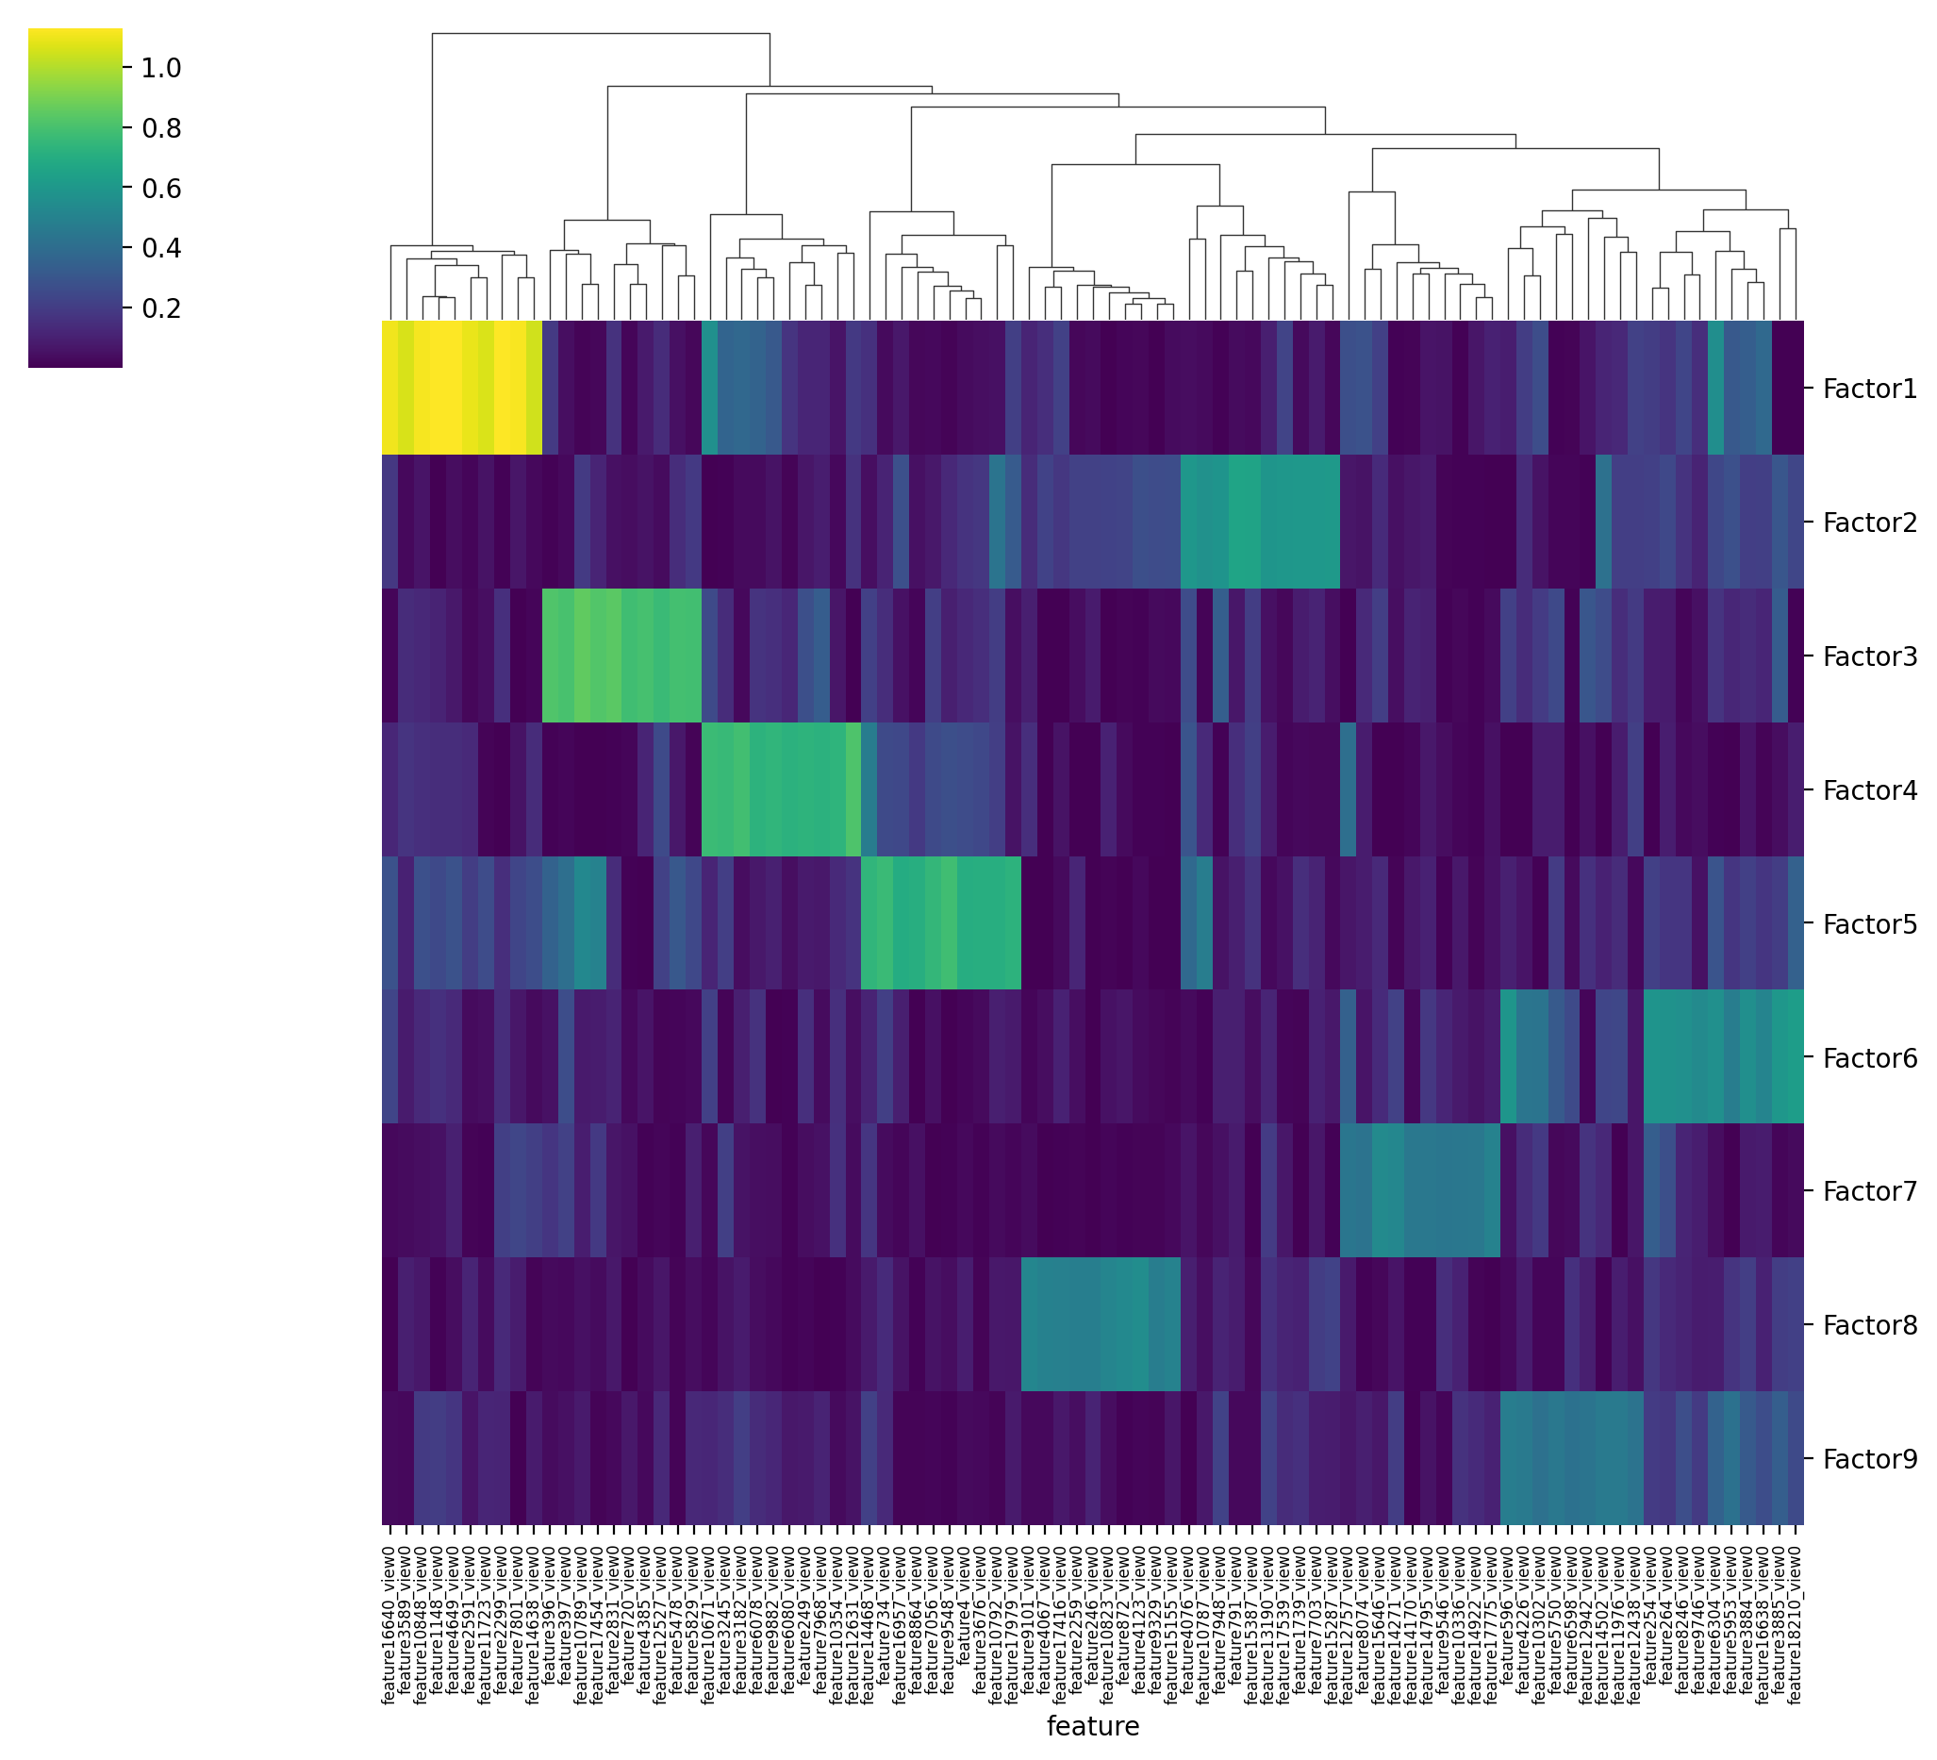

### Highest Genes in Each Factor

* Factor 1: MYH11, ATP1A2, DES, C2orf40, HSPB6, THBS4, CHRDL1, C7, OGN, SCRG1
* Factor 2: ATP5G2, HPN, SLC34A2, APOA1, SLC5A5, CREB3L3, MUC15, IGF2BP1, PROC, TTR, C12orf56
* Factor 3: AGR2, CAPN8, AGR3, MUC17, TSPAN8, ANXA10, CYP2C18, PIGR, ERN2, FAM3D
* Factor 4: MS4A1, PLA2G2D, CD19, CD79A, LY9, FCRL3, FCRL5, ADAM6, IGJ, MGC29506, S100A2

## **6 – Ontologies**

A group of genes that heavily influence latent factors that MOFA found as important patterns across RNA-seq and mutation data.

### Factor 1

* **GO Biological Process 2025**:
  + Genes are heavily related to heart and contractions and even regulation of blood circulation, which all relate to muscular function of the stomach for digestion for example.
* **GO Cellular Components:**
  + Genes are *also* important for cell communication and movement which heavily impact how stomach cancer grows and spreads.
* **GO Molecular Functions:**
  + These genes are also enriched in sodium/potassium transporter activity and ion binding, which help control cell signal and balance – they’re often altered in cancer to support the growth and survival of the tumour.

### Factor 2

* **GO Biological Process 2025**:
  + Enriched in negative regulation processes, suggesting how tumours suppress immune response or alter tissue structure to spread and survive.
* **GO Cellular Components:**
  + The genes are found in places like vesicles and Golgi which are areas that help the cell make and move proteins; so, these parts in cancer are often changed to help the tumour grow.
* **GO Molecular Functions:**
  + The genes are involved in sodium transport, kinase regulation, and protein interactions, which are important for cell signalling and communication. They play a *crucial* role in how cancer cells grow and respond to signals if weakened.

### Factor 3

* **GO Biological Process 2025**:
  + Genes are crucial in protein unfolding, rna processes, and immune regulation, thus suggesting very strong linkage to tumour behaviour.
* **GO Cellular Components:**
  + Similarly to factor 2 genes, they’re *also* found in vesicle and Golgi, thus pointing to their important in cancer cell signalling.
* **GO Molecular Functions:**
  + Genes involved in immune receptor activities, affecting how the tumour interacts with the immune system or can alter gene expressions.

### Factor 4

* **GO Biological Process 2025**:
  + Genes are linked to B cell activation and immune signalling, suggesting a strong immunity related role.
* **GO Cellular Components:**
  + Genes are once again pointing to involvement in immunity in addition to cell signalling zones.
* **GO Molecular Functions:**
  + Includes ion and metal binding, once again heavily related to immune responses and inflammation.

### Conclusion

1. Factor 1: Plays a role in cell mobility, ion transport, and muscle contraction; processes linked to tumour growth and stomach muscle activity which raises the possibility that stomach cancer influences tissue dynamics and preserves cell viability.
2. Factor 2: Protein transport mechanisms are altered, and immune responses are suppressed in enrichment. These characteristics might aid in tumour growth.
3. Factor 3: Immune control, RNA handling, and unfolded protein response are important mechanisms in this factor which suggests that tumours frequently exhibit stress inducing activities.
4. Factor 4: Strongly linked to immunological function like B cell activation, probably presenting immune-related processes that affect inflammation or tumour presence.

## **7 – Improvements**

* To capture more biological variation, include additional omics layers like proteomics or methylation especially as the mutation omics was weak.
* Instead of keeping clinical data apart, use it as a third view so that MOFA+ may directly learn from signals related to phenotypes.
* To investigate patient subtypes or predict clinical outcomes, use clustering or classification on the latent components.

# **References**

# Rees, M. (2024). What to know about adenocarcinoma stomach cancer. [online] Medicalnewstoday.com. Available at: https://www.medicalnewstoday.com/articles/adenocarcinoma-stomach-cancer#causes [Accessed 5 Jun. 2025].

1. Linkedomics.org. (2025). LinkedOmics :: Data Download. [online] Available at: https://linkedomics.org/data_download/TCGA-STAD/ [Accessed May 27. 2025].