APPMessageNotificationSetting
select * from APPMessageNotificationSetting
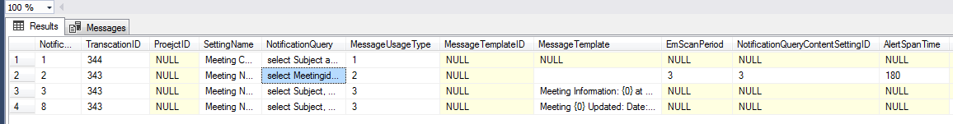
Usage Type:
public enum EmAppNotificationMessageUsageType
{
ICSFormatQuery = 1,
TargetDateQuery = 2,
NotificationContentQuery = 3,
}

- ICSFormatQuery
Need to set:
1) MessageUsageType = 1
2) TranscationID
A master detail transaction which contains 6 ICS Format fields:
Summary, Location, BeginDate, EndDate, Details, DetailsHTML
3) NotificationQuery
A query which exactly match the ICS columns below:
select Subject as Summary, Location as Location, StartTime as BeginDate, EndTime as EndDate, Description as Details, '' as DetailsHTML
from UDMeeting
where MeetingID=@RootValueID
How To Work:
When the Transaction Form sends a message, it reads the setting and build the ICS file as an attachment for external email.
- TargetDateQuery
Need to set:
- MessageUsageType = 2
- TranscationID: Transaction which need to send message
- SettingName
- NotificationQuery:
Must contains TargetValueID (TransactionRID), TargetDate

select Meetingid as TargetValueID, StartTime as TargetDate from UDMeeting

- EmScanPeriod: always 3 (3 is type of Minutes)
- NotificationQueryContentSettingID: Child settingID which has MessageUsageType=3 as message body text.
- AlertSpanTime: Scan Interval

How To Work:
Scan every AlterSpanTime to check the query result,
if (timsSpan.Minutes > 0 && timsSpan.Minutes <= aSettingdto.AlertSpanTime.Value)
Then send message.
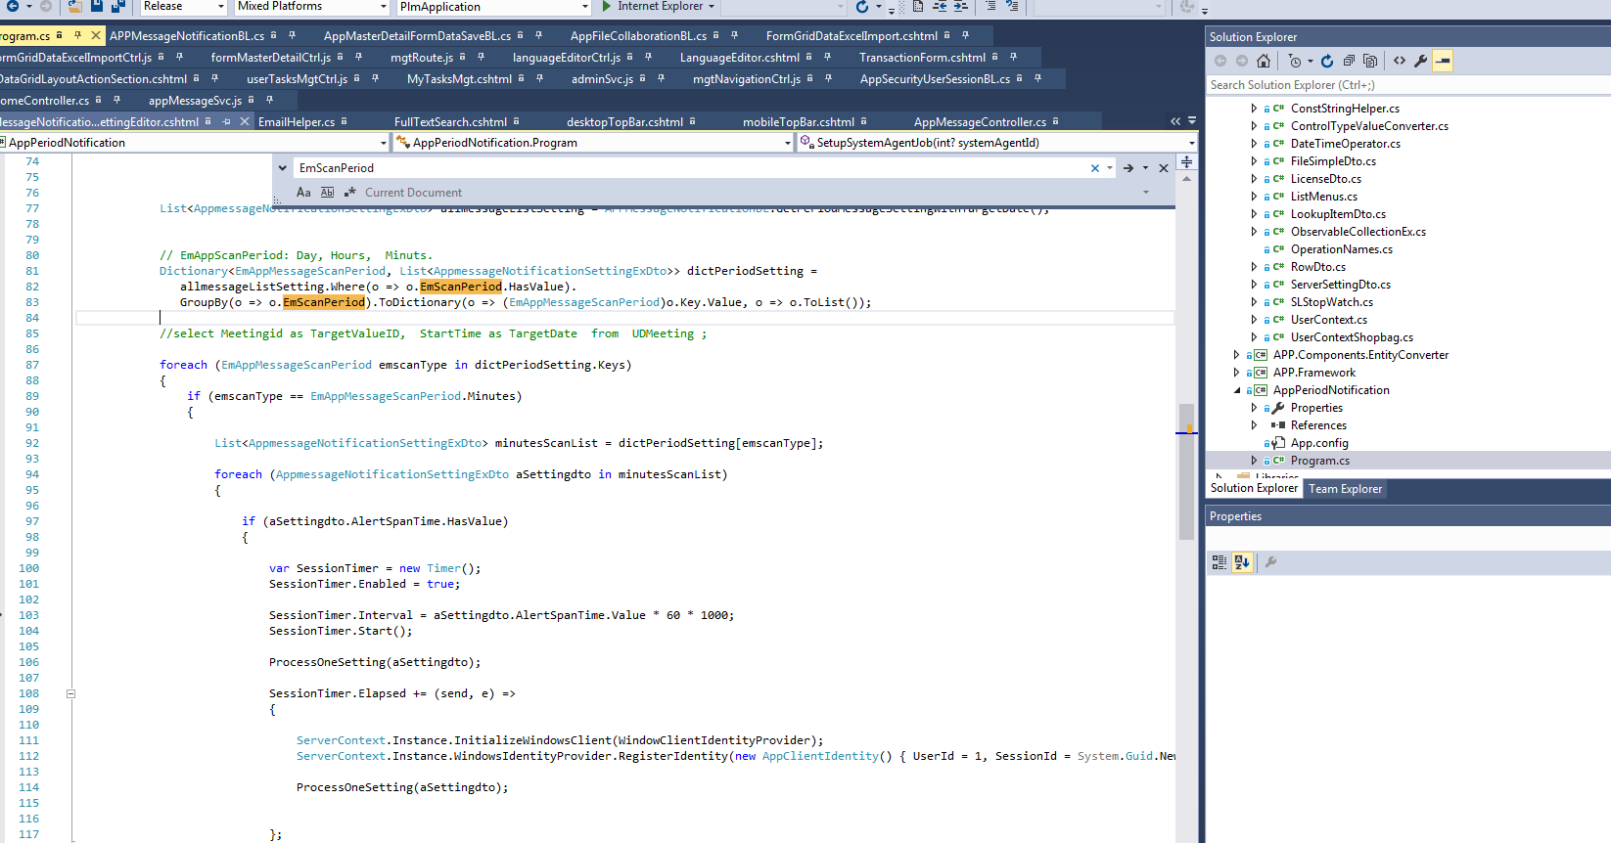
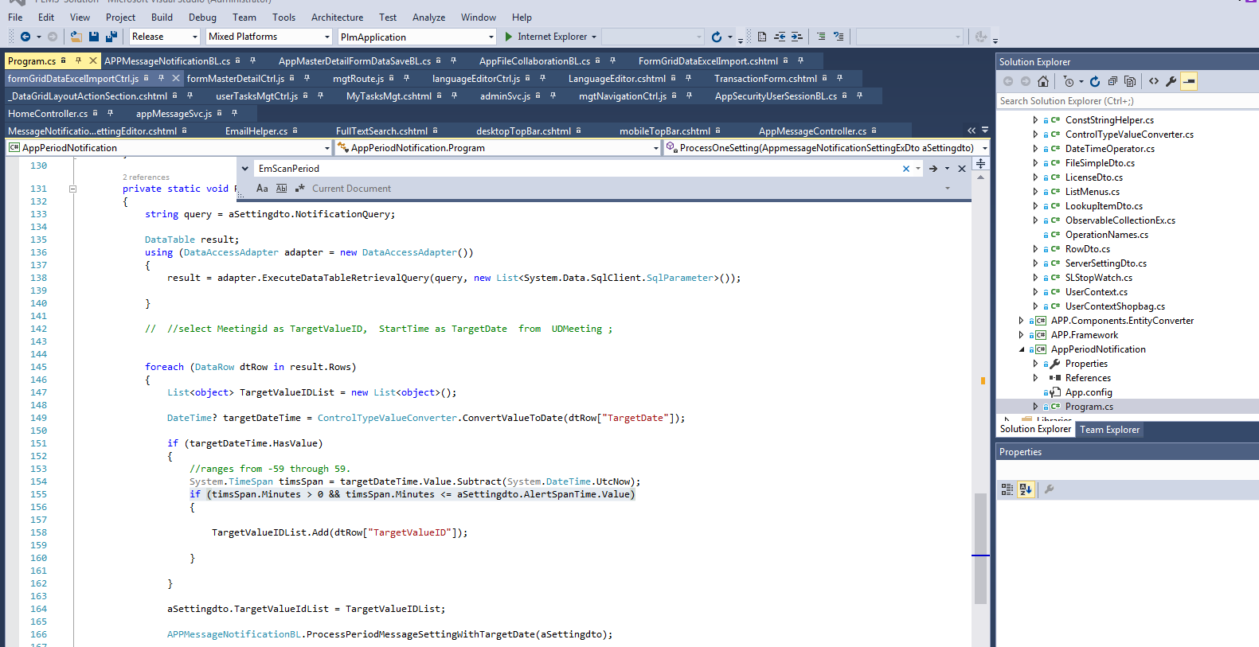

- NotificationContentQuery
Need to set:
- MessageUsageType = 3
- TranscationID
- SettingName
- NotificationQuery:
select Subject, Subject, StartTime, Location from UDMeeting where MeetingID = @targetValueId
- MessageTemplate:
Meeting {0} Updated: Date:: {1} Location: {2}

