Sandbox Testing Steps
- Create Trainer Paypal Test Account.
We have already created 2 Trainer Test Paypal Accounts:
First name: rainerA
Last name: TestA
Email ID: TrainerA@personal.example.com
Password: aaaaaaaa
Credit Card Number: 4032030449083337
Credit Card Type: VISA
Expiration Date: 12/2025

First name: TrainerB
Last name: TestB
Email ID: TrainerB@personal.example.com
Password: aaaaaaaa
Credit Card Number: 4032037264625159
Credit Card Type: VISA
Expiration Date: 12/2025

If you need more Trainer Paypal Test account, they can be created on :
https://developer.paypal.com/
User: peter@fit-concierge.com
Password: popStein4

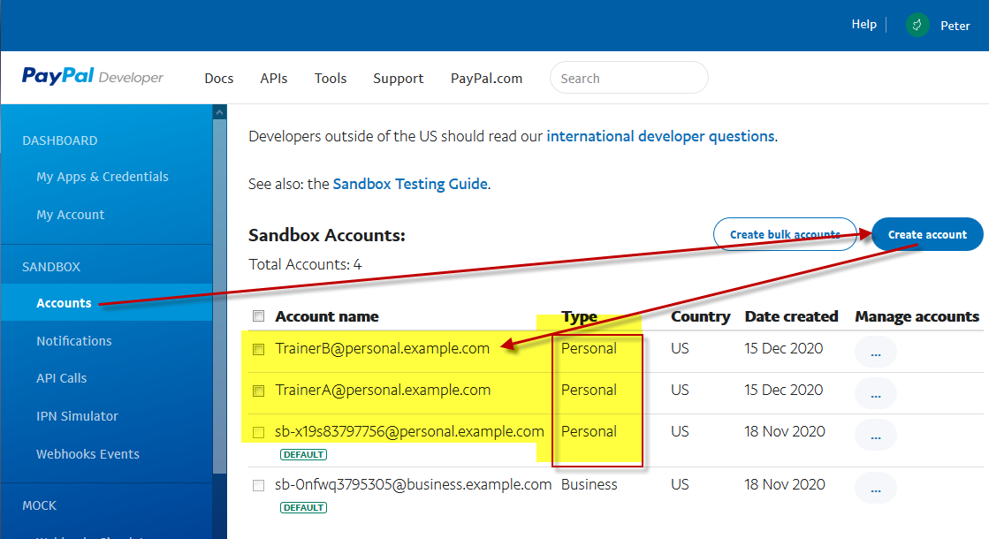

- Set PayPal Account on Fit-concierge/ Trainer Profile

Log in to a Fit-conciege with your trainer user/pass, and set the PayPal account email.

log in with Trainer User: trainer99@test.com
Pass: trainer99
Go to registration wizard, click continue until the input payment information page, enter the email TrainerA@personal.example.com (one of the sandbox accounts), click continue until the last page to save the changes.

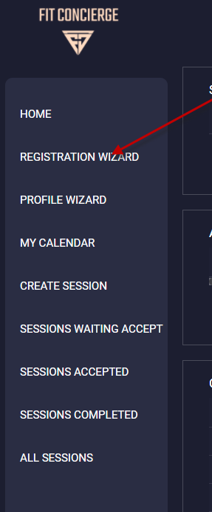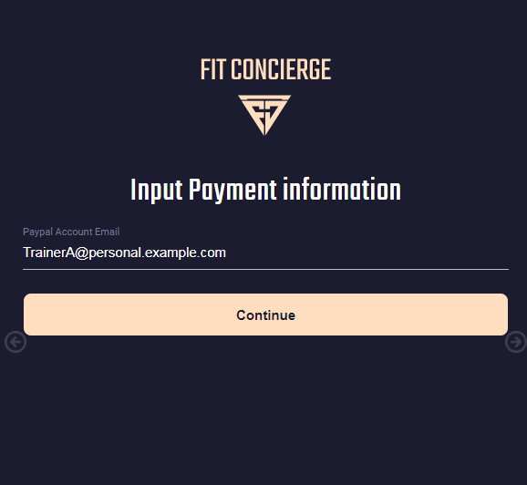

- Client Book Session and Payment

Sign with a client, book a session, make payment and submit

Client user: client5@test.com
Pass: client5

Client can pay with paypal or visa

Test Paypal account:
User: sb-x19s83797756@personal.example.com
Pass: vQu1[6I#

Test Visa:
Credit Card Number: 4032039140845753
Code: 111
Credit Card Type: VISA
Expiration Date: 11/2025
Billing address: 1 Main St, San Jose, CA 95131

Or you can use ur own visa to test, it will not charge on sandbox mode.

Booking Steps:
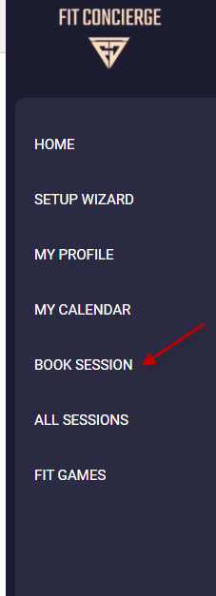 |  | 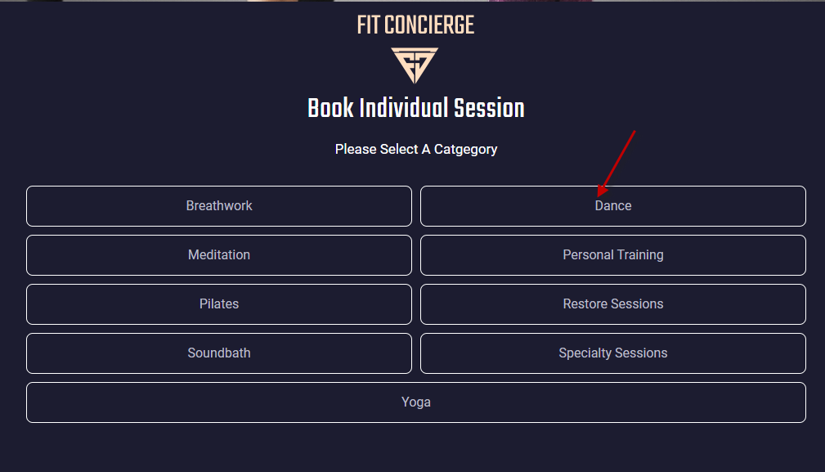  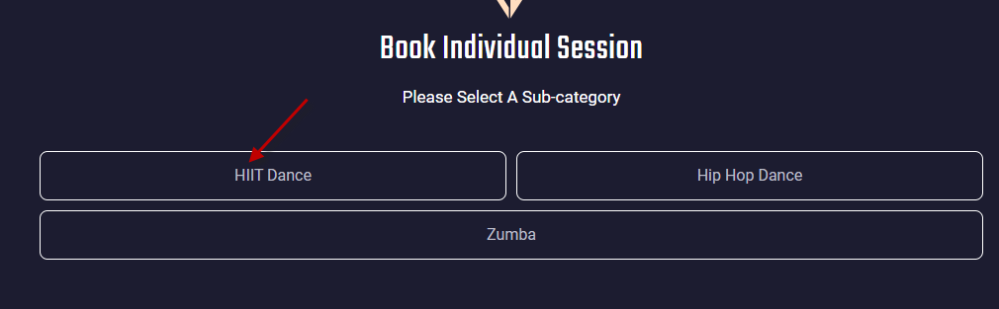  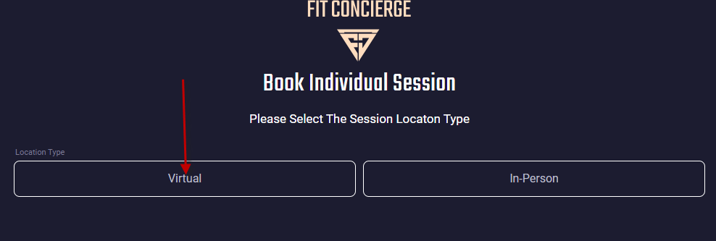  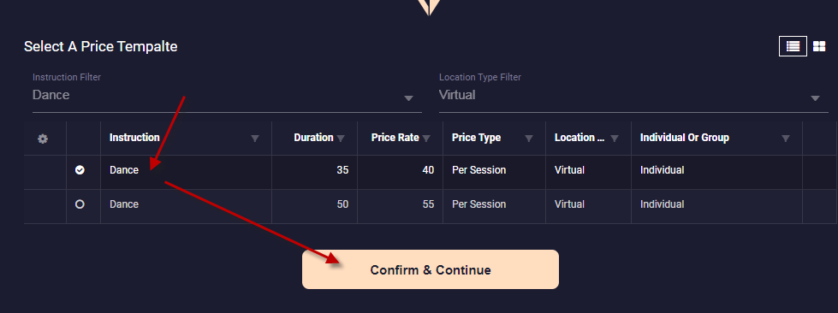 | 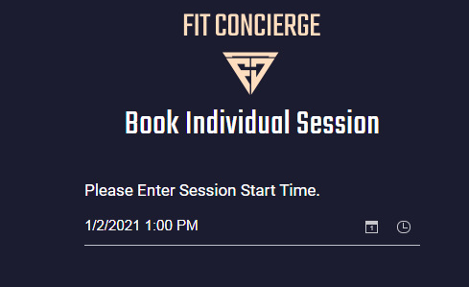  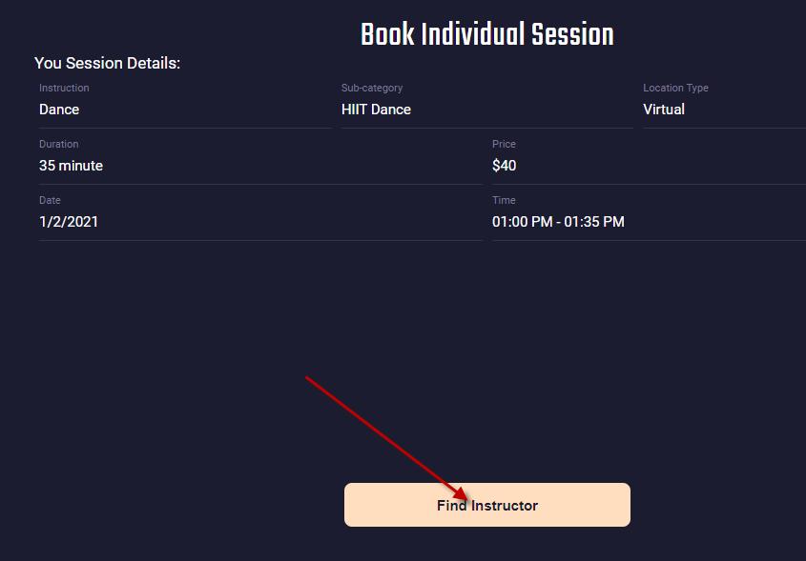  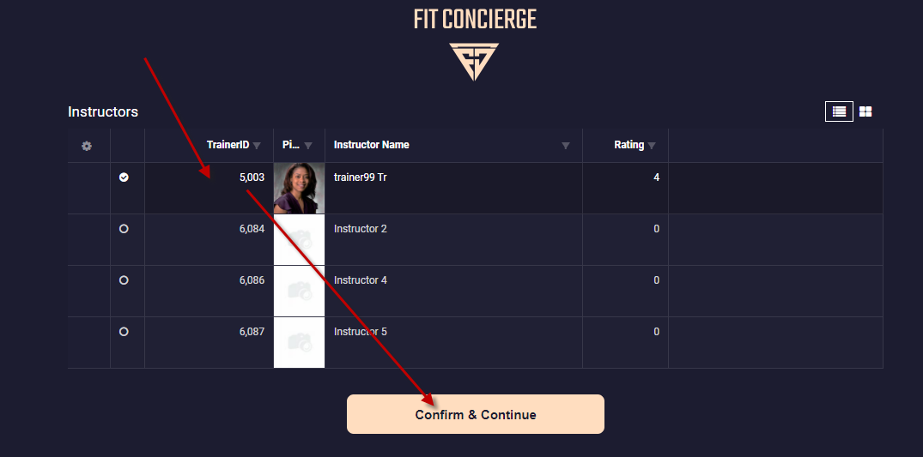 | 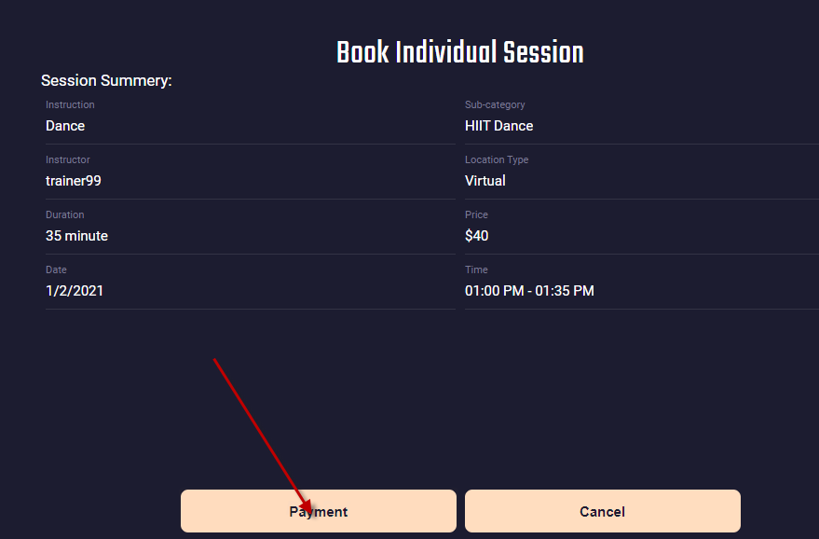  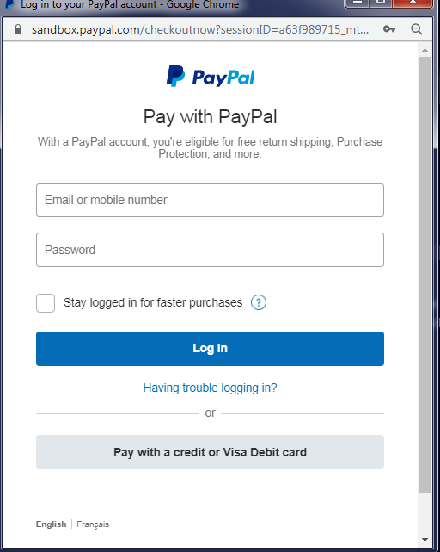 | 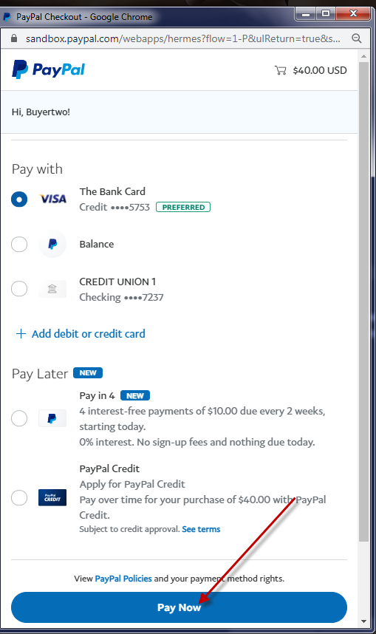  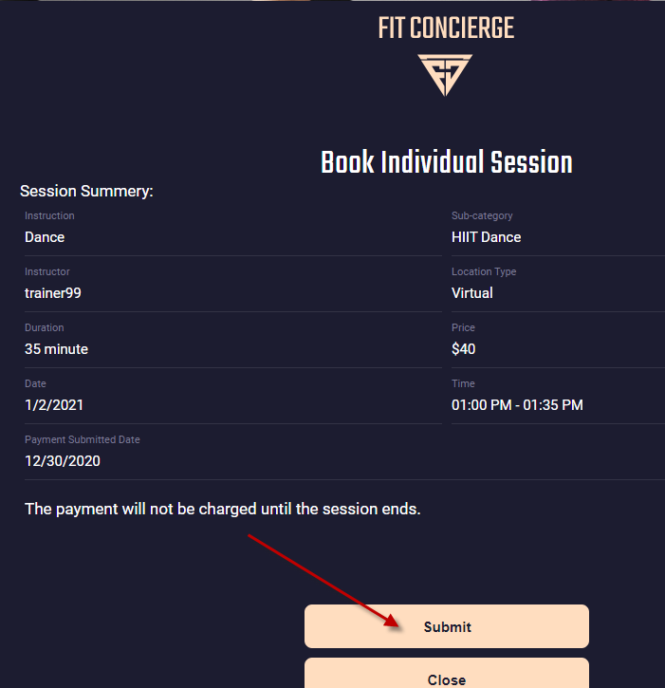

The new booked session should be displayed on dashboard then.
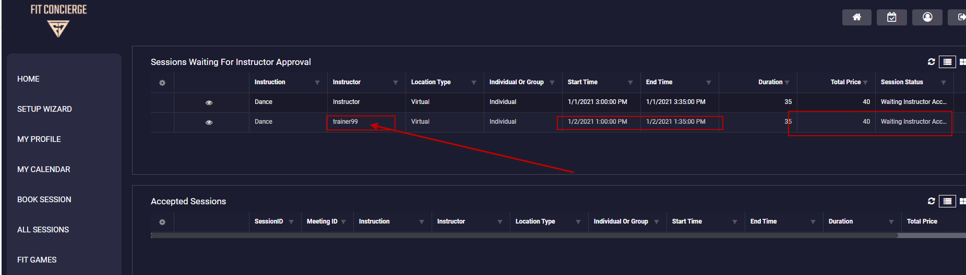

- Trainer Accept session
Login with Trainer
Trainer User: trainer99@test.com
Pass: trainer99

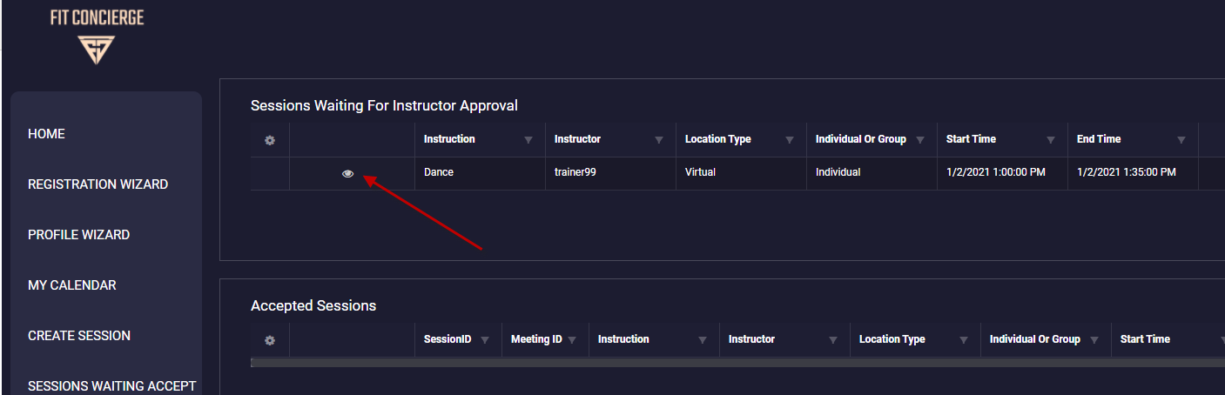
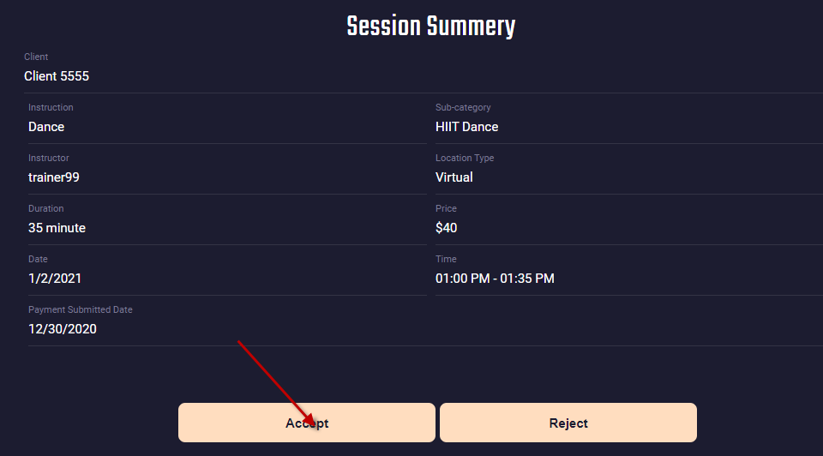

The Accepted session will moved to the Accepted Sessions table on trainer homepage.
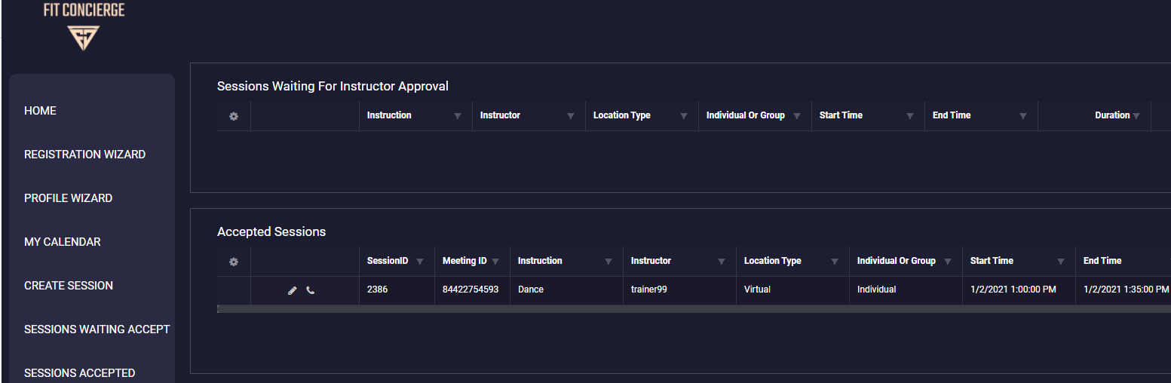

- Trainer complete session, and capture payments.

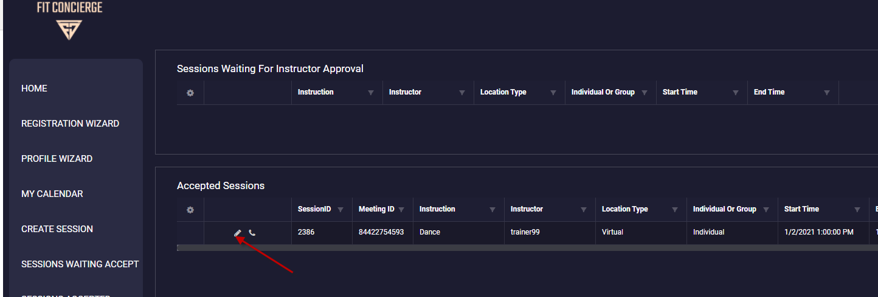
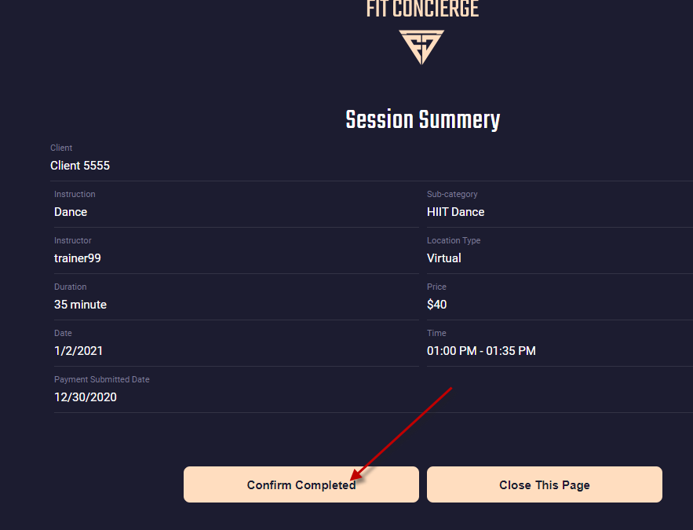
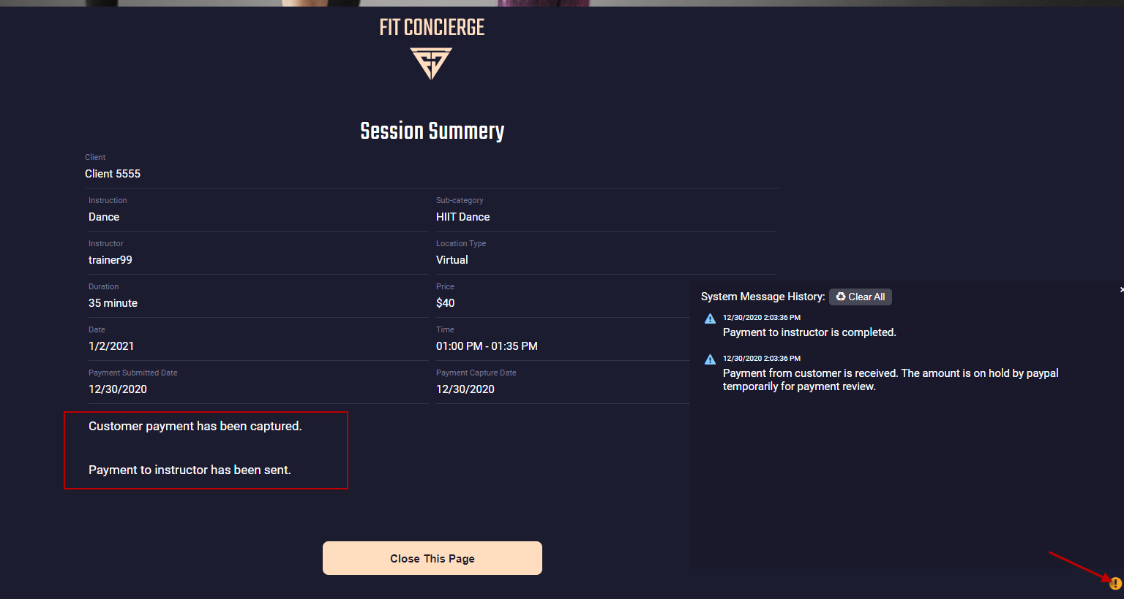

- You can check payment received and payouts on Fit-concierge store paypal test acount.

Login to: https://www.sandbox.paypal.com/
User: sb-0nfwq3795305@business.example.com
Pass: EK)hX!0)

Note: for live, it will be the live paypal account of fit-concierge: user:peter@fit-concierge.com Password: popStein4

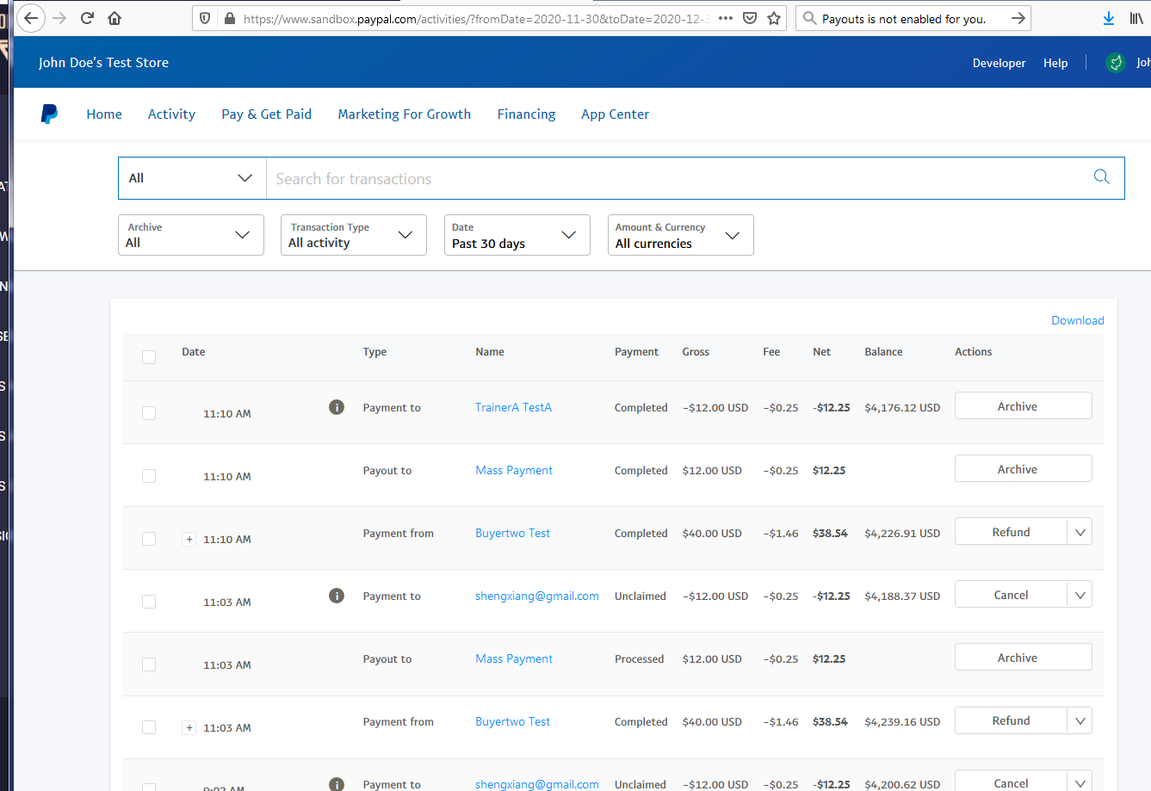

- Other Settings:
Trainer commission rate is based on the setting on Session Price Template, which can be set on the Price Template page on mgt site as below
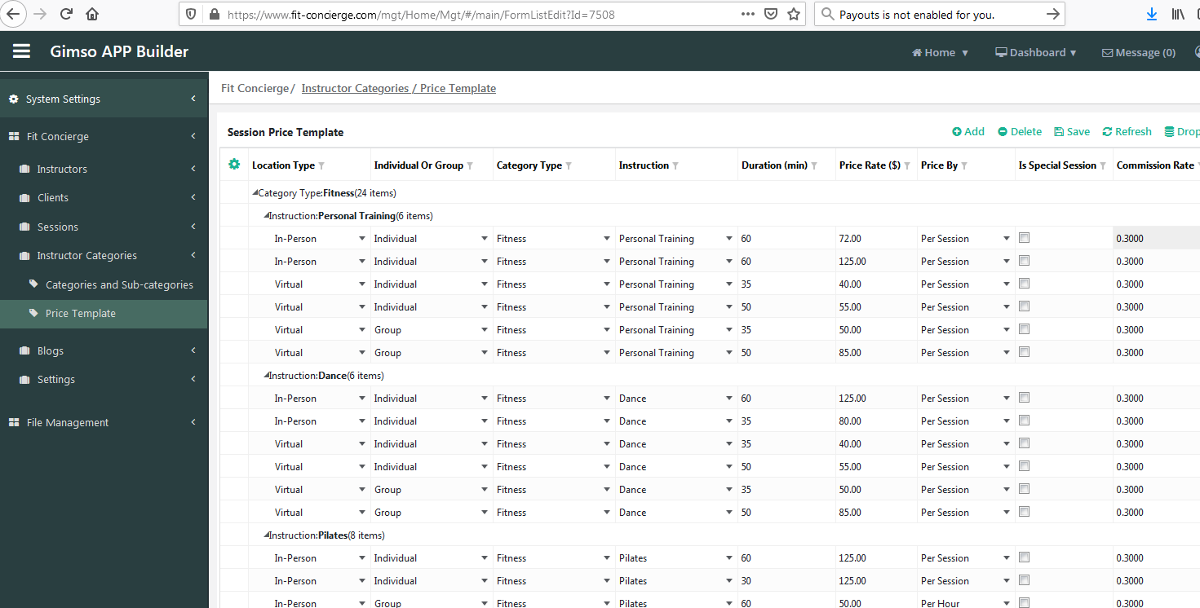

Go Live Setup

- Login https://developer.paypal.com/
Go to dashboard => My Apps & Credentials, Switch to Live, Create Live App, Copy the live API ClientID and Secret.

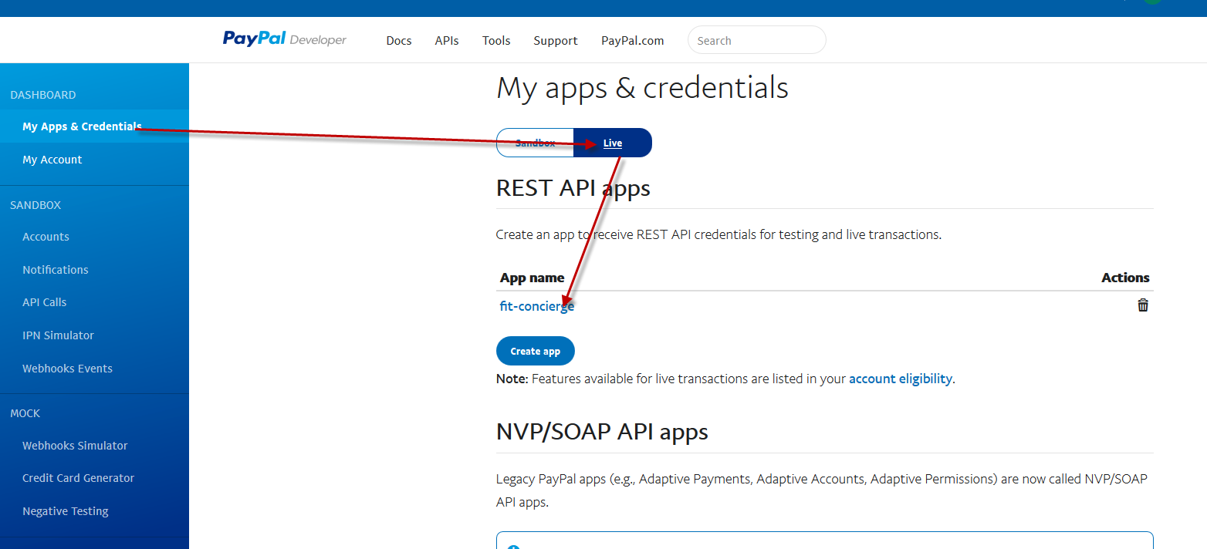

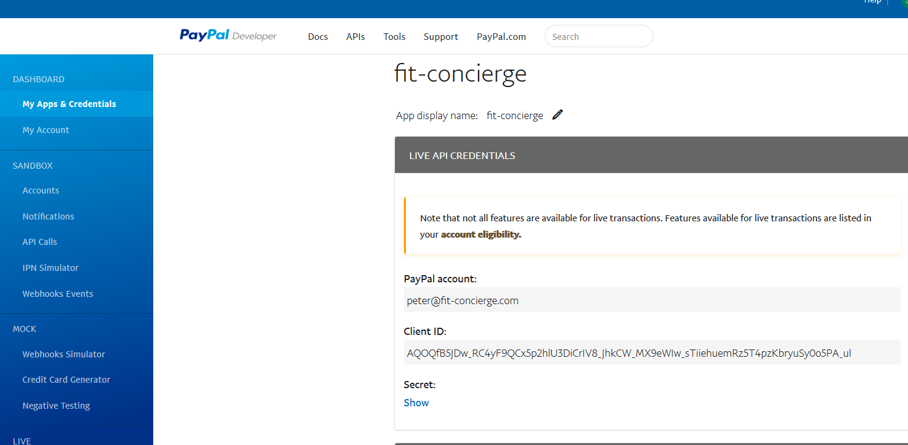

- Run script to change appWebApiProvider keys. Change APIKey = live clientId, ApiSecret = live secret

Need To Reset Application Pool after script!!!!
--- Live
update [AppWebApiProvider] set ApiKey = 'AQOQfB5JDw_RC4yF9QCx5p2hlU3DiCrIV8_JhkCW_MX9eWIw_sTiiehuemRz5T4pzKbryuSy0o5PA_ul',
ApiSecret = 'EP5tkULq5Nl3RWzJSPfhrFLyR79VMwCFVY5IZ_XOhKs0FTLs_pvLH9SF-D4VL_IU6oFiCHe1UWatmTB7',
AuthorizationTypePrefix = 'api-m' where ProviderName = 'PaypalApi'

--- Sandbox
-- update [AppWebApiProvider] set ApiKey = 'ASO3vShHiZH9YVklJwyKgcgvl0UE4oda7lnnKukkJEQ1wrYnWEr1yKGwuznDthGG0ZtfGon-bgPcPueC',
-- ApiSecret = 'EFOzp48Qpu0f7Rpo-3gWnw0HOtc_QJs4Hy8dnSUe63jkVqTqOowdPLsRmk5tV7FlZAq-abSaedK43qjU',
-- AuthorizationTypePrefix = 'api-m.sandbox' where ProviderName = 'PaypalApi'

- Web Site Index.html file change:

Modify this line to use live client Id:
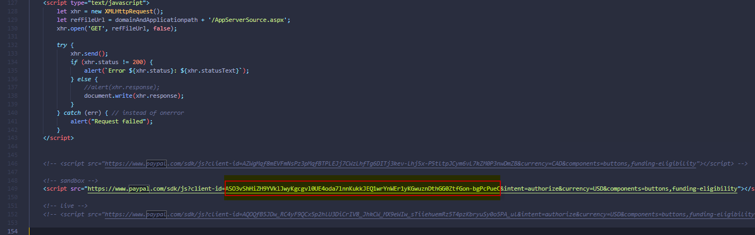

Notes:
- Currency Pending payment issue:
Change setting on account setting=>payment preferences=>block payments=>Allow payments sent to me in a currency I do not hold:
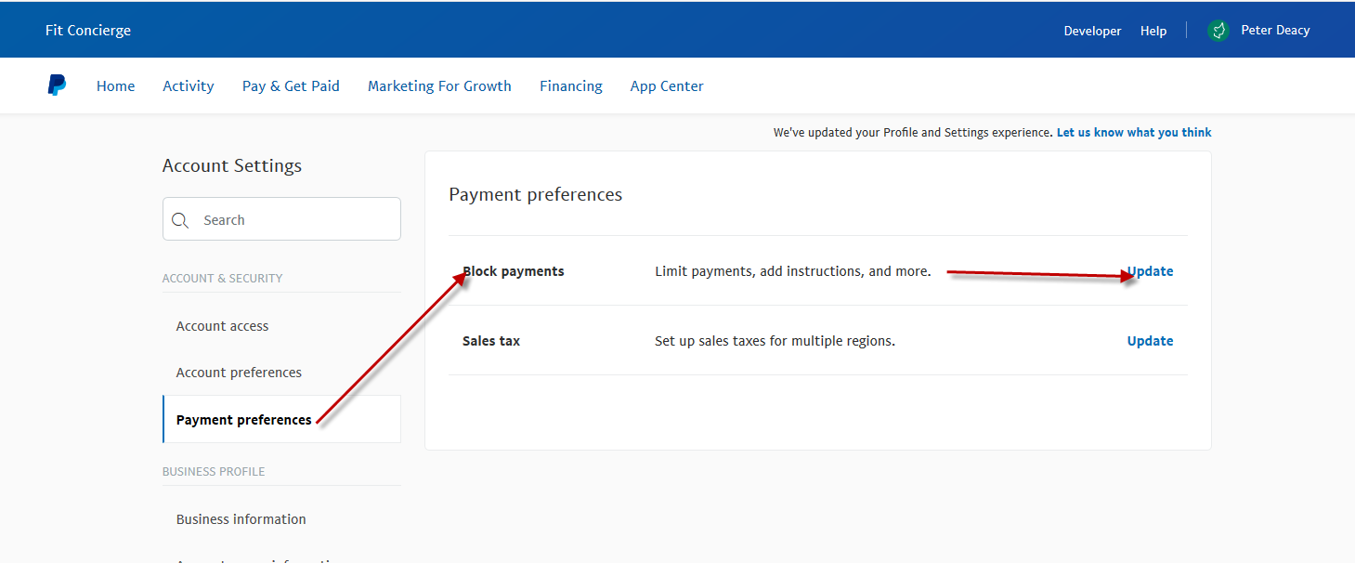
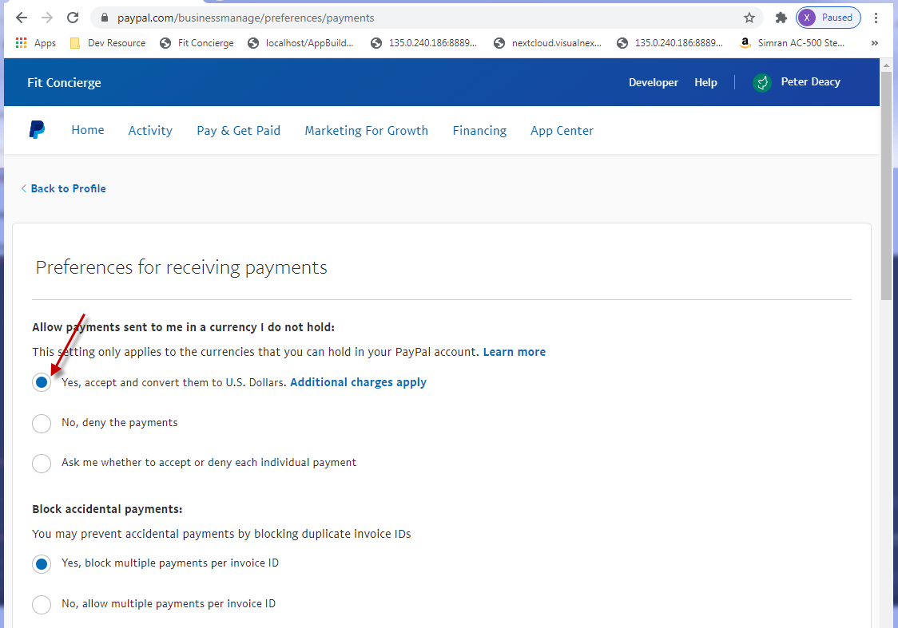

Other Reason:
https://www.paypal.com/us/brc/article/funds-availability

Payout Failed Issue:
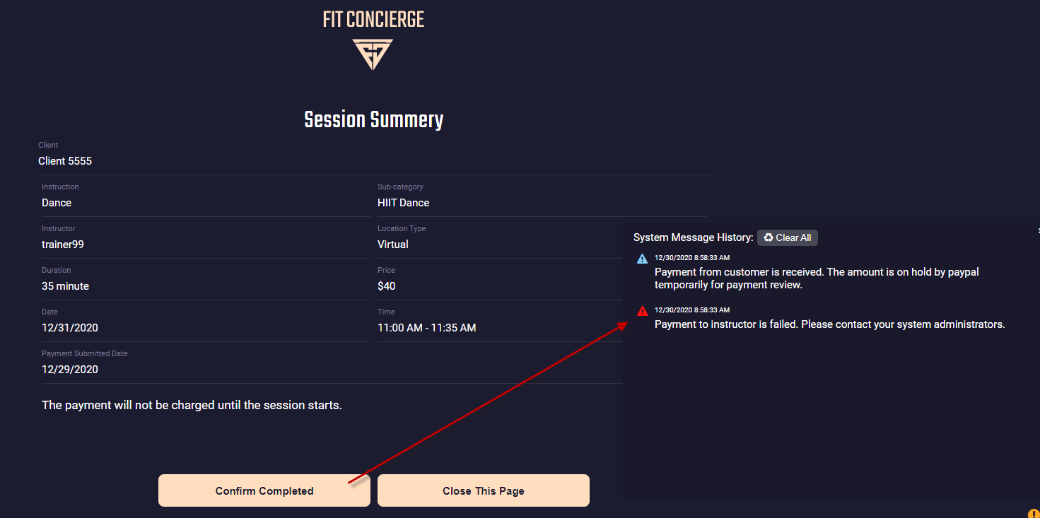

Reason 1: INSUFFICIENT_FUNDS
Log: (fit_session table PaypalPayoutLog column)
{"name":"INSUFFICIENT_FUNDS","message":"Sender does not have sufficient funds. Please add funds and retry.","debug_id":"35ce4dc389e0e","information_link":"https://developer.paypal.com/docs/api/payments.payouts-batch/#errors","links":[]}

Simulate the issue on paypal site:
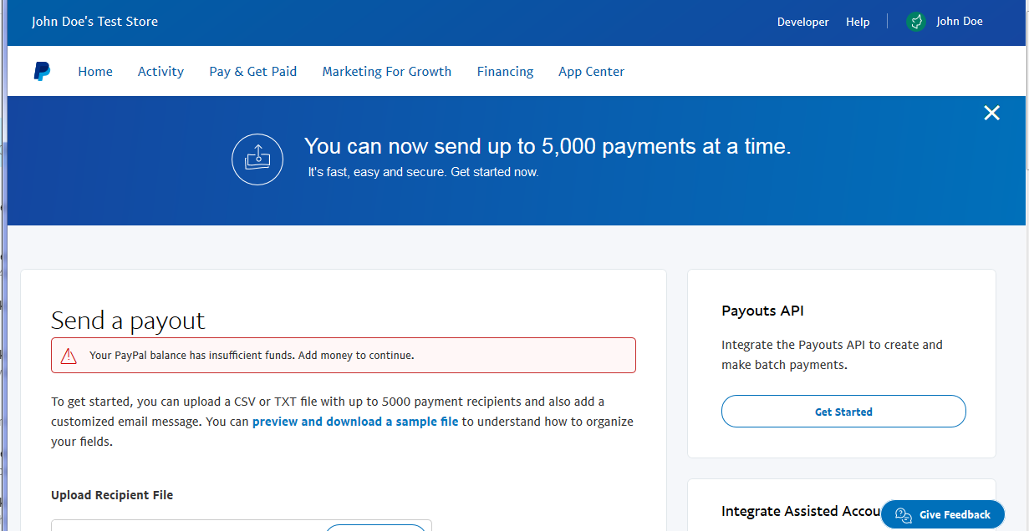

Reason 2: Payout function is not enabled.
Log: (fit_session table PaypalPayoutLog column)

sandbox
{"name":"REQUIRED_SCOPE_MISSING","message":"Access token does not have required scope.","debug_id":"252d6d897623d","information_link":"https://developer.paypal.com/docs/api/payments.payouts-batch/#errors","links":[]}

live
{"name":"REQUIRED_SCOPE_MISSING","message":"Access token does not have required scope.","debug_id":"f8ad1e02182e4","information_link":"https://developer.paypal.com/docs/api/payments.payouts-batch/#errors","links":[]}
Simulate the issue on paypal site:
