1. Create a new folder, go to this folder from cmd and get latest.

git clone <https://github.com/ncdiapp/sftecnextjs.git>

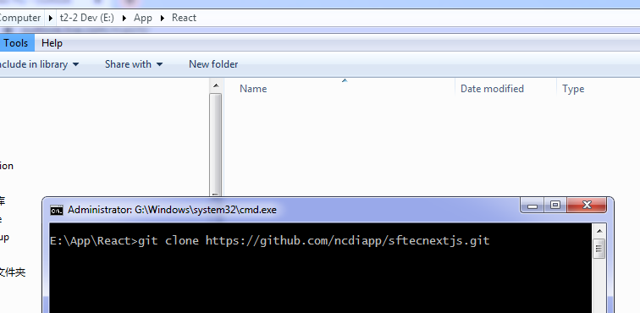

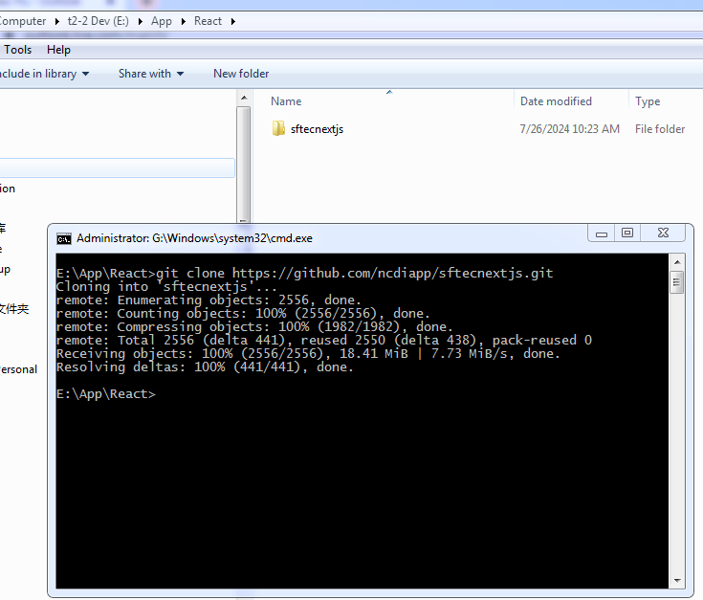

2. Go to the cloned folder, go to the subfolder below, and copy the folder path.

Mine is: E:\App\React\sftecnextjs\OtherProjects\CollectionBoardEditor

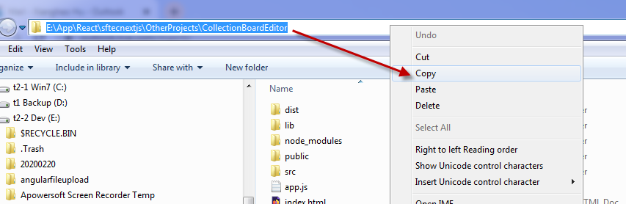

3. Open the folder from visual studio code. And click the Go Live button on the bottom right . The Collection Board Editor should be launched automatically in browser popup window.

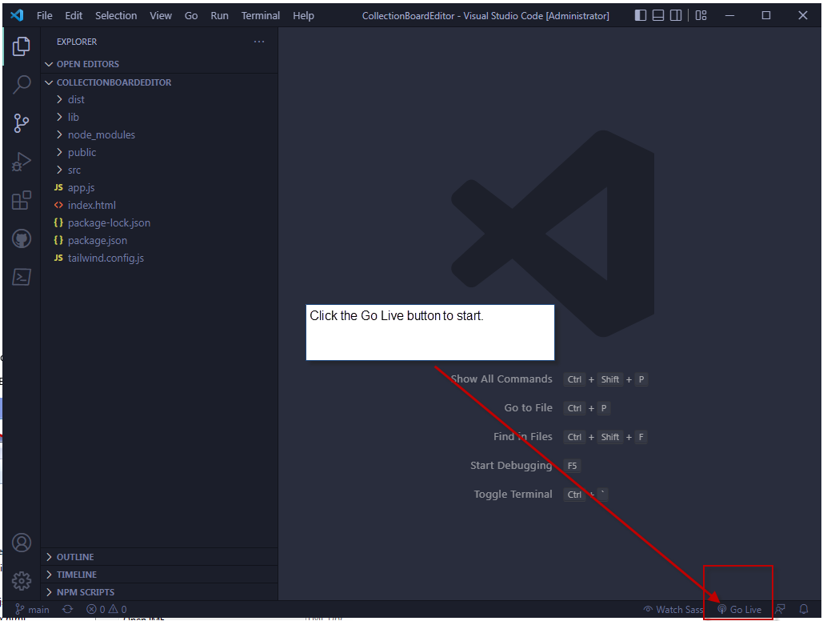

If you did not install the live server extension in your visual studio code, you can find the extension quickly as below.

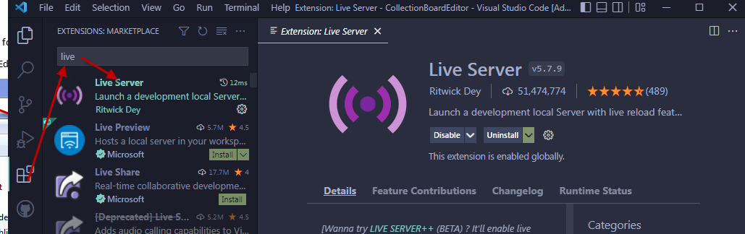

4. Usage

