**BÁO CÁO THỰC HÀNH LAB 1**

**LẬP TRÌNH HƯỚNG ĐỐI TƯỢNG**

2.2 The very first Java program

2.2.1 Write, compile the first Java application.

Result

2.2.2 Write, compile the first dialog Java program.

Result

2.2.3 Write, compile the first input dialog Java application.

Result

2.2.4 Write, compile, and run the following example.

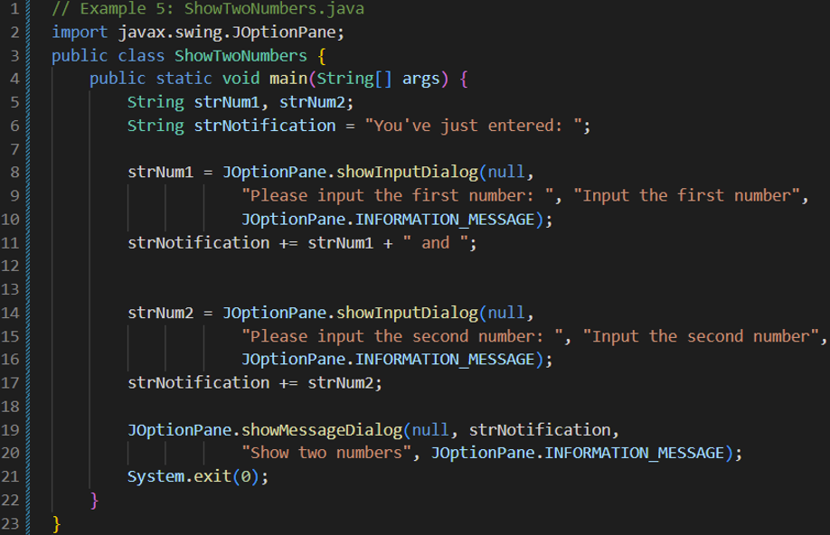

Result

2.2.5 Write a program to calculate sum, difference, product, and quotient of double numbers which are entered by users.

**Notes**

* To convert from String to double, you can use

**double num1 = Double.parseDouble(strNum1)**

* Check the divisor of the division

2.2.6 Write a program to solve linear equations.

- The first-degree equation (linear equation) with one variable

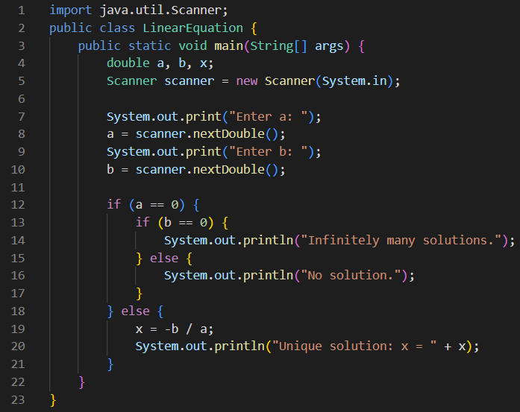

Result

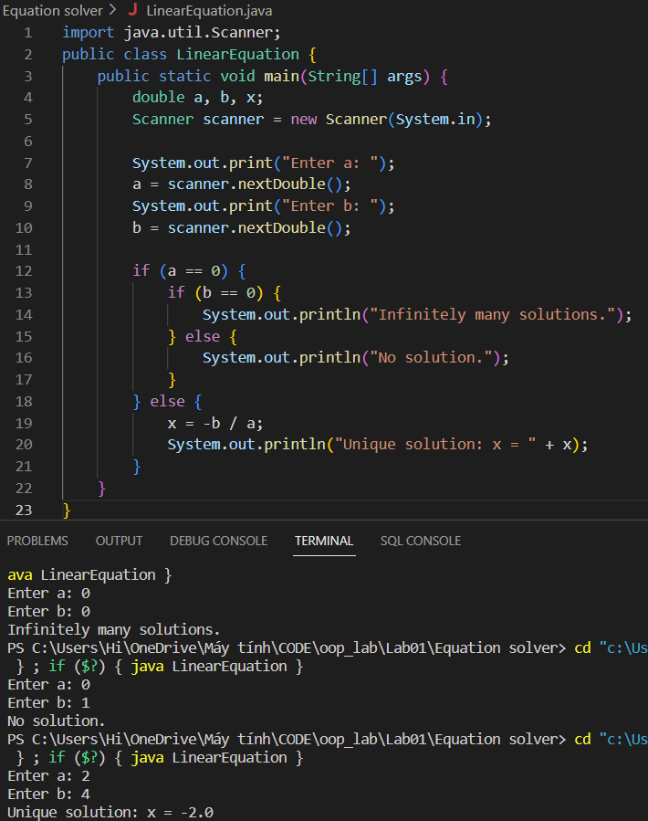

- The system of first-degree equations (linear system) with two variables

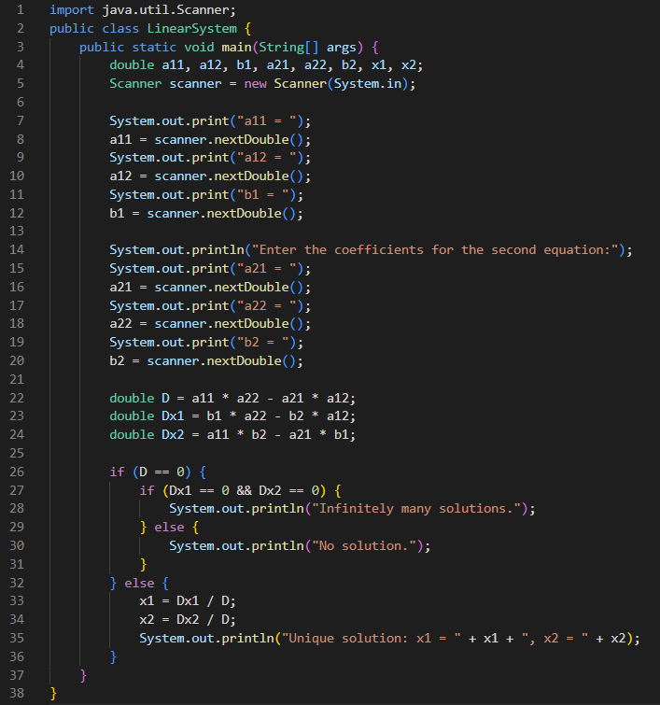

Result

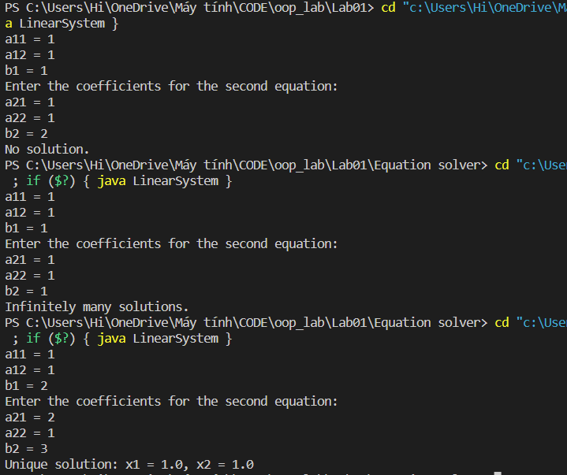

- The second-degree equation with one variable

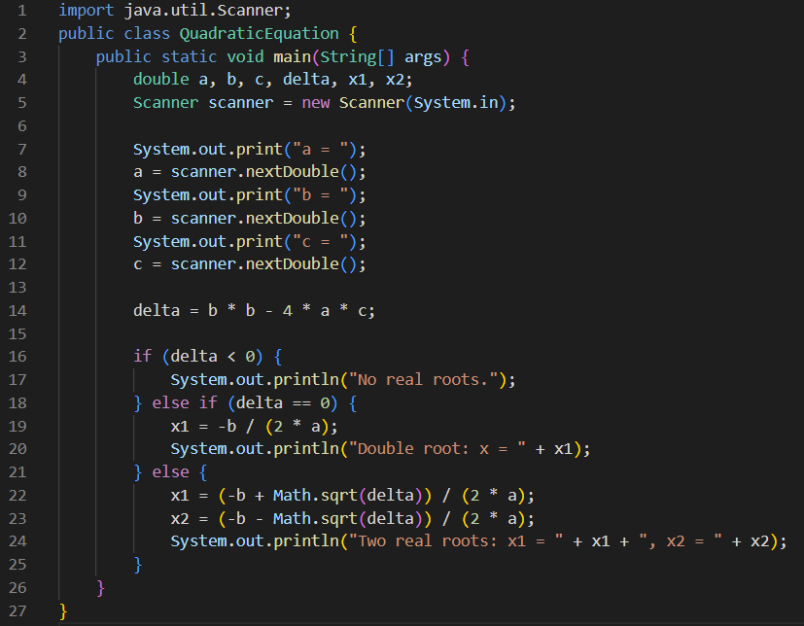

Result

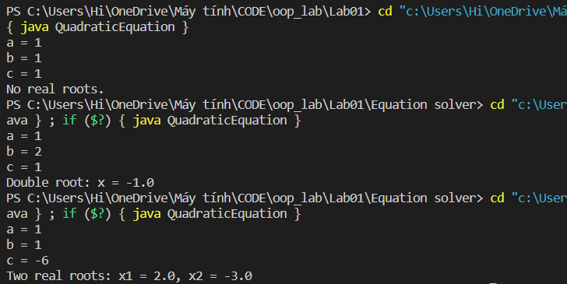

6 Exercises

6.1 Write, compile and run the ChoosingOption program

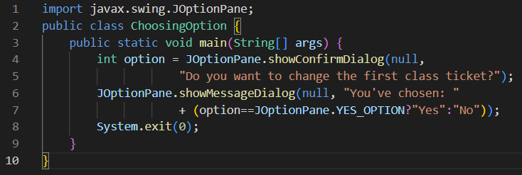

Result

- What happens if users choose “Cancel”?

The result is “No” because if the user does not select “Yes”, the default answer is “No”.

- How to customize the options to users, e.g. only two options: “Yes” and “No”, OR “I do” and “I don’t”

Use showOptionDialog instead of showConfirmDialog.

6.2 Write a program for input/output from keyboard.

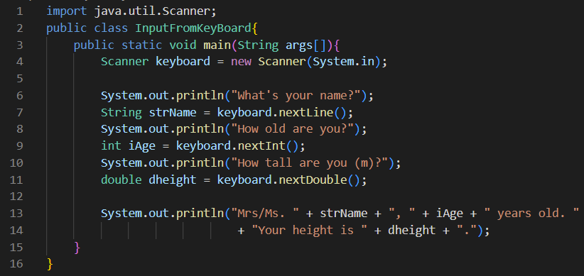

Result

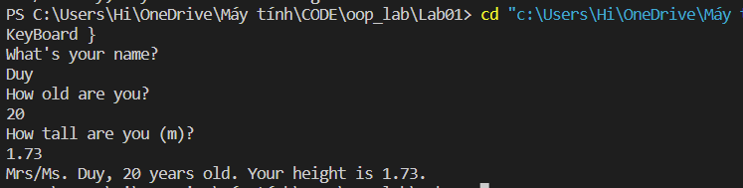

6.3 Write a program to display a triangle with a height of n stars (*), n is entered by users.

6.4 Write a program to display the number of days of a month, which is entered by users (both month and year). If it is an invalid month/year, ask the user to enter again.

Result

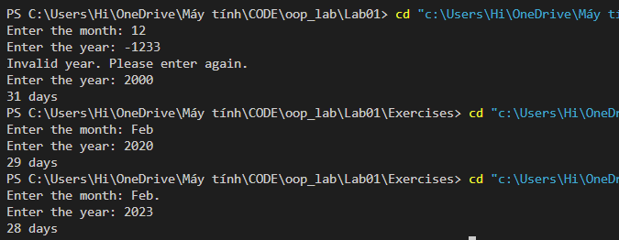

6.5 Write a Java program to sort a numeric array, and calculate the sum and average value of array element.

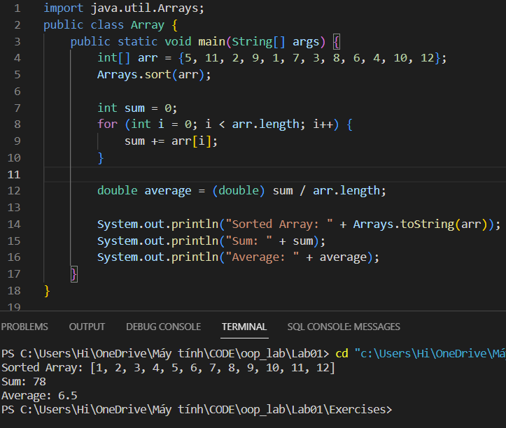

6.5 Write a Java program to add two matrices of the same size.

Result

