
Tidy Data and Joins Activity KEY

Question 1: Assess Tidyness per the tidy data principles:
- P1: Every column is a variable
- P2: Every row is an observation
- P3: Every row is a single value

Survey dataframe

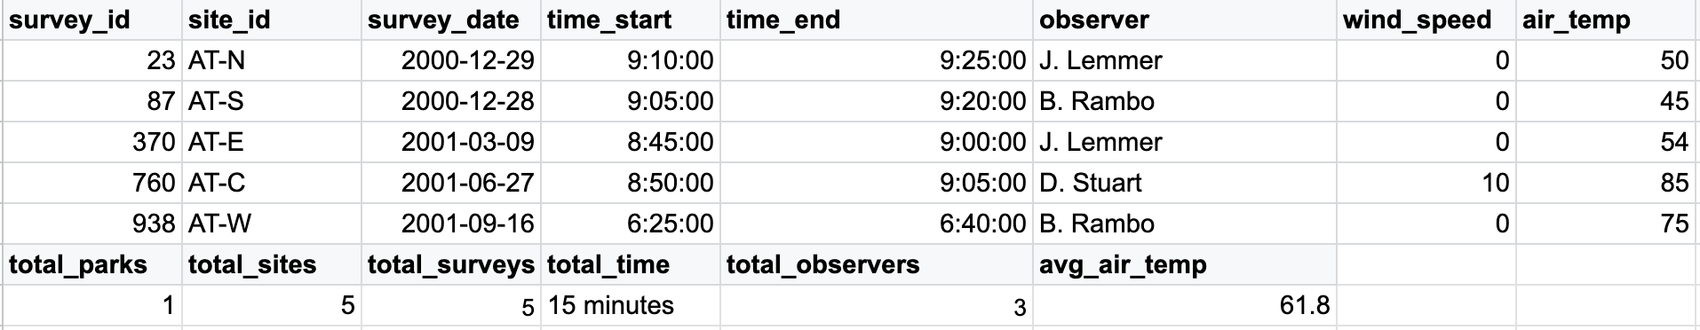
- Does it adhere to tidy data principles?
  - P1: No. The last row makes each column have multiple variables.
  - P2: No. Except for the last two rows, all rows have a single observation.
  - P3: No: the cells in the second-to-last row have headers instead of values.
- How to tidy: The easiest step would be to remove the last two rows of the dataframe. We can always recalculate these summary statistics.
- Tidied Survey DF:
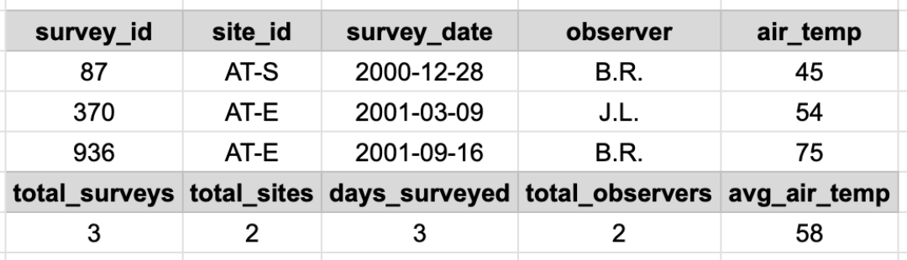

Taxonomy dataframe
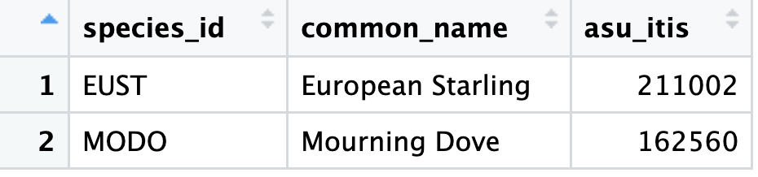
- Does it adhere to tidy data principles?
  - This one satisfies all three tidy data principles.

Bird dataframe
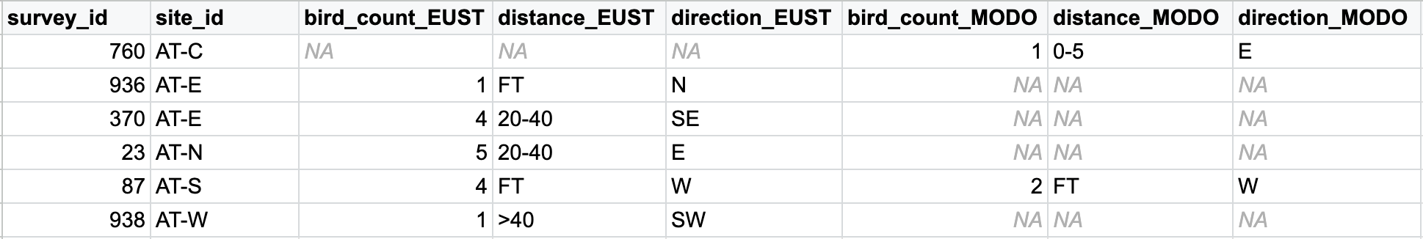

- Does it adhere to tidy data principles?
  - P1: No. There are variables spread across two columns. For example, two columns with values for distance.
  - P2: This dataframe mixes observations of two different bird species. Notice also that if we want to add a new observed species, we would need to add two columns instead of one row.
  - P3: Yes.
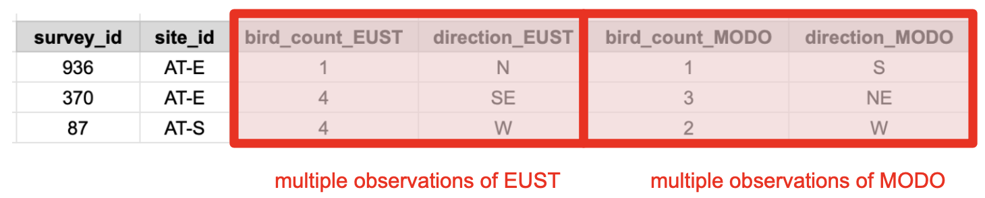
- How to tidy: Transform the data from a wide format to a long format, where you keep the columns for survey_id and site_id and add columns for species, bird_count, and direction.

Tidied Birds DF:
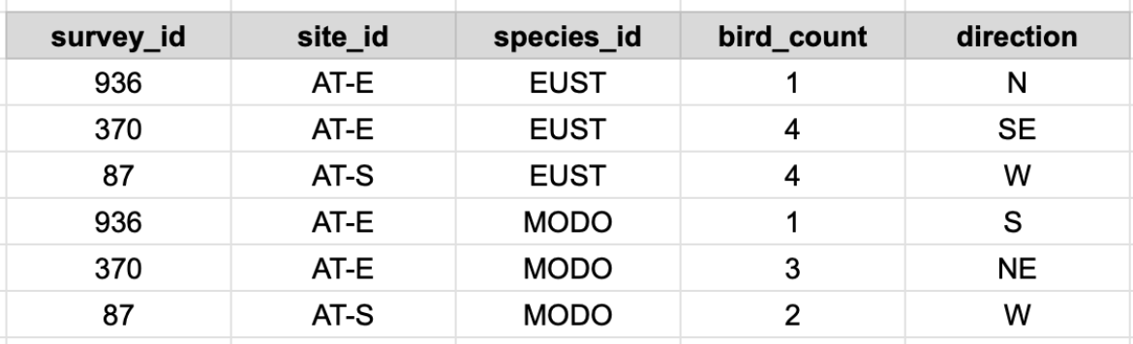

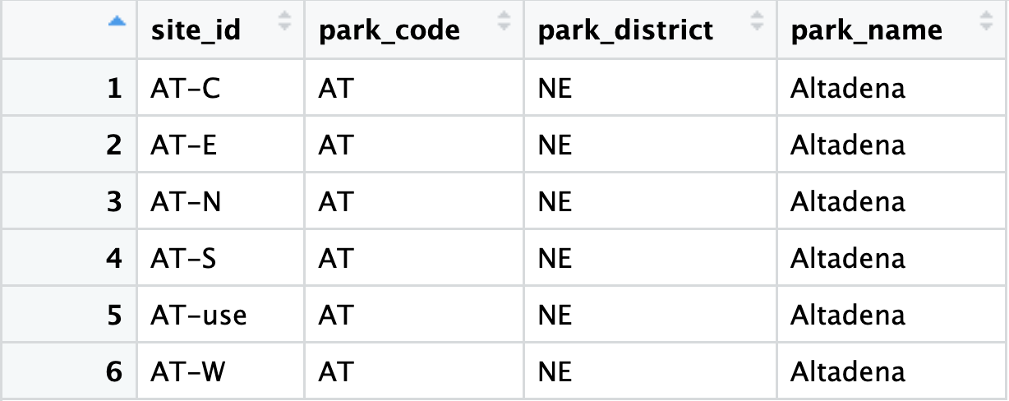
Site dataframe

- Does it adhere to tidy data principles?
  - This is a tidy data frame but not normalized. You can create a separate table with park code, park district and park name. And then have a site table with site id and park code.
Tidied Site table
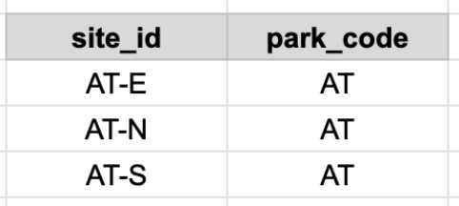
Tidied Parks table
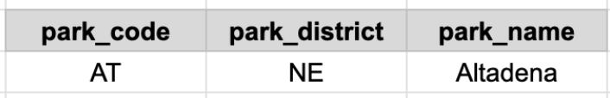

Question 2: Identify keys
Remember that:
- For tidy data, where variables and columns are equivalent, a column is a key if it has a different value in each row.
- Primary Key: chosen key for a table, uniquely identifies each observation in the table
- Foreign Key: reference to a primary key in another table
Table | Primary Key | Foreign Keys
surveys | survey_id | site_id
taxonomy | species_id | -
bird_records | survey_id + species_id (compound key) | survey_id, site_id, species_id
sites | site_id | park_code
parks | park_code | -
Primary keys are boxed in red and foreign keys are in blue.
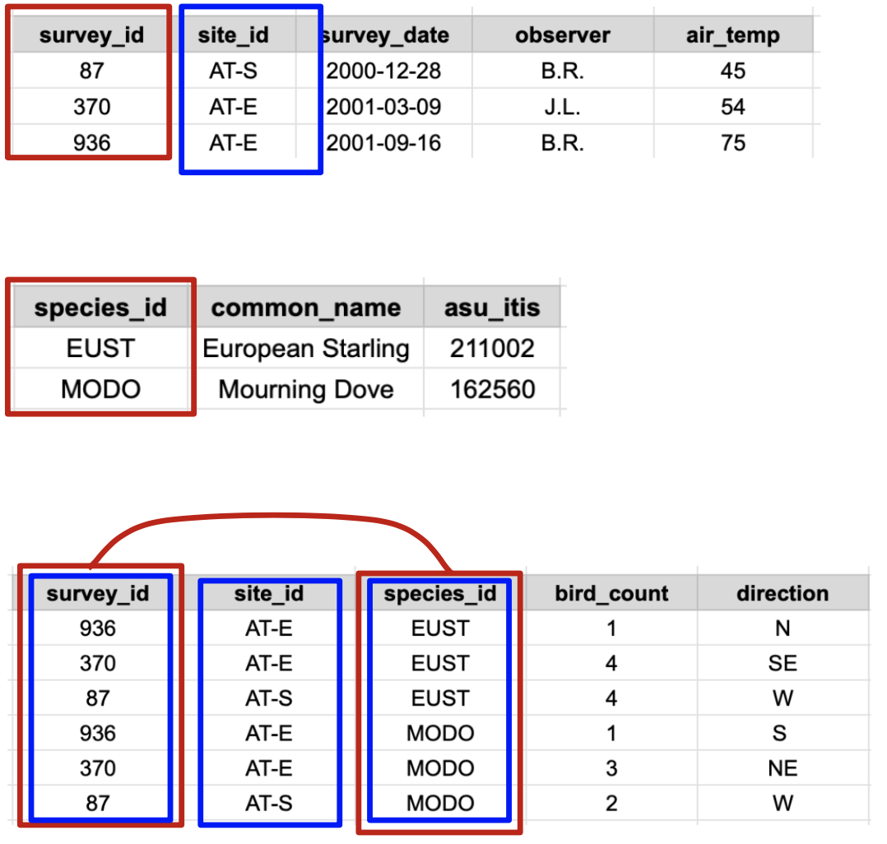
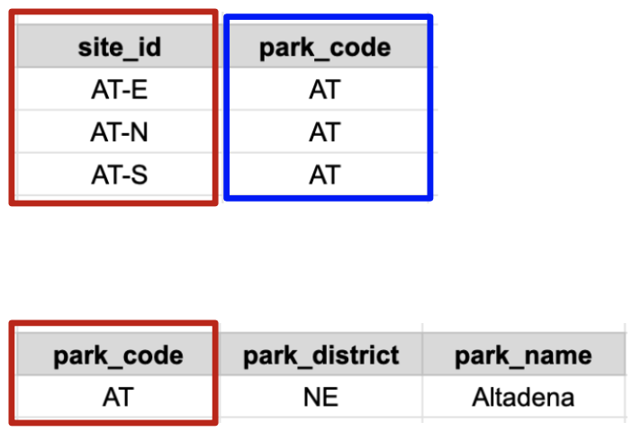

Question 3: Join the data tables
There are many ways to join all tables to form a single one. This is one example.

Step 1:
- Do a left join of the sites dataframe (on the left) with parks dataframe (on the right), join by park_code. This gets us back to our denormalized dataframe. Let’s call the resulting dataframe DF1.
sites | parks
 | 
Result: df1 = left_join(sites, parks, by = “park_code”) (note, any join will work here but left_join is a good default option
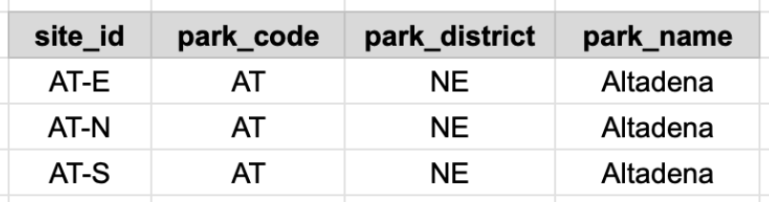

Step 2:
- Join df1 with surveys data frame by using the site_id key.
- Notice that not all elements of site_id in df1 are used in the site_id column of the surveys data frame. This means we need to decide how we want to join the data because there can be NAs depending on the join we choose.
- Let’s do an inner_join between both data frames so we only keep sites where we have observations. Call the resulting data frame df2.
df1 (from Step 1) | surveys
 | 
Result: df2 = inner_join(df1, surveys, by = “site_id”)
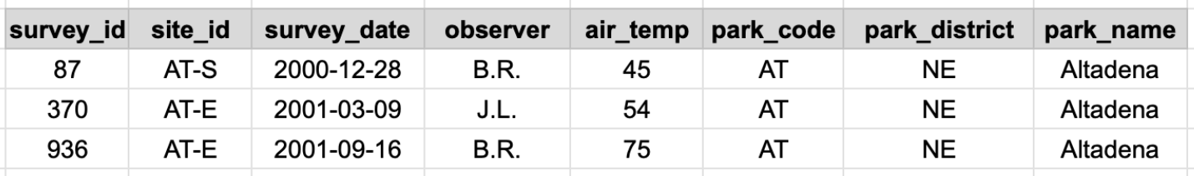

Step 3:
- Join the taxonomy data frame to the bird_records data frame by species_id.
- This is similar to step 1: do a left_join of the bird_records (on the left) to the taxonomy data frame (on the right). We get a new df3.

birds_records | taxonomy
 | 

Result: df3 = left_join(birds_records, taxonomy, by = “species_id”)
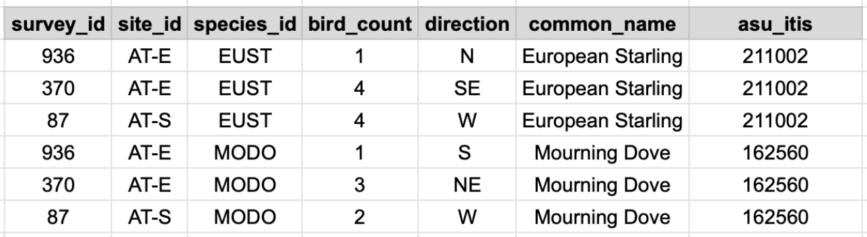

Step 4: At this point, we only have two datasets:

df2 = inner_join(df1, surveys, by = “site_id”)

df3 = left_join(birds_records, taxonomy, by = “species_id”)


- Notice that the simplest option for a primary key for df2 would be survey_id. There's also the compound key survey_id + site_id.
- These two keys (survey_id and survey_id + site_id) appear as foreign keys in df3. So, we could do left_join(df3, df2, by = …) by any of these keys.
- If we do the left_join(df3, df2, by = …) by survey_id we would get a repeated site_id column (the site_id from df2 and the site_id from df3; R would differentiate by naming them site_id.x and site_id.y).
  - Here this would be just an annoyance, since all the site_id.x and site_id.y would match, but this can be problematic if multiple site_id values matched with any survey_id values or vice versa.
- If we do the join by survey_id + site_id we would not get any repeated columns. So, to avoid any duplicate columns, let’s do left_join(df3, df2, by = c(“survey_id”, “site_id”).
Final Data
