
Tidy Data and Joins Activity
Learning Objectives

- Practice identifying tidy and untidy elements of data tables.
- Recognize primary and foreign keys
- Exercise thinking about how to join two data frames

About the data

These exercises will use bird survey data collected from the central Arizona-Phoenix metropolitan area by Arizona State University researchers.

The data tables in this exercise have been adapted from this dataset (https://portal.edirepository.org/nis/mapbrowse?packageid=knb-lter-cap.256.10) for teaching purposes. They were created for this specific exercise and should not be used for any official analysis or data visualization. Please refer to the raw data from the data portal to complete any data analysis or visuals.

Set Up

- Get together in pairs or small groups
- Obtain materials from instructors including:
  - Activity handout
  - Blank paper(s)

Question 1: Assess Tidyness

Assess the “tidyness” of each of the following data tables.
- Does each table follow the three tidy data principles? If not, which ones aren’t met?
- How would you wrangle the data to make it tidy? Describe the steps you would take to tidy the data.

Survey dataframe
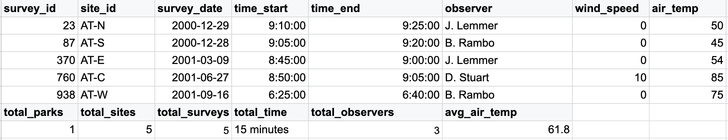

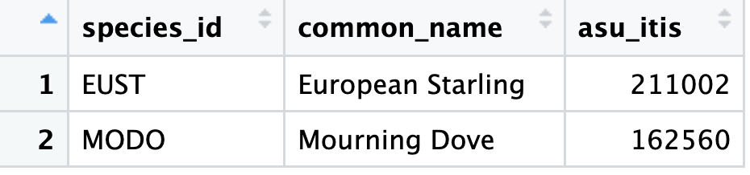
Taxonomy dataframe

Bird dataframe
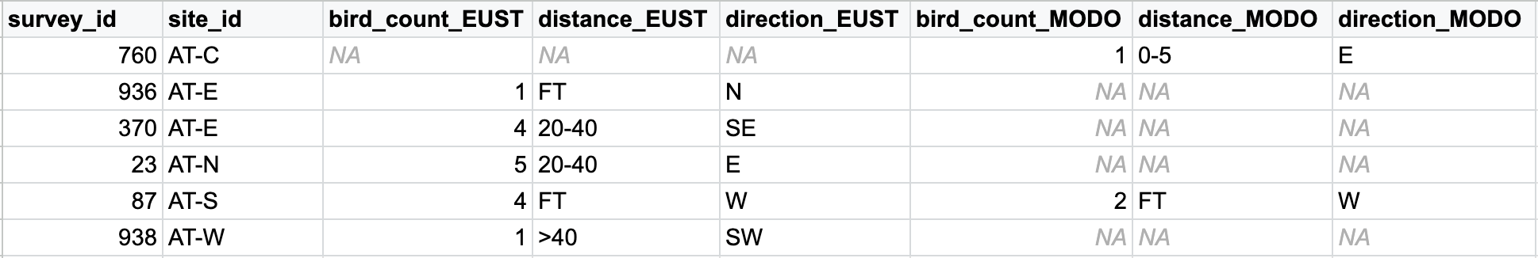

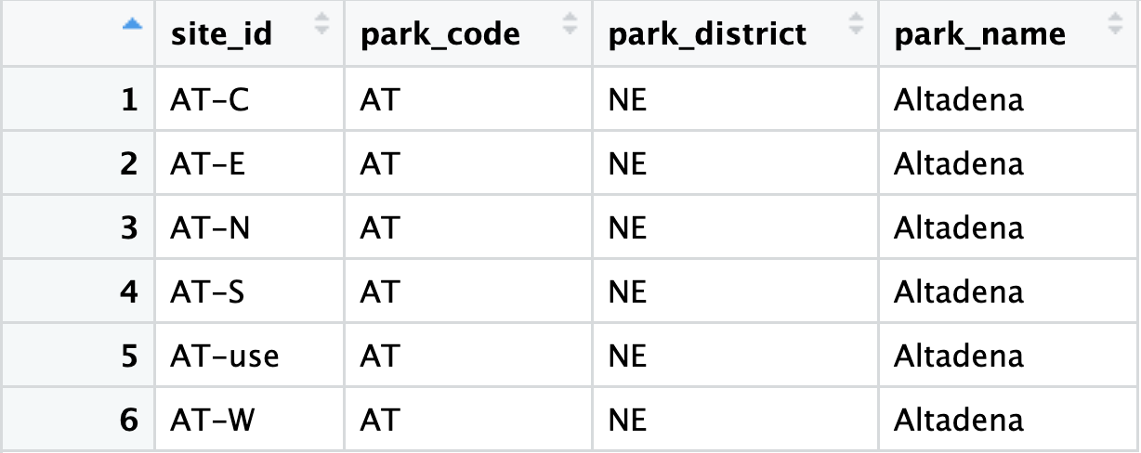
Site dataframe

Question 2: Identify keys
Identify the primary and foreign keys of each table. Use the tidy data frames below. For some tables, it might be necessary to create a compound key.
Survey table
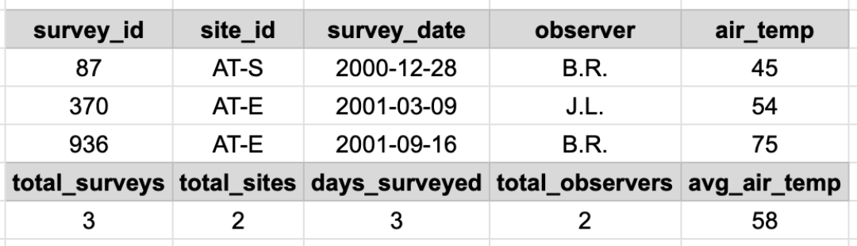
Taxonomy table
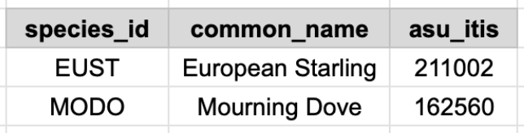
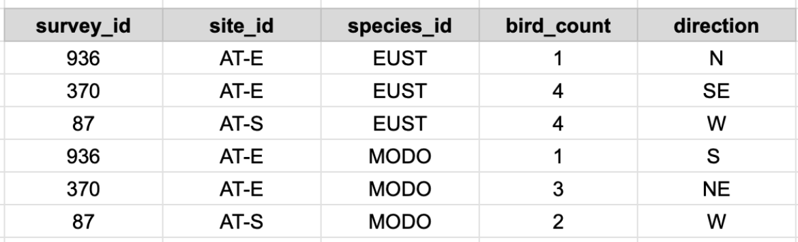
Bird table
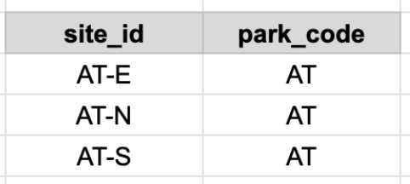
Site table
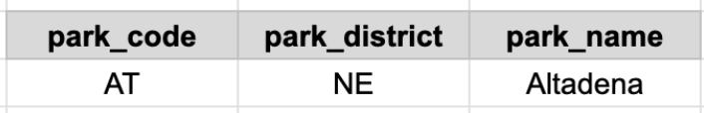
Parks table

Table | Primary Key | Foreign Keys
surveys
taxonomy
bird_records
sites
parks

Question 3: Join the data tables
Describe the steps on how would you join these data frames to have one data frame with all the information. The final data frame would look like this:

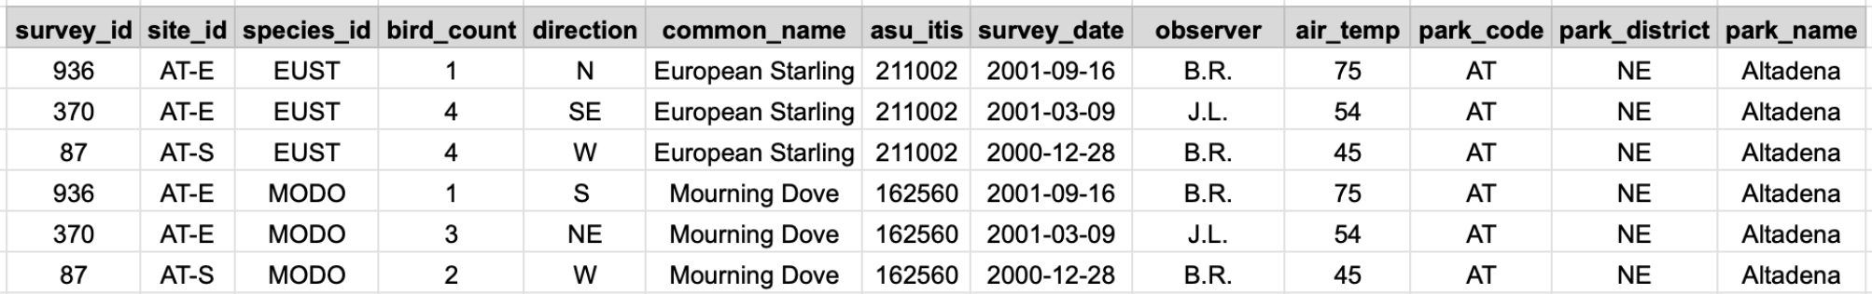

- Which tables would you join first?
- What type of join would you use?
- By what variable would you join each table?

