MBARARA UNIVERSITY OF SCIENCE AND TECHNOLOGY
DATABASE MANAGEMENT SYSTEM
INDIVIDUAL PROJECT REPORT
MUSASIZI NOREEN

EXECUTIVE SUMMARY

The Supplies Module serves as the strategic gatekeeper of the bakery’s supply chain, moving beyond simple record-keeping to provide a robust framework for procurement and vendor oversight. By centralizing the management of raw materials—such as flour, yeast, and dairy—the module ensures that the Supplies Manager can maintain a clean, standardized catalog of essential ingredients. This structure eliminates the risk of duplicate entries and ensures that every item entering the production cycle is categorized and measured against a baseline market price, allowing for precise tracking of ingredient usage and sourcing costs.
The module's primary technical strength lies in its Vendor Management and Price History tracking, which protects the bakery from market volatility and supplier unreliability. Every transaction is recorded as a formal Purchase Order that links a specific staff member to a verified vendor, creating an unbreakable audit trail for financial accountability. Because the system captures the "Actual Price" paid at the moment of the transaction, the Supplies Manager can analyze price trends over months or years, providing the data needed to negotiate better bulk deals and identify which suppliers consistently offer the best value for money.
Ultimately, the Supplies Module streamlines the flow of goods from the external market into the bakery's internal operations, transforming procurement from a manual chore into an automated, analytical process. By separating supplier data from transaction history through a normalized relational design, the system ensures that any changes to vendor details or material types only need to be updated once to reflect across the entire database. This high level of organization empowers the manager to make fast, evidence-based decisions that secure the bakery’s supply chain and directly contribute to long-term profitability and operational stability.

BUSINESS CASE
The Business Case for the Bakery Supplies Management System (BSMS) is a formal justification for moving from manual, paper-based procurement to a centralized relational database. Currently, the bakery faces significant financial leakage and operational risk due to the lack of historical price tracking and vendor performance data. Without a digital system, the Supplies Manager cannot effectively negotiate bulk discounts, monitor inflation trends, or hold suppliers accountable for inconsistent quality or late deliveries.
The proposed solution involves implementing a MySQL-based relational database that centralizes vendor information, raw material catalogs, and purchase history. By automating the procurement workflow, the system ensures total accountability, as every transaction is digitally linked to the specific employee who authorized the purchase. This structure not only prevents unauthorized spending but also provides a permanent, searchable audit trail that is essential for financial transparency and internal reporting.
Ultimately, the BSMS offers a high Return on Investment (ROI) by transforming the supply chain into a data-driven strategic asset. The shift from intuition-based buying to evidence-based sourcing allows the bakery to optimize its spending and secure its supply of essential ingredients like flour and sugar. By reducing the time spent on manual administration and minimizing procurement errors, the system allows the Supplies Manager to focus on high-level sourcing strategies that directly increase the bakery's long-term profitability.

ENTRIES AND ATTRIBUTES
Supplies [ Supplier ID (primary key ) , Supplier name , Contact Person Name , Phone Number, Email Address , Physical Address , Payment Terms ].
Customers[ Customer ID (Primary key ), Full name, Email Address , Dietary Preferences ,].
Orders[ Order ID (Primary Key ), Order date , Customer ID ( Foreign key to link the buyer ) , Employee ID ( Foreign key to track who processed the sale ), Payment Status( such as Paid, Pending, Refunded), Order type ( such as Take away , Custom cake Delivery) ].
Inventory [ Inventory ID(Primary key ), Item Name ( such as butter), Current quantity , Unit of measure , Expiry Date , Storage location ].
Employees[ Employee ID (Primary key), First name and last name , Role ( such as Pastry chef , Cashier, Head Baker, Contact number and email Address , Hire Date , Salary.]

ENTITY RELATIONSHIPS
1.One Supplier supplies many Supply Items.
2.One Supplier can have many Purchase Orders.
3.One Purchase Order can result in one or more Deliveries.
4.One Staff member can receive many Deliveries.
5.One Customer can place many Sales Orders.
6.One Product can appear in many Sales Orders.

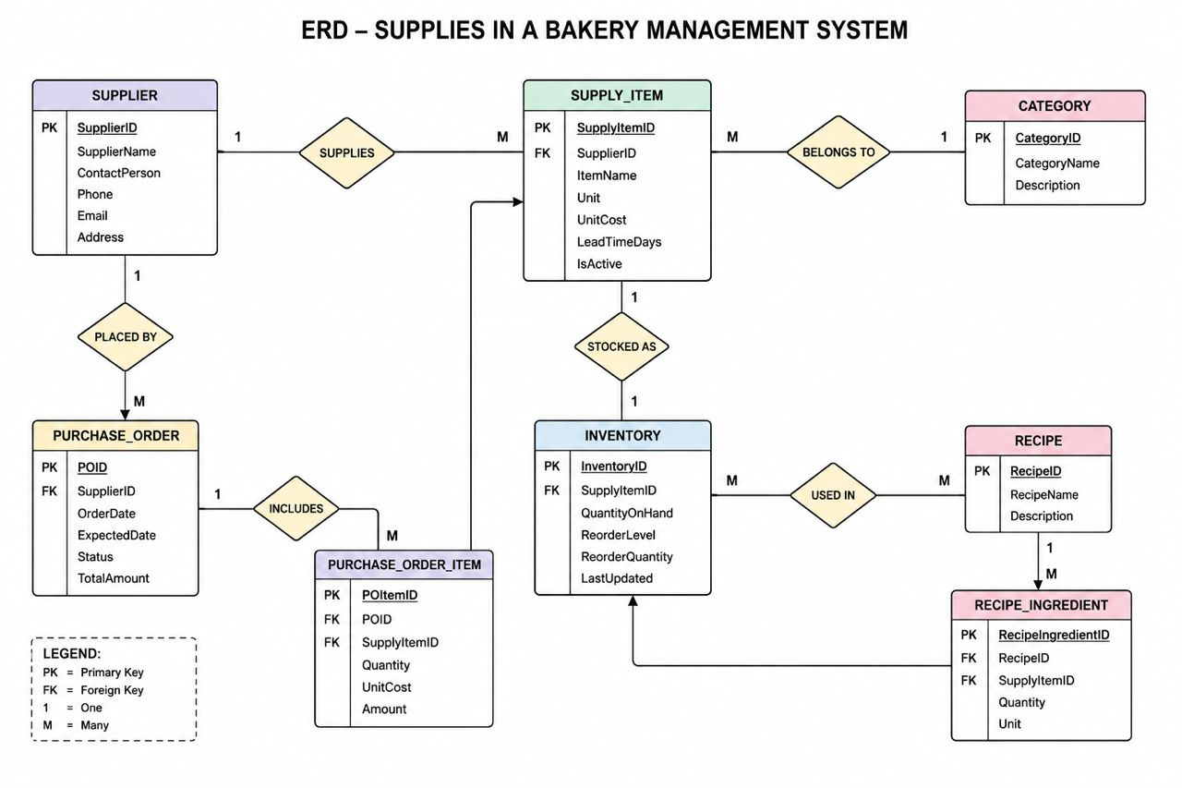
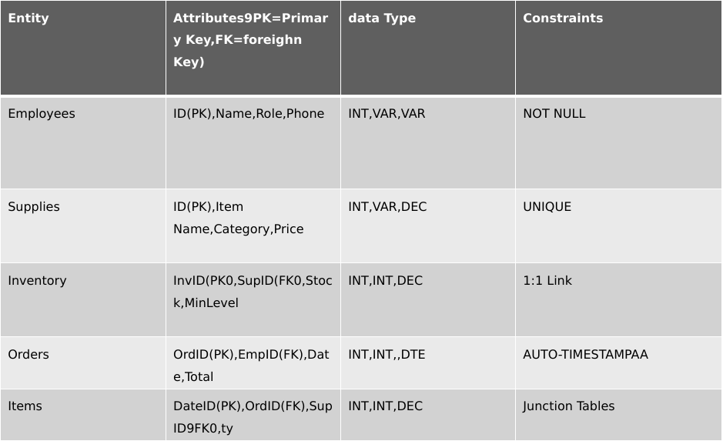
DATABASE SCHEMA

DESCRIPTION OF QUERIES

