1、

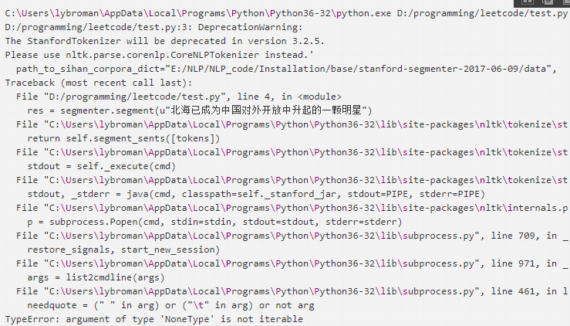

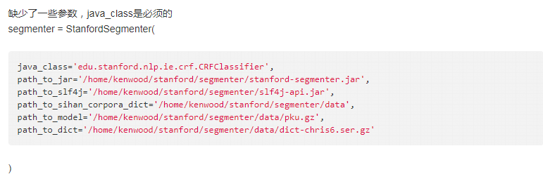

2、

Traceback (most recent call last):

File "train.py", line 28, in <module>

model.save(outp1)

File "/usr/lib64/python2.7/site-packages/gensim/models/word2vec.py", line 1563, in save

super(Word2Vec, self).save(*args, **kwargs)

File "/usr/lib64/python2.7/site-packages/gensim/utils.py", line 495, in save

self._smart_save(fname_or_handle, separately, sep_limit, ignore, pickle_protocol=pickle_protocol)

File "/usr/lib64/python2.7/site-packages/gensim/utils.py", line 370, in _smart_save

compress, subname)

File "/usr/lib64/python2.7/site-packages/gensim/utils.py", line 412, in _save_specials

restores.extend(val._save_specials(cfname, None, sep_limit, ignore, pickle_protocol, compress, subname))

File "/usr/lib64/python2.7/site-packages/gensim/utils.py", line 424, in _save_specials

np.save(subname(fname, attrib), np.ascontiguousarray(val))

File "/usr/lib64/python2.7/site-packages/numpy/lib/npyio.py", line 511, in save

pickle_kwargs=pickle_kwargs)

File "/usr/lib64/python2.7/site-packages/numpy/lib/format.py", line 562, in write_array

version)

File "/usr/lib64/python2.7/site-packages/numpy/lib/format.py", line 308, in _write_array_header

header = asbytes(_filter_header(header))

File "/usr/lib64/python2.7/site-packages/numpy/lib/format.py", line 467, in _filter_header

return tokenize.untokenize(tokens)

File "/usr/lib64/python2.7/tokenize.py", line 262, in untokenize

return ut.untokenize(iterable)

File "/usr/lib64/python2.7/tokenize.py", line 198, in untokenize

self.add_whitespace(start)

File "/usr/lib64/python2.7/tokenize.py", line 187, in add_whitespace

assert row <= self.prev_row

AssertionError

这是python自带的tokenize.py中的函数没写完整，抛出了assert异常，补全函数或者换一个正常的文件。