Communication 2 — Short IR Communication
Tutorial Group: Communication

Goal
Replace the physical UART connection used in Communication Direct_Serial with a short infrared (IR) communication link using a light beam between the Arduino Mega 2560 and ESP32.
An infrared communication link has the advantage that the two microcontrollers do not have to be physically connected by a wire. This allows the processors to be separated by distance while still communicating. In this tutorial, we will begin with a very short distance so that the basic operation of the IR link can be understood and verified. In future communication tutorials, the distance will be increased as we explore the capabilities and limitations of the communication system.
Using an infrared light beam as the communication medium also removes the electrical connection between the two processors. In Communication Direct_Serial, the physical connection required us to deal with the different logic voltages used by the Arduino Mega 2560 and ESP32. With an IR link, the communication signal crosses the gap as light rather than as an electrical voltage, eliminating the direct 5v to 3.3v interface issue we encountered in the previous tutorial.
Learning objectives:
- Explain how infrared light can be used as a communication medium between two microcontrollers.
- Use an IR LED and IR phototransistor to send digital information between the Arduino Mega 2560 and ESP32.
- Configure and test a short-distance IR communication link.
- Compare the infrared communication link with the physical UART connection used in Communication Direct_Serial.

What You Need
- Arduino Mega 2560
- ESP32 development board
- Computer(s) with the Arduino and ESP32 IDE
- Two breadboards – one dedicated to the Arduino Mega 2560 and one dedicated to the ESP32, and jumper wires
- 2 x IR LEDs and 2 x IR phototransistors
- 2 × 330 Ω resistors
- 2 × 10 kΩ resistors
- USB cables

The IR LED and IR phototransistor should be positioned facing each other, as close as possible (2" or less), unobstructed and shielded (use a piece of dark paper to form a tube around them).
If possible, using two laptops will make the tutorial easier, since the Arduino Mega 2560 and ESP32 can be programmed and monitored independently.
⚠️ IMPORTANT: The two breadboards are intentionally separate. Do not connect the VCC/positive power rail of the Mega 2560's 5v breadboard to the VCC/positive power rail of the ESP32's 3.3v breadboard.

Part 1 — Understand the Interface
In Communication Direct_Serial, the Arduino Mega 2560 and ESP32 were connected directly with an electrical UART signal. Because the Mega 2560 uses 5v logic and the ESP32 uses approximately 3.3v logic, we had to carefully consider the voltage levels and use a resistor divider to protect the ESP32 input.
In this communication tutorial, we will replace that physical electrical connection with a short-range infrared (IR) optical connection.
For this tutorial, we will use two electrically isolated circuits to create our optical communication link:
- An infrared LED that produces the infrared light.
- An IR phototransistor that detects the infrared light.
The IR LED and phototransistor will be positioned directly facing one another. They will be separated by a short distance and shielded from external light sources. This gives us a simple and controlled optical path while we learn the basic principles of infrared communication.

How the IR Communication Works
The Arduino Mega 2560 provides a digital signal to the IR LED through a 330 Ω current-limiting resistor connected to the MEGA Serial1 TX (D18). When the Arduino output is HIGH, current flows through the IR LED and it produces infrared light. When the output is LOW, the IR LED is off.
The phototransistor on the ESP32 receiving side detects the changes in infrared light. A 10 kΩ pull-down resistor keeps the ESP32 RX (GPIO16) held LOW until the infrared light beam is detected, which pulls it HIGH.
There is no electrical connection between the two microcontrollers. The Arduino Mega 2560 and ESP32 use separate VCC power supplies and separate GND connections. The only connection between them is the infrared light beam.
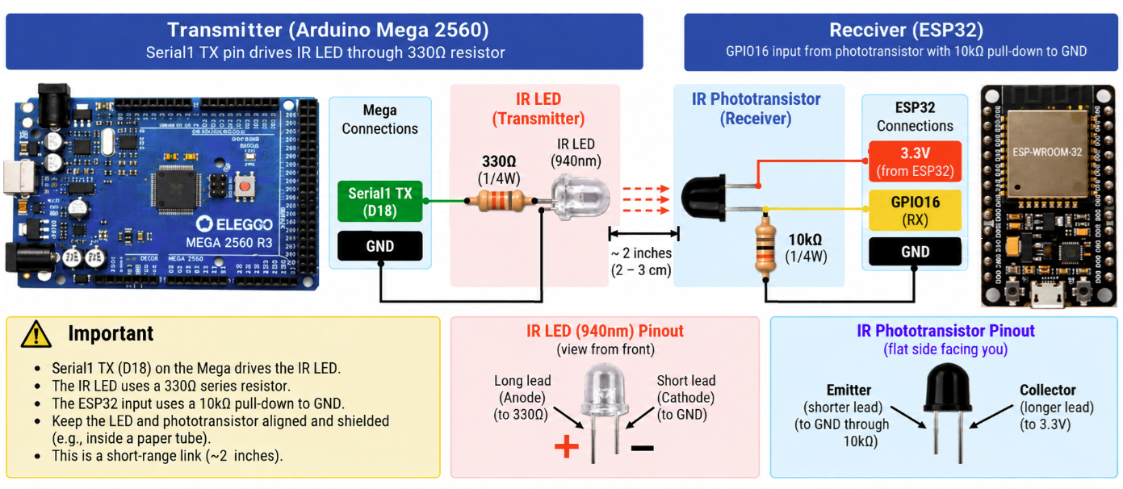
DO NOT CONNECT THE POWER SUPPLIES VCC or GND TOGETHER.

Part 2 — Test the Communication
Use the same transmitter and receiver programs from the previous tutorial, Communication Direct_Serial.
Load the transmitter program onto the Arduino Mega 2560 and the receiver program onto the ESP32. Position the IR LED and IR phototransistor facing each other, no more than 2 inches apart, and use a piece of dark paper wrapped into a tube around both components to shield them from other light sources in the room.
Run the programs and observe the communication between the Arduino Mega 2560 and ESP32. The important observation is that the communication still works even though there is no physical wire connecting the two microcontrollers.

Part 3 — Two-Way IR Communication
For an optional two-way implementation, a second set of IR LEDs and phototransistors, along with the required resistors, will also be needed. Determine how you would connect and configure the second optical path so that the ESP32 can transmit to the Arduino Mega 2560. Use what you learned in the previous tutorial to determine the appropriate UART connections and signal paths.

Keep the two optical paths physically separated. Each paper tube should shield its own IR LED and IR phototransistor from external light sources and from the infrared light produced by the other communication path.
With both optical paths operating, this creates a two-way infrared communication link, with one optical path carrying information from the Arduino Mega 2560 to the ESP32 and a second optical path carrying information from the ESP32 back to the Arduino Mega 2560.

Part 4 — Further Experiments
- Remove the dark-paper tube. Leave the IR LED and phototransistor facing each other at the same distance. Run the communication again and observe whether it becomes less reliable.
- Repeat the experiment in a dark room. Compare the results with normal room lighting.
- While the communication is operating, shine a flashlight or other bright light toward the IR phototransistor. Observe what happens to the received signal.
- Slowly move the IR LED to one side while keeping the phototransistor stationary. Observe how much the alignment can change before communication becomes unreliable.
- Gradually increase the distance between the IR LED and phototransistor. Determine the greatest distance at which the communication still works reliably.

What You Should Understand
- An IR LED can be used to convert a digital electrical signal into infrared light.
- An IR phototransistor can detect changes in that infrared light and convert them back into an electrical signal.
- Two microcontrollers can communicate without an electrical connection between their circuits.
- The Arduino Mega 2560 and ESP32 can use completely separate power supplies, including separate VCC and GND connections.
- The distance, alignment, and shielding of the IR LED and phototransistor can affect communication reliability.
- Light from the surrounding environment can interfere with an infrared receiver.
- A simple dark-paper tube can help shield the receiver from unwanted light.
- A second IR LED and phototransistor pair can be used to create communication in the opposite direction.

Before Moving On
In this tutorial, the IR LED and phototransistor were kept no more than 2 inches apart so that you could first understand the basic operation of an optical communication link.
In the next communication tutorials, we will increase the distance between the two devices and introduce modulation of the infrared signal, as well as error detection. Modulation will help the receiver distinguish the intended communication signal from unwanted light and improve the system's resistance to light noise, and error detection will help determine that a message was not received properly and should be resent.

