Communication 1 — Direct Serial Communication
Tutorial Group: Communication

Goal
Build a direct UART serial connection between an Arduino Mega 2560 and an ESP32.
In this tutorial, you will learn how two microcontrollers can exchange serial data even though they use different logic voltages. You will examine the electrical requirements of each direction of communication, build a simple resistor-divider level shifter, and verify communication at several baud rates.
Learning objectives:
- Connect two microcontrollers using UART serial communication.
- Explain the difference between 5v and 3.3v logic levels.
- Explain why the ESP32 TX signal can connect directly to the Arduino Mega 2560 RX input.
- Explain why the Arduino Mega 2560 TX signal must be reduced before reaching the ESP32 RX input.
- Build a simple 1 kΩ / 2 kΩ resistor-divider level shifter.
- Use a common ground while keeping the two processor power supplies separate.
- Test serial communication at several baud rates.

What You Need
- Arduino Mega 2560
- ESP32 development board
- Computer(s) with the Arduino and ESP32 IDE
- Two breadboards – one dedicated to the Arduino Mega 2560 and one dedicated to the ESP32, and jumper wires
- 1 × 1 kΩ resistor
- 1 × 2 kΩ resistor
- USB cables

If possible, using two laptops will make the tutorial easier, since the Arduino Mega 2560 and ESP32 can be programmed and monitored independently.
⚠️ IMPORTANT: The two breadboards are intentionally separate. Do not connect the VCC/positive power rail of the Mega 2560's breadboard to the VCC/positive power rail of the ESP32's breadboard. The Mega 2560 uses 5v logic, while the ESP32 uses 3.3v logic. Note that in this tutorial, they are electrically connected together with level shifters, so the two GNDs must be connected.

Part 1 — Understand the Interface
The Arduino Mega 2560 and ESP32 can communicate using ordinary UART serial communication, but they do not operate at the same logic voltage. This is an important electrical difference that must be understood before connecting the two processors.
For this experiment, the Arduino Mega 2560 operates at 5v and the ESP32 operates at approximately 3.3v. Both devices use digital signals to represent binary data. A digital LOW is represented by a voltage near 0v, while a digital HIGH is represented by a voltage appropriate to that processor's logic supply.
The important point is that 5v and 3.3v are not interchangeable logic levels. The ESP32 GPIO pins are designed for approximately 3.3v operation. A voltage above the ESP32's specified input limit can damage its GPIO.
The Arduino Mega 2560, on the other hand, is designed to operate with 5v logic. Therefore, simply connecting every corresponding signal between the two processors would not be safe.
The two directions of communication are not electrically identical. That is why this tutorial uses a direct connection in one direction and a resistor divider in the other.
Because the two HIGH levels are compatible but relatively close to the Mega 2560's minimum guaranteed HIGH threshold, this direct connection is intended for short distances and modest baud rates. It is not recommended for long cable runs or high-speed communication. At 1200 baud, however, it should work very well over the short distance between two breakout boards on the same laboratory bench.

Data traveling from the ESP32 to the Arduino
ESP32 TX ───────────────────────────────> Mega 2560 RX
The ESP32 produces a HIGH of approximately 3.3v. The Arduino Mega 2560 is operating from a 5v supply, but that does not mean its input must receive 5v to recognize a HIGH. A digital input has a specified HIGH-voltage threshold. If the incoming signal is above that threshold, the Arduino interprets it as a logic HIGH.
For the Mega 2560, the specified minimum HIGH input voltage is approximately 3.0v when operating at 5v. The ESP32's output HIGH is approximately 3.3v, which is above that threshold.
Therefore, the ESP32's 3.3v HIGH is high enough for the Arduino Mega 2560 to recognize as a HIGH.
The LOW level is also compatible because both devices use a voltage near 0v to represent LOW.

Data traveling from the Arduino to the ESP32
Mega 2560 TX ────────────────────────────────> ESP32 RX
The Arduino Mega 2560 can produce a HIGH close to 5v. The ESP32 GPIO is a 3.3v device and must not be connected directly to that 5v signal.
Instead, we need a simple circuit that reduces the Mega 2560's approximately 5v signal to a voltage suitable for the ESP32. For this tutorial, we will use a two-resistor voltage divider.
The divider uses:
- A 1 kΩ between Mega 2560 TX and the ESP32 RX node.
- A 2 kΩ between the ESP32 RX node and GND.
The important idea is that the divider protects the ESP32 input from the higher-voltage Arduino signal.

Complete interface
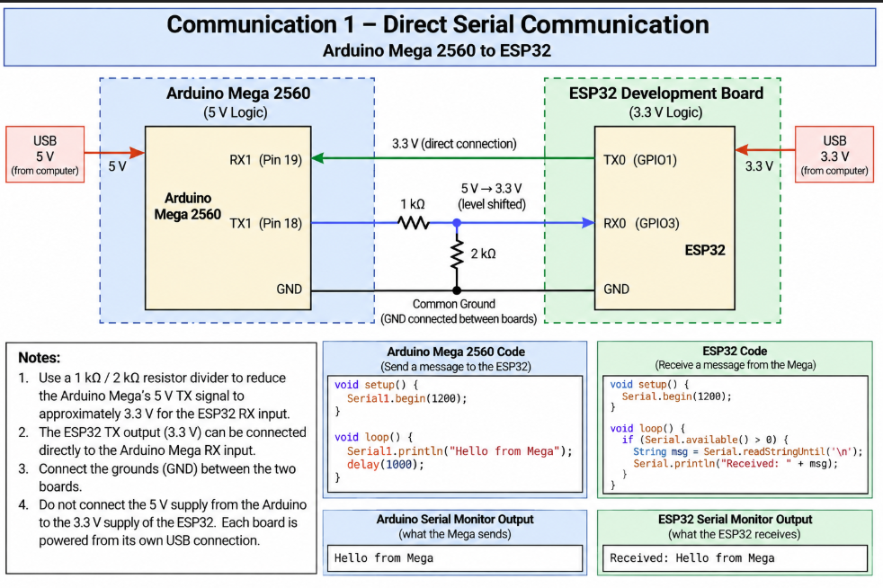

DO NOT CONNECT THE POWER SUPPLIES TOGETHER
- DO NOT connect ESP32 3.3v to Arduino 5v.
- DO NOT connect the ESP32 VCC/3.3v supply to the Mega 2560 5v supply.
- DO NOT use the serial connection as a way to power either processor.
For this tutorial, each microcontroller is powered independently through its own USB connection. The only power-related connection between the two systems is their common GND. It is important that the two processors share a common ground. Connect GND of the ESP32 to the GND of the Mega 2560, but do NOT connect 5v to 3.3v.
A 3.3v output is not automatically incompatible with a 5v processor. Likewise, a 5v output is not automatically safe for a 3.3v processor. Always determine the electrical requirements of both sides before connecting the two different microcontrollers.

Part 2 — First Test
With the electrical interface understood and wired as shown in Part 1, we can perform the first communication test.
For this test, the Arduino Mega 2560 will transmit, the ESP32 will receive, and the UART communication speed will be 9600 baud. The ESP32 will display the received characters through its USB serial connection.

Arduino Mega 2560 — Transmitter
Upload this program to the Arduino Mega 2560.
// Arduino Mega 2560 transmitter
void setup()
{
Serial1.begin(9600);
}
void loop()
{
Serial1.println("Hello from Mega 2560");
delay(1000);
}
The Mega 2560 sends the message "Hello from Mega 2560" once every second using Serial1.

ESP32 — Receiver
Upload this program to the ESP32.
// ESP32 receiver
void setup()
{
Serial.begin(115200);
Serial2.begin(9600);
}
void loop()
{
while (Serial2.available())
{
Serial.write(Serial2.read());
}
}
The ESP32 receives the data through Serial2. It then sends the received characters through its USB serial connection using Serial, allowing you to see the message in the Serial Monitor.
Important: The exact GPIO pins used for Serial2 depend on the ESP32 development board being used. Use the UART pins appropriate for your board and connect the selected ESP32 TX/RX pins to the corresponding connections described in Part 1.

Expected Result
Open the ESP32 Serial Monitor at 115200 baud. You should see:
Hello from Mega 2560
Hello from Mega 2560
Hello from Mega 2560
Hello from Mega 2560
The communication between the two microcontrollers is running at 9600 baud. The ESP32's USB serial connection to the computer is running separately at 115200 baud so that the received information can be displayed.

Part 3 — Test Communication Reliability and Both Directions
The first test demonstrated Arduino Mega 2560 → ESP32. Now test the opposite direction.
Modify the programs so that the ESP32 transmits and the Mega 2560 receives.
The signal path is now ESP32 TX → Mega 2560 RX.
Remember that this direction does not require the resistor divider. The ESP32's approximately 3.3v HIGH is sufficient for the Mega 2560's input.
Create a short message such as "Hello from ESP32" and verify that the Mega 2560 receives it correctly.
Have each processor periodically send a message identifying itself.
Observe both directions independently.
Modify the programs so that communication works in both directions. Have the Mega 2560 transmit "Hello from Mega 2560" and the ESP32 transmit "Hello from ESP32". Observe the two directions independently.
Mega 2560: Hello from Mega 2560
ESP32: Hello from ESP32

Part 4 — Experiment with the Electrical Interface
Now that the basic connection works, deliberately change one part of the system at a time.

Experiment 1 — Disconnect the common ground
Disconnect the wire connecting ESP32 GND and Mega 2560 GND. Observe what happens to the communication. Then reconnect the ground.
Question: Why does the signal become unreliable when the two systems no longer share the same voltage reference?

Experiment 2 — Change the baud rate
Test 1200, 2400, 4800, and 9600 baud. Make sure both processors are changed to the same baud rate. Then deliberately configure the two processors for different baud rates, such as Mega 2560: 9600 and ESP32: 4800. Also try setting the baud rates of both processors to different rates. Observe the result.
Question: Why must both processors agree on the baud rate?

Experiment 3 — Send Longer Messages
Change the transmitted message to something longer.
SoutheastCon Communication Test — Arduino Mega 2560 to ESP32
Observe whether the entire message is received correctly. Then try sending several messages rapidly.
Question: What happens when the transmitter sends data faster than the receiver can process it?

Experiment 4 — Add a Sequence Number
Modify the transmitter so that each message contains a sequence number.
Message 1
Message 2
Message 3
Message 4
Continue increasing the number. The receiver should display the messages. Now consider how the receiver could detect a missing message.
Message 21
Message 22
Message 24
Message 25
It can determine that Message 23 was not received. This is the beginning of an important communication-system concept: error detection.

What You Should Understand
At the completion of this tutorial, you should understand:
- UART is an asynchronous serial communication method.
- UART does not require a shared clock signal.
- The transmitter's TX connects to the receiver's RX.
- Both processors must agree on the baud rate and serial format.
- The Arduino Mega 2560 uses 5v logic.
- The ESP32 uses approximately 3.3v logic.
- A 3.3v ESP32 output can be recognized as HIGH by the Mega 2560's input.
- A 5v Mega 2560 output must not be connected directly to an ESP32 GPIO.
- A simple resistor divider can reduce the Mega 2560's 5v TX signal to approximately 3.3v.
- The 1 kΩ / 2 kΩ divider is used only in the Mega 2560 TX → ESP32 RX direction.
- The two processors must share a common ground.
- The two processors must not have their 5v and 3.3v power supplies connected together.
- Each processor can be powered independently.
- Communication speed and logic voltage are separate concepts.
- A communication system can detect missing messages by using sequence numbers.

Before Moving On
- I can explain what UART serial communication is.
- I understand why TX connects to RX.
- I understand why both processors must use the same baud rate.
- I can explain the difference between 5v and 3.3v logic.
- I can explain why the ESP32 TX can connect directly to the Mega 2560 RX.
- I can explain why the Mega 2560 TX cannot connect directly to the ESP32 RX.
- I can identify the 1 kΩ and 2 kΩ resistors in the voltage divider.
- I understand that the voltage divider reduces the Mega 2560's approximately 5v signal to approximately 3.3v.
- I understand why the two processor grounds must be connected.
- I understand why the 5v and 3.3v power supplies must not be connected together.
- I can communicate between the Arduino Mega 2560 and ESP32 in at least one direction.
- I can explain why both ends of a UART connection must agree on the baud rate.
- I can describe one way to detect a missing message.
If you can complete these tasks and explain what you are seeing in the serial connection, you are ready for the next tutorial.

