2068-Leap V2
User Manual and Language Reference
Timex Sinclair 2068

V2 Enhanced -- Emulator-Qualified Release (v2.0.0-emu.1) • 2026-10-11

Contents

If page numbers are not visible, open the document in Word or LibreOffice and update the table of contents field.

2068-Leap V2 -- User Manual and Language Reference
For the Timex Sinclair 2068 with the 2068-Leap V2 Enhanced ROMs -- the Emulator-Qualified Release (tag v2.0.0-emu.1).

Contents
Part | What it is for
Part 1, Introduction | what 2068-Leap V2 is, how to start it, how this manual works
Part 2, Beginner's guide | a step-by-step course: the editor, your first program, numbers, words, decisions, loops, procedures, arrays, the screen, sound, tapes
Part 3, Keywords | every statement, function, operator and command, A to Z, with examples
Part 4, Concepts | the ideas behind the language, A to Z: numbers, strings, arrays, sessions, tapes, errors, memory ...
Part 5, Packages | the five loadable packages: mode, sprite, printer, shapes, graphics
Part 6, Practical examples | complete programs to type in and change
Appendices | messages, error codes, character set, limits, memory map, package card, hardware notes, keyword index

The manual follows the plan of the Sinclair QL User Guide: a gentle beginner's guide, then a keyword reference and a concepts reference each in alphabetical order, with the tables at the back.

What 2068-Leap V2 is
The Timex Sinclair 2068 normally starts in the BASIC of its ROM. 2068-Leap replaces that ROM with a new one: a full-screen program editor, a modern structured BASIC without line numbers, a compiler that checks the whole program before it runs it, floating-point arithmetic, strings and arrays, sound, graphics and tape storage, all within the machine's original 16 KB ROM and the 8 KB extension ROM (EXROM) of the Timex hardware.
V2 is the current version. It is a new design, not a small change to the first release ("V1 Release 1 Beta"): the earlier system read the program text again, statement by statement, every time it ran it, and its arithmetic was almost entirely whole-number. V2 compiles the program when you RUN it, has real numbers, long names, string and numeric arrays, procedures that call themselves, and keeps your variables when a program stops so that you can look at them. V1's manual (docs/user_manual.md) remains in the repository as history; do not use it to learn V2.
Its main features:
- a full-screen editor with bold keywords and a status line;
- programs without line numbers: labels, IF blocks, FOR loops, procedures (PROC/CALL), one-line functions (DEF FN);
- whole numbers and 5-byte floating-point numbers, converted automatically, with maths functions in degrees;
- 21 user-defined characters that you design yourself (defined with POKE, printed with CHR$(144) to CHR$(164));
- strings up to 31 characters and the full set of string functions;
- arrays of numbers and of strings, which can be saved to tape on their own and kept across runs (the Array Store);
- sessions: the variables of a program that stopped stay available to typed statements;
- tape SAVE, LOAD and VERIFY for programs, arrays, and whole programs with their variables;
- sound from the loudspeaker (BEEP) and the AY sound chip (SOUND);
- graphics: PLOT, LINE, colours; and, from loadable packages, circles, filled areas, rectangles, sprites, the printer and the TS2068's special video modes.

The status of this release
2068-Leap V2 Enhanced has been through a complete qualification in the ZEsarUX emulator: more than a thousand automated tests of the language, the editor, the tape routines and the packages. The release is called emulator-qualified: it has not been tried on a physical TS2068, a real cassette recorder, a ZX Printer or a joystick (see Appendix G). Everything in this manual that depends on hardware says so.
Every example in this manual has been run on the release, by an automated test, and produced exactly the output shown (see Appendix I).

Starting it
On an emulator. Use the files of the release (roms/leap_v2_home.bin and roms/leap_v2_exrom.bin, or the combined roms/leap_v2_zesarux.bin) as the TS2068's ROM and EXROM. docs/emulator_setup.md describes Fuse and ZEsarUX. (A stock ZEsarUX 13.0 does not map the EXROM the way the real hardware does and shows a blank screen; use the patched one described there.) Switch on and the editor appears.
On a TS2068. Fit the two ROM images in place of the ROM and the extension ROM. Nothing about real hardware has been tested.
The package tapes are .tzx files for an emulator's tape interface: v2_mode.tzx, v2_sprite.tzx, v2_printer.tzx, v2_shapes.tzx, v2_graphics.tzx. A package is loaded by typing LOAD "NAME" EXT (for example LOAD "SHAPES" EXT) and starting the tape; Fuse does not start the tape automatically.

How to read this manual
- Type the examples. They are small. Change numbers and words and see what happens.
- In the text, COMMANDS AND PROGRAM TEXT are in a typewriter face. The language is not case-sensitive: print and PRINT are the same, and the editor will show keywords in bold either way.
- A box of program text is a program: type each line on its own line. A line in a box beginning with a colon, such as : PRINT x, is typed on the editor's last line after the program has run.
- A box labelled with output shows exactly what appeared on the screen. A picture shows what the screen looked like. In a listing of a whole screen, a line of three dots (...) stands for any number of blank rows (the empty part of the screen above the status line).
- A typed example (keys, then the screen) shows the lines as they were typed, one after another, each ended with ENTER, and then the screen as it looked.
- Words in italics in a syntax line are things you supply.
- The language reference parts are in alphabetical order. Where something has two names (a keyword and the concept it belongs to) each points to the other.

What changed from V1, in one paragraph
If you used V1: there are still no line numbers, but now RUN compiles the whole program first. Names are long (31 characters), numbers can have fractions, INT truncates toward zero, AND/OR skip what they do not need, IF is always a block closed by ENDIF, subroutines are PROC/CALL, GOSUB is gone, arrays hold strings too, and LPRINT, the sprites, CIRCLE/FILL, MODE and others are on tape as packages. The full list is the table in the concept Differences from Sinclair BASIC and docs/v2/V2_FEATURE_MATRIX.md.

Part 2 -- Beginner's guide
This part teaches the language from nothing, one small step at a time. You do not need to have programmed before. Read it with the machine in front of you, and type in every example; each one has been run on the real V2 ROM, and what you see on your screen should be exactly what is printed here.
Each chapter is short. If you already know BASIC, read Chapter 1 for the editor and skim the rest; the Keywords and Concepts parts are the reference.

Chapter 1 -- Switching on
Switch on the machine. The screen is empty except for one line at the bottom:

...
LINE 1/0
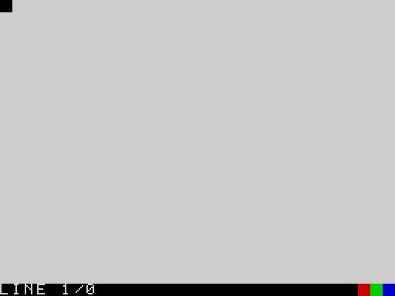
The screen after switching on
You are in the editor. It is where you write programs. The bottom row is the status line: it says LINE 1/0, meaning "you are on line 1, and the program has 0 lines so far". The three little coloured squares at its right are only decoration. Everything above the status line is for your program and for what it prints.
There are no line numbers in 2068-Leap V2. A program is simply a list of lines, one under the other, and it runs from the top to the bottom.

Chapter 2 -- Your first program
Type the following line exactly as shown, and press ENTER:
PRINT "HELLO"
PRINT is a statement: an instruction. It shows something on the screen. What you want shown goes after it; between double quotes it is text and is shown just as you typed it. When you press ENTER the line is stored as part of the program, the word PRINT turns bold to show that the machine knows it, and the cursor moves to the next, empty line:
PRINT "HELLO"
PRINT "HELLO"
...
LINE 2/1
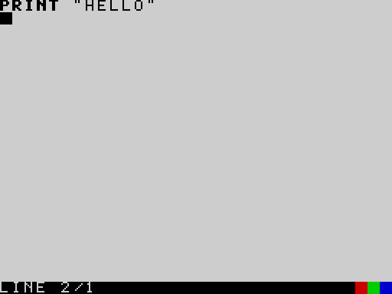
The editor with one line of program
The status line now says LINE 2/1: you are on line 2, and the program has 1 line. The empty line you are on is the last line. That is where you type commands. Type
RUN
and press ENTER. The machine reads the whole program, checks it, and carries it out:
PRINT "HELLO"
RUN
HELLO

The program's output
HELLO appears. The screen now belongs to the program. Press any key, and you are back in the editor with your program on the screen, ready to change or add to:
PRINT "HELLO"
RUN
{ANY}
PRINT "HELLO"
...
LINE 2/1
(The command RUN you typed is gone: it was a command, not part of the program, and the last line is empty again, ready for the next command.)
A program may have as many lines as you like. Add a second line, and RUN again:
PRINT "HELLO"
PRINT "I AM A COMPUTER"
HELLO
I AM A COMPUTER
The command LIST shows your program from the top, one line to a row, with the keywords in bold:
PRINT "HELLO"
PRINT "I AM A COMPUTER"
LIST
PRINT "HELLO"
PRINT "I AM A COMPUTER"
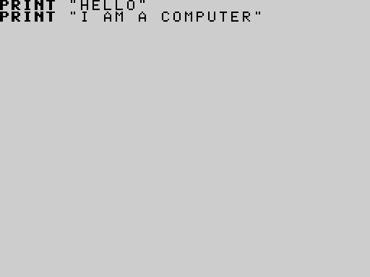
LIST
A long program does not fit on the screen: LIST shows 23 lines at a time and waits for a key before the next page. Press BREAK (CAPS SHIFT and SPACE together) to stop the listing.
To start again with an empty program, type NEW. There is no warning, and no way back:
PRINT "HELLO"
NEW
...
LINE 1/0

Chapter 3 -- Correcting mistakes
Everybody makes mistakes. The editor has keys to put them right. Hold CAPS SHIFT and press:
Keys | Effect
5 | cursor left
8 | cursor right
6 | down to the next line
7 | up to the previous line
0 (DELETE) | delete the character before the cursor
1 | delete the whole line the cursor is on
ENTER | insert a blank line

Characters you type are inserted where the cursor is. Moving up or down puts the cursor at the start of the line it arrives on. ENTER stores the line as it now reads.
Suppose you meant to write PRINT "TWO" but typed PRINT "TWWO". Move up to the line, move right to the extra W, and delete it:
PRINT "ONE"
PRINT "TWWO"
PRINT "THREE"
{UP}{UP}{RIGHT}{RIGHT}{RIGHT}{RIGHT}{RIGHT}{RIGHT}{RIGHT}{RIGHT}{RIGHT}{DEL}\
PRINT "ONE"
PRINT "TWO"
PRINT "THREE"
...
LINE 2/3
(Nine presses of "cursor right" bring the cursor just after the second W; DELETE then removes that W.)
What if the machine does not understand a line? Type this, with a deliberate mistake:
PRINT "HELLO"
PRINT 3 +
PRINT "BYE"
RUN
PRINT "HELLO"
PRINT 3 +
PRINT "BYE"
RUN
...
SYNTAX ERROR
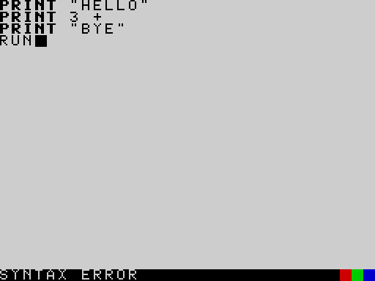
A syntax error
RUN first looks at the whole program. It found something it could not understand -- 3 + with nothing to add -- so nothing ran at all (not even the first PRINT), and the status line says SYNTAX ERROR. Press a key and the cursor goes to the line with the mistake (line 2):
PRINT "HELLO"
PRINT 3 +
PRINT "BYE"
RUN
{ANY}\
PRINT "HELLO"
PRINT 3 +
PRINT "BYE"
...
LINE 2/3
Fix it and RUN again. You cannot do damage by making a mistake: the worst that happens is a message.
The messages are explained in Appendix A.

Chapter 4 -- Numbers
The machine can calculate. PRINT shows the answer to a sum as well as text:
PRINT 2 + 3
PRINT 10 - 4
PRINT 6 * 7
PRINT 20 / 4
5
6
42
5
+ adds, - subtracts, * multiplies and / divides. Multiplication and division are done before addition and subtraction, as in school; use brackets to change that:
PRINT 2 + 3 * 4
PRINT (2 + 3) * 4
14
20
Whole numbers are shown as they are. If the answer has a fraction, it is shown with four decimal places:
PRINT 7 / 2
PRINT 1 / 3
PRINT 22 / 7
3.5000
0.3333
3.1429
To remember a number for later, give it a name with =. Such a named place is called a variable; you do not have to prepare it first:
price = 12
quantity = 3
total = price * quantity
PRINT total
36
A variable can change. This is the whole point: the same line can do different things at different times.
score = 10
score = score + 5
score = score * 2
PRINT score
30
(score = score + 5 does not say that something is equal to itself plus five -- which would be silly. It says: take what score is now, add five, and keep that in score.)
A name is made of letters and digits, starts with a letter, and can be up to 31 characters long. Capital and small letters are the same. There is no underscore. You cannot use a keyword (PRINT, FOR, ...) as a name.
The machine has built-in functions that give you numbers: ABS, SQR (square root), SIN, INT, RND (a random number) and others. A function's argument goes in brackets, always -- even when there is no argument (PI()):
PRINT SQR(144)
PRINT ABS(-9)
PRINT INT(3.99)
PRINT PI()
12.0000
9
3
3.1416
(SQR always gives a fraction-style answer, so it prints 12.0000.)
How the machine keeps numbers -- and why 30000 * 3 prints 90000.0000 -- is explained in the concept Numbers.

Chapter 5 -- Words
Text in double quotes is a string. A string variable has a $ at the end of its name. A string can hold up to 31 characters.
name$ = "ADA"
PRINT "HELLO, "; name$
HELLO, ADA
The semicolon in PRINT joins things with nothing between them; a comma puts the next thing in the second half of the line:
PRINT "NAME", "SCORE"
PRINT "ADA", 120
PRINT "ALAN", 95
NAME SCORE
ADA 120
ALAN 95
+ joins two strings together:
a$ = "SUN"
b$ = "SHINE"
PRINT a$ + b$
PRINT LEN(a$ + b$)
SUNSHINE
8
LEN counts the characters. LEFT$, RIGHT$ and MID$ take pieces out of a string:
w$ = "SUNSHINE"
PRINT LEFT$(w$, 3)
PRINT RIGHT$(w$, 5)
PRINT MID$(w$, 4, 2)
SUN
SHINE
SH
(MID$(w$, 4, 2) is "two characters, starting at the 4th". The first character is number 1.)
You cannot add a number to a string ("A" + 1 is an error). STR$ turns a number into text and VAL turns text into a number:
PRINT "YOU HAVE " + STR$(3) + " MESSAGES"
PRINT VAL("40") + 2
YOU HAVE 3 MESSAGES
42

Chapter 6 -- Making decisions
A program becomes interesting when it can choose. IF does that. The statements between THEN and ENDIF are carried out only if the condition is true:
age = 15
IF age >= 13 THEN
PRINT "TEENAGER"
ENDIF
PRINT "DONE"
TEENAGER
DONE
Change age to 9 and TEENAGER is skipped. The comparisons are = (equal), <> (not equal), <, >, <= (less than or equal) and >=. They work on numbers and on strings.
ELSE gives the other choice:
age = 9
IF age >= 13 THEN
PRINT "TEENAGER"
ELSE
PRINT "NOT YET"
ENDIF
NOT YET
Conditions can be combined with AND, OR and NOT:
temp = 22
IF temp > 15 AND temp < 25 THEN
PRINT "PLEASANT"
ENDIF
PLEASANT
An IF can contain another IF, to pick between more than two things (there is no ELSEIF):
mark = 72
IF mark >= 80 THEN
PRINT "A"
ELSE
IF mark >= 60 THEN
PRINT "B"
ELSE
PRINT "C"
ENDIF
ENDIF
B
Always close an IF with ENDIF. Putting a statement on the same line as THEN (IF x THEN PRINT "A") is an error: the only one-line form is IF ... THEN GOTO label, which comes in Chapter 8.

Chapter 7 -- Doing things again
Computers are good at boring repetition. FOR ... NEXT repeats the lines between them:
FOR i = 1 TO 5
PRINT i
NEXT i
1
2
3
4
5
The variable i counts, 1 up to 5. You can use it inside the loop:
FOR n = 1 TO 5
PRINT n; " times 7 is "; n * 7
NEXT n
1 times 7 is 7
2 times 7 is 14
3 times 7 is 21
4 times 7 is 28
5 times 7 is 35
STEP changes the amount counted each time, and may be negative, to count down:
FOR i = 10 TO 0 STEP -5
PRINT i
NEXT i
PRINT "LIFT OFF"
10
5
0
LIFT OFF
Loops can be put inside loops:
FOR row = 1 TO 3
FOR col = 1 TO 4
PRINT "*";
NEXT col
PRINT
NEXT row
****
****
****
(A PRINT that ends in ; stays on the same line; a plain PRINT ends the line.)

Chapter 8 -- Labels, jumps and remarks
A label is a line with just a name and a colon. GOTO jumps to it. This makes a loop that goes on until a condition is met:
n = 0
again:
n = n + 1
PRINT n
IF n < 3 THEN GOTO again
PRINT "FINISHED"
1
2
3
FINISHED
IF ... THEN GOTO label is the one-line form of IF. Use FOR when you know how many times; use a label when you do not.
REM starts a remark, a note for people. The machine ignores everything after it on the line. Remarks make programs easier to understand later:
REM compute the area of a rectangle
width = 8
height = 5
PRINT width * height : REM the answer is 40
40
Several statements can share a line if they are separated by :.
END stops the program early; STOP does too. If you reach the last line, the program stops anyway.

Chapter 9 -- Procedures and functions
When a piece of a program is needed several times, give it a name. A procedure is defined with PROC and ENDP and used with CALL. It receives one number, its parameter:
CALL stars(3)
CALL stars(7)
CALL stars(1)
END
PROC stars(n):
FOR i = 1 TO n
PRINT "*";
NEXT i
PRINT
ENDP
***
*******
*
Put procedures after an END, so the program does not run into them. A procedure can call itself, which is the neat way to do something that is made of smaller copies of itself:
CALL countdown(4)
END
PROC countdown(n):
IF n > 0 THEN
PRINT n
CALL countdown(n - 1)
ENDIF
ENDP
4
3
2
1
For a one-line calculation that gives back a value, define a function with DEF FN:
DEF FN double(x) = x * 2
DEF FN area(r) = 3.14159 * r * r
PRINT FN double(21)
PRINT FN area(10)
42
314.1590

Chapter 10 -- Lists of things
A variable holds one thing. An array holds a numbered row of them. You tell the machine the size with DIM, and then use a number in brackets to pick one. The numbering starts from 0:
DIM temps(5)
temps(0) = 18
temps(1) = 21
temps(2) = 19
temps(3) = 25
temps(4) = 23
total = 0
FOR i = 0 TO 4
total = total + temps(i)
NEXT i
PRINT "AVERAGE "; total / 5
AVERAGE 21.2000
DIM temps(5) makes five places: temps(0) to temps(4). The size must be a plain number. Names that end in $ make arrays of strings, up to 15 characters each:
DIM day$(3)
day$(0) = "MON"
day$(1) = "TUE"
day$(2) = "WED"
FOR i = 0 TO 2
PRINT day$(i)
NEXT i
MON
TUE
WED
Numeric arrays keep whole numbers only (from -32768 to 32767). Storing 1.5 in one, or using a place that does not exist (temps(5) above), stops the program with a message.

Chapter 11 -- Asking questions
INPUT waits for you to type something and press ENTER:
INPUT "What is your name? "; n$
INPUT "How old are you? "; age
PRINT "Next year "; n$; " will be "; age + 1
What is your name? Sam
How old are you? 12
Next year Sam will be 13
(Here Sam and 12 were typed at the two questions.) Put a $ on the variable if you want text; leave it off for a number. If you type something that is not a number where a number is wanted, you get 0.

Chapter 12 -- The screen
The text screen is 32 columns by 23 rows. AT row, column moves where the next PRINT starts; TAB column moves along the current row. Row 0, column 0 is the top left. CLS clears the screen.
CLS
AT 5, 10
PRINT "MIDDLE"
AT 0, 0
PRINT "TOP LEFT"
AT 8, 20
PRINT "LOWER"
TOP LEFT
MIDDLE
LOWER
Colour. INK sets the colour of the writing, PAPER the background, and BORDER the border: the numbers are 0 black, 1 blue, 2 red, 3 magenta, 4 green, 5 cyan, 6 yellow, 7 white. BRIGHT 1 and FLASH 1 make colours brighter or flashing. After changing PAPER, use CLS to paint the whole screen with it.
BORDER 1
PAPER 0
INK 7
CLS
FOR c = 1 TO 6
INK c
AT c * 2, 6
PRINT "COLOUR NUMBER "; c
NEXT c
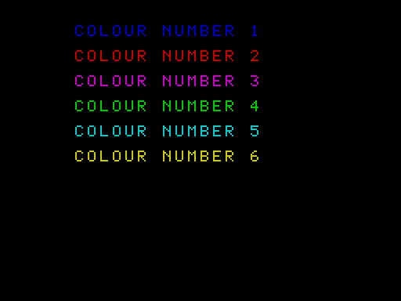
Six colours of writing on black
Drawing. The drawing screen is 256 dots across and 192 down. PLOT x, y puts down one dot; x runs from 0 at the left and y from 0 at the top. LINE x1, y1 TO x2, y2 draws a straight line.
INK 2
LINE 40, 150 TO 128, 30
LINE 128, 30 TO 216, 150
LINE 216, 150 TO 40, 150
INK 1
FOR x = 60 TO 196 STEP 4
PLOT x, 170
NEXT x
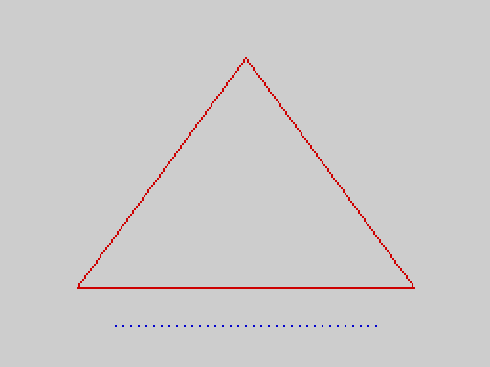
A triangle with a dotted line below it
Your own characters. You can design 21 characters of your own, 8 x 8 dots each, and print them like letters with PRINT CHR$(144) to PRINT CHR$(164). Each is defined by eight POKEs: one number for each row of dots, starting at address 61824 for character 144. A row of dots is a number: add 128, 64, 32, 16, 8, 4, 2 and 1 for the dots that are on, from left to right (so ..####.. is 16 + 8 + 4 + 2 = 60). This makes character 144 into a solid block and prints it:
FOR r = 0 TO 7
POKE 61824 + r, 255
NEXT r
PRINT PEEK(61824)
PRINT CHR$(144); CHR$(144); CHR$(144)
255

The number 255, and three solid blocks on the row below
The whole story, with a program that lets you draw a character with # and ., is in the concept User-defined characters.
Further shapes -- circles, filled areas, rectangles -- come from the packages (Chapter 16).

Chapter 13 -- Sound
BEEP duration, pitch makes a note on the loudspeaker. Both numbers are plain counts: the duration is how many waves, the pitch is a delay (a bigger pitch gives a lower note). Try this short rising scale:
FOR p = 200 TO 100 STEP -20
BEEP 80, p
NEXT p
PRINT "DONE"
DONE
SOUND programs the three-voice sound chip. See the keywords BEEP and SOUND, and the concept Sound.

Chapter 14 -- Keeping your work
When you switch off, the program is lost. Save it on tape first:
SAVE "MYPROG"
(Names are up to 10 characters.) The machine shows SAVED when it is done. To get it back later, switch on and type LOAD "MYPROG"; LOADED is shown. VERIFY "MYPROG" checks that the tape matches what is in the machine.
SAVE "MYPROG" ALL saves more: the program and the numbers and strings it was using, so you can carry on exactly where you stopped.
score = 120
name$ = "ADA"
RUN
SAVE "MYPROG" ALL [SAVED]
power on
LOAD "MYPROG" [LOADED]
: PRINT score
120
: PRINT name$
ADA
(The lines starting with a colon are explained in the next chapter.) The tape messages are explained under SAVE and the concept Tapes.

Chapter 15 -- Looking inside a stopped program
When a program has stopped -- it ended, or you pressed BREAK, or it hit an error -- the machine keeps its variables. On the empty last line, a statement typed after a colon is carried out at once, using them:
total = 0
FOR i = 1 TO 10
total = total + i
NEXT i
RUN
: PRINT total
55
: PRINT i
11
: total = 0
: PRINT total
0
That is a powerful way to find out why a program did something odd, or to try out an idea without rewriting the program. You can even start the program again from a label, with the variables as they are, using : GOTO label. Changing the program in any way discards the kept variables. The concept Sessions has the full rules.

Chapter 16 -- Packages: more statements
The language in the ROM is complete for most programs. Specialist statements come on tape as packages, which you load with LOAD "NAME" EXT. There are five:
To get | Load | You then have
circles and filled areas | SHAPES | CIRCLE, FILL
rectangles, big pixels | GRAPHICS | BLOCK, FRAME, INVERT, CPLOT
moving pictures | SPRITE | GRAB, SHOW, HIDE, MOVE
the printer | PRINTER | LPRINT, LLIST
video modes, ULAplus | MODE | MODE, ULAPLUS, PALETTE

With the shapes package loaded (LOAD "SHAPES" EXT):
INK 4
CIRCLE 128, 96, 80
INK 2
CIRCLE 128, 96, 50
INK 1
CIRCLE 128, 96, 20
FILL 128, 96
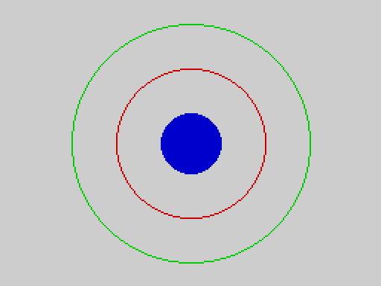
Three circles with the middle one filled
Only one package is loaded at a time; loading another replaces it, and NEW removes it. Part 5 describes each package.

Where next
- Look up any word in Part 3, Keywords: every entry has examples you can type in.
- Read the Concepts when you wonder why: how numbers work, what a session is, how memory is used.
- Try the programs in Part 6 -- a sieve, a sorting program, a game, animation -- and change them.
- When something goes wrong, Appendix A explains every message.

Part 3 -- Keywords
Every statement, function, operator and command of the 2068-Leap V2 language, in alphabetical order. Entries for the statements of the five loadable packages are included in their place and marked [package: name]; each of those works only after LOAD "NAME" EXT (see Part 5).

How to read an entry
Each entry gives the syntax, the kind of keyword, a description, examples and, where they matter, notes, the errors it can cause, and related entries.
Notation | Meaning
KEYWORD | type it exactly like this (upper or lower case: print and PRINT are the same)
italics | something you supply: a number, an expression, a name
[ ] | optional
{ } | may be repeated
a | b | one of the alternatives

Kinds are: statement (does something; used in a program or after : on the editor's last line), function (gives a value; used inside an expression), operator, command (typed on the empty last line of the editor, not allowed in programs), and part of (a word that belongs to another statement).
Examples marked with an output block show exactly what the program prints on the release ROM; every one of them is run on the emulator-qualified release by make doc-examples. Screen pictures are produced the same way.
Two things are different from Sinclair BASIC and matter everywhere:
- Statements are not numbered, and a statement never starts with LET.
- Functions are always written with brackets, even when they take no argument: PI(), INKEY$(), FREE(). DIV and MOD are functions too: MOD(17, 5), not 17 MOD 5.
Programs are written one statement (or several, separated by :) per line. In the examples below, each line of the box is one line of the program.

ABS
ABS(n) -- function
The size of n without its sign.
PRINT ABS(-5)
PRINT ABS(2.5)
PRINT ABS(-2.5)
5
2.5000
2.5000
Notes. ABS(-32768) is 32768, which is outside the whole-number range, so it is a floating-point value: it prints as 32768.0000 (see Numbers).
See also SGN, INT.

ALL
SAVE "name" ALL -- part of SAVE
Saves the program and its variables and arrays. See SAVE and the concept Sessions.

AND
a AND b -- operator
True (1) when both a and b are true; otherwise 0. Any value other than 0 counts as true. AND is a logical operator -- it gives 0 or 1, never a bit pattern: 3 AND 5 is 1, not 1. (There is no bitwise AND in V2.)
AND binds more loosely than the comparisons and more tightly than OR, so a > 3 AND a < 10 means (a > 3) AND (a < 10).
AND stops as soon as the answer is known: if a is false, b is not evaluated at all. This makes guards safe:
y = 0
IF y <> 0 AND 10 / y > 1 THEN
PRINT "big"
ELSE
PRINT "safe"
ENDIF
safe
a = 5
PRINT a > 3 AND a < 10
PRINT 3 AND 0
PRINT 3 AND 5
1
0
1
See also OR, NOT, the concept Truth and comparisons.

ARRAY
SAVE "name" ARRAY a, LOAD "name" ARRAY a -- part of SAVE / LOAD
Saves or loads a single array (and, on loading, puts it in the Array Store). See SAVE, LOAD and the concept Array Store.

AT
AT row, col -- statement
Moves the printing position, so that the next PRINT starts at that row and column. Row 0 is the top of the screen and column 0 the left edge. AT is a statement of its own, used before PRINT; it is not an item inside PRINT as it is in Sinclair BASIC.
AT 3, 5
PRINT "here"
AT 0, 0
PRINT "top"
top
here
Notes.
- Rows 0 to 22 are the text area. Row 23 is the status bar: printing there scrolls the screen up. A row above 23 is treated as 23.
- The column is taken modulo 32 (not clamped): AT 0, 40 is column 8.
- CLS puts the position back at row 0, column 0.
See also TAB, PRINT, CLS.

ATTR
ATTR(row, col) -- function
The colour attribute of the character cell at row, col: one number made of
Part | Value
ink colour | 0 to 7
paper colour | 8 times (0 to 7)
bright | 64 if on
flash | 128 if on

A cell outside the screen (row above 23, column above 31) gives 0.
INK 2
PAPER 6
CLS
PRINT ATTR(0, 0)
PRINT ATTR(10, 12)
PRINT ATTR(30, 0)
50
50
0
Here 50 = 6 x 8 + 2: paper 6 (yellow) and ink 2 (red).
See also INK, PAPER, BRIGHT, FLASH, POINT.

BEEP
BEEP duration, pitch -- statement
Makes a sound through the loudspeaker. In the V2 release this is not the Sinclair `BEEP`: there are no seconds and no musical notes. Both numbers are raw counts:
- duration is the number of complete sound waves (cycles) to produce; 0 produces none;
- pitch is the length of the pause in each half-wave: the larger the number, the lower the note.
One cycle takes about 52 x pitch + 222 processor T-states, so the frequency is the processor clock divided by that: about 3 528 000 / (52 x pitch + 222) hertz on a TS2068 (3 500 000 on the emulator the release was measured on). BEEP 1000,100 costs 5 421 600 T-states, 650 Hz at 3.5 MHz.
Wanted note (approximately) | pitch
262 Hz (middle C) | 255
440 Hz (A) | 149
880 Hz | 72
1760 Hz | 34

BEEP 220, 149
PAUSE 10
BEEP 440, 72
PRINT "done"
done
Notes.
- The program stops running while it beeps. Interrupts are switched off during the sound, so BREAK is not noticed until it ends: keep duration short (a few hundred cycles).
- A pitch of 0 is the slowest wave of all (65 536 steps per half-wave), not the highest.
- The result was measured on the emulator; the sound itself was not heard on a real machine.
Compared with Sinclair BASIC. On the Spectrum and in the TS2068's own BASIC, BEEP seconds, semitones takes a length in seconds and a pitch in semitones above middle C (0 is middle C, 12 an octave above, a negative number below; the range is -60 to 69). V2's BEEP was inherited from the first release (V1) with raw counts; the intended behaviour was the Sinclair one, and a change is being considered (see docs/v2/V2_BEEP_SOUND_MODE_COMPATIBILITY.md). Until then, this procedure gives Sinclair's BEEP in BASIC: put the length in seconds in the variable dur, and CALL sbeep(semitones). It works out the frequency (middle C is 261.6256 Hz and each semitone is 2^(1/12) higher), turns it into the cycle count and the pitch that V2's BEEP wants, and beeps. It accepts whole semitones (a fraction is cut off) from -60 to 69; the pitch it asks for is accurate to about 1% up to three octaves above middle C, but the loudspeaker routine's steps become coarse above that (a note at +60 is about 11% sharp).
dur = 1
CALL convert(0)
PRINT cyc; " "; pit
CALL convert(12)
PRINT cyc; " "; pit
CALL convert(-12)
PRINT cyc; " "; pit
CALL convert(9)
PRINT cyc; " "; pit
END
PROC sbeep(semi):
CALL convert(semi)
BEEP cyc, pit
ENDP
PROC convert(semi):
n = 60 + semi
o = DIV(n, 12) - 5
f = 261.6256
FOR i = 1 TO MOD(n, 12)
f = f * 1.0594630944
NEXT i
IF o > 0 THEN
FOR i = 1 TO o
f = f * 2
NEXT i
ENDIF
IF o < 0 THEN
FOR i = 1 TO 0 - o
f = f / 2
NEXT i
ENDIF
cyc = INT(f * dur)
pit = INT((3528000 / f - 222) / 52)
IF pit < 1 THEN
pit = 1
ENDIF
ENDP
261 255
523 125
130 514
440 149
(Each line is the number of cycles and the pitch for one second of that note: middle C, the C above it, the C below it and the A above middle C. The stock TS2068 ROM, run in the emulator, gives the same cycle counts to within one and a pitch that sounds the same to within a fraction of a percent.) To play a tune, set dur and call sbeep for each note:
dur = 0.2
FOR note = 0 TO 7
CALL sbeep(note * 2 - DIV(note, 4))
NEXT note
END
PROC sbeep(semi):
n = 60 + semi
o = DIV(n, 12) - 5
f = 261.6256
FOR i = 1 TO MOD(n, 12)
f = f * 1.0594630944
NEXT i
IF o > 0 THEN
FOR i = 1 TO o
f = f * 2
NEXT i
ENDIF
cyc = INT(f * dur)
pit = INT((3528000 / f - 222) / 52)
BEEP cyc, pit
ENDP
See also SOUND, PAUSE, the concept Sound.

BLOCK [package: graphics]
BLOCK x0, y0, x1, y1 -- statement
Fills a rectangle with the current ink (and paper) colours. The corners may be given in any order. Needs the graphics package. See Part 5.
With the graphics package loaded (LOAD "GRAPHICS" EXT):
INK 4
BLOCK 10, 40, 60, 70
INK 2
FRAME 70, 40, 120, 70
INK 1
BLOCK 130, 40, 180, 70
INVERT 140, 50, 170, 60
INK 0
PRINT POINT(30, 60)
1
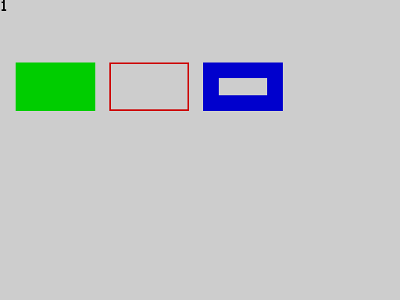
BLOCK, FRAME and INVERT
See also FRAME, INVERT, CPLOT, PLOT, LINE.

BORDER
BORDER n -- statement
Sets the colour of the border. Only the low three bits of n count, so the colours repeat every eight:
n | 0 | 1 | 2 | 3 | 4 | 5 | 6 | 7
colour | black | blue | red | magenta | green | cyan | yellow | white

BORDER 2
PAUSE 25
BORDER 7
PRINT "border"
border
See also INK, PAPER.

BRIGHT
BRIGHT n -- statement
Turns the bright (extra intensity) attribute on for everything printed or drawn next. Only the low bit of n counts: BRIGHT 1 is on, BRIGHT 0 off; BRIGHT 2 is off.
BRIGHT 1
CLS
a = ATTR(0, 0)
BRIGHT 0
CLS
b = ATTR(0, 0)
PRINT a
PRINT b
120
56
(CLS paints the whole screen with the colours in force; ATTR then reports them. 120 is 56, the default paper 7 and ink 0, plus 64 for bright.)
See also FLASH, INK, PAPER, INVERSE, OVER.

CALL
CALL name(expression) -- statement
Runs the procedure name (see PROC), giving it the value of expression as its one parameter. When the procedure ends, the program carries on after the CALL.
CALL hello(5)
CALL hello(6)
END
PROC hello(n):
PRINT "n = "; n
ENDP
n = 5
n = 6
Notes.
- A procedure always takes exactly one value, even if you do not need it: CALL beep_twice(0).
- A procedure may call itself (see PROC).
- CALL to a name that is not a procedure is a compile error (an undefined label gives SYNTAX ERROR). A known limitation: CALL of an ordinary label is accepted, jumps there and runs on without ever returning (accepted defect Q-24); always CALL procedures only.
See also PROC, ENDP, GOTO, DEF FN.

CHR$
CHR$(n) -- function
A string of one character: the character whose code is n (0 to 255). Any other value stops the program with a run-time error.
PRINT CHR$(72) + CHR$(105)
PRINT CODE(CHR$(200))
Hi
200
See the character set for the characters that exist. CHR$(144) to CHR$(164) are the 21 user-defined characters, which you define with POKE.
See also CODE, STR$.

CIRCLE [package: shapes]
CIRCLE x, y, radius -- statement
Draws a circle with its centre at pixel x, y. Needs the shapes package. See Part 5.
With the shapes package loaded (LOAD "SHAPES" EXT):
INK 1
CIRCLE 128, 96, 60
INK 2
CIRCLE 128, 96, 30
FILL 128, 96
INK 0
PRINT "done"
done
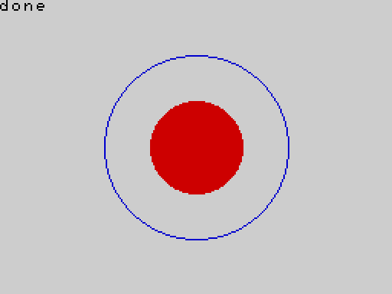
Two circles, the inner one filled
See also FILL, PLOT, LINE.

CLEAR
CLEAR -- statement
Sets every variable back to 0 (numbers) or "" (strings) and removes the contents of ordinary arrays. The program stays as it is. In a FOR loop, CLEAR also ends the loop (so a later NEXT is a run-time error). The Array Store and any loaded package are not touched.
x = 5
PRINT x
CLEAR
PRINT x
5
0
After CLEAR, an ordinary array is empty and its elements can no longer be used (an index is out of range). Typed after a colon on the editor's last line, : CLEAR clears the variables kept from the last run (see the concept Sessions).
See also RUN, NEW, DIM.

CLS
CLS -- statement
Clears the text area of the screen, paints it with the current ink, paper, bright and flash colours, and puts the printing position at the top left (row 0, column 0).
PRINT "gone"
CLS
PRINT "fresh"
fresh
See also AT, INK, PAPER.

CODE
CODE(a$) -- function
The character code of the first character of a$, or 0 if a$ is empty.
PRINT CODE("A")
PRINT CODE("abc")
PRINT CODE("")
PRINT CODE(" ")
65
97
0
32
See also CHR$, VAL, LEN.

COS
COS(angle) -- function
The cosine of an angle given in degrees (not radians); fractions of a degree are allowed. The result is a floating-point number.
PRINT COS(60)
PRINT COS(0)
0.5000
1.0000
See also SIN, TAN, RAD, DEG, PI.

CPLOT [package: graphics]
CPLOT x, y -- statement
Plots a coarse "big pixel": a 4 x 4 block of ordinary pixels on a grid of 64 columns by 48 rows. x is 0 to 63 and y 0 to 47, counted from the top left (larger values are treated as the last column or row). Needs the graphics package: type LOAD "GRAPHICS" EXT first. See Part 5.
A diagonal line across the whole screen, drawn one big pixel at a time:
With the graphics package loaded (LOAD "GRAPHICS" EXT):
INK 2
FOR x = 0 TO 63
CPLOT x, DIV(x * 47, 63)
NEXT x
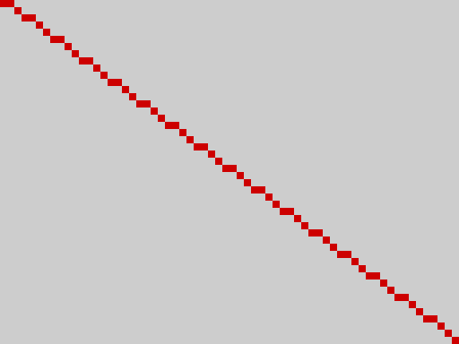
A diagonal line of big pixels, from the top left to the bottom right
See also PLOT, BLOCK.

DEF FN
DEF FN name(parameter) = expression -- statement
Defines a one-line function with one numeric parameter. You use it with FN inside an expression: FN name(argument). The name may be as long as any other name. The definition itself does nothing when it is reached; it may be anywhere in the program, even after the places that use it.
DEF FN sq(x) = x * x
PRINT FN sq(7)
PRINT FN sq(1.5)
y = 3
PRINT FN sq(y + 1)
49
2.2500
16
The body can use the program's variables (their value when the function is called) and other functions:
DEF FN a(x) = x + 1
DEF FN b(x) = FN a(x) * 2
n = 10
DEF FN plus(k) = k + n
PRINT FN b(3)
PRINT FN plus(1)
n = 20
PRINT FN plus(1)
8
11
21
Notes.
- The function and its parameter are numbers; a function cannot return a string, and cannot be given one.
- Defining the same function name twice is a compile error.
- DEF FN cannot be typed as an immediate statement (after a colon on the last editor line).
See also FN, PROC.

DEG
DEG(r) -- function
Converts an angle from radians to degrees.
PRINT DEG(PI())
PRINT DEG(1)
180.0000
57.2958
See also RAD, PI, SIN.

DIM
DIM name(size), DIM name$(size), DIM name$(size, width) -- statement
Declares an array. size is the number of elements, and it must be a plain whole number in the program (not a variable or a sum). The elements are numbered from 0: DIM a(5) has a(0) to a(4).
- A numeric array holds whole numbers from -32768 to 32767, two bytes each. Storing a fraction or a number outside that range is a run-time error.
- A string array name$(size) holds strings of up to 15 characters. name$(size, width) gives each element width bytes, so it holds width - 1 characters: DIM n$(10, 32) holds 31 characters.
- Every element starts as 0 or "".
DIM a(5)
FOR i = 0 TO 4
a(i) = i * i
NEXT i
PRINT a(3)
PRINT DIMN(a)
9
5
DIM n$(3)
n$(0) = "123456789012345"
n$(1) = "1234567890123456789"
PRINT n$(0)
PRINT n$(1)
PRINT LEN(n$(1))
123456789012345
123456789012345
15
The second line is cut to the 15 characters an element can hold. With a width:
DIM w$(2, 32)
w$(0) = "1234567890123456789012345678901"
PRINT w$(0)
PRINT LEN(w$(0))
1234567890123456789012345678901
31
Errors.
Mistake | What happens
index below 0 or at/above size | run-time error (RUNTIME ERROR)
a(2) = 40000 or a(2) = 1.5 | run-time error
a variable as the size (DIM a(n)) | compile error (SYNTAX ERROR)
a size of 0 | compile error
DIM of a name twice in one program | compile error
not enough memory | run-time error (OUT OF MEMORY)

Notes.
- An array lives in the main memory, or -- if it does not fit there -- in the 2 KB overflow area (segment 2). A single array must fit entirely in one of them: with an empty program the largest numeric array has 4063 elements, the largest string array 508 elements of 15 characters (254 of 31). See Limits.
- An array has one dimension.
- A numeric array and a scalar variable can share a name: x and x(1) are different things.
- An array saved with SAVE ... ARRAY and loaded with LOAD ... ARRAY is kept in the Array Store; a DIM of the same name and size in the program then uses it (see Array Store).
See also DIMN, CLEAR, FREE, the concept Arrays.

DIMN
DIMN(name) -- function
The size an array was declared with: DIMN(a) after DIM a(5) is 5.
DIM scores(12)
PRINT DIMN(scores)
PRINT DIMN(scores) - 1
12
11
Notes. DIMN works on numeric arrays only. DIMN of a string array is a compile error: keep the size in a variable if you need it. (This is a limitation of the release; the earlier description of DIMN(a$) was wrong.)
See also DIM.

DIV
DIV(a, b) -- function
The whole-number part of a divided by b, rounded toward zero. Fractions are cut off first. Dividing by zero stops the program with a run-time error. (DIV is written like a function, not between its operands.)
PRINT DIV(17, 5)
PRINT DIV(-7, 2)
PRINT DIV(20, 4)
3
-3
5
See also MOD, INT, the operator /.

ELSE
ELSE -- part of IF
Starts the part of a block IF that is run when the condition is false. See IF.

END
END -- statement
Stops the program. Reaching the last line does the same, so END is needed only to stop before the end -- typically before the procedures that follow the main program. Variables are kept (see the concept Sessions).
PRINT "start"
CALL work(1)
END
PROC work(n):
PRINT "working"
ENDP
start
working
See also STOP, PROC.

ENDIF
ENDIF -- part of IF
Closes a block IF. See IF.

ENDP
ENDP -- part of PROC
Ends a procedure; the program returns to the statement after the CALL. See PROC.

EXIT FOR
EXIT FOR -- statement
Leaves the innermost FOR loop at once, carrying on after its NEXT. The loop variable keeps the value it had.
FOR i = 1 TO 10
IF i = 4 THEN
EXIT FOR
ENDIF
PRINT i
NEXT i
PRINT "i = "; i
1
2
3
i = 4
Notes. EXIT FOR outside a FOR loop is a compile error. EXIT FOR after a GOTO out of the loop is fine; there may be at most a handful of EXIT FOR statements waiting in one loop (see Limits).
See also FOR, NEXT, GOTO.

EXT
SAVE "name" EXT, LOAD "name" EXT -- part of SAVE / LOAD
Saves or loads a package: LOAD "SHAPES" EXT adds the statements CIRCLE and FILL to the language. See Part 5 and the commands SAVE and LOAD.

FILL [package: shapes]
FILL x, y -- statement
Floods the area around pixel x, y with the current ink colour, spreading in every direction until it meets pixels that are already set (a line, a circle, any outline). The area must be closed: if the outline has a gap, the colour spills out through it. Needs the shapes package: type LOAD "SHAPES" EXT first. See Part 5.
A house drawn with LINE, then filled:
With the shapes package loaded (LOAD "SHAPES" EXT):
INK 1
LINE 70, 150 TO 70, 90
LINE 70, 90 TO 128, 40
LINE 128, 40 TO 186, 90
LINE 186, 90 TO 186, 150
LINE 186, 150 TO 70, 150
INK 2
FILL 128, 110

A house outline filled with red
See also CIRCLE, BLOCK, LINE.

FLASH
FLASH n -- statement
Makes what is printed next flash (its ink and paper swap about twice a second). Only the low bit of n counts: FLASH 1 on, FLASH 0 off.
FLASH 1
CLS
a = ATTR(0, 0)
FLASH 0
CLS
b = ATTR(0, 0)
PRINT a
PRINT b
184
56
(184 is 56 plus 128 for flash.)
See also BRIGHT, INK, PAPER.

FN
FN name(expression) -- part of an expression
Calls a function defined with DEF FN. See DEF FN.

FOR
FOR variable = start TO limit [STEP step] ... NEXT [variable] -- statement
Repeats the statements between FOR and NEXT. The variable is set to start, the statements run, and at NEXT the step (1 if you leave STEP out) is added; the loop goes round again while the variable has not gone past limit. The limit and step are worked out once, when the loop starts.
FOR i = 1 TO 3
PRINT i
NEXT i
PRINT "after: "; i
1
2
3
after: 4
After a normal finish the variable holds the first value past the limit (4 here).
A negative step counts down:
FOR i = 3 TO 1 STEP -1
PRINT i
NEXT i
PRINT i
3
2
1
0
If start is already beyond limit in the direction of the step, the loop does not run at all:
FOR i = 3 TO 1
PRINT i
NEXT i
PRINT "after"
after
Loops nest, and NEXT may leave out the variable name (it closes the innermost loop):
FOR i = 1 TO 2
FOR j = 1 TO 2
PRINT i * 10 + j
NEXT
NEXT
11
12
21
22
Whole-number and fractional loops. If the start, limit and step are all whole numbers the loop counts with whole numbers. If any of them is a fraction, the loop is a floating-point loop: the step is added each time, and the result keeps the rounding errors of floating-point arithmetic, so the number of times round the loop for a fractional step is only as exact as the arithmetic (the 25 loops of the qualification test were all exact, but do not rely on it). When the count matters, use a whole-number loop and divide inside it:
FOR x = 0 TO 1 STEP 0.25
PRINT x
NEXT x
0
0.2500
0.5000
0.7500
1.0000
(The first value is the whole number 0, so it prints without decimals.)
FOR k = 0 TO 4
PRINT k / 4
NEXT k
0
0.2500
0.5000
0.7500
1
Notes.
- STEP 0 never moves the variable; the loop runs until BREAK or EXIT FOR.
- Jumping out of a loop with GOTO is allowed; jumping into one is not (the NEXT then stops the program with a run-time error).
- A FOR with no matching NEXT is a compile error, and so is a NEXT for a different variable than the innermost open FOR.
- Any loop variable name may be used, including a long one.
- A FOR/NEXT pass with nothing inside costs about 1100 to 1200 T-states: roughly 3 000 empty passes per second. See the concept Speed.
See also NEXT, STEP, TO, EXIT FOR, GOTO.

FRAME [package: graphics]
FRAME x0, y0, x1, y1 -- statement
Draws the outline of a rectangle between two opposite corners (given in any order), in the current ink. Needs the graphics package: type LOAD "GRAPHICS" EXT first. See Part 5.
Six nested frames, each in the next colour:
With the graphics package loaded (LOAD "GRAPHICS" EXT):
FOR i = 0 TO 5
INK i + 1
FRAME 20 + i * 14, 20 + i * 10, 235 - i * 14, 170 - i * 10
NEXT i
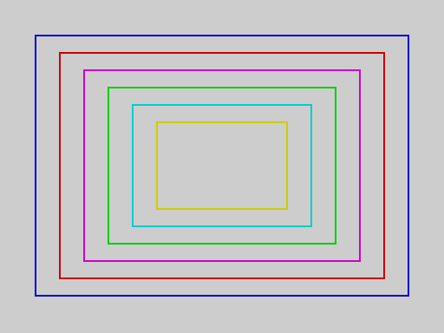
Six nested rectangles in six colours
See also BLOCK, INVERT, LINE.

FREE
FREE(), FREE(1) -- function
FREE() is the number of bytes still free in the main memory pool, which the program text, the variables and the arrays share. FREE(1) is the number of bytes free in the 2 KB overflow area (segment 2) that arrays use when they do not fit in the main pool, and where the Array Store lives.
PRINT FREE(1)
DIM a(100)
PRINT FREE(1)
2048
2048
(FREE() itself depends on the program: a short program on an empty machine leaves about 8100 bytes, and a numeric array costs two bytes per element.)
See also DIM, the concept Memory.

GOTO
GOTO label -- statement
Continues the program at the line label:. A label is a line consisting of a name followed by a colon; GOTO can only go to labels (there are no line numbers).
n = 0
again:
n = n + 1
PRINT n
IF n < 3 THEN GOTO again
PRINT "finished"
1
2
3
finished
The label may come before or after the GOTO:
GOTO skip
PRINT "never printed"
skip:
PRINT "here"
here
Notes.
- A label may not be a keyword (out: is an error: OUT is a statement). Names that merely begin with a keyword (tomato, format) are fine.
- GOTO may jump out of a FOR loop or a procedure. It may not jump into the middle of a loop: the loop's NEXT then fails with a run-time error. A label inside a procedure belongs to the procedure's code and should only be reached by CALL.
- A GOTO to a label that does not exist is a compile error (nothing runs).
- Typed after a colon on the editor's last line, : GOTO label runs the program from that label using the variables kept from the last run (see Sessions).
See also IF, CALL, the concept Labels.

GRAB [package: sprite]
GRAB slot, row, col, width, height -- statement
Copies a rectangle of the screen -- both the pixels and the colours -- into a sprite slot (0 to 7). The rectangle starts at character cell row, col and is width by height character cells (each from 1 to 4). The picture stays on the screen; the copy is kept until you GRAB into that slot again. Needs the sprite package: type LOAD "SPRITE" EXT first. See Part 5.
Draw a red diamond on yellow in the top left, grab it, clear the screen to a blue background, and show two copies of it:
With the sprite package loaded (LOAD "SPRITE" EXT):
INK 2
PAPER 6
LINE 23, 16 TO 31, 24
LINE 31, 24 TO 23, 31
LINE 23, 31 TO 16, 24
LINE 16, 24 TO 23, 16
LINE 16, 24 TO 31, 24
GRAB 0, 2, 2, 2, 2
GRAB 1, 2, 2, 2, 2
INK 7
PAPER 1
CLS
SHOW 0, 8, 6
SHOW 1, 8, 20
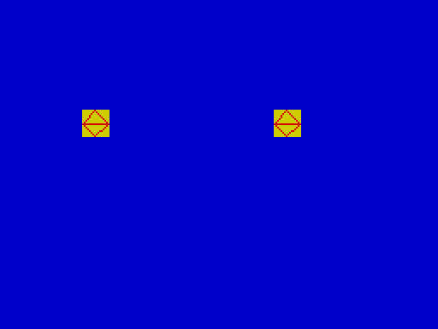
Two copies of the grabbed diamond, on a blue screen
See also SHOW, HIDE, MOVE.

HIDE [package: sprite]
HIDE slot -- statement
Removes a shown sprite, restoring the screen exactly as it was underneath it. Hiding a sprite that is not shown is a run-time error. Needs the sprite package: type LOAD "SPRITE" EXT first.
The same picture as under SHOW, but the sprite is hidden again at the end: the background is whole, with no hole where the sprite was.
With the sprite package loaded (LOAD "SPRITE" EXT):
INK 2
PAPER 6
LINE 23, 16 TO 31, 24
LINE 31, 24 TO 23, 31
LINE 23, 31 TO 16, 24
LINE 16, 24 TO 23, 16
GRAB 0, 2, 2, 2, 2
INK 0
PAPER 5
CLS
FOR r = 0 TO 22
AT r, 0
PRINT "###############################";
NEXT r
SHOW 0, 9, 14
PAUSE 25
HIDE 0

The background of hash signs, with the sprite hidden again
See also SHOW, MOVE, GRAB.

IF
IF condition THEN ... [ELSE ...] ENDIF IF condition THEN GOTO label -- statement
Chooses what to do. In the block form, THEN is the last thing on its line; the statements that follow, up to ELSE or ENDIF, run when the condition is true (not 0), and those between ELSE and ENDIF run when it is false. Every block IF is closed by ENDIF.
score = 75
IF score > 100 THEN
PRINT "WELL DONE"
ELSE
IF score > 50 THEN
PRINT "GOOD"
ELSE
PRINT "TRY AGAIN"
ENDIF
ENDIF
GOOD
The only one-line form is IF condition THEN GOTO label:
x = 1
IF x = 1 THEN GOTO done
PRINT "skipped"
done:
PRINT "end"
end
A condition is any number: 0 is false and anything else (including a fraction) is true. Comparisons give 1 or 0, so IF a > 3 THEN and IF (a > 3) <> 0 THEN mean the same.
Notes.
- There is no ELSEIF; write ELSE, a new IF, and one more ENDIF.
- A one-line IF x THEN PRINT "y" is a compile error: write the block form.
- Blocks nest.
- A missing ENDIF, or an ELSE/ENDIF with no IF, is a compile error.
See also AND, OR, NOT, GOTO, the concept Truth and comparisons.

IN
IN(port) -- function
Reads one byte from an input port. port is the full 16-bit port address: the high byte also selects which keyboard half-row is read, as on the Spectrum (IN(65278) reads the row with CAPS SHIFT, IN(32766) the row with SPACE). Joystick and keyboard bits are active low.
k = IN(65278)
PRINT k >= 0
PRINT k <= 255
1
1
See also OUT, INKEY$, STICK, PEEK.

INK
INK n -- statement
Sets the ink (foreground) colour used for printing and drawing from now on. Only the low three bits of n count, so the colours repeat every eight:
n | 0 | 1 | 2 | 3 | 4 | 5 | 6 | 7
colour | black | blue | red | magenta | green | cyan | yellow | white

INK 2
PAPER 6
CLS
PRINT ATTR(0, 0)
50
Colour changes affect what is printed or drawn afterwards; to repaint the whole screen, use CLS after the change. A fraction is cut off (INK 2.5 is 2).
See also PAPER, BRIGHT, FLASH, INVERSE, OVER, BORDER, ATTR.

INKEY$
INKEY$() -- function
The key being held down right now, as a one-character string, or the empty string "" if no key is down. It does not wait for a key.
a$ = INKEY$()
PRINT LEN(a$)
0
A typical loop waits for a key:
count = 0
wait:
count = count + 1
IF INKEY$() = "" AND count < 20 THEN GOTO wait
PRINT "released after "; count
released after 20
See also INPUT, STICK, PAUSE.

INPUT
INPUT variable INPUT "prompt"; variable INPUT "prompt", variable -- statement
Waits for you to type something and press ENTER, and stores it in variable. A numeric variable takes a number (fractions are fine, up to 20 characters; anything that is not a number gives 0, and text after a number is ignored: 12abc gives 12). A string variable (a$) takes up to 31 characters. What you type is shown on the screen as you type it. If you give a prompt, it is printed first, with nothing between it and your answer.
INPUT n
PRINT n + 1
42
43
INPUT "Name? "; n$
PRINT "Hello, "; n$
Name? Ann
Hello, Ann
INPUT "Value? "; v
PRINT v * 2
Value? 3.75
7.5000
INPUT has no editing: DELETE and the cursor keys are ignored, so a character typed by mistake cannot be taken back (here the keys were a, b, DELETE, c, ENTER, and the answer is abc):
INPUT t$
PRINT t$
abc
abc
Notes.
- Whether you separate the prompt from the variable with ; or with , makes no difference.
- Only a plain variable can be read into. INPUT a(1) -- an array element -- is a compile error; read into a variable and then store it.
- ENTER on its own gives 0 or "".
- Only printable characters are accepted; every other key (DELETE, the cursor keys) is ignored.
See also INKEY$, VAL, the concept Input.

INT
INT(n) -- function
n with its fraction cut off, toward zero. (Sinclair BASIC rounds down instead, so INT(-3.5) is -4 there but -3 here.) For a whole number the result is the number itself.
PRINT INT(3.7)
PRINT INT(-3.7)
PRINT INT(7 / 2)
PRINT INT(5)
3
-3
3
5
To round to the nearest whole number, add a half first: INT(x + 0.5) for positive x.
See also DIV, MOD, ABS.

INVERSE
INVERSE n -- statement
When n is 1, what is printed next has its ink and paper colours swapped. Only the low bit counts.
INVERSE 1
CLS
PRINT ATTR(0, 0)
7
(The default paper 7 and ink 0 become ink 7 on paper 0: 7 = 0 x 8 + 7.)
See also INK, PAPER, OVER.

INVERT [package: graphics]
INVERT x0, y0, x1, y1 -- statement
Flips every pixel of a rectangle: set pixels become clear and clear pixels become set, whatever OVER is. Doing it twice puts the picture back. Needs the graphics package: type LOAD "GRAPHICS" EXT first. See Part 5.
A solid block, with a second rectangle inverted across its corner -- the part over the block becomes empty, the part outside it becomes solid:
With the graphics package loaded (LOAD "GRAPHICS" EXT):
INK 1
BLOCK 40, 40, 140, 110
INVERT 100, 80, 200, 150
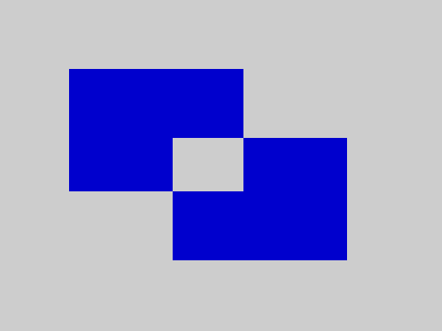
An inverted rectangle overlapping a solid block
See also BLOCK, FRAME, OVER.

LEFT$
LEFT$(a$, n) -- function
The first n characters of a$. If n is larger than the length you get the whole string; n of 0 (or less) gives "".
PRINT LEFT$("abcdef", 2)
PRINT LEFT$("abcdef", 99)
PRINT LEN(LEFT$("abcdef", 0))
ab
abcdef
0
See also RIGHT$, MID$, LEN.

LEN
LEN(a$) -- function
The number of characters in a$ (0 to 31).
PRINT LEN("hello world")
PRINT LEN("")
PRINT LEN(STR$(12345))
11
0
5
See also CODE, LEFT$, MID$.

LINE
LINE x0, y0 TO x1, y1 -- statement
Draws a straight line between two pixels, in the current ink. x runs 0 to 255 from the left and y 0 to 191 from the top (this differs from Sinclair BASIC, where y counts up from the bottom). Coordinates off the screen are moved to the nearest edge.
INK 1
LINE 20, 30 TO 235, 30
LINE 235, 30 TO 235, 170
LINE 235, 170 TO 20, 170
LINE 20, 170 TO 20, 30
INK 2
LINE 20, 30 TO 235, 170
INK 0
PRINT POINT(20, 100)
PRINT POINT(120, 100)
1
0
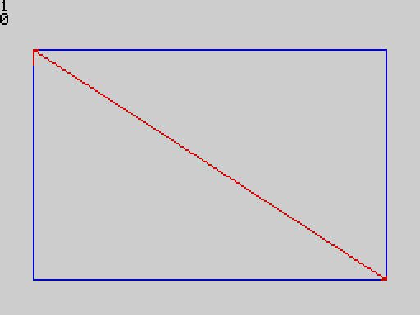
A box with a diagonal
See also PLOT, POINT, CIRCLE, CLS.

LIST
LIST -- command
Typed on the editor's empty last line. Shows the program from its first line, keywords in bold, 23 lines at a time. When the screen is full it waits for a key and then shows the next page; BREAK (CAPS SHIFT + SPACE) at a full page stops the listing. At the end of the program it waits for a key and returns to the editor.
PRINT "Hello"
FOR i = 1 TO 3
PRINT i
NEXT i
LIST
PRINT "Hello"
FOR i = 1 TO 3
PRINT i
NEXT i
See also RUN, NEW, the concept The editor.

LLIST [package: printer]
LLIST -- statement
Prints the program, one program line per printed line (a long line wraps at 32 characters), on the ZX Printer. Needs the printer package; without it LLIST is not known and the program fails to compile. See Part 5.
With the printer package loaded (LOAD "PRINTER" EXT):
PRINT "listing"
LLIST
See also LPRINT, LIST.

LOAD
LOAD "name" LOAD "" LOAD "name" ARRAY array LOAD "name" EXT -- command
Reads from tape what SAVE wrote:
Command | Loads
LOAD "name" | the program called name -- and, if it was saved with ALL, the variables and arrays that went with it
LOAD "" | the next program on the tape, whatever its name
LOAD "name" ARRAY a | one array, into the Array Store (the program is not touched)
LOAD "name" EXT | a package (see Part 5)

PRINT "from tape"
SAVE "first" [SAVED]
power on
LOAD "" [LOADED]
The result is shown on the status line: LOADED, or LOAD FAILED, BAD TAPE VERSION, NO VARIABLES, ABORTED. Details are under SAVE and in the concept Tapes.
See also SAVE, VERIFY.

LOWER$
LOWER$(a$) -- function
a$ with its capital letters changed to lower case.
PRINT LOWER$("Hello, WORLD 1")
hello, world 1
See also UPPER$.

LPRINT [package: printer]
LPRINT expression -- statement
Prints one number or string on the ZX Printer, wrapping at 32 characters. Needs the printer package; without it, LPRINT is a compile error. Only one item may follow LPRINT (not a list), and a number is printed as a whole number. See Part 5.
With the printer package loaded (LOAD "PRINTER" EXT):
LPRINT "hello"
LPRINT 42
PRINT "sent"
sent
Without the package:
LPRINT "hello"
See also LLIST, PRINT.

MID$
MID$(a$, start, length) -- function
length characters of a$, starting at character number start. The first character is number 1. A start below 1 counts as 1; a length that runs past the end gives what is left; a start beyond the end gives "".
PRINT MID$("abcdef", 3, 2)
PRINT MID$("abcdef", 3, 99)
PRINT LEN(MID$("abcdef", 10, 2))
PRINT MID$("abcdef", -1, 3)
cd
cdef
0
abc
V2 has no a$(i TO j) slicing; MID$ does that job.
See also LEFT$, RIGHT$, LEN.

MOD
MOD(a, b) -- function
The remainder of a divided by b, with the sign of a (truncating division). Fractions are cut off first. b of 0 stops the program with a run-time error.
PRINT MOD(17, 5)
PRINT MOD(-10, 3)
PRINT MOD(10, -3)
PRINT MOD(20, 4)
2
-1
1
0
See also DIV, INT.

MODE [package: mode]
MODE m -- statement
Selects the video mode: MODE 0 is the normal mode and MODE 1 the TS2068's extended-colour mode (every row of eight pixels can have its own colours; the ROM's own source calls it "High Resolution Graphics", which it is not). Any other value is a run-time error. Needs the mode package. See Part 5.
With the mode package loaded (LOAD "MODE" EXT):
MODE 1
MODE 0
PRINT "back to normal"
back to normal
See also ULAPLUS, PALETTE.

MOVE [package: sprite]
MOVE slot, row, col -- statement
Moves a shown sprite to a new character cell: the screen under the old position is restored, and the sprite is drawn at the new one. Moving a sprite that is not shown is a run-time error. Needs the sprite package: type LOAD "SPRITE" EXT first.
The sprite is shown at the left and moved, step by step, across the striped background to the right; the picture shows where it ends up, and the background it passed over is intact:
With the sprite package loaded (LOAD "SPRITE" EXT):
INK 2
PAPER 6
LINE 23, 16 TO 31, 24
LINE 31, 24 TO 23, 31
LINE 23, 31 TO 16, 24
LINE 16, 24 TO 23, 16
GRAB 0, 2, 2, 2, 2
INK 0
PAPER 5
CLS
FOR r = 0 TO 22
AT r, 0
PRINT "###############################";
NEXT r
SHOW 0, 9, 2
FOR c = 3 TO 26
MOVE 0, 9, c
PAUSE 1
NEXT c
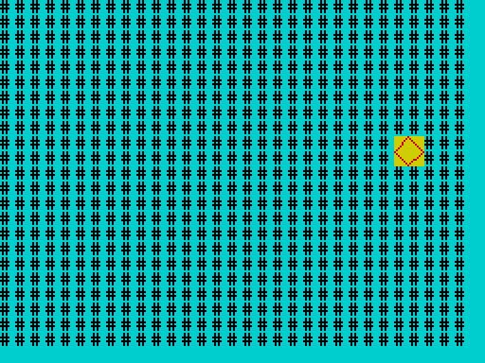
The sprite at the right-hand end of its path; the hash signs it crossed are unharmed
See also SHOW, HIDE, GRAB.

NEW
NEW -- command
Typed on the editor's empty last line. Wipes the program, the variables kept from the last run, the Array Store, and any loaded package, and starts a clean machine.
PRINT "one"
PRINT "two"
NEW
...
LINE 1/0
(The bottom line says: line 1 of an empty program.) There is no confirmation: NEW cannot be undone.
See also RUN, CLEAR, LOAD.

NEXT
NEXT [variable] -- part of FOR
Ends the body of a FOR loop and adds the step. See FOR.

NOT
NOT value -- operator
1 if value is 0, otherwise 0. NOT is a logical operator (no bit patterns). It binds more loosely than the comparisons, so NOT a = 4 means NOT (a = 4); use brackets for anything else.
a = 5
PRINT NOT 0
PRINT NOT 5
PRINT NOT a = 4
PRINT NOT NOT 3
1
0
1
1
See also AND, OR.

OR
a OR b -- operator
True (1) when a or b (or both) is true; otherwise 0. Like AND, it is a logical operator giving 0 or 1, and it stops as soon as the answer is known: if a is true, b is not evaluated. OR binds more loosely than AND.
a = 5
PRINT a < 3 OR a > 4
PRINT 0 OR 7
PRINT 0 OR 0
1
1
0
See also AND, NOT.

OUT
OUT port, value -- statement
Writes the low byte of value to an output port. port is the full 16-bit port address.
OUT 254, 2
PRINT "red border"
red border
(Port 254 is the ULA: bits 0 to 2 set the border colour. BORDER is the safe way to do this.)
See also IN, POKE, BORDER, SOUND.

OVER
OVER n -- statement
When n is 1, printing and drawing exclusive-OR with what is already on the screen: drawing a pixel that is already set clears it, and printing a character over itself erases it. OVER 0 returns to normal. Only the low bit counts.
PLOT 10, 100
OVER 1
PLOT 10, 100
OVER 0
PRINT POINT(10, 100)
PRINT "A"
AT 1, 0
OVER 1
PRINT "A"
OVER 0
AT 4, 0
PRINT "end"
0
end
(The second PLOT cleared the pixel the first one set, and the second PRINT "A" erased the first: row 1 is empty again.)
See also INVERSE, INVERT, PLOT.

PALETTE [package: mode]
PALETTE index, value -- statement
Writes value to ULAplus palette entry index (0 to 63). Needs the mode package and a machine or emulator with ULAplus. An index of 64 or more is a run-time error. See Part 5.
With the mode package loaded (LOAD "MODE" EXT):
ULAPLUS 1
PALETTE 0, 255
ULAPLUS 0
PRINT "palette set"
palette set
See also ULAPLUS, MODE.

PAPER
PAPER n -- statement
Sets the paper (background) colour for what is printed or drawn next; CLS paints the whole screen with it. The colours are those of INK; only the low three bits of n count.
PAPER 6
INK 2
CLS
PRINT ATTR(5, 5)
50
See also INK, BRIGHT, FLASH, BORDER, CLS.

PAUSE
PAUSE n -- statement
Waits for n frames (one frame is one display interrupt: 1/50 s in the qualification emulator; a real TS2068 is expected to run at 60 a second, which has not been measured) and goes on. PAUSE 0 waits for a key to be pressed. BREAK ends a long pause.
PRINT "wait"
PAUSE 50
PRINT "done"
wait
done
The measured cost is 69 700 T-states per frame count: PAUSE 100 took 6 978 474 T-states on the emulator, 2.0 seconds at the emulator's 50 frames per second.
See also BEEP, INKEY$.

PEEK
PEEK(address) -- function
The byte (0 to 255) stored at an address (0 to 65535). Reading the ROM works; writing it (with POKE) does nothing.
POKE 23296, 65
PRINT PEEK(23296)
PRINT PEEK(0)
65
243
(Address 0 is the first byte of the ROM: 243 is the Z80 instruction DI.)
Notes. An address of 65536 or more is a run-time error. Addresses can be written as decimal numbers above 32767 (PEEK(65535)).
See also POKE, USR, the memory map.

PI
PI() -- function
The number pi, 3.14159265... (written with brackets, like every function).
PRINT PI()
PRINT 2 * PI()
3.1416
6.2832
See also RAD, DEG, SIN, COS.

PLOT
PLOT x, y -- statement
Sets one pixel, in the current ink colour. The screen is 256 pixels wide and 192 high; x counts from the left (0 to 255) and y from the top (0 to 191). Values outside the screen are moved to the nearest edge, and a fraction is cut off.
A dotted sine wave across the screen:
INK 1
FOR x = 0 TO 255
PLOT x, 96 - INT(70 * SIN(x * 360 / 256))
NEXT x
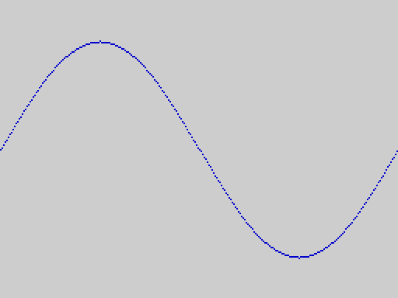
A wave drawn with single pixels
The wave starts at its middle height at the left edge (y = 96) and rises up the screen for positive sine values, because y counts down from the top. Note that this is different from Sinclair BASIC, where PLOT 0,0 is at the bottom left.
PLOT 300, 100
PLOT -5, 100
PRINT POINT(255, 100)
PRINT POINT(0, 100)
1
1
(Off-screen coordinates are moved to the nearest edge, so those two points land on the right and left edges.)
See also POINT, LINE, INK, OVER, CPLOT, CIRCLE.

POINT
POINT(x, y) -- function
1 if the pixel at x, y is set (ink), 0 if it is clear (paper). Coordinates are as for PLOT, and off-screen values are moved to the nearest edge.
This program draws a small shape and then reads it back with POINT, printing a # for every set pixel and a . for every clear one:
LINE 100, 100 TO 107, 107
LINE 107, 100 TO 100, 107
FOR y = 100 TO 107
a$ = ""
FOR x = 100 TO 107
IF POINT(x, y) = 1 THEN
a$ = a$ + "#"
ELSE
a$ = a$ + "."
ENDIF
NEXT x
PRINT a$
NEXT y
#......#
.#....#.
..#..#..
...##...
...##...
..#..#..
.#....#.
#......#
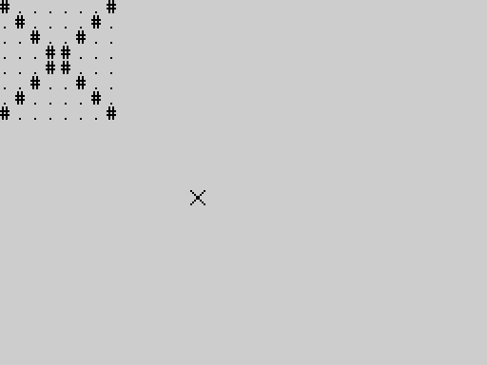
The cross on the screen, and its read-back as text at the top
See also PLOT, ATTR.

POKE
POKE address, value -- statement
Stores a byte in memory: the low byte of value, so POKE a, 300 stores 44 and POKE a, -1 stores 255. A fraction is cut off. address is 0 to 65535; above that is a run-time error. Writing to the ROM does nothing.
POKE 23296, 300
PRINT PEEK(23296)
POKE 23296, -1
PRINT PEEK(23296)
44
255
Warning. POKE can overwrite the memory the system itself uses -- the program, the variables, the screen handler -- and so crash the machine. Use the addresses in the memory map that are free.
See also PEEK, USR, OUT, and for designing your own characters with POKE the concept User-defined characters.

PRINT
PRINT [item [separator item]... [separator]] -- statement
Shows values on the screen, starting at the printing position. An item is a number or a string (anything that can follow = in an assignment). The separator between items is
- ; -- the next item follows immediately, with nothing between;
- , -- the next item starts at the next zone: columns 0 and 16 (two zones per 32-column row).
A ; or , at the end of the statement keeps the printing position on the line, so that the next PRINT carries on from there. Otherwise the position moves to the start of the next line. PRINT by itself prints an empty line.
PRINT "A"; "B"
PRINT "A", "B"
PRINT 1; 2; 3
PRINT
PRINT "x";
PRINT "y"
AB
A B
123
xy
How numbers look:
- A whole number is shown as it is.
- Any other number -- a fraction, or a number that does not fit the whole-number range (-32768 to 32767) -- is shown with four decimal places (rounded; very small values show as 0.0000).
PRINT 7 / 2
PRINT 6 / 2
PRINT 1 / 3
PRINT 65535
PRINT 123456789 * 10
PRINT -0.5
PRINT 0.1 + 0.2
3.5000
3
0.3333
65535.0000
1234567890.0000
-0.5000
0.3000
A line longer than the screen is wrapped; when the text reaches the bottom of the screen, the screen scrolls up:
FOR i = 1 TO 30
PRINT i
NEXT i
8
9
10
11
12
13
14
15
16
17
18
19
20
21
22
23
24
25
26
27
28
29
30
Notes.
- Position (AT, TAB) and colour (INK, PAPER, ...) are separate statements, used before PRINT; they are not items of PRINT.
- The text area is 23 rows of 32 columns; the bottom row of the screen (row 23) is reserved for the status line.
- PRINT to a printer is LPRINT (package printer).
- A string constant longer than 31 characters is a compile error.
See also AT, TAB, INK, CLS, STR$, LPRINT, the concept Numbers.

PROC
PROC name(parameter): ... ENDP -- statement
Defines a procedure: a named piece of program that you run with CALL. It has exactly one parameter, which gets the value passed by CALL. The statements run until ENDP, and then the program returns to the statement after the CALL.
When the program runs into a PROC ... ENDP in its ordinary flow, it skips over it, so procedures can be placed anywhere; most programs put them after an END.
For example:
CALL squareof(7)
CALL squareof(12)
END
PROC squareof(n):
PRINT n; " squared is "; n * n
ENDP
7 squared is 49
12 squared is 144
The parameter is a copy: the procedure may change it without affecting anything outside. A variable of the same name is hidden while the procedure runs and is restored when it returns. Every other variable of the program is shared, so a procedure can use and change it:
n = 100
total = 0
CALL add(5)
CALL add(7)
PRINT total
PRINT n
END
PROC add(n):
total = total + n
n = 0
ENDP
12
100
A procedure may call itself. Here is the factorial pattern, which prints from 1 up:
CALL countdown(5)
END
PROC countdown(n):
IF n > 1 THEN
CALL countdown(n - 1)
ENDIF
PRINT n
ENDP
1
2
3
4
5
Notes.
- A procedure always has one parameter. To pass nothing, give it a dummy value (CALL setup(0)); to pass several things, use variables.
- A procedure cannot return a value: put it in a variable, or use DEF FN for one-line calculations.
- Recursion is limited by memory: a procedure with one parameter can call itself about 670 deep with an empty program (see Limits).
- A PROC with no ENDP is a compile error; so is a PROC inside an immediate statement.
See also CALL, ENDP, DEF FN, END, the concept Procedures.

RAD
RAD(d) -- function
Converts an angle from degrees to radians.
PRINT RAD(180)
PRINT RAD(90)
3.1416
1.5708
See also DEG, PI, SIN.

RANDOMISE
RANDOMISE n -- statement
Sets the starting point of the random number sequence of RND. The same n always gives the same sequence, which is useful for repeatable tests. A program that wants different numbers each time must give RANDOMISE something that changes (a value read from the keyboard timing, say); RANDOMISE with no number is a compile error.
RANDOMISE 5
a = RND(1000)
RANDOMISE 5
b = RND(1000)
PRINT a = b
PRINT a
1
2
See also RND.

REM
REM text -- statement
A remark. Everything from REM to the end of the line is ignored (even a :), so a remark can end a line after other statements.
REM this whole line is ignored : PRINT "no"
x = 1 : REM and so is this
PRINT x
1
Notes. The apostrophe ' is not a comment character in V2 (it is a compile error).

RIGHT$
RIGHT$(a$, n) -- function
The last n characters of a$; the whole string if n is larger than its length.
PRINT RIGHT$("abcdef", 2)
PRINT RIGHT$("abcdef", 99)
ef
abcdef
See also LEFT$, MID$.

RND
RND(n) -- function
A random whole number from 0 to n - 1. (RND(6) is 0, 1, 2, 3, 4 or 5.) With n below 1 the result is 0.
RANDOMISE 7
FOR i = 1 TO 3
PRINT RND(6)
NEXT i
PRINT RND(1)
PRINT RND(0)
3
1
0
0
0
To roll a die: RND(6) + 1.
See also RANDOMISE.

RUN
RUN -- command
Typed on the editor's empty last line. Compiles the whole program, and, if there is no error, runs it with fresh variables. If the compiler finds a mistake, nothing runs: the message appears on the status line, and when you press a key the cursor goes to the line where the error was found.
When the program ends it leaves its output on the screen and waits for a key; the key returns you to the editor. If the program stops with a run-time error, what it had printed stays on the screen and the message appears on the bottom line.
PRINT "HELLO"
x = 3
PRINT x * 2
RUN
HELLO
6
PRINT 1 +
PRINT 2
RUN
PRINT 1 +
PRINT 2
RUN
...
SYNTAX ERROR
See also LIST, NEW, CLEAR, STOP, the concept Sessions.

SAVE
SAVE "name" SAVE "name" ALL SAVE "name" ARRAY array SAVE "name" EXT -- command
Writes to tape (or the emulator's tape output). name is up to 10 characters.
Command | Writes
SAVE "name" | the program
SAVE "name" ALL | the program and the variables and arrays it has now, and the Array Store
SAVE "name" ARRAY a | one array
SAVE "name" EXT | the package currently loaded (NO PACKAGE if none)

Each ends by showing SAVED on the status line. SAVE ... ALL lets you stop work and carry on later: after the LOAD, : PRINT x, : GOTO label and the rest see the saved values. The variables come back only on the same ROM version, with the same package (if any) loaded first; otherwise the program loads and the message says NO VARIABLES.
Notes.
- SAVE ... ALL, LOAD and VERIFY of an ALL tape pause for about 2.4 seconds before the tones start (the program's identity check is calculated first).
- If a very large program plus its overflow arrays cannot be laid out for saving, SAVE ... ALL says OUT OF MEMORY; SAVE "name" still works.
- A tape written by this version cannot be loaded by earlier V2 ROMs; V1 and stock Spectrum tapes are refused with BAD TAPE VERSION.
x = 5
y$ = "hello"
z = 2.5
RUN
: x = x + 1
SAVE "demo" ALL [SAVED]
power on
LOAD "demo" [LOADED]
: PRINT x
6
: PRINT y$
hello
: PRINT z
2.5000
See also LOAD, VERIFY, the concept Tapes.

SGN
SGN(n) -- function
The sign of n: -1, 0 or 1.
PRINT SGN(-7)
PRINT SGN(0)
PRINT SGN(0.5)
-1
0
1
See also ABS.

SHOW [package: sprite]
SHOW slot, row, col -- statement
Draws a grabbed sprite at character cell row, col, remembering the screen underneath so that HIDE or MOVE can restore it. The slot must have been grabbed (GRAB) and must not already be shown. Needs the sprite package: type LOAD "SPRITE" EXT first. See GRAB for a complete example.
A sprite is drawn on top of whatever is there, colours and all. Here one sprite is shown on a striped background:
With the sprite package loaded (LOAD "SPRITE" EXT):
INK 2
PAPER 6
LINE 23, 16 TO 31, 24
LINE 31, 24 TO 23, 31
LINE 23, 31 TO 16, 24
LINE 16, 24 TO 23, 16
GRAB 0, 2, 2, 2, 2
INK 0
PAPER 5
CLS
FOR r = 0 TO 22
AT r, 0
PRINT "###############################";
NEXT r
SHOW 0, 9, 14
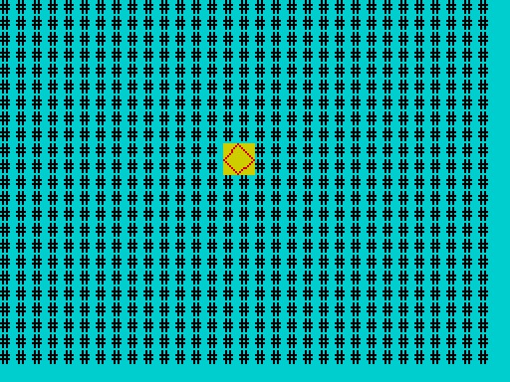
A sprite over a background of hash signs
Errors (all run-time): a slot above 7, a row above 23 or column above 31, a slot that was never grabbed, a slot that is already shown, or a sprite that would not fit on the screen at that position.
See also GRAB, HIDE, MOVE.

SIN
SIN(angle) -- function
The sine of an angle in degrees.
PRINT SIN(30)
PRINT SIN(90)
PRINT SIN(0.5)
0.5000
1.0000
0.0087
See also COS, TAN, RAD, DEG, PI.

SOUND
SOUND register, value -- statement
Writes value (0 to 255) to a register of the AY-3-8912 sound chip. The chip makes three tones and a noise, and keeps playing while the program goes on, until you silence it.
register is the register number as the chip knows it, and V2 requires it to be 1 to 16: any other number is a run-time error. This differs from the original TS2068 BASIC, whose SOUND accepts 0 to 16 (checked on the stock ROM in the emulator: it rejects 17 and above and nothing else). V2 therefore cannot write register 0, the fine pitch of channel A, with SOUND; the chip has no register 16, so a write to 16 does nothing in either system. (A one-line change to V2's SOUND would make it accept 0; see docs/v2/V2_BEEP_SOUND_MODE_COMPATIBILITY.md. Until then, OUT 245, 0 followed by OUT 246, value writes register 0 directly: 245 and 246 are the chip's register and data ports.)
Register | Holds
0 | channel A pitch, fine (not reachable with V2's SOUND; see above)
1 | channel A pitch, coarse (the low 4 bits)
2, 3 | channel B pitch, fine and coarse
4, 5 | channel C pitch, fine and coarse
6 | noise pitch
7 | mixer: which tones and noise are on (a bit set = off)
8, 9, 10 | volume of channels A, B, C (0 to 15)
11, 12, 13 | volume envelope

SOUND 7, 62
SOUND 1, 1
SOUND 8, 10
PAUSE 50
SOUND 8, 0
PRINT "silent again"
silent again
This switches channel A's tone on (mixer 62 turns on only tone A), sets its pitch and volume, waits a second, and silences it. Pitch is the period: the larger the number, the lower the note.
Notes. The register number is sent to the chip unchanged (read from the ROM, and checked on the emulator by watching the port writes). The sound itself was not heard on a real machine.
See also BEEP, OUT.

SQR
SQR(n) -- function
The square root of n. A negative n stops the program with a run-time error. The result is a floating-point number.
PRINT SQR(16)
PRINT SQR(2)
PRINT SQR(0)
4.0000
1.4142
0.0000
See also ABS, INT.

STEP
STEP value -- part of FOR
Gives the amount a FOR loop adds each time round. See FOR.

STICK
STICK(n) -- function
Reads joystick n (1 or 2) through the sound chip's input port. Any other n is a run-time error. STICK(1) gives a number from 0 to 15, one bit per direction switch (a bit is 1 while its switch is closed; 0 means nothing is pressed). STICK(2) gives 0 or 1 -- a hardware limitation of the machine's second joystick connection, not of BASIC.
j = STICK(1)
PRINT j >= 0 AND j <= 15
k = STICK(2)
PRINT k >= 0 AND k <= 1
1
1
Notes. The joystick reading was not tried with a real joystick (hardware not tested).
See also INKEY$, IN.

STOP
STOP -- statement
Stops the program, like END. Variables are kept (see Sessions), so you can look at them with : PRINT x and carry on with : GOTO label.
PRINT "a"
STOP
PRINT "b"
a
See also END, BREAK (the concept BREAK).

STR$
STR$(n) -- function
The number n as a string, spelled exactly as PRINT would show it.
PRINT STR$(5) + "!"
PRINT STR$(-2.5)
PRINT STR$(0)
PRINT LEN(STR$(100))
5!
-2.5000
0
3
See also VAL, CHR$, PRINT.

TAB
TAB col -- statement
Moves the printing position to column col of the current row (0 is the left edge). The column is taken modulo 32. Used before PRINT, as AT is.
TAB 10
PRINT "tab10"
TAB 40
PRINT "Z"
tab10
Z
(Column 40 is 40 - 32 = 8.)
See also AT, PRINT.

TAN
TAN(angle) -- function
The tangent of an angle in degrees. TAN(90) and the other odd multiples of 90 stop the program with a run-time error.
PRINT TAN(45)
PRINT TAN(0)
1.0000
0.0000
See also SIN, COS, RAD.

THEN
THEN -- part of IF
Follows the condition of an IF. See IF.

TO
TO -- part of FOR and LINE
Separates the start from the limit in FOR, and the two end points in LINE.

ULAPLUS [package: mode]
ULAPLUS n -- statement
Turns the ULAplus colour extension off (0) or on (1) on hardware that has it. Any other value is a run-time error. Needs the mode package. See Part 5 and PALETTE.
With the mode package loaded (LOAD "MODE" EXT):
ULAPLUS 1
ULAPLUS 0
PRINT "ok"
ok
See also PALETTE, MODE.

UPPER$
UPPER$(a$) -- function
a$ with its small letters changed to capitals.
PRINT UPPER$("Hello, world 1")
HELLO, WORLD 1
See also LOWER$.

USR
USR(address) -- function
Runs the machine-code routine that starts at address, and gives its result as a number from 0 to 65535.
The routine's contract:
- It is entered with CALL, so it must end with RET.
- On entry HL holds the address (as it does for any JP (HL)).
- It returns its result in HL -- this differs from Sinclair BASIC, which returns it in BC.
- It may destroy any register: AF, BC, DE, HL, IX and the alternate set. The interpreter's own IY is saved and restored by the ROM. The stack pointer must be as it was at entry.
- Interrupts must be left enabled (the keyboard, BREAK and PAUSE rely on them).
- It must not touch memory that the system uses: see the memory map.
REM machine code at 23296: LD HL,777 / RET
POKE 23296, 33
POKE 23297, 9
POKE 23298, 3
POKE 23299, 201
PRINT USR(23296)
777
The next routine uses IX, IY, BC, DE and the alternate registers freely and still returns cleanly, and the program carries on:
REM LD IY,0 / LD IX,0 / EXX / LD BC,515 / LD DE,1029 / LD HL,7 / RET
POKE 23296, 253
POKE 23297, 33
POKE 23298, 0
POKE 23299, 0
POKE 23300, 221
POKE 23301, 33
POKE 23302, 0
POKE 23303, 0
POKE 23304, 217
POKE 23305, 1
POKE 23306, 3
POKE 23307, 2
POKE 23308, 17
POKE 23309, 5
POKE 23310, 4
POKE 23311, 33
POKE 23312, 7
POKE 23313, 0
POKE 23314, 201
x = USR(23296)
PRINT x
PRINT "alive"
FOR i = 1 TO 3
PRINT i
NEXT i
7
alive
1
2
3
Notes. A result of 32768 or more prints with four decimals (it is a floating-point number); use MOD or DIV on it if you need the bytes. A routine that does not end properly (no RET, a corrupted stack) crashes the machine: save your program first.
See also PEEK, POKE, the memory map.

VAL
VAL(a$) -- function
The number at the start of a$. Leading spaces and a sign are allowed; the number may have a fraction; reading stops at the first character that cannot continue it. If there is no number, the result is 0.
PRINT VAL("42")
PRINT VAL("3.5abc")
PRINT VAL("abc")
PRINT VAL(" -7")
PRINT VAL("1.5.2")
PRINT VAL("")
42
3.5000
0
-7
1.5000
0
See also STR$, INPUT.

VERIFY
VERIFY "name" -- command
Compares the tape with what is in memory, without changing memory, and reports VERIFIED or VERIFY FAILED. VERIFY of a program saved with ALL also checks the saved variables, and, like SAVE ... ALL, takes about 2.4 seconds to get ready.
With the same program in memory, the tape verifies; change one character of the program and it does not:
PRINT "hello"
x = 7
SAVE "prog" [SAVED]
power on
store: PRINT "hello" ;; x = 7
VERIFY "prog" [VERIFIED]
PRINT "hello"
x = 7
SAVE "prog" [SAVED]
power on
store: PRINT "hello" ;; x = 8
VERIFY "prog" [VERIFY FAILED]
A tape written with ALL verifies against the program and its variables, when the program has been run to the same point:
x = 5
y$ = "hi"
RUN
SAVE "demo" ALL [SAVED]
power on
store: x = 5 ;; y$ = "hi"
RUN
VERIFY "demo" [VERIFIED]
See also SAVE, LOAD.

Part 4 -- Concepts
The ideas behind the language, in alphabetical order. Where a keyword is the natural place to start, the entry points to it in Part 3.

Array Store
The Array Store is a 2 KB region of memory (the "overflow" segment, $E000 to $E7FF) that holds arrays outside the life of the program. An array in the store survives RUN, CLEAR, and every edit of the program; only NEW (or switching off) empties it.
How an array gets there: LOAD "name" ARRAY a reads one array from tape into the store (and SAVE "name" ARRAY a writes one from the running program's session). The next time a program does DIM a(n) with the same name and the same size, that array is not created empty: it adopts the stored one, with its contents.
DIM a(4)
a(2) = 9
RUN
SAVE "arr" ARRAY a [SAVED]
power on
LOAD "arr" ARRAY a [LOADED]
store: DIM a(4) ;; PRINT a(2)
RUN
9
If the program's DIM has a different size or width than the stored array, the program stops with ARRAY SIZE MISMATCH:
DIM a(4)
a(2) = 9
RUN
SAVE "arr" ARRAY a [SAVED]
power on
LOAD "arr" ARRAY a [LOADED]
store: DIM a(5) ;; PRINT a(2)
RUN [ve:65]
When the store is nearly full, another array cannot be loaded: here an array of 1018 numbers (2036 bytes) leaves no room for even a one-element array:
DIM big(1018)
DIM s(1)
RUN
SAVE "big" ARRAY big [SAVED]
SAVE "s" ARRAY s [SAVED]
power on
LOAD "big" ARRAY big [LOADED]
LOAD "s" ARRAY s [ARRAY STORE FULL]
Messages specific to arrays and tapes:
Message | Meaning
ARRAY NOT DIMD | SAVE ... ARRAY a for an array the program has not declared
BAD ARRAY TAPE | the tape block is not a well-formed array (wrong shape, or damaged)
ARRAY STORE FULL | the store is full: no room is left for another entry
LOAD FAILED | the data does not fit in what is left of the store, or the tape is damaged
ARRAY SIZE MISMATCH | a DIM disagrees with the stored array of that name

The store shares its 2 KB with ordinary arrays that did not fit in the main memory: FREE(1) reports what is left.
See also DIM, SAVE, LOAD, Arrays, Memory.

Arrays
An array is a numbered row of values of one kind, with one name: a(0), a(1), a(2), ... The program declares it with DIM before using it.
- Numeric arrays (DIM a(n)) hold whole numbers from -32768 to 32767. Storing a fraction or a bigger number stops the program with a run-time error. This is a difference from ordinary variables, which accept any number.
- String arrays (DIM a$(n) or DIM a$(n, width)) hold strings of up to 15 characters, or width - 1 characters if you give a width (up to 32, which allows the full 31).
- The first element is number 0. DIM a(5) makes a(0) to a(4).
- The size must be a plain number in the program. There is no DIM a(n) with a variable, and no array of two dimensions.
- The index may be any whole-number expression: a(i + 1), a(a(3) - 7). An index outside the array, or a fraction, stops the program with a run-time error.
- DIMN(a) gives the size of a numeric array.
DIM score(5)
DIM name$(5)
name$(0) = "ADA"
name$(1) = "ALAN"
name$(2) = "GRACE"
score(0) = 90
score(1) = 85
score(2) = 99
best = 0
FOR i = 1 TO 2
IF score(i) > score(best) THEN
best = i
ENDIF
NEXT i
PRINT name$(best); " has the top score, "; score(best)
GRACE has the top score, 99
Elements of a new array are 0 (or ""). A numeric array and an ordinary variable may share a name (x and x(1) are different things).
Capacity. Arrays are kept in the main memory, or, if that is too full, in the 2 KB overflow segment; one array has to fit in one or the other. On an empty program the largest numeric array has 4063 elements, the largest 15-character string array 508 elements, and the largest 31-character one 254. Each array also costs a little overhead. See Limits.
See also DIM, DIMN, Array Store.

BREAK
BREAK is CAPS SHIFT + SPACE. Hold both keys while a program is running and it stops, the status line shows BREAK, and the program's variables are kept (see Sessions), so you can look at them and carry on.
PRINT "counting"
n = 0
top:
n = n + 1
GOTO top
counting
n = 0
top:
n = n + 1
GOTO top
RUN [ve:66]
: PRINT n > 0
1
BREAK works in tight loops and in PAUSE. It does not work during BEEP, which switches interrupts off while it sounds (use short beeps), nor while the program waits for a tape signal (SPACE aborts a tape operation instead). In the editor, BREAK is ignored; in LIST, BREAK at a full page ends the listing.
See also STOP, END, Sessions.

Differences from Sinclair BASIC
2068-Leap V2 is a new language that looks like Sinclair BASIC in places; it is not compatible with it.
 | Sinclair BASIC | 2068-Leap V2
lines | numbered | not numbered; labels are the jump targets
LET | LET x = 1 | x = 1 (LET is an error)
subroutines | GOSUB/RETURN | PROC/CALL/ENDP, one parameter, recursive
one-line IF | IF a THEN PRINT | block IF ... THEN ... ENDIF; one line only for THEN GOTO label
ELSEIF | -- | none: ELSE and a nested IF
FOR | integer or float | same; also EXIT FOR; a bare NEXT
names | one letter for numbers | up to 31 letters and digits; no underscore
strings | a$(2 TO 4), any length | MID$; at most 31 characters
arrays | many dimensions, any size by variable | one dimension; fixed size; whole numbers only (numeric)
READ/DATA/RESTORE | yes | none
PRINT AT, PRINT INK | items inside PRINT | separate statements AT, TAB, INK...
INT | rounds down (INT -3.5 = -4) | truncates toward zero (INT(-3.5) = -3)
functions | SIN x, LEN a$ | always with brackets: SIN(x), LEN(a$), PI(), INKEY$()
trigonometry | radians | degrees (RAD, DEG convert)
DIV, MOD | operators | functions: MOD(a, b)
powers | ^ | none
AND, OR, NOT | AND/OR on numbers give a value | logical only, 0 or 1; short-circuit
number display | up to 8 digits and exponent (1E+10) | whole numbers plain; others with 4 decimals; no exponent
coordinates | PLOT 0,0 bottom left | PLOT 0,0 top left
BEEP | seconds and semitones | cycles and pitch delay
USR | result in BC | result in HL
CLEAR | clears and sets RAMTOP | clears variables only
CONTINUE | yes | none: : GOTO label restarts at a label
RUN | line-by-line | whole program compiled first; mistakes reported before anything happens
tapes | Sinclair tapes | V2 tapes; Sinclair and V1 tapes are refused
characters | full set | nine characters have no glyph (see Appendix C); 21 user-defined characters, defined by POKE at 61824, printed with CHR$(144) to CHR$(164); no USR "a"

Errors
There are two kinds.
Compile errors are found by RUN (or by an immediate statement) before anything runs. The status line shows the message, and when you press a key the cursor goes to the line where the mistake was found. Nothing has been executed, so there is nothing to undo.
PRINT "one"
PRINT 2 +
PRINT "three"
RUN
PRINT "one"
PRINT 2 +
PRINT "three"
RUN
...
SYNTAX ERROR
Run-time errors happen while the program is running: dividing by zero, an array index out of range, a number too big, a bad argument. The program stops, the screen shows the message on the status line, and the program's variables are kept.
PRINT "before"
PRINT 1 / 0
PRINT "after"
before
The screen shows only the message (RUNTIME ERROR), not a number. The numbers used inside the system are listed in Appendix B for the curious.
The messages you can meet are in Appendix A. The commonest:
Message | Usual cause
SYNTAX ERROR | a statement is not written correctly, or uses a name that does not exist (a package statement without its package)
UNEXPECTED TOKEN | something that cannot go there: a stray ENDIF, a missing :, an unterminated string
NAME TOO LONG | a name of more than 31 characters
NESTING TOO DEEP | too many brackets, IFs or loops inside each other
TOO MANY VARIABLES | more than 251 numeric, 251 string or 255 array names
OUT OF MEMORY | the program, its variables and arrays do not fit
RUNTIME ERROR | division by zero, index out of range, bad argument, number too big ...
STACK OVERFLOW | expressions or procedure calls nested too deeply
BREAK | you pressed CAPS SHIFT + SPACE

Expressions
An expression is a calculation that gives a number or a string. In order of precedence -- what is worked out first -- an expression is made of:
- brackets and function calls: (a + b), ABS(x), FN f(x), a(i)
- unary minus: -x
- * and /
- + and -
- the comparisons = <> < > <= >=
- NOT
- AND
- OR
Operators of the same rank are worked out left to right: 10 - 2 - 3 is 5 and 100 / 10 / 5 is 2.
PRINT 1 + 2 * 3
PRINT (1 + 2) * 3
PRINT -2 * 3
PRINT 10 - 2 - 3
PRINT 2 + 3 > 4
PRINT NOT 1 = 2
PRINT 1 = 1 AND 2 = 2
7
9
-6
5
1
1
1
+ also joins strings (see Strings). There is no operator for powers: multiply, or use a loop. There is no MOD or DIV operator: they are functions.

Input
There are three ways for a program to read from the keyboard.
- INPUT x stops and waits for a whole line, shown as it is typed, ended with ENTER. A number variable reads a number (anything that does not start like one gives 0); a string variable reads up to 31 characters.
- INKEY$() looks at the keyboard now and returns the key being held or "". It never waits.
- PAUSE 0 waits for any key and throws it away.
INPUT is for questions and forms; INKEY$() is for games and menus that must go on while no key is pressed. The joysticks are read with STICK.
INPUT "Name? "; n$
INPUT "Age? "; age
PRINT n$; " will be "; age + 1; " next year"
Name? Ada
Age? 7
Ada will be 8 next year
See also INPUT, INKEY$, STICK, VAL.

Labels
A label is a line made of a name and a colon:
again:
It marks a place in the program that GOTO (and IF ... THEN GOTO) can go to. It must be on a line of its own. A label's name follows the rules for Names, cannot be a keyword, and cannot be used for two places in one program (a duplicate label is a compile error).
Procedures and functions have names too, and CALL and FN find them wherever they are in the program -- before or after the call.
See also GOTO, PROC, Names.

Memory
This concept explains where your program and its data live, what FREE() tells you, and what things cost. Every figure was measured on the release.

How a program is stored and compiled
Your program is kept as plain text: the lines exactly as you typed them. Each line costs its length in characters plus 3 bytes (a 2-byte length in front and an end mark behind), and that includes any spaces you indented it with. That text is the program: LIST shows it, SAVE writes it to tape, LLIST prints it, and the editor works on it. It is never replaced by anything.
When you type RUN (or an immediate statement after a colon), V2 compiles the text. It reads the whole program, checks it, and writes a second, compact version made of bytecode: one-byte instruction codes with small operands (a variable is a one-byte number, a small whole number one byte, a jump two bytes, a fractional number five bytes, a string constant its characters). The bytecode is then run. It lives in a separate area of its own (4011 bytes, addresses 42069 to 46079), not in the main memory pool and not counted by FREE(). It is built again at every RUN, thrown away when you edit, and never saved: tapes hold only the text. Because the text is kept, LIST always shows your program as you wrote it; nothing is reconstructed from the bytecode, and there is no way to get the compiled form back out.
So a line's cost has two parts, which you must not confuse: the text (length + 3, in the pool, always) and the code (a few bytes in the code area, only while compiled). The code is usually smaller than the text. Here is a small program and what the compiler makes of it:
total = 0
FOR i = 1 TO 10
total = total + i
NEXT i
PRINT total
55
Line (text bytes: length + 3) | Compiled to | Code bytes
total = 0 (12) | push 0, store in variable 0 | 4
FOR i = 1 TO 10 (18) | push 1 (start), push 10 (limit), push 1 (step), start the loop on variable 1 | 10
total = total + i (20) | load total, load i, add, store total | 7
NEXT i (9) | next of variable 1: add the step, go round again | 4
(after the loop) | drop the loop's frame | 1
PRINT total (14) | load total, print the number, new line | 4
(end of program) | halt | 1
Total | 73 bytes of text | 31 bytes of code

Typical figures: a small assignment such as x = 1 is 4 bytes of code; x = 1.5 is 7 (a fractional number takes five bytes); x = 40000 is 8; PRINT "hello" is 9 (the five letters are in the code); a label or a REM takes none; PROC 8 and DEF FN 10. The code area holds 4011 bytes, which is about a thousand lines of x = 1: that is the second limit on program size (the program stops compiling with OUT OF MEMORY when the code does not fit). The first limit, usually reached sooner, is the pool.

The main memory pool
The program text, the names, the variables and the arrays all share one pool of 8397 bytes (addresses 33370 to 41766). On an empty machine, with a one-line program that prints FREE(), it is divided like this:
What | Bytes | Notes
program text | 15 | this one line: PRINT FREE() is 12 characters + 3
table of names | 0 | one record for every name in the program (below); empty here
gap kept for typed statements | 81 | room for the new names an immediate statement may create (see Sessions)
free | 8153 | what FREE() reports
run-time tables for the variables | 148 | slots for every variable, plus 4 spare number slots and 4 spare string slots that expressions use for their intermediate results

From the bottom of the pool upward: the program text, then the table of names, then the 81-byte gap, then the arrays as they are created by DIM. From the top downward: the run-time tables (carved when the program starts, sized exactly for the variables the compiler found), and below them the control stack, which holds one frame for every active procedure call and every active FOR loop. The free space is the gap between the top of the arrays and the control stack: arrays grow into it from below and the stack grows into it from above.

What FREE() measures
FREE() is the size of that free gap in bytes: the room left for arrays and for procedure calls and loops to come. It does not include the code area, the overflow segment (FREE(1), 2048 bytes at its own address; see Arrays and the Array Store), or the variables' tables, which were already taken out when the program started. Because the tables are sized when the program starts, a variable costs memory from the beginning of the run, even if the program has not got to the line that uses it. What changes while the program runs is:
- DIM takes the space for the array, and CLEAR gives it back;
- every procedure call and every FOR loop that is still going takes 12 bytes of the same space until it ends: a program that calls itself 600 times deep uses over 7000 bytes. This is why recursion has a limit.
PRINT FREE()
DIM a(100)
PRINT FREE()
DIM n$(5)
PRINT FREE()
CLEAR
PRINT FREE()
8056
7853
7769
8056
(DIM a(100) took 203 bytes: 200 for the hundred two-byte elements and 3 for its description. DIM n$(5) took 84: five 16-byte elements and 4. CLEAR gave both back. The first figure is 8056 rather than 8153 because this program's own text and names are in the pool too.)
CALL deeper(3)
END
PROC deeper(n):
PRINT FREE()
IF n > 0 THEN
CALL deeper(n - 1)
ENDIF
ENDP
8022
8010
7998
7986
(Each level of the procedure costs 12 bytes while it is active.)

What things cost
Item | Cost, in bytes of pool
a line of program text | its length + 3 (a REM and the spaces you indent with cost exactly as much as code)
the program's first use of a number name (whole or fractional) | 12 + the length of the name: 4 + the name in the table of names, 3 + 5 in the run-time tables
each further use of the same name | nothing (the code area takes a byte or two)
a string name | 36 + the length of the name: the name, and a 32-byte slot (31 characters and a length)
a label, or a PROC or DEF FN name | 7 + the length of the name (a PROC or DEF FN also has its parameter, which is a number name)
a numeric array DIM a(n) | 2 per element, plus about 11 + the length of the name
a string array DIM a$(n) | 16 per element (the width, with a width), plus about 13 + the length of the name
a procedure call, or a FOR loop, while active | 12 (taken from the free gap, returned at the end)
numbers and string constants in the program | nothing in the pool (they are in the code area)
the 4 + 4 spare slots, and the 81-byte gap | 148 + 81, always
a package | nothing (below)

A name's cost is paid once per name, not once per use, and a longer name costs one byte more per character: a 31-character name is 31 bytes dearer than a one-character one. Whole numbers and fractional numbers cost the same (every number name has both kinds of slot).

Packages and memory
A package is loaded into a 1 KB window of its own (addresses 62464 to 63487) which is not part of the pool: loading a package does not reduce `FREE()`. The same program prints the same figure with and without a package loaded:
With the shapes package loaded (LOAD "SHAPES" EXT):
PRINT FREE()
8153

Making the best use of memory
- Arrays are cheaper than variables. A number variable costs at least 13 bytes; an array element costs 2. If you have many similar values, put them in an array and use a loop. A string variable costs at least 37 bytes, a string array element 16.
- Use fewer, shorter names where memory is tight; reuse a variable instead of a new name for something you have finished with. (Reuse costs nothing; a new name costs 12 or more.)
- Text costs memory. A remark line is 3 + its length, and so are blank-looking lines and indentation: a long program that is nearly out of memory is helped by removing comments and indentation, or by shortening them.
- Put repeated code in a procedure: it is text once and a few bytes of code at each CALL.
- Give back arrays you have finished with with CLEAR (it also clears the variables, so keep what you need elsewhere first), and keep arrays as small as they need to be: string arrays are 16 bytes an element even when the strings are short; a width of 8 (DIM a$(n, 8)) makes them half the size.
- Remember what runs out first. The pool (about 8.1 KB of text, names and data) normally runs out before the 4 KB code area; a program of about 750 short PRINT lines does not run, because its text fills the pool. If the pool is the problem the message is OUT OF MEMORY when you RUN; if the code area is, it is OUT OF MEMORY when the compiler runs out of room.
- Recursion is limited by the 12 bytes a level: a procedure that calls itself needs 12 bytes of free space for every level.
- If a program needs more space for arrays, remember the 2 KB overflow segment: a numeric array that does not fit in the pool is placed there if it fits there (see Arrays).
For the figures of every limit see Appendix D, and for the address map of the whole machine Appendix E. FREE() and FREE(1) are described under FREE.

Names
Variables, arrays, labels, procedures and functions all have names, which follow the same rules:
- letters and digits only, starting with a letter. No underscore and no other symbol: my_var is an error, myvar and my2 are fine;
- up to 31 characters (a longer name is NAME TOO LONG);
- capitals and small letters are the same: Score, SCORE and score are one name;
- a name ending in $ is a string: name$ is not the same variable as name;
- a name must not be a keyword (print = 3, abs = 3 and out: are errors). Names that only begin with a keyword are fine: tomato, format, to1.
A number variable, a string variable and an array can have the same letters: x, x$ and x(1) are three different things. A variable needs no declaration and starts as 0 or "".
tomato = 2
to1 = 3
longername = 4
Score = 5
PRINT tomato + to1 + longername + score
14

Numbers
V2 has two kinds of number.
- Whole numbers from -32768 to 32767 are exact.
- Floating-point numbers hold everything else -- fractions, larger numbers, the results that overflow the whole numbers -- with about 9 significant digits, up to about 1.7 x 10^38.
You rarely need to care which is which: arithmetic promotes automatically. A whole-number result that would overflow becomes floating-point, and any calculation involving a fraction is floating-point.
x = 32767
PRINT x + 1
PRINT x * 2
y = -32768
PRINT y - 1
PRINT 200 * 200
32768.0000
65534.0000
-32769.0000
40000.0000
How they are shown: a whole number is shown plainly; every other number is shown with four decimal places, rounded (so a number in the whole-number range that has a fractional part, and any number outside it, show .0000 or a fraction). There is no exponent notation: the biggest number shows as a 39-digit string, the smallest nonzero shows as 0.0000.
PRINT 6 / 2
PRINT 7 / 2
PRINT 1 / 3
PRINT 100000 / 3
PRINT 65535
PRINT 3000000000000
PRINT 0.00004
3
3.5000
0.3333
33333.3333
65535.0000
3000000000000.0000
0.0000
Notes on floating point:
- Decimal fractions are held in binary, so a value is the nearest binary number: 2.99995 shows as 2.9999 and 0.00005 as 0.0000.
- A result larger than about 1.7 x 10^38 stops the program with a run-time error; a literal that big is a compile error. A result smaller than the smallest number becomes 0.
- Numbers from 32768 to 65535 written in a program are floating-point numbers, but can still be used as addresses (POKE 65000, 1).
- There are no hexadecimal numbers and no 1E3 notation: write the digits.
- INT truncates toward zero; DIV and MOD truncate too.
- Two numbers of different kinds compare by value: 5 = 5.0 is true.
x = 100000
FOR i = 1 TO 10
x = x * x
PRINT "x has grown"
NEXT i
x has grown
x has grown
(x is 10^5, then 10^10, then 10^20; the third squaring would give 10^40, which is beyond about 1.7 x 10^38, so the program stops there with a run-time error.)
See also PRINT, INT, DIV, MOD, STR$, VAL.

Procedures
A procedure is a named piece of program, defined once with PROC ... ENDP and run from anywhere with CALL. It takes one value (its parameter), which is a copy: changing it inside does not change anything outside. Everything else in the program -- variables, arrays -- is shared.
Procedures can call other procedures and themselves. The rule of thumb for writing a recursive procedure: first ask whether the answer is simple (IF n > 1); if not, call yourself with a smaller problem.
CALL hanoi(3)
END
PROC hanoi(n):
IF n > 0 THEN
CALL hanoi(n - 1)
PRINT "move disc "; n
CALL hanoi(n - 1)
ENDIF
ENDP
move disc 1
move disc 2
move disc 1
move disc 3
move disc 1
move disc 2
move disc 1
For one-line calculations that give a value, use DEF FN. A procedure does not give a value back; use a variable.
Limits. A recursion can go about 670 calls deep before the program stops with STACK OVERFLOW. A procedure always takes exactly one parameter.
Known limitation. CALL of an ordinary label (not a PROC) is not rejected: it jumps there and runs on without returning (accepted defect Q-24). Always CALL real procedures.
See also PROC, CALL, ENDP, DEF FN.

Programs
A V2 program is a list of lines, written in the full-screen editor. A line holds one or more statements, separated by :, and is at most 127 characters; long lines wrap on the screen. There are no line numbers: the order of the lines is the order of the program.
- A line that consists of a name and a colon is a label.
- REM starts a comment.
- The program runs from its first line and stops at END, at STOP, at its last line, on an error or on BREAK. PROC ... ENDP blocks and DEF FN lines in its path are skipped, so put them at the end, after an END.
- RUN compiles the whole program to a compact code first and then runs the code. A mistake anywhere is reported before anything happens.
REM a tiny program
total = 0
FOR i = 1 TO 5 : total = total + i : NEXT i
PRINT "sum 1 to 5 is "; total
sum 1 to 5 is 15
See also The editor, RUN, LIST, Labels.

Screen
The text screen is 32 columns by 23 rows, with the 24th row (row 23) reserved for the editor's status line and messages. Text starts at the top left, wraps at column 31 and scrolls up when it passes the last row.
Colours. The screen is divided into 768 cells of 8 x 8 pixels (32 x 24). Each cell has one ink colour and one paper colour, with optional bright and flash, taken together as its attribute (ATTR). Printing a character or setting a pixel with PLOT or LINE gives its cell the colours that are current (INK, PAPER, BRIGHT, FLASH, INVERSE, OVER), so a cell can only show the last colours drawn in it: this is "colour clash". Here a long blue line is crossed by a short red one. The red line colours the cell where they cross, so the blue line turns red for the width of that cell (eight pixels), although only the red line was drawn there:
INK 1
LINE 40, 100 TO 215, 100
INK 2
LINE 128, 60 TO 128, 140
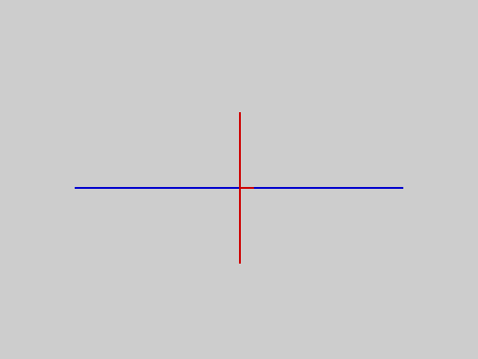
A blue line, red for eight pixels where a red line crosses it
CLS clears the screen to the current colours and puts the printing position at the top left; BORDER sets the border.
Graphics coordinates. The pixel screen is 256 across (0 to 255, from the left) by 192 down (0 to 191, from the top). Off-screen coordinates are moved to the edge.
Character cells and sprites. AT row, col addresses cells (row 0 to 22 for text); the sprite package uses cells too.
Other modes. The TS2068 has an extended-colour video mode (the mode package's MODE 1), in which each row of eight pixels has its own colours and the colour clash above disappears vertically, and the ULAplus palette; see Part 5.
See also PRINT, AT, TAB, CLS, INK, PAPER, PLOT, LINE, POINT, ATTR, BORDER.

Sessions
When a program stops -- at its end, at END or STOP, on BREAK or on an error -- its variables are kept. That kept set is the session. It lets you ask the program questions and change things, using immediate statements: statements typed on the editor's empty last line after a colon.
x = 5
y$ = "hi"
RUN
: PRINT x
5
: PRINT y$ + "!"
hi!
: x = x + 2
: PRINT x
7
An immediate statement may use every variable, array, procedure and function of the program. It may create new variables (they start at 0 or ""), DIM new arrays and call the program's procedures:
g = 1
END
PROC add(n):
g = g + n
ENDP
RUN
: CALL add(4)
: PRINT g
5
: z = 40
: PRINT z + g
45
: GOTO label starts the program at that label with the variables as they are (it does not continue where the program stopped: loops and procedure calls that were in progress are gone).
n = 0
top:
n = n + 1
PRINT n
IF n < 3 THEN GOTO top
END
more:
PRINT n * 10
RUN
1
2
3
: GOTO more
30
: GOTO top
4
: PRINT n
4
What starts and ends a session:
Event | Ordinary variables | Array Store
RUN | start fresh (0 and "") | kept
the program ends, STOP, BREAK, an error | kept: they are the session | kept
an immediate statement | runs in the session | kept
CLEAR (or : CLEAR) | set to 0 and "" | kept
any edit of the program | the session ends | kept
NEW | session ends, program cleared | emptied
LOAD "name" of a program | session ends | kept
LOAD ... ARRAY | session ends | changed
LOAD ... EXT (a package) | session ends | kept
LOAD of a SAVE ... ALL tape | the saved session becomes the current one | replaced by the saved one

x = 5
RUN
: PRINT x
5
EDIT
: PRINT x
0
(EDIT stands for "change the program in any way": the variables are gone.)
Things an immediate statement cannot do: define a label, a procedure or a function (a compile error -- they would vanish with the statement). A compile error in an immediate statement leaves the session unchanged. About ten short new names fit in a session; beyond that the statement is refused with OUT OF MEMORY.
If there has been no RUN since the last edit, the first immediate statement compiles the stored program and starts a fresh session for it: : x = 3 and then : PRINT x shows 3 even before any RUN.
PRINT "hello"
: x = 3
: PRINT x
3
NEW
: PRINT x
0
See also RUN, CLEAR, GOTO, SAVE (ALL), Tapes.

Sound
There are two ways to make sound.
`BEEP` uses the loudspeaker. It gives a single tone and the program waits until it finishes. Both numbers are raw (this is not the Sinclair BEEP; see the keyword BEEP for a procedure that gives it): the first is the number of cycles, the second the delay in each half-cycle. The frequency is about 3 528 000 / (52 x pitch + 222) hertz. A short tune:
DEF FN pitch(f) = DIV(3528000 / f - 222, 52)
DIM p(5)
p(0) = FN pitch(262)
p(1) = FN pitch(294)
p(2) = FN pitch(330)
p(3) = FN pitch(349)
p(4) = FN pitch(392)
FOR i = 0 TO 4
BEEP 120, p(i)
NEXT i
PRINT p(0)
PRINT p(4)
254
168
(The program works out the pitch value for each note's frequency from the formula above, plays the five notes of a C major scale's start -- C, D, E, F, G -- about half a second each, and prints the first and last pitch values.)
`SOUND` writes to the AY-3-8912 sound chip, which has three tone channels and a noise generator that keep playing on their own:
SOUND 7, 62
SOUND 1, 1
SOUND 8, 10
PAUSE 50
SOUND 8, 0
PRINT "done"
done
See also BEEP, SOUND, PAUSE.

Speed
V2 compiles the program before it runs it, so it is much faster than an interpreter that reads the text again every time. Here is what things cost on the release, measured in the emulator by tools/qual/manual_measure.py (T-states of the Z80, which runs at about 3.5 MHz, so a million T-states is about 0.29 seconds). Each figure is what one extra statement adds to a loop; the loop's own FOR/NEXT pass costs 1107 T-states, about 3000 passes a second.
Statement in the loop | Adds (T-states) | About, per second
a = i | 1 240 | 2 800
a = i * 2 + 1 (whole numbers) | 4 600 | 760
a = a * 1.0001 (floating point) | 55 200 | 63
t(3) = i : x = t(3) (array store and load) | 4 500 | 780
a$ = LEFT$(a$ + "x", 20) | 9 300 | 380
PLOT 100, 100 | 2 800 | 1 250
CALL p(1) (an empty procedure) | 3 800 | 920
AT 5, 0 : PRINT 7; | 5 800 | 600
PRINT 7 when the screen scrolls | 250 000 | 14

Things to take from the table:
- Whole-number arithmetic is much faster than floating point -- about twelve times here. Use whole numbers for counters, indices and scaled values (work in hundredths instead of fractions of a unit).
- Scrolling is expensive: moving the whole screen up one line costs about 245 000 T-states, 70 milliseconds. A program that prints line after line to a full screen is limited to about 14 lines a second; one that prints at fixed positions with AT is not.
- PAUSE n takes n x 69 700 T-states, and BEEP 52 x pitch + 222 per cycle.
- Compilation itself takes a moment for a long program; RUN then starts.

Strings
A string is a piece of text of 0 to 31 characters. String variables end in $. String constants are written in double quotes and may not themselves contain a double quote.
- + joins strings. A result longer than 31 characters is cut to 31: no error.
- All six comparisons work on strings (= <> < > <= >=), character by character, using the character codes; capital letters come before small ones ("B" < "a"), and a string that is the start of another comes first ("ab" < "abc").
- The functions: LEN, CODE, VAL, CHR$, STR$, UPPER$, LOWER$, LEFT$, RIGHT$, MID$. A string constant longer than 31 characters is a compile error.
- A string and a number cannot be mixed in an expression: "a" + 1 is a compile error; use STR$.
- There is no a$(2 TO 4) slicing: use MID$.
a$ = "HELLO WORLD"
PRINT LEFT$(a$, 5)
PRINT RIGHT$(a$, 5)
PRINT MID$(a$, 7, 3)
PRINT LOWER$(a$)
PRINT "abc" < "abd"
PRINT "B" < "a"
PRINT "ab" < "abc"
b$ = a$ + " AND " + a$ + " AND " + a$
PRINT LEN(b$)
PRINT b$
HELLO
WORLD
WOR
hello world
1
1
1
31
HELLO WORLD AND HELLO WORLD AND
See also the string functions in Part 3, Arrays for string arrays.

Tapes
SAVE, LOAD and VERIFY are commands, typed on the editor's empty last line. The name is up to 10 characters.
Command | Does
SAVE "name" | writes the program
SAVE "name" ALL | writes the program and its session (variables, arrays) and the Array Store
SAVE "name" ARRAY a | writes one array
SAVE "name" EXT | writes the loaded package
LOAD "name" | reads a program (and the session, if it was saved with ALL)
LOAD "" | reads the next program on the tape, whatever its name
LOAD "name" ARRAY a | reads an array into the Array Store
LOAD "name" EXT | reads a package
VERIFY "name" | compares the tape with memory

A program saved with SAVE "name" comes back without variables; one saved with ALL comes back with them, so you can stop work and carry on:
x = 5
y$ = "hello"
z = 2.5
RUN
: x = x + 1
SAVE "demo" ALL [SAVED]
power on
LOAD "demo" [LOADED]
: PRINT x
6
: PRINT y$
hello
: PRINT z
2.5000
PRINT "hello"
x = 7
RUN
hello
SAVE "prog" [SAVED]
power on
LOAD "prog" [LOADED]
: PRINT x
0
VERIFY checks that what is on tape matches what is in memory:
PRINT "hello"
x = 7
SAVE "prog" [SAVED]
power on
store: PRINT "hello" ;; x = 7
VERIFY "prog" [VERIFIED]
PRINT "hello"
x = 7
SAVE "prog" [SAVED]
power on
store: PRINT "hello" ;; x = 8
VERIFY "prog" [VERIFY FAILED]
The `ALL` tape. SAVE ... ALL, LOAD and VERIFY of an ALL tape take about 2.4 seconds to start (the machine first works out a check number that identifies this ROM and the loaded package). The variables of an ALL tape come back only
- on the same ROM version that wrote it, and
- with the same package loaded (or none), loaded before the ALL tape.
Otherwise the program loads but the variables do not, and the message is NO VARIABLES. A damaged tape gives LOAD FAILED. If a very large program plus its overflow arrays cannot be laid out for saving, SAVE ... ALL says OUT OF MEMORY -- SAVE "name" still works.
Tape compatibility. A tape written by this version cannot be loaded by earlier V2 ROMs, and V1 and stock Spectrum tapes are refused with BAD TAPE VERSION.
Messages: SAVED, LOADED, VERIFIED, VERIFY FAILED, LOAD FAILED, NO VARIABLES, BAD TAPE VERSION, ABORTED (SPACE pressed during a tape operation), NO PACKAGE (SAVE ... EXT with no package loaded), OUT OF MEMORY, and the array messages under Array Store.
Tapes are read and written through the ordinary tape port. All tape tests were run on the emulator, through its real tape input; nothing was tried on a real cassette recorder.

The editor
When the machine is switched on you are in the editor: an empty program, with a status line at the bottom (row 23) that says LINE n/m -- the cursor is on line n, and the program has m lines -- and three small coloured squares at its right end.
The program is a list of lines. You type a line and press ENTER to store it. Keywords such as PRINT and FOR are shown in bold as soon as they are recognised.
Key | What it does
letters, digits, symbols | insert at the cursor
ENTER | store the line (as it now reads) and go to the next one
CAPS SHIFT + 5 (left arrow) | cursor left
CAPS SHIFT + 8 (right arrow) | cursor right
CAPS SHIFT + 6 (down) | the next line
CAPS SHIFT + 7 (up) | the previous line
CAPS SHIFT + 0 (DELETE) | delete the character before the cursor
CAPS SHIFT + 1 | delete the whole line
CAPS SHIFT + ENTER | insert a blank line
CAPS SHIFT + SPACE (BREAK) | stops a running program (ignored in the editor)

Moving up or down puts the cursor at the start of the line it arrives on. You cannot move below the empty line after the last program line -- the last line -- and you cannot go above line 1.
The commands RUN, LIST, NEW, SAVE, LOAD, VERIFY, and the immediate statements (: statement) are typed on that empty last line. Typed on any other line they would simply be stored as program lines.
Here three lines are typed. Pressing up moves to the previous line, and a letter is inserted there; the status line shows where the cursor is:
PRINT "one"
PRINT "two"
PRINT "three"
{UP}{UP}{RIGHT}{RIGHT}{RIGHT}{RIGHT}{RIGHT}{RIGHT}{RIGHT}{RIGHT}X\
PRINT "one"
PRINT "tXwo"
PRINT "three"
...
LINE 2/3
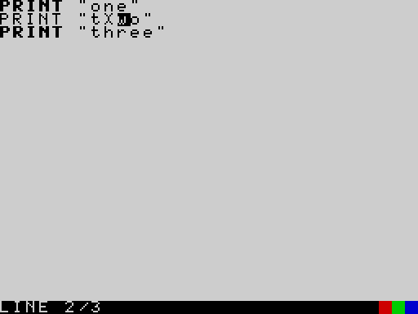
The editor with a character inserted in the second line
Deleting characters and lines, and inserting a blank line:
PRINT "one"
PRINT "two"
PRINT "three"
{UP}{DELLINE}
PRINT "one"
PRINT "two"
...
LINE 3/2
(Deleting the line the cursor was on leaves the cursor on the empty last line.)
ABC{LEFT}{LEFT}{DEL}\
BC
...
LINE 1/0
When RUN finds a compile error, the message appears on the status line. Press a key, and the cursor is on the line with the mistake:
PRINT 1
PRINT 2 +
PRINT 3
RUN
PRINT 1
PRINT 2 +
PRINT 3
RUN
...
SYNTAX ERROR
Any change to the program -- storing a line, deleting a line, LOAD, NEW -- ends the variable session (see Sessions).
LIST shows the program from its first line, 23 lines at a time: when the screen fills, it waits for a key before showing the next page; BREAK at a full page stops the listing. At the end it waits for a key and returns to the editor.

Truth and comparisons
The comparisons =, <>, <, >, <=, >= give 1 when they are true and 0 when they are false, for numbers and for strings. Wherever a condition is needed (IF, AND, OR, NOT), any number other than 0 counts as true -- including fractions and negative numbers -- and 0 as false. AND, OR and NOT give 1 or 0.
PRINT 5 > 3
PRINT 5 < 3
PRINT 3 <= 3
PRINT 3 <> 3
IF 2.5 THEN
PRINT "2.5 is true"
ENDIF
IF 0 THEN
PRINT "never"
ELSE
PRINT "0 is false"
ENDIF
1
0
1
0
2.5 is true
0 is false
AND and OR short-circuit: the right-hand side is not worked out if the left-hand side has already decided the answer. That makes a guard like y <> 0 AND 10 / y > 1 safe. See AND and OR.

User-defined characters
V2 has 21 user-defined characters (UDGs), as the Spectrum does: character codes 144 to 164. Each is an 8 x 8 picture that you design yourself and then print like any letter with PRINT CHR$(144). The pictures live in a table of 168 bytes (8 bytes for each of the 21 characters) at address 61824 ($F180); there is no statement to define one: you `POKE` the eight bytes.
- The picture. Each of the eight bytes is one row of the character, from the top row down. A byte is eight pixels: the bit values 128, 64, 32, 16, 8, 4, 2, 1 are the pixels from left to right, so a row ..####.. is 16 + 8 + 4 + 2 = 60. (The # pixels are ink, the . pixels paper.)
- The address. Character code c (144 to 164) has its eight bytes at 61824 + (c - 144) * 8. Character 144 is at 61824 to 61831, 145 at 61832 to 61839, and so on up to 164 at 61992 to 61999. (On the Spectrum the letters A to U name the same 21 characters; here you use their codes, and USR "a" does not exist.)
- Printing. PRINT CHR$(144) prints character 144 in the current colours at the printing position, exactly like a letter: it follows INK, PAPER, BRIGHT, FLASH, OVER and INVERSE. It may be put in a string (a$ = CHR$(144) + CHR$(145)), and strings of it can be joined, measured and compared like any other. There is no way to type a user-defined character on the keyboard into a program, so always write it as CHR$(code).
The easiest way to design a character is to draw it with # and ., and let the program work out the bytes. Here a smiling face is drawn as eight strings, and a loop turns each one into a number and pokes it:
DIM g$(8, 9)
g$(0) = "..####.."
g$(1) = ".#....#."
g$(2) = "#.#..#.#"
g$(3) = "#......#"
g$(4) = "#.#..#.#"
g$(5) = "#..##..#"
g$(6) = ".#....#."
g$(7) = "..####.."
FOR r = 0 TO 7
v = 0
FOR c = 1 TO 8
v = v * 2
IF MID$(g$(r), c, 1) = "#" THEN
v = v + 1
ENDIF
NEXT c
POKE 61824 + r, v
NEXT r
INK 2
PAPER 6
CLS
AT 0, 0
PRINT PEEK(61824); " "; PEEK(61826)
AT 5, 8
FOR i = 1 TO 12
PRINT CHR$(144);
NEXT i
60 165
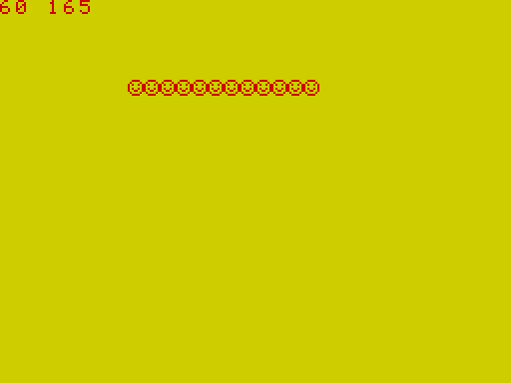
A smiling face printed twelve times as character 144
(Row 0, ..####.., is 60; row 2, #.#..#.#, is 165. The face is character 144, printed twelve times in red on yellow.)
A character can be redefined at any time, and each of the 21 can be different. This program makes two characters, a solid square (144) and a diamond (145), by poking the byte values directly, and prints a pattern with them:
FOR r = 0 TO 7
POKE 61824 + r, 255
NEXT r
POKE 61832, 24
POKE 61833, 60
POKE 61834, 126
POKE 61835, 255
POKE 61836, 255
POKE 61837, 126
POKE 61838, 60
POKE 61839, 24
INK 1
CLS
FOR row = 3 TO 18
FOR col = 4 TO 27
AT row, col
IF MOD(row + col, 2) = 0 THEN
PRINT CHR$(144);
ELSE
PRINT CHR$(145);
ENDIF
NEXT col
NEXT row
AT 0, 0
INK 0
PRINT PEEK(61832)
24
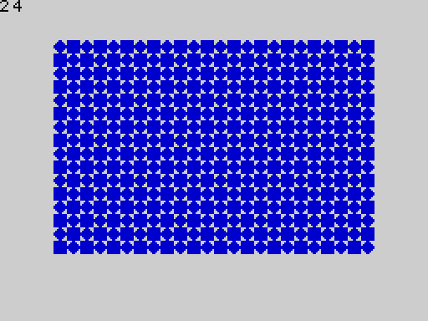
A chess-board pattern of squares and diamonds

Using them
Defining a character is only half of the job; here is what they are good for, with a program for each.
1. A reusable way to define them. Designing in # and . is so much easier than working out numbers that it is worth turning into a procedure once. This PROC defines character c from eight strings kept in the array g$ (rows 0 to 7). Put it at the end of any program that uses UDGs:
PROC defchar(c):
FOR r = 0 TO 7
v = 0
FOR k = 1 TO 8
v = v * 2
IF MID$(g$(r), k, 1) = "#" THEN
v = v + 1
ENDIF
NEXT k
POKE 61824 + (c - 144) * 8 + r, v
NEXT r
ENDP
2. Pictures bigger than one character. One character is only 8 x 8 dots. A bigger picture is several characters side by side, printed in the right places. This program draws a 16 x 16 rocket from four characters (144 and 145 on the top row, 146 and 147 below), cutting the picture into four quarters:
DIM p$(16, 17)
DIM g$(8, 9)
p$(0) = ".......##......."
p$(1) = "......####......"
p$(2) = "......####......"
p$(3) = ".....######....."
p$(4) = ".....######....."
p$(5) = ".....##..##....."
p$(6) = ".....##..##....."
p$(7) = ".....######....."
p$(8) = ".....######....."
p$(9) = "....########...."
p$(10) = "...##########..."
p$(11) = "..####.##.####.."
p$(12) = "..###..##..###.."
p$(13) = "..##...##...##.."
p$(14) = ".......##......."
p$(15) = "......#..#......"
FOR q = 0 TO 3
FOR r = 0 TO 7
g$(r) = MID$(p$(DIV(q, 2) * 8 + r), MOD(q, 2) * 8 + 1, 8)
NEXT r
CALL defchar(144 + q)
NEXT q
INK 2
CLS
AT 8, 15
PRINT CHR$(144); CHR$(145)
AT 9, 15
PRINT CHR$(146); CHR$(147)
AT 0, 0
INK 0
PRINT "rocket"
END
PROC defchar(c):
FOR r = 0 TO 7
v = 0
FOR k = 1 TO 8
v = v * 2
IF MID$(g$(r), k, 1) = "#" THEN
v = v + 1
ENDIF
NEXT k
POKE 61824 + (c - 144) * 8 + r, v
NEXT r
ENDP
rocket
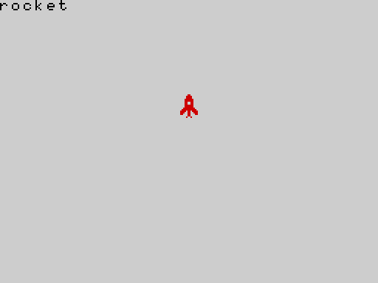
A 16 by 16 rocket made of four user-defined characters
(The four characters must touch, so they are printed with AT on two neighbouring rows, with a semicolon at the end of the first so the cursor does not move to the next line before the second AT.)
3. Moving pictures. Redefine a character, or switch between two, and the picture on the screen changes. Here two characters are two poses of a figure (148 and 149), and the program shows one pose after the other while it moves the figure across the screen. With OVER 1 in force, printing a character draws it, and printing the same character again in the same place erases it, so each pose is drawn, held for a moment with PAUSE, and erased before the next one appears a column further on:
DIM g$(8, 9)
g$(0) = "...##..."
g$(1) = "...##..."
g$(2) = "..####.."
g$(3) = ".#.##.#."
g$(4) = "...##..."
g$(5) = "..#..#.."
g$(6) = ".#....#."
g$(7) = "#......#"
CALL defchar(148)
g$(0) = "...##..."
g$(1) = "...##..."
g$(2) = "..####.."
g$(3) = "..#.##.."
g$(4) = "...##..."
g$(5) = "...##..."
g$(6) = "...##..."
g$(7) = "..#..#.."
CALL defchar(149)
INK 1
CLS
x = 0
FOR n = 1 TO 20
pose = 148 + MOD(n, 2)
AT 10, x
OVER 1
PRINT CHR$(pose);
PAUSE 3
AT 10, x
PRINT CHR$(pose);
OVER 0
x = x + 1
NEXT n
AT 10, x
PRINT CHR$(148);
AT 0, 0
PRINT x
END
PROC defchar(c):
FOR r = 0 TO 7
v = 0
FOR k = 1 TO 8
v = v * 2
IF MID$(g$(r), k, 1) = "#" THEN
v = v + 1
ENDIF
NEXT k
POKE 61824 + (c - 144) * 8 + r, v
NEXT r
ENDP
20
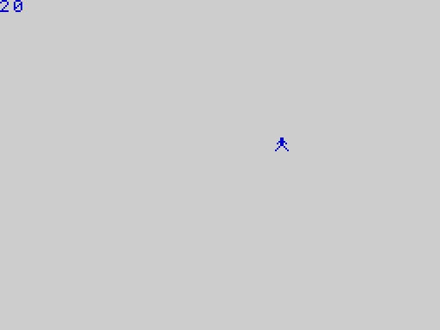
The figure at the end of its walk
4. Characters in strings. A user-defined character is a character like any other, so a string can hold a whole row of them. This builds a status line of lives -- one heart character for each life left -- and a bar of the same character to show a level:
DIM g$(8, 9)
g$(0) = ".##..##."
g$(1) = "########"
g$(2) = "########"
g$(3) = "########"
g$(4) = ".######."
g$(5) = "..####.."
g$(6) = "...##..."
g$(7) = "........"
CALL defchar(150)
heart$ = CHR$(150)
lives$ = ""
FOR i = 1 TO 5
lives$ = lives$ + heart$
NEXT i
INK 2
CLS
AT 5, 2
PRINT lives$
INK 0
AT 0, 0
PRINT LEN(lives$)
PRINT CODE(lives$)
END
PROC defchar(c):
FOR r = 0 TO 7
v = 0
FOR k = 1 TO 8
v = v * 2
IF MID$(g$(r), k, 1) = "#" THEN
v = v + 1
ENDIF
NEXT k
POKE 61824 + (c - 144) * 8 + r, v
NEXT r
ENDP
5
150
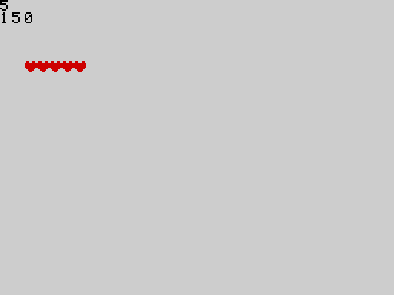
Five red hearts made from one user-defined character
(LEN counts five characters and CODE gives 150, the code of the heart.)
What they survive. The table is ordinary memory that nothing in V2 clears, so a user-defined character stays defined when you RUN again, CLEAR, CLS, NEW, change the video mode (the MODE statement) or LOAD another program; it is not saved on tape (not even by SAVE ... ALL), and it is lost when the machine is switched off. The table is not set to zero when the machine starts (on the emulator it is; on real hardware the memory may hold anything), so a program should define every character it uses, at its start. An undefined character prints as a blank.
FOR r = 0 TO 7
POKE 61824 + r, 255
NEXT r
PRINT "defined"
store: CLS ;; AT 5, 0 ;; PRINT CHR$(144); ;; AT 0, 0 ;; PRINT POINT(0, 40); POINT(7, 47)
SAVE "show" [SAVED]
power on
store: FOR r = 0 TO 7 ;; POKE 61824 + r, 255 ;; NEXT r
RUN
LOAD "show" [LOADED]
RUN
11
...
(The first program defines character 144 as a solid square. Then another program is loaded from tape with LOAD and run: the square is still defined, so it prints, and both corner pixels are set.)
Differences from stock TS2068 and Sinclair BASIC.
 | Sinclair / stock TS2068 BASIC | 2068-Leap V2
number of user characters | 21 (A to U in graphics mode) | 21, codes 144 to 164
defining one | POKE USR "a" + n, value | POKE 61824 + (code - 144) * 8 + n, value
typing one | graphics mode (G) and a letter key | not possible: use CHR$(code)
USR "a" | address of the character | not available: USR takes only a number
contents when switched on | the machine's own copy of the letters A to U | not set: define what you use
redefining the ordinary letters | by changing CHARS | not possible: the letters (codes 32 to 127) are in the ROM
the 16 block graphics (128 to 143) | typed in graphics mode | printed with CHR$(128) to CHR$(143); they cannot be redefined

See also CHR$, POKE, PEEK, Appendix C, Screen.

Part 5 -- Packages
The V2 language that is built into the ROM is complete for programs, text, arrays, sound and simple graphics. Everything more specialised lives in packages: small programs on tape that add statements to the language. There are five:
Package | Tape name | Size | Statements it adds
mode | MODE | 165 bytes | MODE, ULAPLUS, PALETTE
sprite | SPRITE | 834 bytes | GRAB, SHOW, HIDE, MOVE
printer | PRINTER | 345 bytes | LPRINT, LLIST
shapes | SHAPES | 1007 bytes | CIRCLE, FILL
graphics | GRAPHICS | 467 bytes | CPLOT, BLOCK, FRAME, INVERT

Loading a package
Type, on the editor's empty last line,
LOAD "SHAPES" EXT
and start the tape. The status line shows LOADED, and the new statements can be used from then on. Every example in this part (and every package example in Part 3) is run on the release ROM exactly like this: the package tape is played into the real tape loader, LOAD ... EXT is typed, and only then is the program run.
x = 1
package SHAPES
power on
LOAD "SHAPES" EXT [LOADED]
store: CIRCLE 128, 96, 40 ;; PRINT "drawn"
RUN
drawn
...
The rules:
- One package at a time. A package occupies a 1 KB window of memory. Loading another package replaces the first: its statements stop working.
- `NEW` unloads the package (and so does switching the machine off).
- Loading a package ends the current variable session (see Sessions).
- A statement of a package that is not loaded is a compile error: RUN shows SYNTAX ERROR, the cursor goes to the line when you press a key, and nothing runs. (LPRINT without its package is the same.)
- SAVE "name" EXT writes the package currently loaded back to tape; with none loaded it shows NO PACKAGE.
- A SAVE ... ALL tape remembers which package was loaded when it was written. Load the same package, before loading the ALL tape, or the variables will not come back (NO VARIABLES). See Tapes.
Loading two packages in turn leaves only the second:
x = 1
package SHAPES
package GRAPHICS
power on
LOAD "SHAPES" EXT [LOADED]
LOAD "GRAPHICS" EXT [LOADED]
store: BLOCK 10, 40, 60, 70 ;; PRINT "block"
RUN
block
...
store: CIRCLE 128, 96, 40
RUN [SYNTAX ERROR]
(The last RUN fails to compile: CIRCLE belongs to the shapes package, which the graphics package replaced. The status line then shows SYNTAX ERROR.)
x = 1
package SHAPES
power on
LOAD "SHAPES" EXT [LOADED]
SAVE "copy" EXT [SAVED]
NEW
SAVE "again" EXT [NO PACKAGE]

Arguments
All package statements take numbers; LPRINT also takes a string. The arguments are whole numbers: a fraction is cut off. Only the low eight bits of each argument are used by the statements that take screen positions, so 256 acts as 0 and 300 as 44 -- keep your coordinates inside the ranges given below.

Errors
A package statement that is given a bad argument stops the program with RUNTIME ERROR. The internal code differs by package:
Package | Code | Cause
mode | 12 | MODE not 0 or 1
mode | 13 | ULAPLUS not 0 or 1
mode | 14 | PALETTE index 64 or more
sprite | 15 | slot 8 or more
sprite | 16 | row 24 or more, column 32 or more, or a width or height that is 0 or more than 4
sprite | 17 | SHOW of a slot that was never grabbed
sprite | 18 | SHOW or GRAB of a sprite that is already shown
sprite | 19 | HIDE or MOVE of a sprite that is not shown
sprite | 20 | the sprite would not fit on the screen

Argument mistakes are found when the statement runs, not when the program is compiled: RUN starts, and the program stops when it reaches the bad statement.

The mode package
LOAD "MODE" EXT adds three statements for the TS2068's video hardware.

MODE
MODE 0 selects the normal screen. MODE 1 selects the TS2068's extended-colour mode (the Timex calls it "multicolor" mode; this ROM's source code calls it "High Resolution Graphics", which is not what it is): the display hardware's port $FF is set to the value 2 (bits 0 to 2 = 010). The picture (the 256 x 192 pixels) is unchanged, but the colour attributes now come from a second area at address 24576 ($6000, 6144 bytes) with one attribute byte for every eight pixels across on every scan line, instead of one byte for each 8 x 8 cell at 22528. So, in this mode, the colour of a line of eight pixels can be chosen independently of the lines above and below it: the "colour clash" of the ordinary screen (see Screen) goes away in the vertical direction. Any other value for MODE is a run-time error. Switching to mode 1 first sets the second area to the default colours; switching back to mode 0 shows the ordinary attributes again.
The ROM's own drawing statements know about the mode: with mode 1 selected, PLOT, LINE and printed text set the attribute of the 8 x 1 strip they touch (not the 8 x 8 cell), so each of the eight lines below has its own colour even though they share a cell:
With the mode package loaded (LOAD "MODE" EXT):
MODE 1
PAUSE 25
MODE 0
PRINT "back to normal"
back to normal
With the mode package loaded (LOAD "MODE" EXT):
MODE 1
PAPER 7
CLS
FOR i = 0 TO 7
INK i
LINE 40, 40 + i TO 215, 40 + i
NEXT i
INK 0
PRINT "eight colours, one row"
eight colours, one row
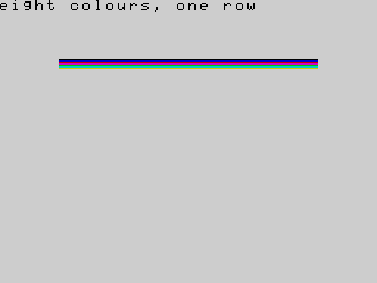
Eight lines, each a different colour, in a single row of character cells (extended-colour mode)
In the ordinary mode the same eight lines would all take the colour of the last one drawn, because they share the same row of 8 x 8 cells. (Only the display changed: ATTR still reads the ordinary 8 x 8 attribute area.)
What V2's `MODE` does not offer. The TS2068 has a third video mode, 512 x 192 two-colour "extended resolution" (also called 64-column mode): port $FF value 6 (bits 110; the ink and paper then come from bits 3 to 5 of the same port). V2 does not select it: MODE 2 is a run-time error (an earlier 64-column mode was removed from the ROM for space). Port $FF can still be written directly with OUT 255, value, but the system keeps a copy of the port ($FF also selects the EXROM bank) and the ROM's drawing routines do not know that mode, so this is not recommended.
(The mode bits are as documented for the TS2068's SCLD video chip: 000 ordinary, 001 second display file, 010 multicolor, 110 extended resolution. These were checked against published port maps and against what the release does -- port $FF bits 0 to 2 become 2 and PLOT colours a single 8 x 1 strip -- but not on a real machine.)
MODE 2

ULAPLUS and PALETTE
ULAplus is a hardware extension that gives 64 programmable colours. ULAPLUS 1 turns it on and ULAPLUS 0 off; PALETTE index, value writes value (0 to 255) to palette entry index (0 to 63). The statements only write to the ULAplus ports; on a machine without ULAplus they have no visible effect. They have not been tried on real ULAplus hardware.
With the mode package loaded (LOAD "MODE" EXT):
ULAPLUS 1
PALETTE 0, 255
ULAPLUS 0
PRINT "palette set"
palette set
PALETTE 64, 0

The sprite package
LOAD "SPRITE" EXT adds four statements for moving pictures around the screen without disturbing the background. A sprite here is a rectangle of 1 to 4 by 1 to 4 character cells (8 x 8 pixels each), grabbed from the screen -- pixels and colours both -- into one of 8 slots (numbered 0 to 7). Positions are in character cells: row 0 to 23, column 0 to 31.
Statement | Does
GRAB slot, row, col, width, height | copies that part of the screen into the slot
SHOW slot, row, col | draws the slot's picture at that position, keeping what was under it
MOVE slot, row, col | puts the screen back where the sprite was, and draws it at the new position
HIDE slot | puts the screen back where the sprite was

A slot can be shown once at a time, and a shown slot cannot be grabbed again until it is hidden. Switching the video mode (MODE) forgets which sprites are shown.
Here is a complete small animation: a diamond grabbed from the top left and moved in a rectangle around a background of hash signs, leaving the background undamaged. The picture shows the diamond in its last position.
With the sprite package loaded (LOAD "SPRITE" EXT):
INK 2
PAPER 6
LINE 23, 16 TO 31, 24
LINE 31, 24 TO 23, 31
LINE 23, 31 TO 16, 24
LINE 16, 24 TO 23, 16
LINE 16, 24 TO 31, 24
GRAB 0, 2, 2, 2, 2
INK 0
PAPER 5
CLS
FOR r = 0 TO 22
AT r, 0
PRINT "###############################";
NEXT r
SHOW 0, 2, 2
FOR c = 3 TO 28
MOVE 0, 2, c
NEXT c
FOR r = 3 TO 20
MOVE 0, r, 28
NEXT r
FOR c = 27 TO 2 STEP -1
MOVE 0, 20, c
NEXT c

A sprite at the bottom left after travelling round three sides of the screen
Errors are listed above. In particular MOVE and HIDE of a sprite that is not shown stop the program:
With the sprite package loaded (LOAD "SPRITE" EXT):
PLOT 4, 4
GRAB 0, 0, 0, 1, 1
HIDE 0
With the sprite package loaded (LOAD "SPRITE" EXT):
PLOT 4, 4
GRAB 0, 0, 0, 1, 1
SHOW 0, 5, 5
SHOW 0, 6, 6

The printer package
LOAD "PRINTER" EXT adds two statements for the ZX Printer (or a compatible printer on the same port).
- LPRINT item prints one number or string, wrapped at 32 characters. A number is printed as a whole number (a fraction is cut off, and values beyond the whole-number range are not reliable): to print a fraction or a big number, print STR$(x).
- LLIST prints the program, one program line per printed line.
The printer is not emulated by the qualification emulator, so these statements are run but the printed paper has not been checked, and nothing here was tried with a real printer. As on the original machine, printing without a printer attached makes the program wait.
With the printer package loaded (LOAD "PRINTER" EXT):
LPRINT "hello"
LPRINT 42
LPRINT STR$(2.5)
PRINT "sent"
sent
Without the package, LPRINT and LLIST do not compile:
LPRINT "hello"

The shapes package
LOAD "SHAPES" EXT adds CIRCLE x, y, radius and FILL x, y.
- CIRCLE draws the outline of a circle centred on pixel x, y in the current ink. x is 0 to 255 and y 0 to 191 from the top. The radius is in pixels; a circle that runs off the edge is clipped at it. A radius of 0 plots the centre point.
- FILL floods the closed area containing pixel x, y with the current ink, up to the outline. A gap in the outline lets the colour out into the rest of the screen.
Both draw in the current INK, PAPER (the colour of the cell the drawing touches), BRIGHT, FLASH and OVER.
With the shapes package loaded (LOAD "SHAPES" EXT):
FOR r = 10 TO 90 STEP 10
INK MOD(r / 10, 7) + 1
CIRCLE 128, 96, r
NEXT r
INK 2
FILL 128, 96
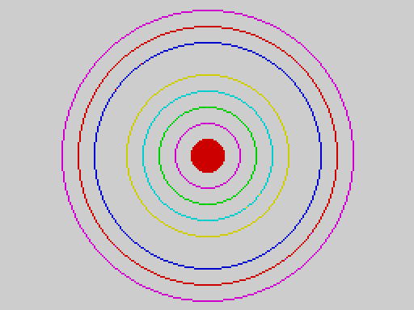
Concentric circles, the innermost filled
With the shapes package loaded (LOAD "SHAPES" EXT):
CIRCLE 128, 96, 40
PRINT POINT(168, 96)
PRINT POINT(128, 96)
1
0
(The point 40 pixels right of the centre is on the circle; the centre itself is not.)

The graphics package
LOAD "GRAPHICS" EXT adds four statements.
Statement | Draws
CPLOT x, y | a 4 x 4-pixel block on a coarse 64 x 48 grid (x 0 to 63, y 0 to 47)
BLOCK x0, y0, x1, y1 | a filled rectangle between two corners
FRAME x0, y0, x1, y1 | the outline of that rectangle
INVERT x0, y0, x1, y1 | the rectangle, with every pixel flipped (set becomes clear and clear becomes set)

The corners of BLOCK, FRAME and INVERT may be given in either order. The pixel coordinates are as for PLOT. All four use the current ink and paper (and BRIGHT and FLASH); INVERT always exclusive-ORs, whatever OVER is.
A bar chart with BLOCK and FRAME:
With the graphics package loaded (LOAD "GRAPHICS" EXT):
DIM h(6)
h(0) = 40
h(1) = 90
h(2) = 65
h(3) = 120
h(4) = 80
h(5) = 30
FOR i = 0 TO 5
INK i + 1
BLOCK 20 + i * 38, 167 - h(i), 48 + i * 38, 167
NEXT i
INK 0
FRAME 10, 20, 245, 175
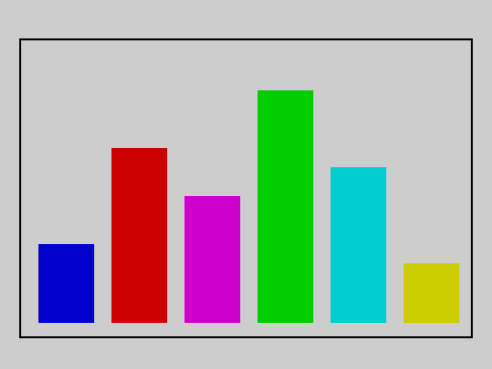
A bar chart of six coloured bars in a frame
INVERT twice gives back the original, which is how a cursor or a highlight bar is moved over a picture without redrawing it:
With the graphics package loaded (LOAD "GRAPHICS" EXT):
BLOCK 40, 40, 80, 60
a = POINT(60, 50)
INVERT 40, 40, 80, 60
b = POINT(60, 50)
INVERT 40, 40, 80, 60
c = POINT(60, 50)
PRINT a
PRINT b
PRINT c
1
0
1

Part 6 -- Practical examples
Complete programs, each of which does something useful or amusing and each of which has been run on the release (the output shown is exactly what appeared on the screen). Type one in, RUN it, then change it: that is the best way to learn.
For the programs that read the keyboard, the keys that were typed are shown in the heading of each example.

1. A multiplication table
Two nested loops, and ; to keep the numbers on a row. TAB lines the columns up.
FOR row = 1 TO 5
FOR col = 1 TO 5
TAB (col - 1) * 4
PRINT row * col;
NEXT col
PRINT
NEXT row
1 2 3 4 5
2 4 6 8 10
3 6 9 12 15
4 8 12 16 20
5 10 15 20 25
(TAB is a statement, so each number is placed by its own TAB. The PRINT by itself ends the row.)

2. Prime numbers
The sieve of Eratosthenes with an array: cross out the multiples of each number, and what is left is prime.
DIM crossed(30)
FOR n = 2 TO 29
IF crossed(n) = 0 THEN
PRINT n;
PRINT " ";
FOR m = n * 2 TO 29 STEP n
crossed(m) = 1
NEXT m
ENDIF
NEXT n
2 3 5 7 11 13 17 19 23 29
(The numbers are printed on one row. A longer row would wrap at the 32nd column.)

3. Fibonacci numbers
Each number is the sum of the two before it. A loop does it with two variables.
a = 0
b = 1
FOR i = 1 TO 12
PRINT a; " ";
t = a + b
a = b
b = t
NEXT i
PRINT
0 1 1 2 3 5 8 13 21 34 55 89
The same sequence by recursion -- elegant, but much slower for big numbers, because it works every number out from scratch:
DIM hold(20)
x = 0
FOR i = 0 TO 11
CALL fib(i)
PRINT x; " ";
NEXT i
PRINT
END
PROC fib(n):
IF n < 2 THEN
x = n
ELSE
CALL fib(n - 1)
hold(n) = x
CALL fib(n - 2)
x = x + hold(n)
ENDIF
ENDP
0 1 1 2 3 5 8 13 21 34 55 89
A procedure cannot return a value, so it leaves its answer in the variable x. The partial result of the first call has to be kept somewhere that the second call cannot overwrite: a plain variable would be shared by every level of the recursion and spoiled by the deeper calls, so the program keeps it in the array element hold(n); each active level has its own n, and so its own element.

4. Sorting
A bubble sort. Passes through the array swap neighbours that are out of order until a pass makes no swap.
DIM d(8)
d(0) = 34
d(1) = 7
d(2) = 23
d(3) = 32
d(4) = 5
d(5) = 62
d(6) = 12
d(7) = 48
swapped = 1
WHILEDONE:
IF swapped = 0 THEN GOTO finished
swapped = 0
FOR i = 0 TO 6
IF d(i) > d(i + 1) THEN
t = d(i)
d(i) = d(i + 1)
d(i + 1) = t
swapped = 1
ENDIF
NEXT i
GOTO WHILEDONE
finished:
FOR i = 0 TO 7
PRINT d(i); " ";
NEXT i
PRINT
5 7 12 23 32 34 48 62
(There is no WHILE: a label and IF ... THEN GOTO make the loop.)
Strings sort the same way, because the comparison operators work on them:
DIM n$(5, 12)
n$(0) = "PEAR"
n$(1) = "APPLE"
n$(2) = "FIG"
n$(3) = "CHERRY"
n$(4) = "BANANA"
FOR i = 0 TO 3
FOR j = 0 TO 3 - i
IF n$(j) > n$(j + 1) THEN
t$ = n$(j)
n$(j) = n$(j + 1)
n$(j + 1) = t$
ENDIF
NEXT j
NEXT i
FOR i = 0 TO 4
PRINT n$(i)
NEXT i
APPLE
BANANA
CHERRY
FIG
PEAR

5. A temperature table
Numbers with fractions print with four decimals, so a table of Fahrenheit values looks like this:
PRINT "C F"
FOR c = 36 TO 40
TAB 0
PRINT c;
TAB 8
PRINT c * 9 / 5 + 32
NEXT c
C F
36 96.8000
37 98.6000
38 100.4000
39 102.2000
40 104
(The last value is exactly 104, a whole number, so it is shown without decimals.)

6. Counting in binary
DIV and MOD take a number to pieces. This program builds a string of binary digits by repeatedly taking the remainder after dividing by 2:
DIM v(4)
v(0) = 5
v(1) = 10
v(2) = 255
v(3) = 1000
FOR k = 0 TO 3
PRINT v(k); " is ";
CALL bin(v(k))
PRINT
NEXT k
END
PROC bin(n):
IF n > 1 THEN
CALL bin(DIV(n, 2))
ENDIF
PRINT MOD(n, 2);
ENDP
5 is 101
10 is 1010
255 is 11111111
1000 is 1111101000
(The procedure prints the digits of the number divided by two first, and then its own last digit: that is what puts the digits in the right order.)

7. A secret code
A Caesar cipher: each capital letter is moved along the alphabet by three places. CODE gives a letter's number and CHR$ turns a number back into a letter; MOD makes the alphabet wrap.
msg$ = "HELLO WORLD"
out$ = ""
FOR i = 1 TO LEN(msg$)
ch$ = MID$(msg$, i, 1)
k = CODE(ch$)
IF k >= 65 AND k <= 90 THEN
k = MOD(k - 65 + 3, 26) + 65
ENDIF
out$ = out$ + CHR$(k)
NEXT i
PRINT msg$
PRINT out$
HELLO WORLD
KHOOR ZRUOG

8. Guess the number
The computer thinks of a number from 1 to 100 and you guess. (RANDOMISE 7 makes the number the same every time so that this page shows the same game; remove that line to play a different game each time -- or give RANDOMISE a number that changes.) The guesses typed here are 50, 25, 5, 3 and 4.
RANDOMISE 7
secret = RND(100) + 1
tries = 0
again:
INPUT "Guess? "; g
tries = tries + 1
IF g < secret THEN
PRINT "Too low"
GOTO again
ENDIF
IF g > secret THEN
PRINT "Too high"
GOTO again
ENDIF
PRINT "Got it in "; tries; " tries"
Guess? 50
Too high
Guess? 25
Too high
Guess? 5
Too high
Guess? 3
Too low
Guess? 4
Got it in 5 tries

9. A menu
INPUT into a string, then decisions on what was typed:
total = 0
menu:
PRINT "1 add ten 2 add one 3 quit"
INPUT c$
IF c$ = "1" THEN
total = total + 10
ENDIF
IF c$ = "2" THEN
total = total + 1
ENDIF
IF c$ = "3" THEN
PRINT "total "; total
END
ENDIF
GOTO menu
1 add ten 2 add one 3 quit
2
1 add ten 2 add one 3 quit
9
1 add ten 2 add one 3 quit
3
total 1

10. Drawing: a spiral
SIN and COS use degrees, so a loop over an angle gives a circle; make the radius grow as the angle does and you get a spiral. Remember that y counts down the screen.
INK 1
FOR a = 0 TO 1080 STEP 4
r = a / 12
x = 128 + INT(r * COS(a))
y = 96 - INT(r * SIN(a) * 0.9)
PLOT x, y
NEXT a
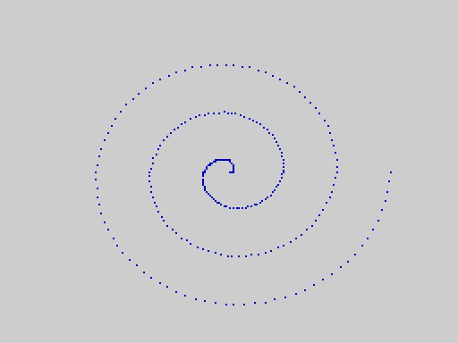
A spiral of single pixels

11. Drawing: lines
Lines from a point on one edge to a moving point on another make a pattern that looks curved:
INK 2
FOR i = 0 TO 255 STEP 8
LINE 0, 0 TO i, 191
NEXT i
INK 1
FOR i = 0 TO 191 STEP 8
LINE 255, 0 TO 0, i
NEXT i
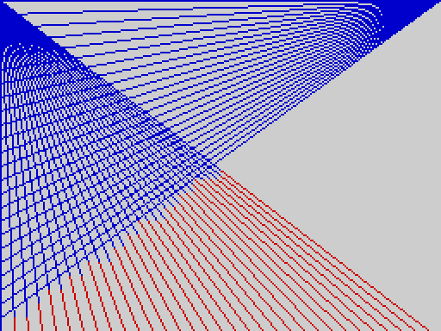
Two fans of straight lines

12. A bouncing ball
OVER 1 draws and erases with the same statement. Plot the ball, pause, plot the same place again to rub it out, move it, and repeat. The picture is the last frame.
OVER 1
x = 20
y = 30
dx = 5
dy = 3
FOR frame = 1 TO 60
CALL ball(0)
PAUSE 1
CALL ball(0)
x = x + dx
y = y + dy
IF x < 5 OR x > 245 THEN
dx = 0 - dx
ENDIF
IF y < 5 OR y > 185 THEN
dy = 0 - dy
ENDIF
NEXT frame
OVER 0
CALL ball(0)
PRINT x; " "; y
END
PROC ball(n):
FOR r = 0 TO 5
LINE x, y + r TO x + 5, y + r
NEXT r
ENDP
180 162
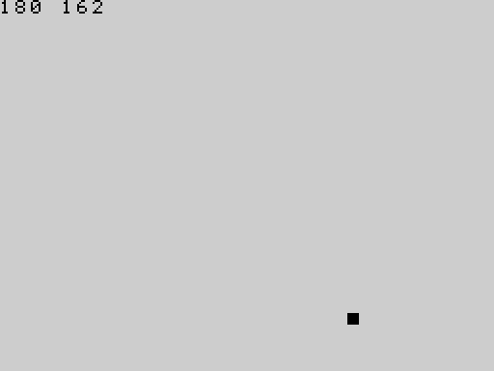
The ball at the end of the run
(The numbers printed are the final position; the small square in the picture is the ball. A procedure draws it, so the same code both draws and rubs out.)

13. A sprite on a background
With the sprite package loaded (LOAD "SPRITE" EXT): draw a small ship from character cells, grab it, and fly it over a starry background without disturbing the stars.
With the sprite package loaded (LOAD "SPRITE" EXT):
INK 6
PAPER 0
CLS
LINE 16, 24 TO 31, 16
LINE 31, 16 TO 31, 31
LINE 31, 31 TO 16, 24
LINE 16, 24 TO 31, 24
GRAB 0, 2, 2, 2, 2
INK 7
PAPER 0
CLS
RANDOMISE 3
FOR i = 1 TO 40
PLOT RND(256), RND(176)
NEXT i
SHOW 0, 10, 0
FOR c = 1 TO 28
MOVE 0, 10, c
PAUSE 2
NEXT c

The ship at the right-hand end of its flight over stars

14. Save a high score
A program that keeps a table of scores and can be put away and brought back with SAVE ... ALL: the variables travel with the program. Typed after the program has run once:
hi = 0
name$ = "NOBODY"
PROC record(s):
IF s > hi THEN
hi = s
name$ = "ADA"
ENDIF
ENDP
RUN
: CALL record(120)
: CALL record(80)
: PRINT hi
120
SAVE "scores" ALL [SAVED]
power on
LOAD "scores" [LOADED]
: PRINT name$
ADA
: PRINT hi
120

Appendices

Appendix A: Messages
What the status line (the bottom row of the screen) can say. The program or command that caused it is described in Part 3 and Part 4.

Compile messages (nothing ran)
Message | Meaning
SYNTAX ERROR | the statement is not written correctly: something is missing, in the wrong place, or is not a known statement (including a package statement whose package is not loaded). When you press a key the cursor goes to the line. Most compile errors show this message; Appendix B distinguishes them
UNEXPECTED TOKEN | something that cannot go here: a stray ELSE, ENDIF, ENDP, THEN, TO, a closing bracket; two values side by side; an unterminated string; a character that is not part of the language (', ?, _); a number literal beyond about 1.7 x 10^38
NAME TOO LONG | a name of more than 31 characters
NESTING TOO DEEP | brackets, IF blocks or loops nested too deeply
TOO MANY VARIABLES | more than 251 different number names, 251 string names or 255 array names
OUT OF MEMORY | the program is too big for the compiler's tables or its code area

Run-time messages (the program stopped)
Message | Meaning
RUNTIME ERROR | a statement failed while the program ran: division by zero, an array index outside the array, a number stored in a numeric array that is not a whole number or is out of range, NEXT without its loop, a bad argument (CHR$(256), SQR(-1), STICK(3), PEEK(65536)), a result too big (beyond about 1.7 x 10^38), a package argument out of range
STACK OVERFLOW | procedures called themselves too deeply, or an expression nested too deeply
OUT OF MEMORY | an array is too big for the memory left
ARRAY SIZE MISMATCH | a DIM differs from the stored array of the same name
BREAK | you pressed CAPS SHIFT + SPACE

Editor and tape messages
Message | Meaning
PROGRAM FULL | the line you just entered does not fit in the memory for programs; it was not stored
SAVED, LOADED, VERIFIED | the tape command worked
VERIFY FAILED | the tape and memory differ (or the tape could not be read)
LOAD FAILED | no matching tape was found, it was damaged, or the data does not fit
NO VARIABLES | a SAVE ... ALL tape was loaded but its variables could not be used (different ROM version or different package)
BAD TAPE VERSION | the tape is from V1, a stock Spectrum or a ROM with an incompatible format
ABORTED | SPACE was pressed during a tape operation
NO PACKAGE | SAVE "name" EXT with no package loaded
ARRAY NOT DIMD | SAVE ... ARRAY a for an array the program does not declare
BAD ARRAY TAPE | the tape block is not a valid array
ARRAY STORE FULL | no room is left in the Array Store
LINE n/m | not an error: the editor's status line (cursor line n of m)

The PROGRAM FULL message is covered by the release qualification (defect RC-2), not by an example of this manual: it needs a nearly full program memory.

Appendix B: Error codes
The status line shows messages, not numbers. Inside the system every error has a number, which appears in the test suites, in the defect register and in the source. They are listed here, with a program that causes each; every program below is run by make doc-examples and must stop with exactly that code.

Compile errors
Compile errors have no effect on anything: nothing ran. The message column is the status line.
Code | Message | Cause
1 | TOO MANY VARIABLES | more than 251 number names (252nd)
2 | SYNTAX ERROR | an identifier at the start of a statement not followed by = (also: an unknown word, LET, GOSUB, a package statement without its package)
3 | SYNTAX ERROR | an expression could not start where it did (PRINT 1 +, PRINT ), x = )
7 | SYNTAX ERROR | GOTO to a label that does not exist
8 | SYNTAX ERROR | IF without THEN
9 | SYNTAX ERROR | an IF block missing its ELSE or ENDIF
10 | SYNTAX ERROR | no loop variable after FOR
11 | SYNTAX ERROR | FOR without TO
12 | SYNTAX ERROR | no label name after GOTO
13, 14, 15 | SYNTAX ERROR | CALL: no procedure name; no (; no )
16 | SYNTAX ERROR | PROC without ENDP
17, 18, 19, 20 | SYNTAX ERROR | PROC: no name; no (; no parameter; no )
22 | SYNTAX ERROR | no comma in a two-argument statement (PLOT 1 2, BEEP 1, POKE, SOUND, OUT, AT)
23, 24, 25 | SYNTAX ERROR | LINE: no comma after x0; no TO; no comma after x1
28 | SYNTAX ERROR | a package statement with the wrong number of arguments
29, 30, 31 | SYNTAX ERROR | a built-in function: no (; no comma between arguments; no )
32 | SYNTAX ERROR | DIM with no name; also LPRINT without the printer package
33 | SYNTAX ERROR | DIM a without (
34 | SYNTAX ERROR | the DIM size (or width) is not a plain number
35 | SYNTAX ERROR | DIM size of 0
37 | SYNTAX ERROR | DIM with no ) (also: a second dimension)
38 | SYNTAX ERROR | an array declared twice
41 | SYNTAX ERROR | an array index with no )
42 | SYNTAX ERROR | an assignment to an array that was never DIM'd
43 | SYNTAX ERROR | INPUT with no variable name
44 | SYNTAX ERROR | EXIT not followed by FOR
46, 47, 48 | SYNTAX ERROR | DIMN: no (; not a numeric array name; no )
49, 50, 51, 52, 53, 54 | SYNTAX ERROR | DEF FN: no FN; no name; no (; no parameter; no ); no =
56 | SYNTAX ERROR | NEXT for another variable (or no loop open)
57 | SYNTAX ERROR | a label or procedure defined twice
60 | NESTING TOO DEEP | nesting too deep
61 | NAME TOO LONG | a name of more than 31 characters
63 | SYNTAX ERROR | EXIT FOR outside a loop
64 | UNEXPECTED TOKEN | a token that cannot go here (see Appendix A); also a literal beyond the number range
65 | SYNTAX ERROR | a FOR with no NEXT
66 | SYNTAX ERROR | a bracketed expression with no )
70 | SYNTAX ERROR | a string literal longer than 31 characters
71 | SYNTAX ERROR | an immediate statement tried to define a label, procedure or function

ce 2 | x 5
ce 3 | PRINT 1 +
ce 7 | GOTO nowhere
ce 8 | IF 1 PRINT 2
ce 9 | IF 1 THEN ;; PRINT 1
ce 10 | FOR = 1 TO 2
ce 11 | FOR i = 1 5
ce 12 | GOTO 5
ce 13 | CALL 5
ce 14 | CALL foo
ce 15 | PROC p(n): ;; ENDP ;; CALL p(1
ce 16 | PROC p(n): ;; PRINT n
ce 17 | PROC
ce 18 | PROC p
ce 19 | PROC p()
ce 20 | PROC p(n
ce 22 | PLOT 1 2
ce 23 | LINE 1 TO 2,3
ce 24 | LINE 1,2 3,4
ce 25 | LINE 1,2 TO 3 4
ce 28 pkg=shapes | CIRCLE 1,2
ce 29 | PRINT ABS 5
ce 30 | PRINT MOD(1 2)
ce 31 | PRINT ABS(1
ce 32 | DIM
ce 33 | DIM a
ce 34 | DIM a(n)
ce 35 | DIM a(0)
ce 37 | DIM a(5
ce 38 | DIM a(3) ;; DIM a(4)
ce 41 | DIM a(3) ;; PRINT a(1
ce 42 | a(1) = 5
ce 43 | INPUT 5
ce 44 | EXIT 5
ce 46 | PRINT DIMN a
ce 47 | PRINT DIMN(5)
ce 48 | DIM a(2) ;; PRINT DIMN(a
ce 49 | DEF 5
ce 50 | DEF FN 5
ce 51 | DEF FN f x
ce 52 | DEF FN f(
ce 53 | DEF FN f(x
ce 54 | DEF FN f(x) 5
ce 56 | FOR i = 1 TO 2 ;; NEXT j
ce 57 | a: ;; a:
ce 61 | pppppppppppppppppppppppppppppppp = 1
ce 63 | EXIT FOR
ce 64 | PRINT 1 2
ce 65 | FOR i = 1 TO 2
ce 66 | PRINT (1 + 2
ce 70 | PRINT "AAAAAAAAAAAAAAAAAAAAAAAAAAAAAAAAA"
ce 1 | @repeat 252 v{i} = 1
ce 39 | @repeat 256 DIM a{i}(1)
ce 60 | @repeat 300 IF 1 THEN
Codes that no program produces: 21 (the colon after a PROC parameter list is optional), 26 and 27 (retired), 36 (a DIM that is too big is reported when it runs, as OUT OF MEMORY), 40, 45 and the rest of the table's gaps. Codes 5, 6, 55 and 62 are "out of compile memory" (message OUT OF MEMORY): the label table, the table of forward references, the code area and the compiler's workspace; see Limits.
An immediate statement that defines a label (code 71):
x = 1
RUN
: here: PRINT 2 [ce:71]
: PROC p(n): PRINT n : ENDP [ce:71]
: PRINT x
1

Run-time errors
Code | Message | Cause
2, 6 | STACK OVERFLOW | recursion (6) or expression nesting (2) too deep
5 | RUNTIME ERROR | division by zero (/, DIV, MOD), TAN(90)
7 | RUNTIME ERROR | NEXT or return with no frame: jumping into a loop; a loop ended by CLEAR
10 | RUNTIME ERROR | array index outside the array
11 | RUNTIME ERROR | a fraction or out-of-range number stored in a numeric array, or used as an index
15 | RUNTIME ERROR | argument out of range: CHR$, STICK, SQR of a negative number, an address of 65536 or more
64 | OUT OF MEMORY | an array does not fit
65 | ARRAY SIZE MISMATCH | DIM differs from a stored array
66 | BREAK | CAPS SHIFT + SPACE
67 | RUNTIME ERROR | a result beyond about 1.7 x 10^38
12 to 14 | RUNTIME ERROR | mode package: bad MODE, ULAPLUS, PALETTE
15 to 20 | RUNTIME ERROR | sprite package (see Part 5)

ve 5 | PRINT 1 / 0
ve 5 | PRINT TAN(90)
ve 5 | PRINT DIV(1, 0)
ve 7 | GOTO inside ;; FOR i = 1 TO 3 ;; inside: ;; PRINT i ;; NEXT i
ve 10 | DIM a(5) ;; PRINT a(5)
ve 11 | DIM a(5) ;; a(2) = 1.5
ve 15 | PRINT CHR$(256)
ve 15 | PRINT SQR(-1)
ve 15 | PRINT STICK(3)
ve 15 | PRINT PEEK(65536)
ve 64 | DIM a(5000)
ve 67 | PRINT 100000 * 100000 * 100000 * 100000 * 100000 * 100000 * 100000 * 100000
ve 6 | CALL r(5000) ;; END ;; PROC r(n): ;; IF n > 0 THEN ;; CALL r(n - 1) ;; ENDIF ;; ENDP
ve 12 pkg=mode | MODE 2
ve 13 pkg=mode | ULAPLUS 2
ve 14 pkg=mode | PALETTE 64, 0
ve 15 pkg=sprite | GRAB 8, 0, 0, 1, 1
ve 16 pkg=sprite | GRAB 0, 0, 0, 5, 1
ve 17 pkg=sprite | SHOW 0, 1, 1
ve 18 pkg=sprite | GRAB 0, 0, 0, 1, 1 ;; SHOW 0, 0, 0 ;; SHOW 0, 1, 1
ve 19 pkg=sprite | HIDE 0
ve 20 pkg=sprite | GRAB 0, 23, 31, 2, 2

Appendix C: The character set
Characters are the standard Spectrum-family set for codes 32 to 127, plus 16 block graphics for codes 128 to 143, and 21 user-defined characters for codes 144 to 164 that you design yourself (see User-defined characters): they are blank until you POKE a picture into them. Nothing is drawn for codes 0 to 31 or 165 to 255. PRINT CHR$(n) prints character n; CODE gives the code of a character.
CLS
PRINT "code characters (16 to a row)"
FOR r = 0 TO 6
AT 2 + r * 2, 0
PRINT 32 + r * 16;
FOR c = 0 TO 15
AT 2 + r * 2, 6 + c
PRINT CHR$(32 + r * 16 + c);
NEXT c
NEXT r
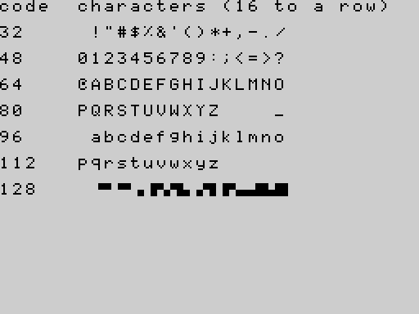
Characters 32 to 143: the first code of each row is at the left
Nine characters have no picture. The font of the release has no glyph for [ \ ] ^ ` ` { | } ~ (codes 91, 92, 93, 94, 96, 123, 124, 125 and 126): they print as a blank. They can be typed, kept in strings, compared and passed to CODE`; they just cannot be seen. (An accepted limitation of the release, Q-26.)
PRINT "a[\]^`{|}~b"
PRINT LEN("a[\]^`{|}~b")
PRINT CODE("[")
a b
11
91
Block graphics. Codes 128 to 143 are 2 x 2 blocks: each bit of (code - 128) is one quarter. Bit 0 is the top right, bit 1 the top left, bit 2 the bottom right, bit 3 the bottom left. The program prints the four quarters of each (1 = filled), in the order top left, top right, bottom left, bottom right:
DIM s$(16, 16)
FOR c = 128 TO 143
CLS
AT 12, 0
PRINT CHR$(c);
a = POINT(0, 96)
b = POINT(7, 96)
d = POINT(0, 103)
e = POINT(7, 103)
s$(c - 128) = STR$(c) + " " + STR$(a) + STR$(b) + STR$(d) + STR$(e)
NEXT c
CLS
FOR i = 0 TO 15
PRINT s$(i)
NEXT i
128 0000
129 0100
130 1000
131 1100
132 0001
133 0101
134 1001
135 1101
136 0010
137 0110
138 1010
139 1110
140 0011
141 0111
142 1011
143 1111

Appendix D: Limits
All figures were measured on the release with an otherwise empty program, unless said otherwise.
What | Limit
characters in a program line | 127 (the editor refuses more)
characters in a name | 31
characters in a string | 31 (a longer constant is a compile error; a longer join is cut)
characters in an INPUT of a number | 20
characters in a tape name | 10
number names (different number variables) | 251
string names | 251; but each costs memory, and about 155 one-character strings fit in a program that does nothing else
array names | 255
size of one numeric array | up to 16383 in the program, but memory allows 4063 on an empty program
size of one string array | 508 elements of 15 characters, or 254 of 31 (empty program)
dimensions of an array | 1
whole numbers | -32768 to 32767 (arrays hold only these)
floating-point numbers | magnitude up to about 1.7 x 10^38, about 9 significant digits
labels in a program | about 440
forward GOTOs waiting for their label at the same time | 274
nested brackets | 105
nested IF blocks | 211
nested FOR loops | 141
operands nested in 1+(1+(1+(... | about 40
EXIT FOR statements in one loop | at least 261
depth of recursion of a one-parameter procedure | 671
program text | about 8.1 KB: the pool is 8397 bytes, shared with names, variables and arrays; 749 lines of PRINT n is the most that runs (750 lines fill the pool: OUT OF MEMORY at RUN)
free main memory on an empty machine | 8153 bytes (FREE()); 2048 in the overflow segment (FREE(1))
bytes of compiled program (the code area, separate from the pool) | 4011; 1000 lines of x = 1 fit, 1010 do not (OUT OF MEMORY while compiling)
procedure calls and FOR loops active at once | 12 bytes of the free gap each (671 deep recursion with an empty program)
session variables created by immediate statements | about ten short names
sprite slots | 8
sprite size | 1 to 4 by 1 to 4 character cells
text screen | 32 columns by 23 rows (row 23 is the status line)
graphics screen | 256 by 192 pixels
CPLOT grid | 64 by 48
SOUND registers | 1 to 16
PAUSE | up to 65535 frames

Most of these are limits of memory and move with what else the program uses; the compiler's own tables (names, labels, forward references) are fixed. The nesting limits are those of the compiler's and the machine's stacks: a program that needs more than that stops with NESTING TOO DEEP, STACK OVERFLOW or OUT OF MEMORY.

Appendix E: Memory map
For PEEK, POKE, USR, IN and OUT. Addresses are decimal with hexadecimal in brackets. Nothing in this appendix has been checked on a physical TS2068 (see Appendix G).
Addresses | Size | Contents
0 - 16383 ($0000-$3FFF) | 16 KB | the HOME ROM
16384 - 22527 ($4000-$57FF) | 6144 | the display: pixels
22528 - 23295 ($5800-$5AFF) | 768 | the display: colour attributes (one per 8 x 8 cell)
23296 - 24575 ($5B00-$5FFF) | 1280 | not used by V2 -- free for your own data and machine code
24576 - 30719 ($6000-$77FF) | 6144 | the second display file: used by MODE 1 (extended-colour mode) as 8 x 1 colour attributes, one byte for every eight pixels of every scan line; free otherwise
30720 - 32767 ($7800-$7FFF) | 2048 | not used by V2 -- free
32768 - 33877 ($8000-$8454) | 1109 | system variables (editor, tape, calculator, graphics): do not touch
33878 - 41766 ($8456-$A326) | about 8.4 KB | the main memory pool: program text, variables, arrays (FREE())
41767 - 42068 ($A327-$A454) | 302 | compiler workspace
42069 - 46079 ($A455-$B3FF) | 4011 | the compiled program
46080 - 49151 ($B400-$BFFF) | 3072 | the system's fixed tables and registers
49152 - 57343 ($C000-$DFFF) | 8 KB | RAM under the EXROM: while a program runs the EXROM is switched in and this RAM is not visible; the FILL work area lives here; do not use
57344 - 59391 ($E000-$E7FF) | 2048 | the overflow segment: the Array Store and arrays that did not fit
59392 - 61695 ($E800-$F0FF) | 2304 | sprite images and saved backgrounds (the sprite package)
61696 - 61823 ($F100-$F17F) | 128 | label table (reserved by the system): do not touch
61824 - 61991 ($F180-$F227) | 168 | the user-defined characters: 8 bytes for each of the codes 144 to 164; yours to POKE (see User-defined characters)
61992 - 62419 ($F228-$F3D2) | 428 | the editor's line buffer, the listing buffer, string and function workspace: do not touch
62420 - 62463 ($F3D3-$F3FF) | 45 | unused
62464 - 63487 ($F400-$F7FF) | 1024 | the package window: a loaded package lives here
63488 - 65279 ($F800-$FEFF) | 1792 | the machine stack grows down into this from $FF00; keep off it
65280 - 65535 ($FF00-$FFFF) | 256 | above the stack's start

Rules for your own machine code (USR):
- Put it in $5B00-$5FFF (23296 to 24575), or $7800-$7FFF. Those are the two blocks that no part of the V2 system uses. Do not place it in the main pool, which belongs to the program.
- Enter with the address in HL; return with RET and the result in HL; any register may be destroyed; leave interrupts enabled; do not use more than a few dozen bytes of stack.
Ports used by the system (IN/OUT): $FE (254) keyboard, speaker, border and tape; $F5/$F6 (245/246) the AY sound chip's register and data ports; $F4 (244) the memory bank select; $FF (255) the video mode and EXROM select; $FB (251) the printer. Changing a port the system keeps a copy of ($FE, $FF) with OUT can confuse the system.

Appendix F: Package reference card
Package | LOAD "..." EXT | Statement | Arguments
mode | MODE | MODE m | m 0 or 1
 |  | ULAPLUS u | u 0 or 1
 |  | PALETTE i, v | i 0-63, v 0-255
sprite | SPRITE | GRAB s, r, c, w, h | slot 0-7; row 0-23; col 0-31; width, height 1-4 cells
 |  | SHOW s, r, c | slot; row; col
 |  | MOVE s, r, c | slot; row; col
 |  | HIDE s | slot
printer | PRINTER | LPRINT x | one number or string
 |  | LLIST | --
shapes | SHAPES | CIRCLE x, y, r | centre 0-255, 0-191; radius in pixels
 |  | FILL x, y | a pixel inside the area
graphics | GRAPHICS | CPLOT x, y | x 0-63, y 0-47
 |  | BLOCK x0, y0, x1, y1 | pixel corners
 |  | FRAME x0, y0, x1, y1 | pixel corners
 |  | INVERT x0, y0, x1, y1 | pixel corners

One package at a time; NEW unloads it; a statement of a package that is not loaded is a compile error.

Appendix G: Hardware notes
Everything in this manual was verified in the ZEsarUX emulator on the accepted release ROMs (tag v2.0.0-emu.1). Nothing was tried on a physical TS2068, a real cassette recorder, a ZX Printer, a joystick, ULAplus hardware or a Dock/EXROM cartridge. In particular:
- the sound (BEEP, SOUND) was measured by counting instructions and port writes; it was never listened to;
- the figures for PAUSE assume the emulator's 50 frames a second; a real TS2068 is expected to interrupt at 60 a second (not measured);
- tape timing was exercised only through the emulator's tape input; the identity-check pause of about 2.4 seconds on SAVE ... ALL, LOAD and VERIFY of an ALL tape has not been timed on real hardware;
- the printer package, the joysticks, MODE 1, ULAplus and the keyboard-matrix details are as the source states, not as seen on a machine;
- the hardware checklist for the release is docs/v2/V2_HARDWARE_CHECKLIST.md.

Appendix H: Keyword index
Group | Keywords
Program structure | REM, END, STOP, GOTO, IF THEN ELSE ENDIF, FOR TO STEP NEXT EXIT FOR, PROC ENDP CALL, DEF FN FN, CLEAR
Values and variables | DIM, DIMN, FREE
Numbers | ABS, SGN, INT, DIV, MOD, SQR, SIN, COS, TAN, PI, RAD, DEG, RND, RANDOMISE
Strings | LEN, CODE, VAL, CHR$, STR$, UPPER$, LOWER$, LEFT$, RIGHT$, MID$
Logic | AND, OR, NOT
Screen and text | PRINT, AT, TAB, CLS, INK, PAPER, BRIGHT, FLASH, INVERSE, OVER, BORDER, ATTR
Graphics | PLOT, LINE, POINT
Sound | BEEP, SOUND
Input | INPUT, INKEY$, STICK, PAUSE
The machine | PEEK, POKE, USR, IN, OUT
Commands | RUN, LIST, NEW, SAVE, LOAD, VERIFY (with ALL, ARRAY, EXT)
Package: mode | MODE, ULAPLUS, PALETTE
Package: sprite | GRAB, SHOW, HIDE, MOVE
Package: printer | LPRINT, LLIST
Package: shapes | CIRCLE, FILL
Package: graphics | CPLOT, BLOCK, FRAME, INVERT

Appendix I: How this manual was checked
- Every example marked with an output block, a picture, a transcript or an error code in this manual is a test. make doc-examples runs them all on the release image (tools/qual/manual_run.py; the parser is tools/qual/manual_examples.py): programs are stored and run; LIST, RUN, NEW and the editor keys are typed through the real keyboard path; SAVE is captured at the tape transport and LOAD / VERIFY run the real tape receiver on a synthesised signal; packages are loaded with LOAD "NAME" EXT through that same receiver; BREAK is pressed in the emulated keyboard matrix; pictures are rendered from screen memory and compared with the committed images.
- This suite is separate from the 1010-case release baseline (make test, make qual, tools/qual/corpus.py), which it does not touch and whose totals it does not change.
- Facts that are not examples (limits, timings) were measured with tools/qual/manual_measure.py and the commands recorded in docs/v2/V2_DOCUMENTATION_FINDINGS.md, which also lists what in the earlier documents turned out to be wrong.

