**(KPIs) Requirements calculated solutions :**

1. **Total Loan Applications:** We need to calculate the total number of loan applications received during a specified period.

SELECT COUNT(id) as Total_Loan_Application

FROM financial_loan

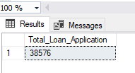

Additionally, it is essential to monitor the **Month-to-Date (MTD)** Loan Applications and track changes Month-over-Month (MoM).

SELECT COUNT(id) as Total_Loan_Application

FROM financial_loan

WHERE MONTH(issue_date) = 12 AND YEAR(issue_date) = 2021

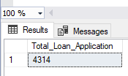

**Previous Month-to-Date (MTD)** Loan Applications

SELECT COUNT(id) as MTD_Loan_Application

FROM financial_loan

WHERE MONTH(issue_date) = 11 AND YEAR(issue_date) = 2021

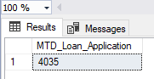

**2.Total Funded Amount:**

SELECT SUM(loan_amount) as Total_Funded_Amount

FROM financial_loan

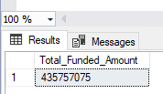

**-MTD_Total Funded Amount:**

SELECT SUM(loan_amount) as MTD_Total_Funded_Amount

FROM financial_loan

WHERE MONTH(issue_date) = 12 AND YEAR(issue_date) = 2021

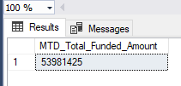

-- **PMTD_Total Funded Amount:**

SELECT SUM(loan_amount) as MTD_Total_Funded_Amount

FROM financial_loan

WHERE MONTH(issue_date) = 11 AND YEAR(issue_date) = 2021

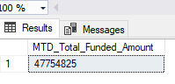

**3.Total Amount Received:**

SELECT SUM(total_payment) as Total_Amount_Received

FROM financial_loan

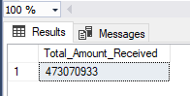

**MTD_Total Amount Received:**

SELECT SUM(total_payment) as MTD_Total_Amount_Received

FROM financial_loan

WHERE MONTH(issue_date) = 12 AND YEAR(issue_date) = 2021

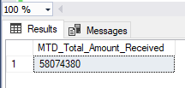

-- PMTD_Total Amount Received:

SELECT SUM(total_payment) as PMTD_Total_Amount_Received

FROM financial_loan

WHERE MONTH(issue_date) = 11 AND YEAR(issue_date) = 2021

**4. Average Interest Rate:**

SELECT ROUND(AVG(int_rate),4) * 100 as Average_Interest_Rate

FROM financial_loan

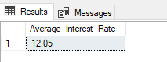

-- **MTD_Average Interest Rate:**

SELECT ROUND(AVG(int_rate),4) * 100 as Average_Interest_Rate

FROM financial_loan

WHERE MONTH(issue_date) = 12 AND YEAR(issue_date) = 2021

-- **PMTD_Average Interest Rate:**

SELECT ROUND(AVG(int_rate),4) * 100 as Average_Interest_Rate

FROM financial_loan

WHERE MONTH(issue_date) = 11 AND YEAR(issue_date) = 2021

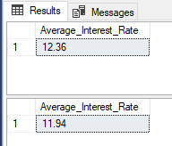

**5.Average Debt-to-Income Ratio (DTI):**

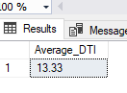

--**MTD_Average Debt-to-Income Ratio (DTI):**

SELECT ROUND(AVG(dti),4) * 100 as MTD_Average_DTI

FROM financial_loan

WHERE MONTH(issue_date) = 12 AND YEAR(issue_date) = 2021

--**PMTD_Average Debt-to-Income Ratio (DTI):**

SELECT ROUND(AVG(dti),4) * 100 as PMTD_ Average_DTI

FROM financial_loan

WHERE MONTH(issue_date) = 11 AND YEAR(issue_date) = 2021

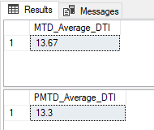

**--1. Good Loan Percentage:**

SELECT

( COUNT(CASE WHEN loan_status = 'Fully Paid' OR loan_status = 'Current' THEN id END) * 100)

/

COUNT(id) as Good_Loan_Percentage

FROM financial_loan

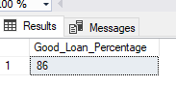

--1. **Good Loan Application**

SELECT COUNT(id) AS Good_Loan_Application

FROM financial_loan

WHERE loan_status = 'Fully Paid' OR loan_status = 'Current'

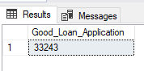

--3. **Good Loan Funded Amount:**

SELECT SUM(loan_amount) AS Good_Loan_Funded_Amount

FROM financial_loan

WHERE loan_status = 'Fully Paid' OR loan_status = 'Current'

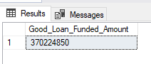

--4. **Good Loan Total Received Amount:**

SELECT SUM(total_payment) AS GoodLoan_Total_Received_Amount

from [Bank loan project DB].[dbo].[financial_loan]

WHERE loan_status IN ('Fully Paid','Current')

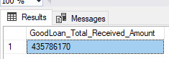

**--Bad Loan KPIs:**

**--1. Bad Loan Percentage:**

SELECT

( COUNT(CASE WHEN loan_status = 'Charged off' THEN id END) * 100)

/

COUNT(id) as Good_Loan_Percentage

FROM [Bank loan project DB].[dbo].[financial_loan]

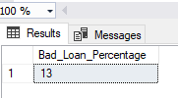

--3. **Bad Loan Applications**

SELECT COUNT(id) as Bad_Loan_Applications

FROM [Bank loan project DB].[dbo].[financial_loan]

WHERE loan_status = 'Charged off'

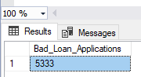

**--4. Bad Loan Total Received Amount:**

SELECT SUM(total_payment) as Bad_Loan_Received_Amount

FROM [Bank loan project DB].[dbo].[financial_loan]

WHERE loan_status = 'Charged off'

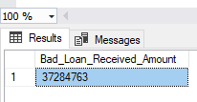

**--Loan Status**

select

loan_status,

COUNT(id) AS Total_Loan_Applications,

SUM(total_payment) AS Total_Amount_Received,

SUM(loan_amount) AS Total_Loan_Amount,

AVG(int_rate * 100) AS Intrest_Rate,

AVG(dti * 100) AS DTI

from [Bank loan project DB].[dbo].[financial_loan]

GROUP BY loan_status

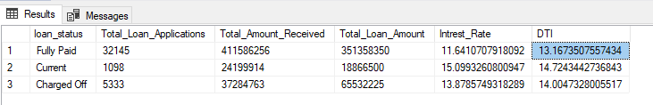

--**Loan Status Month to Date**

select

loan_status,

SUM(total_payment) AS MTD_Total_Amount_Received,

SUM(loan_amount) AS MTD_Total_Loan_Amount

from [Bank loan project DB].[dbo].[financial_loan]

where MONTH(issue_date) = 12

GROUP BY loan_status

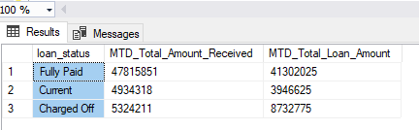

1. **Monthly Trends by Issue Date (Line Chart):**

SELECT

MONTH (issue_date) AS Month_Number,

DATENAME(MONTH, issue_date) AS Month_Name,

SUM(total_payment) AS Total_Amount_Received,

SUM(loan_amount) AS Total_Loan_Amount

FROM [Bank loan project DB].[dbo].[financial_loan]

GROUP BY MONTH (issue_date),DATENAME(MONTH, issue_date)

ORDER BY MONTH (issue_date)

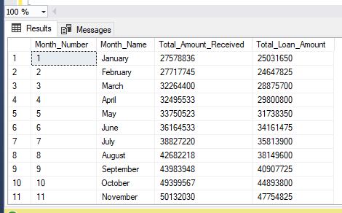

**--2. Regional Analysis by State (Filled Map):**

SELECT

address_state,

COUNT(id) AS Total_Loan_Applications,

SUM(loan_amount) AS Total_Loan_Amount,

SUM(total_payment) AS Total_Amount_Received

FROM [Bank loan project DB].[dbo].[financial_loan]

GROUP BY address_state

ORDER BY COUNT(id) DESC

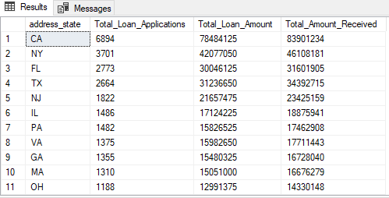

**--3. Loan Term Analysis (Donut Chart):**

SELECT

term,

COUNT(id) AS Total_Loan_Applications,

SUM(loan_amount) AS Total_Loan_Amount,

SUM(total_payment) AS Total_Amount_Received

FROM [Bank loan project DB].[dbo].[financial_loan]

GROUP BY term

ORDER BY term

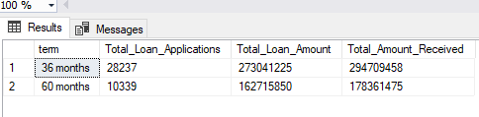

**4. Employee Length Analysis (Bar Chart):**

SELECT

emp_length,

COUNT(id) AS Total_Loan_Applications,

SUM(loan_amount) AS Total_Loan_Amount,

SUM(total_payment) AS Total_Amount_Received

FROM [Bank loan project DB].[dbo].[financial_loan]

GROUP BY emp_length

ORDER BY COUNT(id) DESC

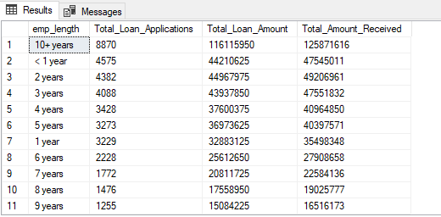

**--5. Loan Purpose Breakdown (Bar Chart):**

SELECT

purpose,

COUNT(id) AS Total_Loan_Applications,

SUM(loan_amount) AS Total_Loan_Amount,

SUM(total_payment) AS Total_Amount_Received

FROM [Bank loan project DB].[dbo].[financial_loan]

GROUP BY purpose

ORDER BY COUNT(id) DESC

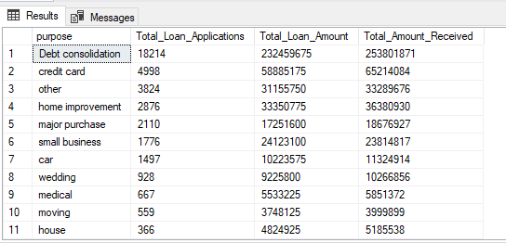

**--6. Home Ownership Analysis (Tree Map):**

SELECT

home_ownership,

COUNT(id) AS Total_Loan_Applications,

SUM(loan_amount) AS Total_Loan_Amount,

SUM(total_payment) AS Total_Amount_Received

FROM [Bank loan project DB].[dbo].[financial_loan]

GROUP BY home_ownership

ORDER BY COUNT(id) DESC

