--Populate Property Address Data

select *

from Arboratestoredataforsql

order by ParcelID

----If a parcelid has an address and anothere parcelid does not have and address

--then we can populated by using firstparcelid address by using self join

select a.ParcelID, a.PropertyAddress, b.ParcelID, b.PropertyAddress, isnull( a.PropertyAddress,b.PropertyAddress)

from Arboratestoredataforsql a

join Arboratestoredataforsql b

on a.ParcelID = b.ParcelID

and a.UniqueID <> b.UniqueID

where a.PropertyAddress is null

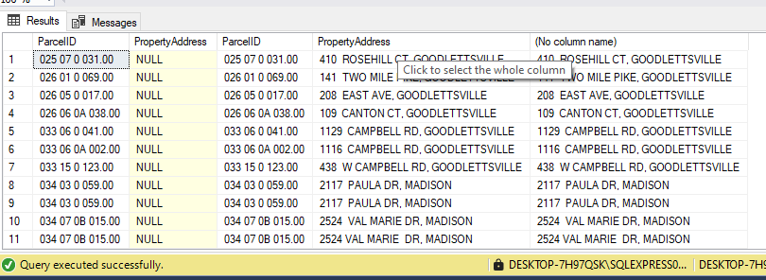

-------------------------------------------------------------------------------

--Saperating address into induvidual columns (Address, City, State) by using substring

select PropertyAddress

from Arboratestoredataforsql

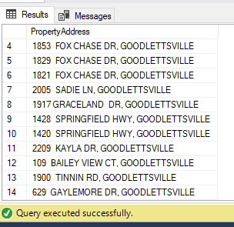

select

substring(PropertyAddress,1, charindex(',',PropertyAddress) -1) As Address

, substring(PropertyAddress,charindex(',',PropertyAddress) +1 , len(PropertyAddress)) As Address

from Arboratestoredataforsql

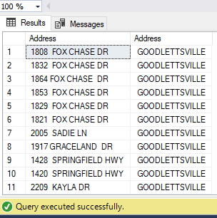

--Added New Columns into the table

Alter table Arboratestoredataforsql

add PropertySplitAddr varchar(255);

update Arboratestoredataforsql

set PropertySplitAddr = substring(PropertyAddress,1, charindex(',',PropertyAddress) -1)

Alter table Arboratestoredataforsql

add PropertySplitCity varchar(255);

update Arboratestoredataforsql

set PropertySplitCity = substring(PropertyAddress,charindex(',',PropertyAddress) +1 , len(PropertyAddress))

select *

from Arboratestoredataforsql

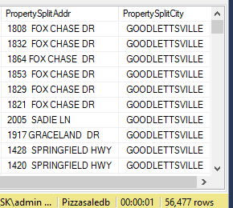

--Saperating owners address into induvidual columns (Address, City, State) by using sql parsename function

select

parsename(replace(OwnerAddress, ',', '.'), 3)

,parsename(replace(OwnerAddress, ',', '.'), 2)

,parsename(replace(OwnerAddress, ',', '.'), 1)

from Arboratestoredataforsql

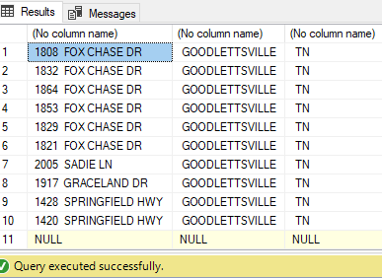

--Added New Columns into the table

Alter table Arboratestoredataforsql

add OwnerSplitAddr varchar(255);

update Arboratestoredataforsql

set OwnerSplitAddr = parsename(replace(OwnerAddress, ',', '.'), 3)

Alter table Arboratestoredataforsql

add OwnerSplitCity varchar(255);

update Arboratestoredataforsql

set OwnerSplitCity = parsename(replace(OwnerAddress, ',', '.'), 2)

Alter table Arboratestoredataforsql

add OwnerSplitState varchar(255);

update Arboratestoredataforsql

set OwnerSplitState = parsename(replace(OwnerAddress, ',', '.'), 1)

select *

from Arboratestoredataforsql

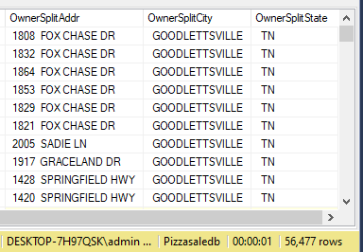

--------------------------------------------------------------------------------------------------

--Remove Duplicates by using window functions

finding out duplicate rows

with rownumcte as(

select *,

row_number() over(

partition by ParcelID,

PropertyAddress,

SaleDate,

SalePrice,

LegalReference

order by

UniqueID

) rownum

from Arboratestoredataforsql

)

select *

from rownumcte

where rownum > 1

order by PropertyAddress

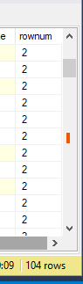

with rownumcte as(

select *,

row_number() over(

partition by ParcelID,

PropertyAddress,

SaleDate,

SalePrice,

LegalReference

order by

UniqueID

) rownum

from Arboratestoredataforsql

)

delete

from rownumcte

where rownum > 1

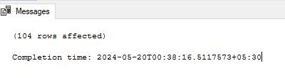

--------------------------------------------------------------------------------

--Delete unused column

select *

from Arboratestoredataforsql

alter table Arboratestoredataforsql

drop column OwnerAddress, TaxDistrict, PropertyAddress